

**Postgraduate coursework graduate incomes: Insights from administrative data**

October 2021

Phil Aungles, Gabrielle Hodgson and Simon Parbery

The authors would like to acknowledge the helpful comments received by departmental colleagues and an anonymous referee on the paper. Any errors or omissions remain the responsibility of the authors. The views expressed in this paper are those of the authors and do not necessarily reflect those of the Department of Education, Skills and Employment or the Australian Government.

ISBN: xxxxxxxx

Creative Commons

With the exception of the Commonwealth Coat of Arms, the Department’s logo, any material protected by a trade mark and where otherwise noted all material presented in this document is provided under a [Creative Commons Attribution 4.0 International](http://dnet.hosts.network/education/Resources/Documents/Creative%20Commons%20Attribution%204.0%20International) (http://creativecommons.org/licenses/by/3.0/au/) licence.

The details of the relevant licence conditions are available on the Creative Commons website (accessible using the links provided) as is the full legal code for the [CC BY 4.0 International](http://dnet.hosts.network/education/Resources/Documents/CC%20BY%204.0%20International) (http://creativecommons.org/licenses/by/4.0/legalcode).

The document must be attributed as ‘Graduate incomes: Insights from administrative data’.

**Contents**

Key findings 1

Postgraduate coursework graduate incomes – insights from administrative data 2

Australian Taxation Office (ATO) administrative data on postgraduate coursework graduate incomes 2

Comparison of ATO administrative data and GOS survey data 4

2018 incomes of 2016 postgraduate coursework graduates 5

2007 cohort of postgraduate coursework graduates – growth in incomes 14

Tracking the growth in incomes of different postgraduate coursework cohorts 26

Conclusion 29

Attachment A: Reporting of graduate incomes from ATO administrative records on the ComparED website 30

Attachment B: Detailed income comparisons of bachelor and postgraduate coursework graduates 31

# Key findings

* Postgraduate coursework graduates earn around a third or 32 per cent more than bachelor graduates immediately following graduation.
* Postgraduate coursework graduates also experience less variation or uncertainty in their incomes than bachelor graduates.
* In part, this is because postgraduate coursework graduates are older and more established in their careers than are bachelor graduates.
* Postgraduate coursework graduates in study areas and institutions with high initial incomes also have higher incomes ten years after graduation.
* While there is some evidence study areas and institutions with lower initial incomes recover after ten years, this effect is much less evident than among bachelor graduates.
* Postgraduate coursework graduates experienced greater uncertainty in their incomes post-GFC, but this effect was more muted in comparison with bachelor graduates.
* Uncertainty in postgraduate coursework graduate incomes returned to pre-GFC levels shortly after, around two to three years after graduation, whereas this took longer among bachelor graduates, around five to seven years after graduation.
* This probably reflects postgraduate coursework graduates being further advanced in their careers with stronger attachment to the labour market and employers than bachelor graduates.

# Postgraduate coursework graduate incomes – insights from administrative data

This paper examines the incomes of postgraduate coursework graduates as revealed by Australian Taxation Office (ATO) administrative data. It closely follows in structure and content of an earlier paper examining incomes of bachelor graduates from ATO administrative data. This paper focuses on results and analysis of postgraduate coursework graduate incomes data. Readers are referred to the earlier paper for a more fulsome explanation of data sources and methods.

The first section of this paper describes the derivation of data on ATO graduate incomes. The second section examines differences in postgraduate coursework graduate incomes among different groups of graduates using data on the 2018 incomes of the cohort of graduates who completed their studies in 2016. The third section examines changes in postgraduate coursework graduate incomes over time. It does this by tracking the 2007 cohort of graduates describing growth in their incomes at least 1 year and up to 10 years following completion of their studies. The fourth section examines different cohorts of postgraduate coursework graduates comparing their incomes both before and after the Global Financial Crisis (GFC). The conclusion summarises findings with respect to the incomes of postgraduate coursework graduates.

For ease of exposition, this paper refers to postgraduate coursework graduates as graduates except where comparisons are made with bachelor level graduates.

## Australian Taxation Office (ATO) administrative data on postgraduate coursework graduate incomes

The creation of the data file for the analysis of postgraduate coursework graduate incomes sourced from ATO administrative records is shown in Figure 1. HEIMS records show there were 333,342 completions in 2016. First, the scope of ATO data on graduate incomes is restricted to graduates who have incurred a study debt through HECS-HELP, FEE-HELP, SA-HELP or OS-HELP programs. International students are not eligible to receive student loans and are therefore out of scope. So only the incomes of domestic graduates are reported in this paper. In 2016 there were 223,016 domestic completions. Second, the focus of this paper is on the incomes of postgraduate coursework level graduates with the incomes of sub-bachelor graduates and bachelor graduates reported separately. In 2016 there were 71,624 domestic postgraduate coursework completions (graduate certificate, postgraduate diploma and masters by coursework). Next, graduates who paid fees up front or who were in receipt of a scholarship and did not incur a student loan debt are out of scope resulting in 50,381 records. Graduates who are deceased, who may have left Australia or who have failed to fill in a tax return are out of scope resulting in 46,381 records. To avoid duplication of records, graduates recorded as completing another postgraduate coursework degree in the following year are excluded from analysis resulting in 45,482 records. Finally, the paper, rather than counting completions, drops to one record per graduate resulting in 44,940 records, enabling examination of the incomes of unique graduates.

**Figure 1: Creation of ATO data file for 2016 postgraduate coursework (PGC) completions**

333,342 completions in 2016 in HEIMS

Restrict to domestic completions

223,016 domestic completions in HEIMS

Restrict to postgraduate coursework completions

71,624 domestic PGC completions in HEIMS

Restrict to completions who had a HELP debt

50,381 domestic PGC completions with a student debt

Restrict to completions with a valid 2017/18 tax return

46,381 domestic PGC completions with a student debt who lodged a 2017/18 tax return

Remove records with a 2017 PGC completion

45,482 domestic PGC completions with a student debt who lodged a 2017/18 tax return and did not complete a PGC degree in 2017

Filter to one record per graduate

44,940 domestic PGC graduates with a student debt who lodged a 2017/18 tax return and did not complete a PGC degree in 2017

### Comparison of ATO administrative data and GOS survey data

One of the main purposes of collecting data on graduate incomes derived from ATO administrative records is that it can provide data at a more disaggregated level than is currently available through provision of survey data on graduate salaries. In turn, this may enable publication of graduate incomes data at more disaggregated level to better inform student choice on the ComparED website. A key question is the comparability of graduate incomes data derived from administrative and survey sources. Currently, the ComparED website shows the median salary of domestic graduates by university by study area for persons employed full-time with data derived from the Graduate Outcomes Survey. Median salaries are only calculated where individuals have an annual salary greater than $20,000, as this value is assumed as the lower bound for the salary of graduates working full-time. Graduate incomes data derived from administrative sources (ATO) are compiled on a different basis due to the nature of the data. As noted in the earlier paper, the preferred measure of graduate income from ATO administrative data is the median total income of domestic graduates. Comparison of the 2017 GOS measure with the 2018 ATO measure of the income of each postgraduate coursework graduate shows a relatively high correlation of 0.98. This provides a level of assurance that both measures are broadly comparable and either measure could be published on the ComparED website. For more information on the reporting of graduate incomes on the ComparED website see Attachment A.

## 2018 incomes of 2016 postgraduate coursework graduates

This section uses ATO administrative data from the 2017-2018 financial year, hereafter referred to as 2018 for ease of exposition, to examine the incomes of different groups of postgraduate coursework graduates immediately following graduation. The focus is on the 2018 incomes of 2016 graduates, that is, the incomes of graduates in 2018 who would have completed their degree at least one year and up to two years previously in 2016.

Figure 2 shows the median income of the 2016 cohort of domestic postgraduate coursework graduates who had completed their degree at least one year and up to two years previously was $67,500 in 2018. This was around a third or 32 per cent higher than the comparable figure for domestic bachelor degree holders of $51,200.

Administrative data on graduate incomes enables a more thorough examination of variation in graduate incomes, particularly among different groups of graduates. The variation in graduate incomes measures, in a material sense, the uncertainty associated with undertaking higher education, as shown by Figure 2. In 2018, those at the 25th percentile of incomes earned $46,900 while those at the 75th percentile earned $90,200, almost twice or 1.92 times their counterparts on lower incomes (the interquartile ratio is used as a simple summary statistic to report the variation in graduate incomes throughout the remainder of this paper). The spread of bachelor degree incomes was larger at 2.11 immediately following graduation. This might be due to postgraduate coursework graduates being older and more established in their careers whereas bachelor degree holders being younger face greater difficulty transitioning to the labour market contributing to greater uncertainty in their incomes.

The remainder of this section focuses on comparison of postgraduate coursework graduate incomes among different groups of graduates. Comparison of bachelor and postgraduate incomes by student and course characteristics and institution is provided in Attachment B.

**Figure 2: 2018 incomes of 2016 graduates by level of course $****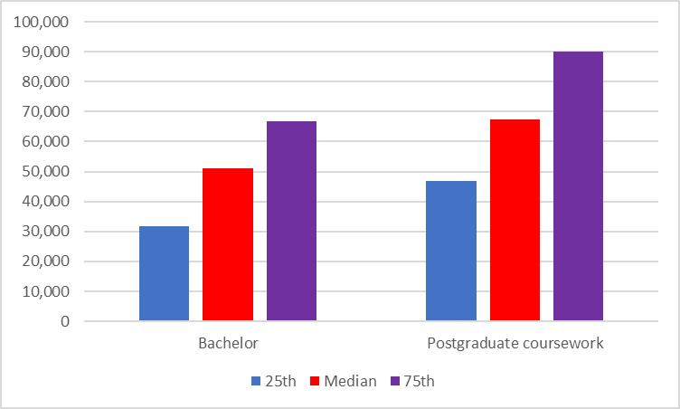***Source: ATO administrative data*

Figure 3 shows the median income of male graduates, as measured by administrative data, was $71,200 which was higher by, 8.0 per cent, than the median income of female graduates of $65,900. There was greater variation in graduate incomes among males than females at least one year and up to two years following graduation. Male incomes at the 75th percentile were 2.07 times higher than at the 25th percentile whereas female graduate incomes were 1.84 times higher.

**Figure 3: 2018 incomes of 2016 postgraduate coursework graduates by gender, $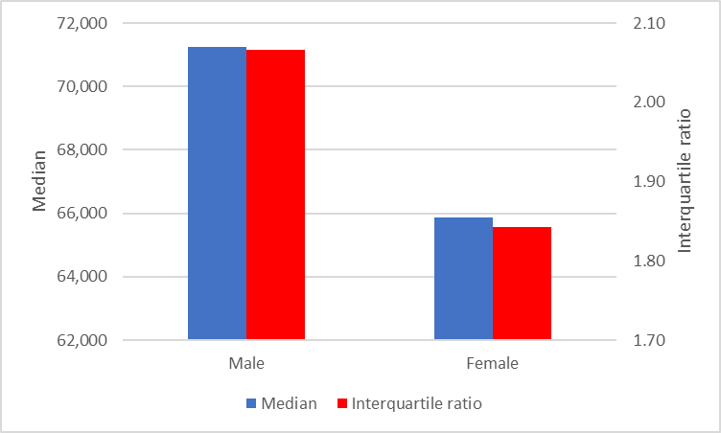***Source: ATO administrative data*

Patterns in median incomes among different groups of postgraduate coursework graduates were similar to those among bachelor graduates. That is graduates who were older (30 years and over), from an English speaking background, from an Indigenous background, with no reported disability, or who attended university (in comparison with graduates who attended a non-university higher education institution) had higher median incomes by a margin of 17 per cent, 2 per cent, 4 per cent, 13 per cent and 2 per cent than their respective counterparts, as shown by Figures 4-10. Unlike bachelor graduates, postgraduate coursework graduates from a high socioeconomic status background had slightly higher median incomes, by 2 per cent, than graduates from a medium socioeconomic status background and, by 1 per cent, than graduates from a low socioeconomic status background. Also, Figure 10 shows the median income of graduates who attended a Regional Network University (RUN) was 8 per cent higher than the median income of graduates from an Australian Technology Network (ATN) university. Further details on comparison of bachelor and postgraduate incomes by student and course characteristics and institution is provided in Attachment B.

Similar to bachelor graduates, an interesting feature shown by Figures 4-10 is that graduates with lower initial incomes, generally from disadvantaged backgrounds, though not always the case, also reported greater variation in incomes. That is, the interquartile ratio was larger among graduates from a non-English speaking background, from a non-Indigenous background, with a reported disability, who attended a non-university higher education institution (NUHEIs) or who attended an ATN university, not only had lower median incomes but were also likely to report more variable incomes than their counterparts. On the other hand, postgraduate coursework graduates who were older graduates (30 years and over) and were from a high socioeconomic status background had both higher median incomes and more variability in their incomes.

**Figure 4: 2018 incomes of 2016 postgraduate coursework graduates by age, $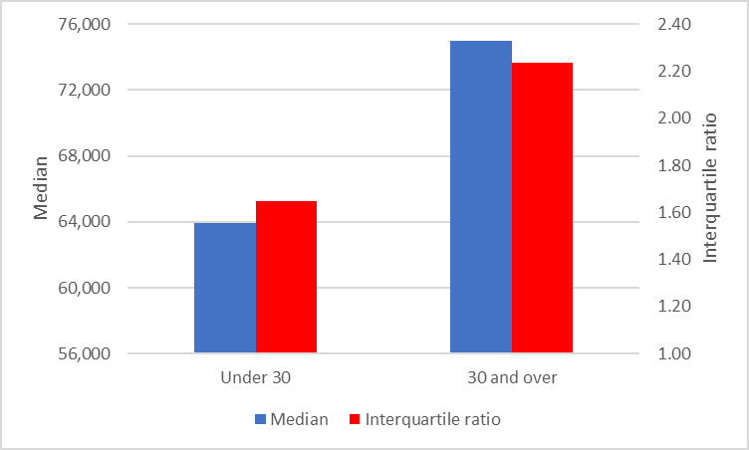***Source: ATO administrative data*

**Figure 5: 2018 incomes of 2016 postgraduate coursework graduates by language background, $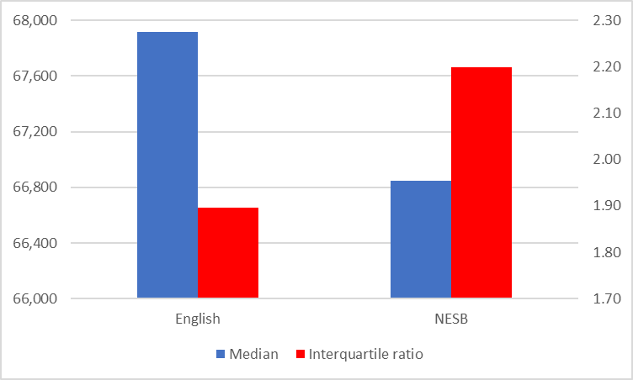***Source: ATO administrative data*

**Figure 6: 2018 incomes of 2016 postgraduate coursework graduates by Indigenous status, $****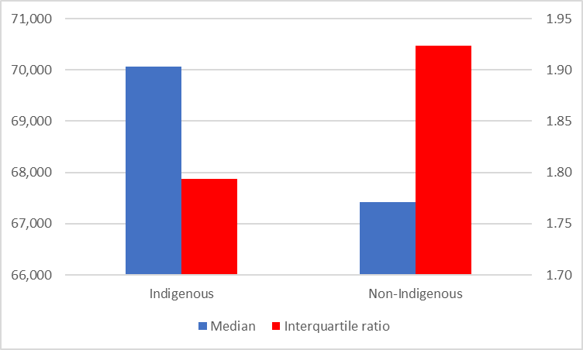***Source: ATO administrative data*

**Figure 7: 2018 incomes of 2016 postgraduate coursework graduates by disability status, $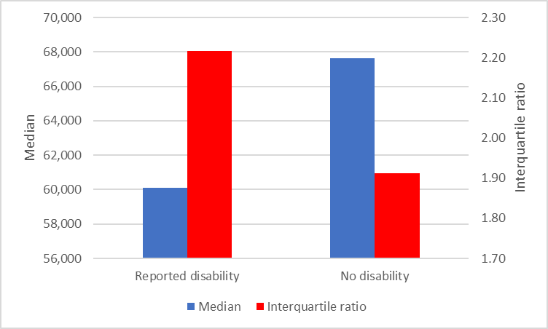***Source: ATO administrative data*

**Figure 8: 2018 incomes of 2016 postgraduate coursework graduates by socioeconomic status, $***Source: ATO administrative data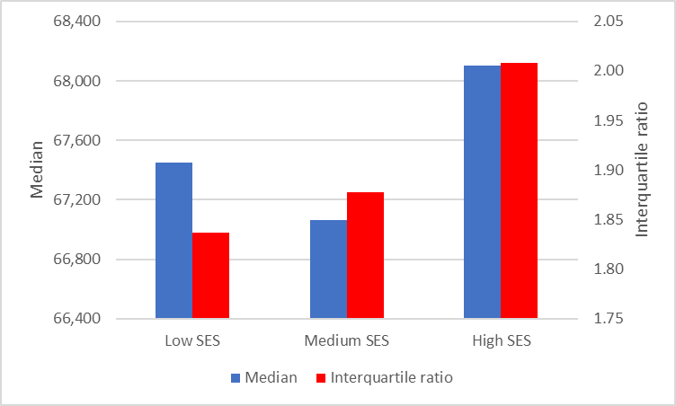*

**Figure 9: 2018 incomes of 2016 postgraduate coursework graduates by type of provider, $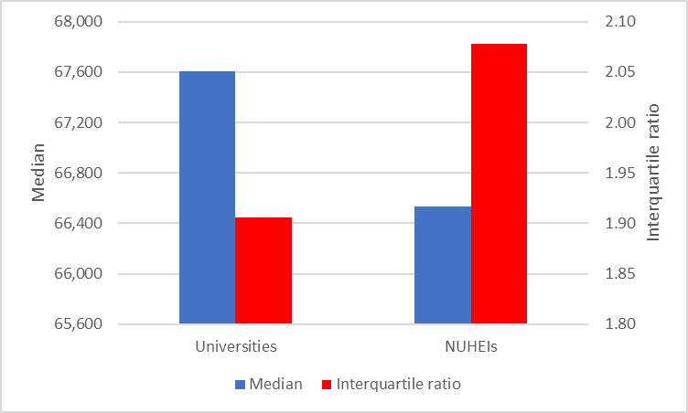***Source: ATO administrative data*

**Figure 10: 2018 incomes of 2016 postgraduate coursework graduates by type of university, $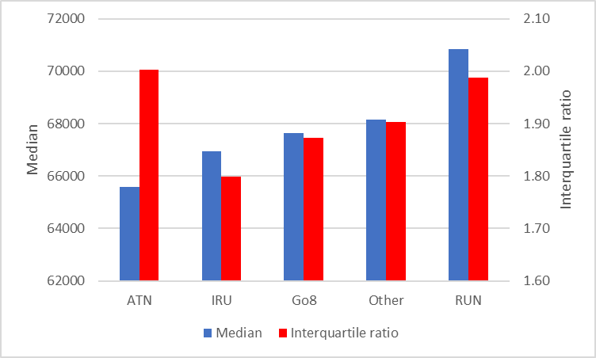***Source: ATO administrative data*

The administrative data on graduate incomes show postgraduate coursework graduates with highest median incomes immediately following graduation were Dentistry ($99,000), Medicine ($87,800), Business and management ($83,300), Nursing ($78,600) and Computing and information systems ($76,800), as shown by Figure 11. Graduates with lowest incomes following graduation were those completing Creative arts degrees who earned $39,400 on average. Other graduates with lower median incomes following completion of their degree included those who completed Tourism, hospitality, personal support, sport and recreation ($46,900) and Communication ($49,800) degrees.

Graduates with lowest incomes were more likely to experience greater variation in their incomes, showing a moderate relationship (correlation = -0.52). For example, the variation in graduate incomes was lower for Dentistry graduates at 1.76 in comparison with 2.84 for Creative arts graduates.

Universities with highest median incomes among postgraduate coursework degree holders at least one year and up to two years following graduation include the University of New South Wales ($80,600), Charles Sturt University ($78,900), Torrens University Australia ($78,500), the University of Newcastle ($77,700) and James Cook University ($76,300), as shown by Figure 12. On the other hand, universities with lowest median incomes among postgraduate coursework degree holders include the University of Divinity ($34,800), Murdoch University ($54,800) and Victoria University ($55,700). Results by university show a moderate negative relationship between median income and variation in incomes (correlation = -0.62).

Figure 13 shows results by non-university higher education institution (NUHEIs). Those with highest median incomes among postgraduate coursework degree holders at least one year and up to two years following graduation include the Australian Institute of Management Education and Training ($97,500), Kaplan Higher Education ($94,200), the Australian Institute of Business ($94,100) and the Australian College of Physical Education ($65,000). Results are displayed where there are more than twenty (20) graduates for each institution or five (5) graduates within each income quartile for confidentiality reasons. The moderate negative relationship between median income and variation in incomes still holds among NUHEIs (correlation = -0.55).

**Figure 11: 2018 incomes of 2016 postgraduate coursework graduates by study area (21), $****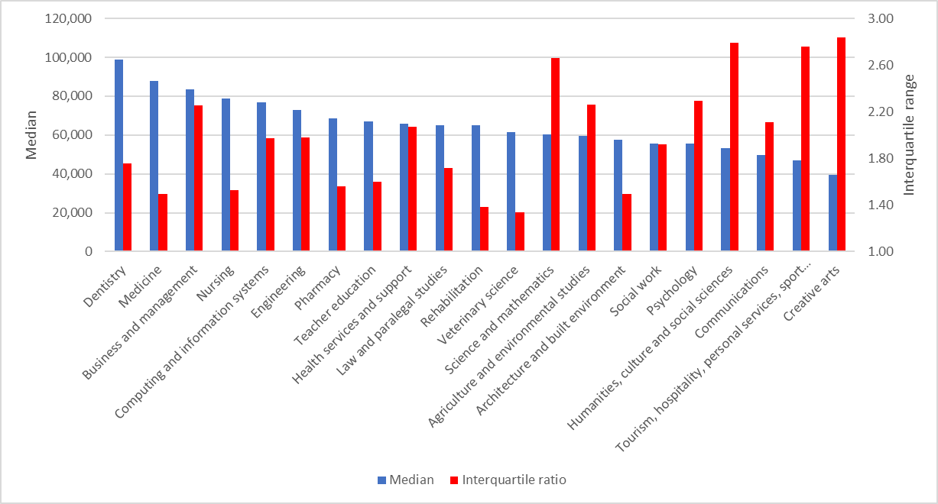***Source: ATO administrative data*

**Figure 12: 2018 incomes of 2016 postgraduate coursework graduates by university, $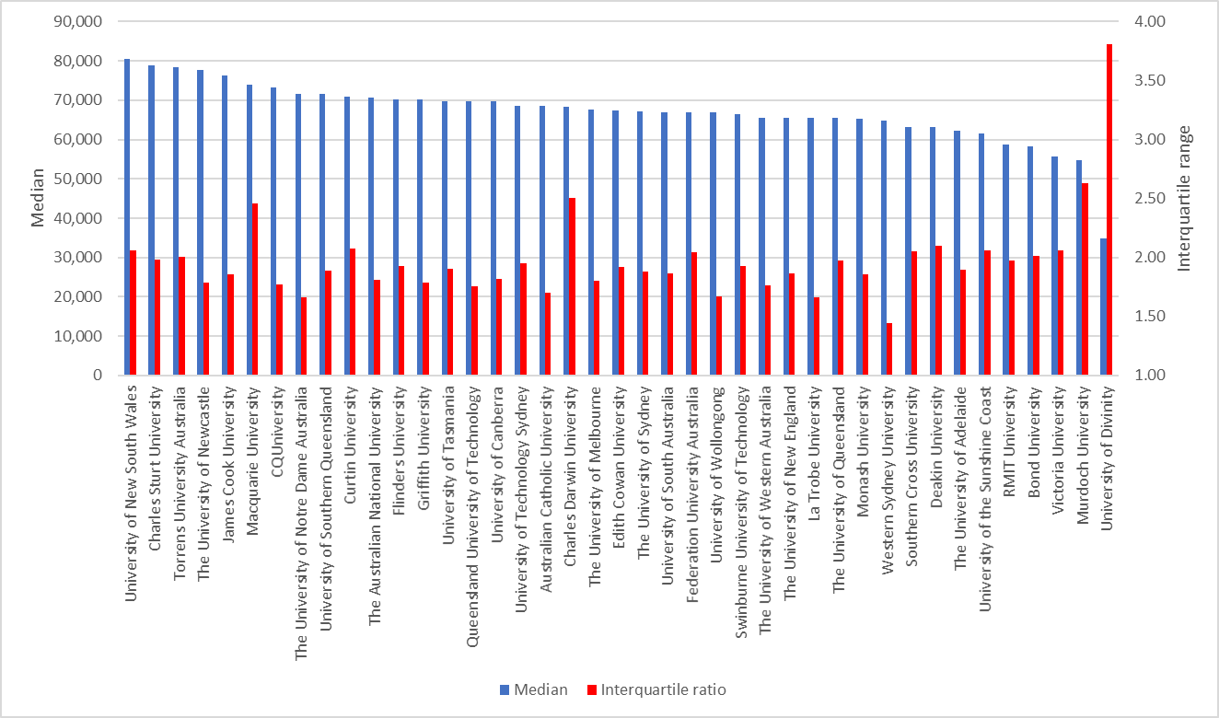***Source: ATO administrative data*

**Figure 13: 2018 incomes of 2016 postgraduate coursework graduates by non-university higher education institution (NUHEI), $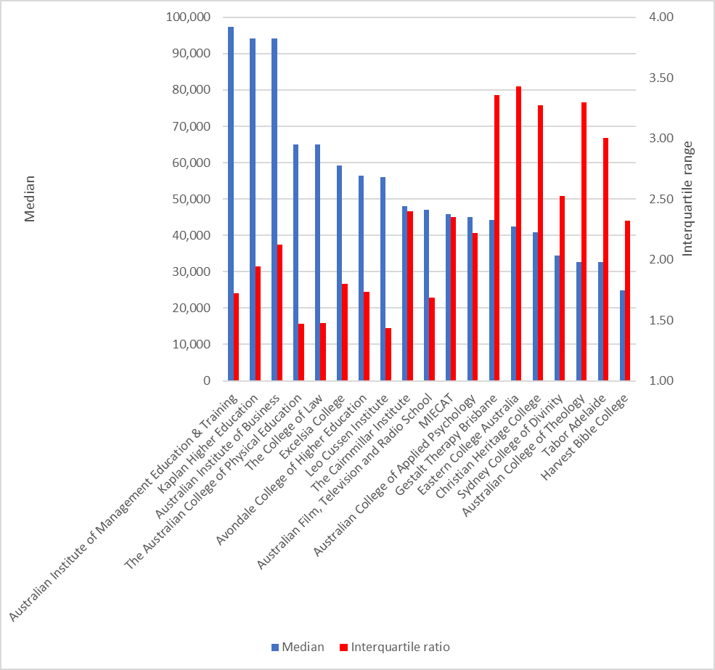***Source: ATO administrative data*

## 2007 cohort of postgraduate coursework graduates – growth in incomes

This section uses ATO administrative data to track graduate incomes over time enabling examination of whether graduates with lower initial incomes recover or if those with higher initial incomes maintain their advantage in terms of achieving higher incomes over the medium and longer term. This section examines the progress of the 2007 cohort of postgraduate coursework graduates, as measured by growth in incomes, at least one year but less than two years after graduation in 2009 through to at least ten years but less than eleven years after graduation in 2018. Note, growth in graduate incomes is assessed using the measure of assessable income as the measure of total income, used previously in this paper, is unavailable before 2014. The accompanying paper on bachelor graduate incomes showed the total income and assessable income measures were closely related.

The median income of postgraduate coursework graduates increased from $52,300 in 2009 at least one year after graduation to $82,600 in 2018 at least ten years after graduation, an increase of 64 per cent, as shown by Figure 13. This is slower than growth in the median income of bachelor level graduates in the ten years after graduation, which increased by 88 per cent. Unlike bachelor graduates where the incomes of those at the 75th percentile rose much faster, the growth of incomes of postgraduate coursework graduates at the 75th percentile was broadly similar to growth in the median income, increasing by 61 per cent. The incomes of postgraduate coursework graduates at the 25th percentile increased more slowly (by 38 per cent), as occurred among bachelor graduates. As a result, the interquartile ratio of postgraduate coursework incomes increased from 1.96 one year after graduation to 2.28 ten years after graduation.

**Figure 13: Median income of 2007 cohort of postgraduate coursework graduates between one and ten years after graduation by interquartile range, $**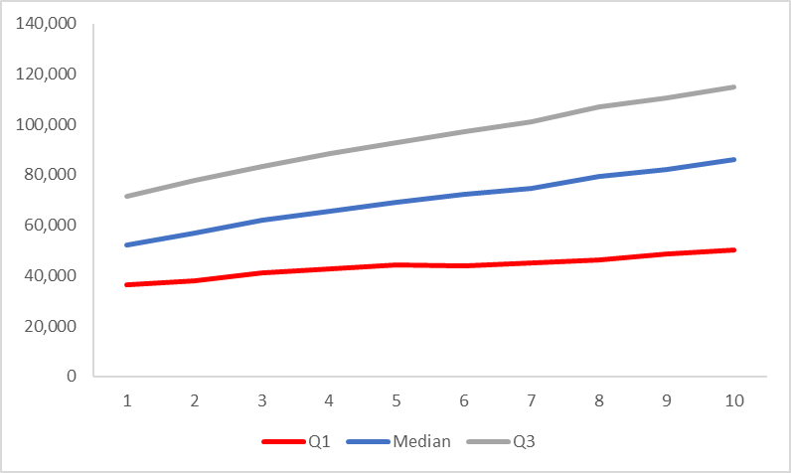

*Source: ATO administrative data*

As occurred among bachelor graduates, the median income of male postgraduate coursework graduates increased more rapidly, from $56,700 in 2009, one year after graduation to $98,800 in 2017, ten years after graduation, an increase of 74 per cent. By way of comparison, the median income of female graduates increased more slowly by 52 per cent, from $50,900 one year after graduation to $77,300 ten years after graduation, as shown by Figure 14.

**Figure 14:** **Median income of 2007 cohort of postgraduate coursework graduates between one and ten years after graduation by gender, $**

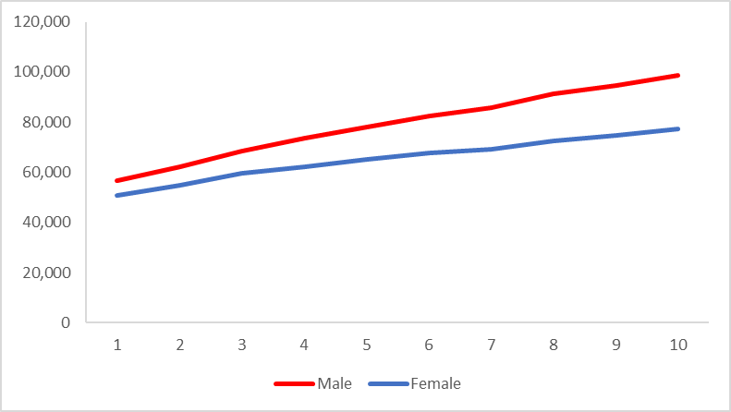  
*Source: ATO administrative data*

Trends in the interquartile ratio of postgraduate coursework graduate incomes by gender are broadly similar as those among bachelor graduates, as shown by Figure 15. As noted, before, immediately following graduation the interquartile ratio of incomes is larger for male than female graduates. However, the variation in the incomes of female graduates increases and exceeds that among males from three years after graduation. While the interquartile ratio in male graduate incomes increases slightly from 2.05 to 2.09 in the ten years after graduation, among female graduates the interquartile ratio in incomes increases from 1.93 to 2.35. That is, there is greater uncertainty associated with the attainment of a postgraduate coursework degree among female than male graduates. In the previous paper concerning bachelor graduates, it was shown that females are much more likely than males to move between various labour market states e.g. between full-time employment, part-time employment, unemployment and not in the labour force. These patterns are also evident across the wider workforce as shown by the ABS Labour Force Survey. The greater variability and change in female labour market patterns likely contributes, in part, to the greater variability in the incomes of female postgraduate coursework graduates over time.

Graduates from study areas with stronger initial postgraduate coursework incomes also experience higher incomes ten years following graduation (correlation = 0.97). For example, graduates with highest incomes ten years after graduation include Dentistry, $187,900, Engineering, $115,600, Medicine, $107,200 and Business and management, $104,200, as shown by Figure 16. However, there is some evidence, though the relationship is not strong, that graduates with lower initial incomes experience stronger growth in their incomes in the ten years following graduation (correlation = -0.41). For example, postgraduate coursework graduates in Veterinary science and Tourism, hospitality, personal services, sport and recreation, experience faster growth in incomes in the decade following graduation, by 104 per cent and 89 per cent respectively.

**Figure 15: Interquartile ratio of incomes of 2007 cohort of postgraduate coursework graduates between one and ten years after graduation by gender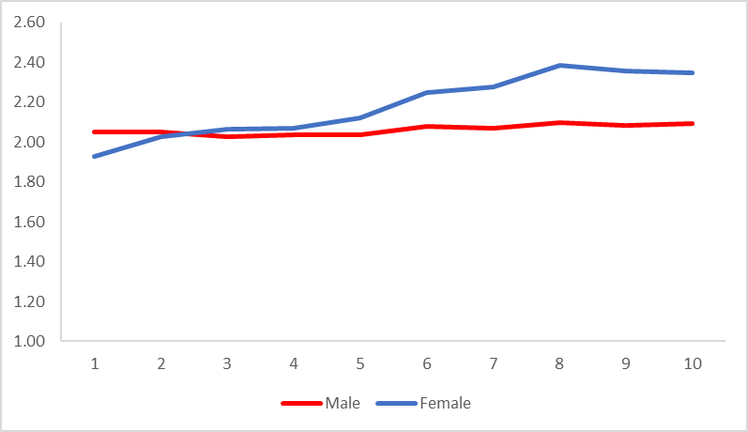***Source: ATO administrative data*

**Figure 16: 2007 cohort of postgraduate coursework graduates, 2009 income (LHS, $) and 2018 income (RHS, $) by study area**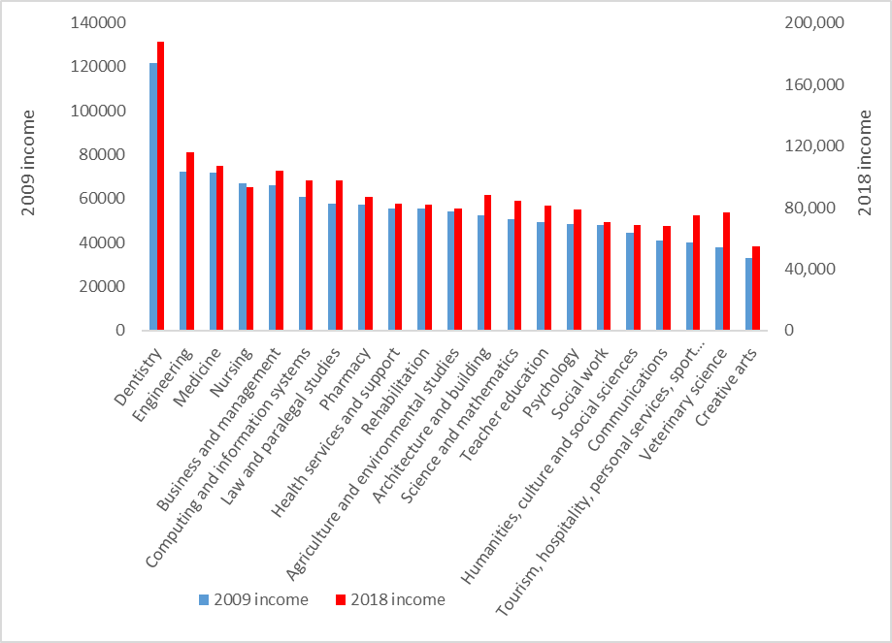

*Source: ATO administrative data*

Figure 17 shows the median income of graduates ten years out by study area and the percentage of female graduates by study area. It shows there are proportionately fewer females in study areas with higher incomes over the longer term, though the relationship is relatively weak. The correlation between income ten years out and the percentage of female graduates = -0.51. Nevertheless, the relationship has strengthened over time as the correlation between income one year out and the percentage of female graduates was lower (correlation = -0.33). Evidence shows male salaries increased much faster than female salaries over time within each study area, with the only exception being Computing and information systems. This suggests factors beyond subject choice such as such as occupation, age, experience, personal factors and possible inequalities within workplaces contribute to the gender gap in salaries over time.

**Figure 17: 2007 cohort of postgraduate coursework graduates, 2018 income (LHS, $) and % female (RHS) by study area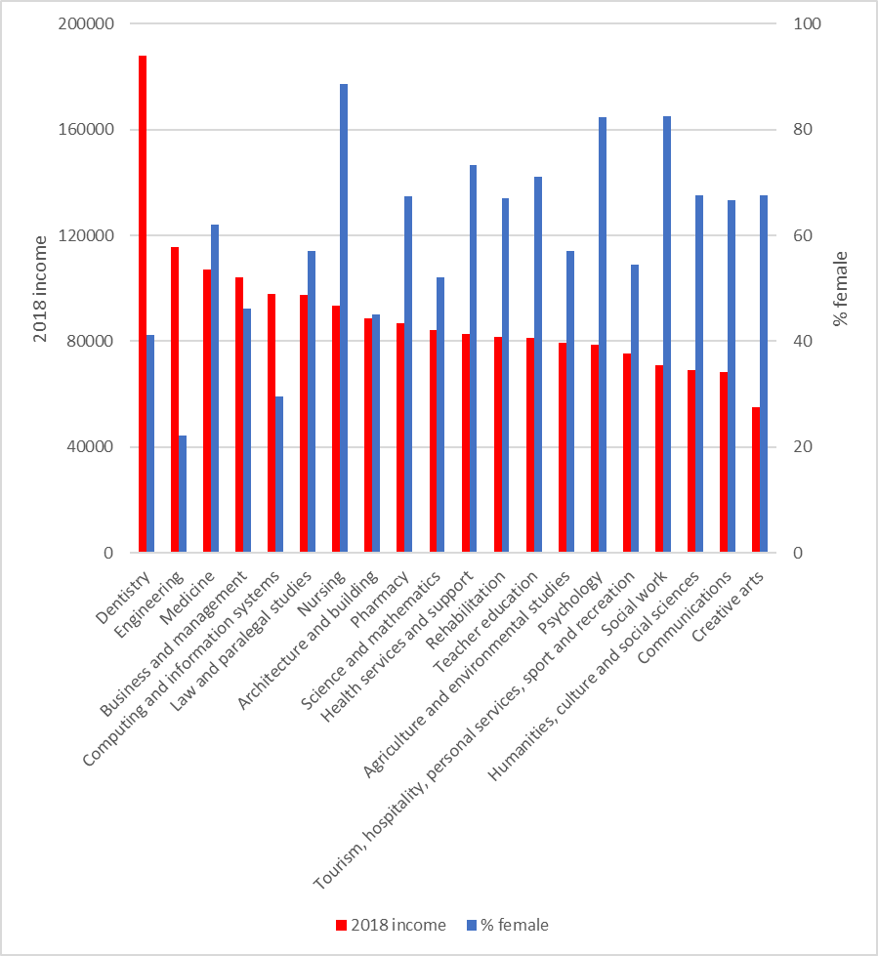***Source: ATO administrative data*

Older graduates are more likely to have an ongoing relationship with an employer and the labour market, which is reflected in higher earnings immediately following graduation, as shown by Figure 18. However, in the decade following graduation, the incomes of younger graduates aged under 30 recovered somewhat, increasing slightly faster by 63 per cent in comparison with 57 per cent for graduates aged 30 and over. Nevertheless, ten years after graduation the median income of younger graduates, $82,200, is still below that of older graduates, $89,400. Immediately following graduation older graduates have greater dispersion in their incomes. Ten years after graduation, it remains the case that older graduates have greater variation in incomes, though the gap narrows considerably over time, as shown by Figure 19.

**Figure 18: Median income of 2007 cohort of postgraduate coursework graduates between one and ten years after graduation by age, $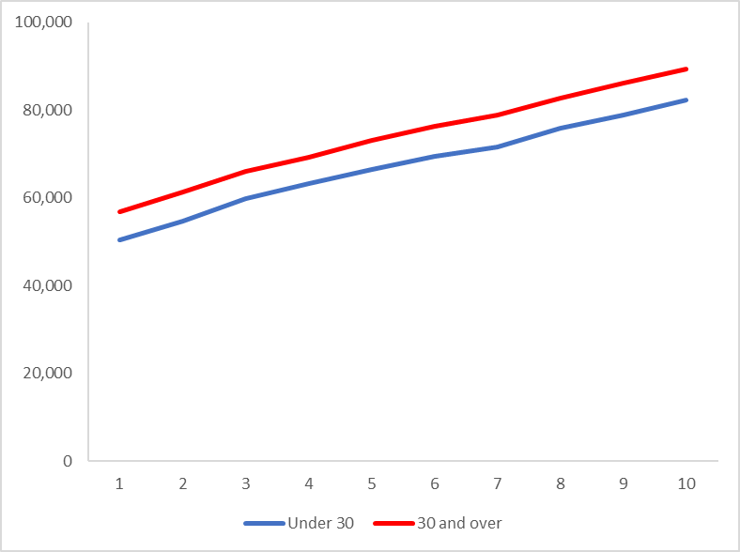***Source: ATO administrative data*

**Figure 19: Interquartile ratio of incomes of 2007 cohort of postgraduate coursework graduates between one and ten years after graduation by age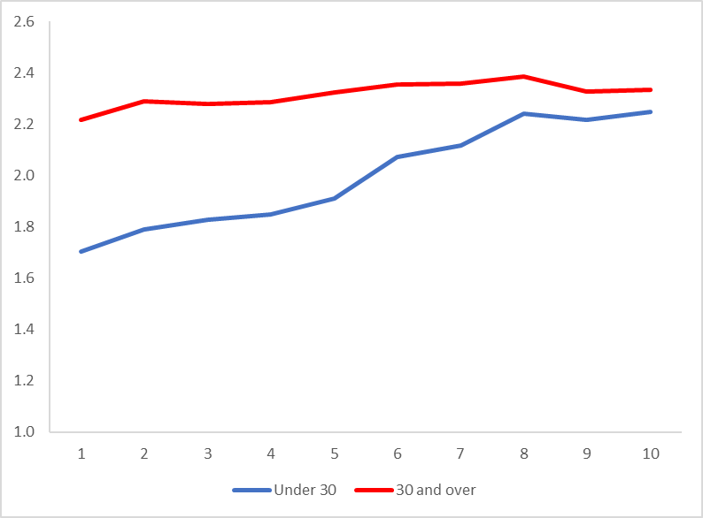***Source: ATO administrative data*

Immediately following graduation, graduates from a non-English speaking background have lower incomes and that disadvantage only increases over time, as shown by Figure 20. In the ten years following graduation, the median income of non-English speaking graduates increased by 62 per cent to $82,500. English speaking graduates experienced slightly faster growth in median income increasing by 64 per cent so that ten years after graduation they had a higher median income of $86,400. Graduates from a non-English speaking background also experience greater variation in their incomes across the ten years following their graduation, as shown by Figure 21.

**Figure 20: Median income of 2007 cohort of postgraduate coursework graduates between one and ten years after graduation by language background, $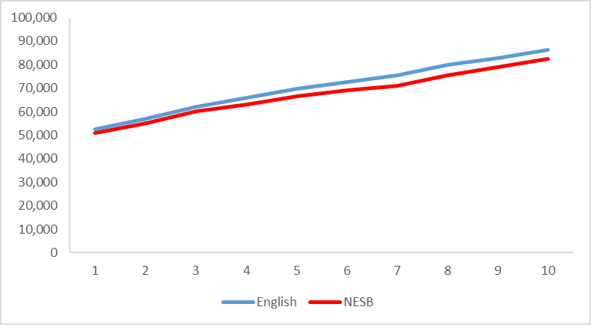***Source: ATO administrative data*

**Figure 21: Interquartile ratio of incomes of 2007 cohort of postgraduate coursework graduates between one and ten years after graduation by language background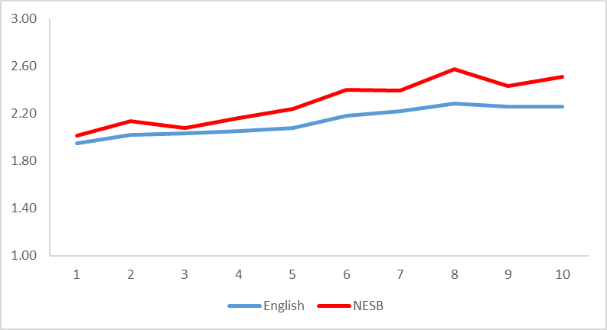***Source: ATO administrative data*

Immediately following graduation Indigenous graduates have a higher median income than non-Indigenous graduates but that diminishes over time, as shown by Figure 22. In the ten years following graduation, the median income of Indigenous graduates increased by 59 per cent to $86,800. Non-Indigenous graduates experienced faster growth in median income increasing by 64 per cent so that ten years after graduation they had a slightly lower median income of $86,000. By ten years after graduation, non-Indigenous graduates experience greater variation in their incomes than Indigenous graduates, as shown by Figure 23.[1]

**Figure 22: Median income of 2007 cohort of postgraduate coursework graduates between one and ten years after graduation by Indigenous status, $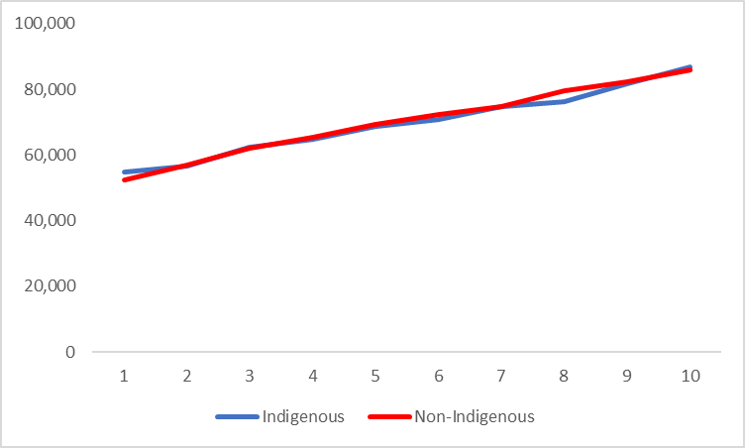***Source: ATO administrative data*

**Figure 23: Interquartile ratio of incomes of 2007 cohort of postgraduate coursework graduates between one and ten years after graduation by Indigenous status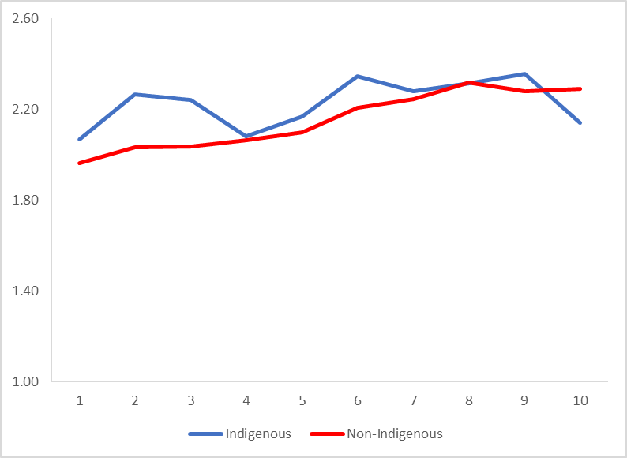***Source: ATO administrative data*

Graduates with a reported disability experience lower incomes immediately following graduation than those with no reported disability, as shown by Figure 24. In the ten years following graduation, the median income of those with a reported disability increased by 59 per cent, more slowly than growth of 64 per cent in the median income of graduates with no reported disability. Not only do graduates with a reported disability experience lower incomes, they also experience greater variation in their incomes, as shown by Figure 25.

**Figure 24: Median income of 2007 cohort of postgraduate coursework graduates between one and ten years after graduation by disability status, $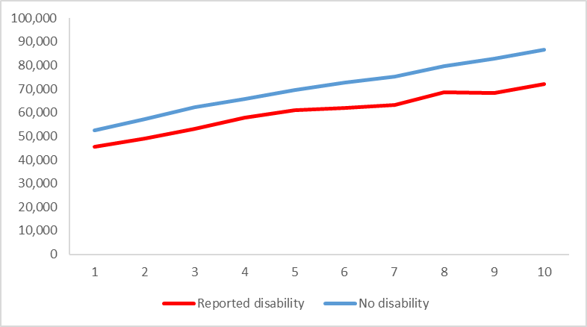***Source: ATO administrative data*

**Figure 25: Interquartile ratio of incomes of 2007 cohort of postgraduate coursework graduates between one and ten years after graduation by disability status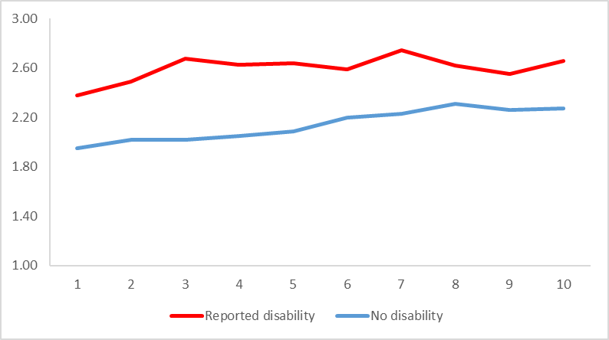***Source: ATO administrative data*

The experience of postgraduate coursework graduates from a low socioeconomic status background following graduation is unlike that of their bachelor counterparts. In the ten years following graduation, postgraduate coursework graduates from a low socioeconomic status background experience broadly similar growth in their incomes increasing by 66 per cent, with 65 per cent also for graduates from a medium SES background and slightly less, 64 per cent for those from a high SES background. As a result, ten years after graduation the median income of high SES graduates of $88,100 continues to surpass that of medium SES graduates, $85,400 and low SES graduates, $84,000, as shown by Figure 26.

**Figure 26: Median income of 2007 cohort of postgraduate coursework graduates between one and ten years after graduation by socioeconomic status, $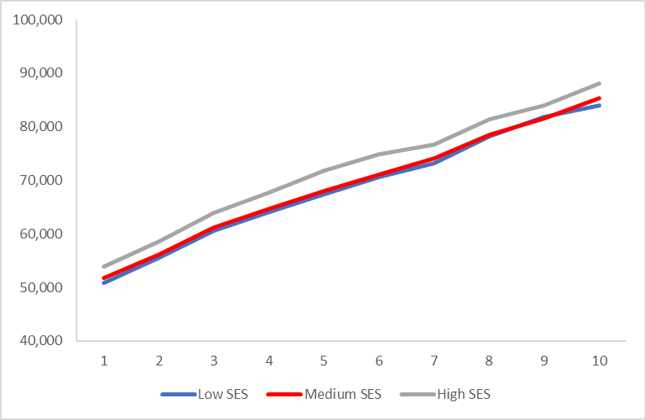***Source: ATO administrative data*

Variation in incomes increases over time among graduates from all socioeconomic backgrounds, as shown by Figure 27. It remains the case that graduates from a high socioeconomic status background experience greater variation in their incomes both immediately following graduation and ten years after graduation.

**Figure 27: Interquartile ratio of incomes of 2007 cohort of postgraduate coursework graduates between one and ten years after graduation by socioeconomic status****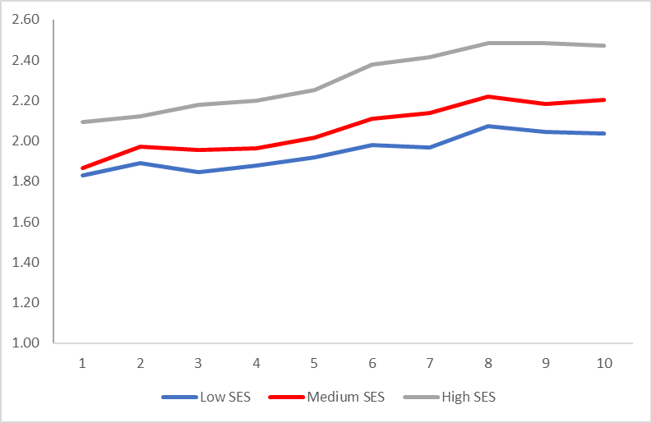***Source: ATO administrative data*

Patterns in changes in income by university are broadly similar to those by study area. For example, graduates from universities with higher initial incomes in 2009 also had higher incomes ten years later in 2018 (correlation = 0.88). Universities with highest incomes ten years after graduation include the University of New South Wales, $111,700, the Australian National University, $98,800 and the University of Technology, Sydney, $95,800, as shown by Figure 28. There is some evidence that universities with lower initial incomes experience a recovery in their incomes with relatively faster growth in their incomes in the ten years following graduation, but the relationship is relatively weak (correlation = -0.18). By way of comparison, bachelor graduates with lower initial incomes experience faster recovery in their incomes and this is associated with the benefits of undertaking further postgraduate study. Graduates experiencing relatively faster growth in their incomes in the ten years following graduation include Murdoch University increasing by 110 per cent and the University of Wollongong and Bond University, both 81 per cent.

Graduates at non-university higher education institutions (NUHEIs) generally experienced slower growth in incomes in the ten years following graduation increasing by 59 per cent in comparison with university graduates whose incomes increased by 65 per cent. Graduates from NUHEIs that had highest incomes ten years after graduation included Excelsia College, $69,100, the Australian College of Applied Psychology, $67,200 and the Australian Film, Television and Radio School, $58,600, as shown by Figure 29. Graduates from NUHEIs with higher incomes immediately following graduation were more likely to have higher incomes ten years after graduation (correlation =0.71).

**Figure 28: 2007 cohort of postgraduate coursework graduates, 2009 income (LHS, $) and 2018 income (RHS, $ ) by university****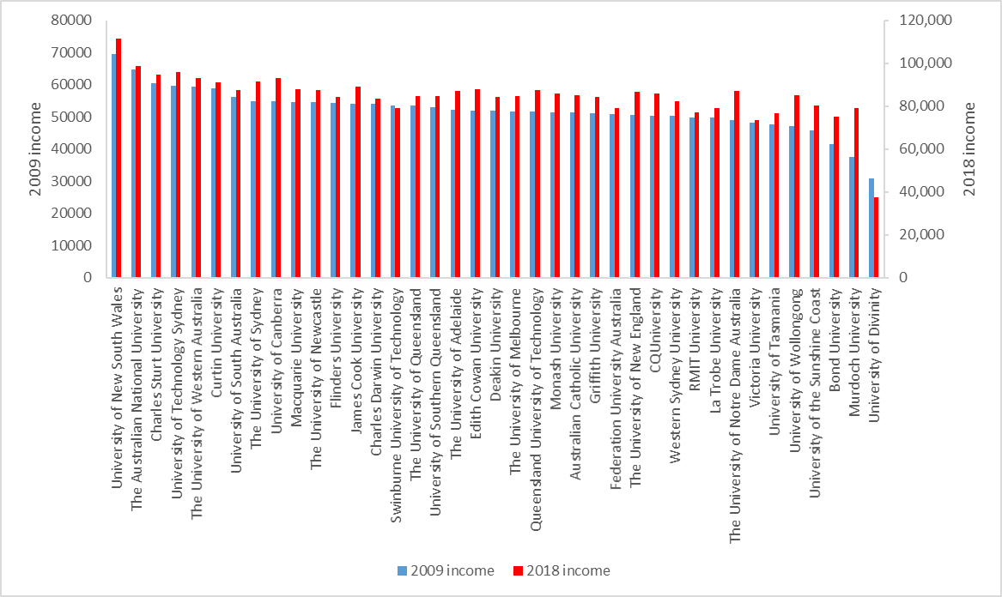**  
Source: ATO administrative data

**Figure 29: 2007 cohort of postgraduate coursework graduates, 2009 income (LHS, $) and 2018 income (RHS, $) by non-university higher education institution (NUHEI)** 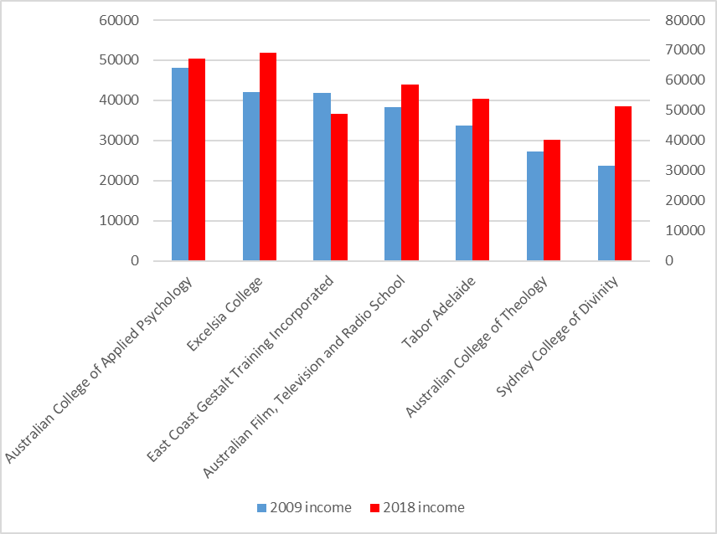  
Source: ATO administrative data

## Tracking the growth in incomes of different postgraduate coursework cohorts

The earlier paper examining the incomes of bachelor graduates found that immediately following graduation, successive cohorts had experienced declining real incomes following the GFC, but their incomes did recover around six to eight years later.

In contrast to the experience of bachelor graduates, the real incomes of postgraduate coursework graduates immediately following graduation have generally increased since the GFC. Figure 30 shows that following the GFC, the real median income of graduates at least one year and up to two years after graduation increased from $52,300 in 2009 to $53,200 in 2012. There was a slight fall to $52,100 in 2014 before their incomes recovered to $56,500 in 2018, an increase of 8 per cent between 2009 and 2018.

**Figure 30: Real median income of initial postgraduate coursework graduates, 2009 – 2018 (2009 prices), $**

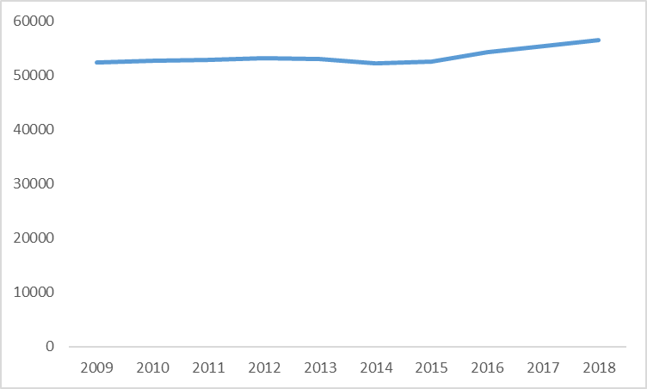

*Source: ATO administrative data*

Tracking the progress of different cohorts of graduates over time, there appear to be contrasting experiences between bachelor and postgraduate coursework graduates. From the earlier paper, initial bachelor graduates experienced a decline in their real incomes following the GFC, but thereafter their incomes appeared to recover in the six to eight years after graduation. On the other hand, from above, initial postgraduate coursework graduates did not appear to suffer from a decline in their real incomes following the GFC. Figure 31 shows the real incomes of different cohorts of postgraduate coursework graduates have broadly followed a similar path following graduation. For example, eight years after graduation, the real incomes of the 2009 cohort of graduates had increased by 29 per cent, only slightly less than the 30 per cent increase for the 2007 cohort. Similarly, six years after graduation, the real incomes of the 2011 cohort of graduates had increased by 25 per cent, slightly more than the 21 per cent increase for the 2007 cohort. Patterns were broadly similar among male and female graduates.

**Figure 31: Growth in real median incomes of different postgraduate coursework graduate cohorts up to ten years after graduation (2009 income of 2007 cohort = 100)**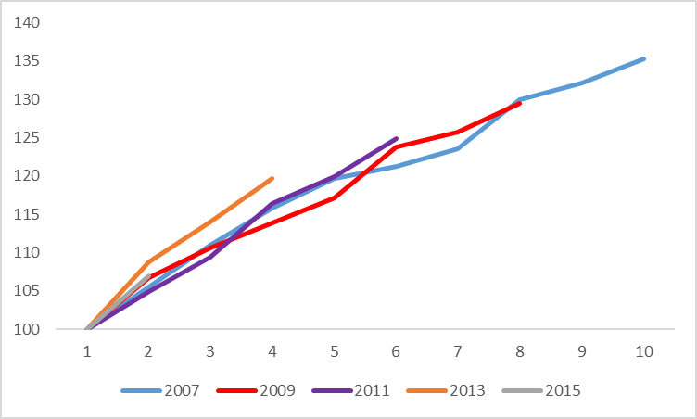 *Source: ATO administrative data*

There is some evidence that since the GFC, the uncertainty associated with attainment of a postgraduate coursework degree has increased, at least for a short period following graduation. Figure 32 shows whether the variation or uncertainty associated with attainment of a degree has changed following the GFC using the interquartile ratio in incomes of the 2007 cohort of graduates as numeraire. That is, where the measure of relative variation is greater than 100, it can be said there is greater uncertainty in graduate incomes among post-GFC graduate cohorts in comparison with the pre-GFC 2007 graduate cohort. For example, for each of the 2009, 2011 and 2013 cohorts immediately following graduation, variation in their incomes was around 4 to 5 per cent higher than for the pre-GFC 2007 cohort of graduates. However, at least two years and up to three years following graduation, the uncertainty in incomes for the 2009, 2011 and 2013 cohorts was equivalent to or lower than that associated with the 2007 cohort. That is, the gap had disappeared up to three years after graduation. The 2015 and 2016 cohorts experienced broadly similar levels of variation in their incomes as the 2007 cohort immediately following graduation. This experience contrasts with bachelor degree graduates where immediately following graduation, the variation in incomes of post-GFC cohorts was 10 per cent higher than for the pre-GFC cohort. Also, it took a little longer, around five to seven years, for the variation associated with bachelor degree incomes to recover to the same level as the pre-GFC 2007 cohort. Once again, these patterns are broadly similar for male and female graduates.

In summary, the GFC appears to have impacted the incomes of bachelor degree graduates, at least initially following graduation, but thereafter their incomes recover in the six to eight years following graduation. The impact of the GFC on the incomes of postgraduate coursework graduates appears more muted. While post-GFC, postgraduate coursework graduates achieved steady growth in their incomes they also experienced more uncertainty in their incomes immediately following graduation though this diminished shortly thereafter, around two to three years after graduation. The contrasting experiences of bachelor and postgraduate coursework graduates is consistent with less experienced graduates having greater difficulty entering the labour market following the GFC. Given postgraduate coursework graduates are more likely to have progressed in their careers with stronger attachment to the labour market and employers, this likely explains the apparent more muted impact of the GFC on their incomes in comparison with bachelor graduates.

**Figure 32: Relative variation in income of different postgraduate coursework graduate cohorts between one and eight years after graduation (2007 graduate cohort as numeraire=100)**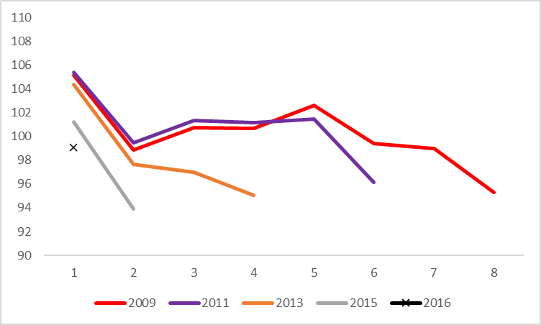

*Source: ATO administrative data*

## Conclusion

Postgraduate coursework graduates earn around a third, 32 per cent, more than bachelor graduates immediately following graduation. They also experience less variation or uncertainty in their incomes. Achieving higher incomes and less uncertainty in their incomes most likely reflects, in part, that postgraduate coursework graduates are older and more established in their careers. Like bachelor graduates, those groups of postgraduate coursework graduates with lower initial incomes were more likely to experience greater uncertainty in their incomes.

Postgraduate coursework graduates’ incomes grow more slowly than that of their bachelor counterparts in the ten years after graduation. At bachelor level, some graduates experience lower incomes immediately following graduation and this may be associated with further studying delaying entry to the labour market. Nevertheless, notwithstanding lower initial incomes, bachelor graduates then experience faster growth in incomes in the ten years following graduation. This effect is much less evident among postgraduate coursework graduates. These graduates are generally older and more established in their careers and hence changes in their incomes over time are less pronounced than they are for bachelor graduates.

The GFC appears to have had a more muted impact on the incomes of postgraduate coursework graduates as they have achieved steady growth in their incomes post-GFC. While they have experienced more uncertainty in their incomes immediately following graduation, this has not been as marked as it has been among bachelor graduates. Also, uncertainty in postgraduate coursework incomes returned to pre-GFC levels shortly thereafter, around two to three years after graduation, whereas this took longer among bachelor graduates, around five to seven years. Once again, the GFC having a more muted impact on postgraduate coursework graduates probably reflects that they are more likely to have progressed in their careers with stronger attachment to the labour market and employers. Conversely, bachelor graduates with fewer labour market connections appear to have experienced greater difficulty in making a successful transition to the labour market post-GFC.

## Attachment A: Reporting of graduate incomes from ATO administrative records on the ComparED website

Figure 1 above showed the derivation of measures of graduate incomes from ATO administrative records. When reporting postgraduate coursework graduate incomes by institution by field of education derived from ATO administrative records, the ComparED website will show three indicators to demonstrate the quality of data:

1. the number of domestic postgraduate coursework completions reported through HEIMS;
2. the number of domestic postgraduate coursework completions reported through ATO data showing total tax records, that is, after removing graduates without a student loan or who did not fill in a tax return; and
3. the number of unique tax records reported through ATO data, removing duplicate records to report the number of unique domestic postgraduate coursework graduates with a tax record.

## Attachment B: Detailed income comparisons of bachelor and postgraduate coursework graduates

**Table A1: 2018 incomes of 2016 graduates by level of course by student and course characteristics**

|  |  |  |  |  |
| --- | --- | --- | --- | --- |
|  | Bachelor | | Postgraduate coursework | |
|  | Median income | Interquartile ratio | Median income | Interquartile ratio |
|  |  |  |  |  |
| Total | $51,200 | 2.11 | $67,500 | 1.92 |
|  |  |  |  |  |
| Male | $51,400 | 2.22 | $71,200 | 2.07 |
| Female | $51,100 | 2.04 | $65,900 | 1.84 |
|  |  |  |  |  |
| Under 30 | $50,300 | 2.11 | $63,900 | 1.65 |
| 30 and over | $57,100 | 2.03 | $75,000 | 2.23 |
|  |  |  |  |  |
| Indigenous | $58,200 | 1.81 | $70,100 | 1.79 |
| Non-Indigenous | $51,100 | 2.11 | $67,400 | 1.92 |
|  |  |  |  |  |
| English speaking background | $51,200 | 2.10 | $67,900 | 2.20 |
| Non-English speaking background | $50,700 | 2.10 | $66,800 | 1.90 |
|  |  |  |  |  |
| Reported disability | $45,000 | 2.53 | $60,100 | 2.21 |
| No reported disability | $51,400 | 2.08 | $67,600 | 1.91 |
|  |  |  |  |  |
| Low socioeconomic status | $52,300 | 1.97 | $67,500 | 1.84 |
| Medium socioeconomic status | $51,200 | 2.07 | $67,100 | 1.88 |
| High socioeconomic status | $50,400 | 2.26 | $68,100 | 2.01 |
|  |  |  |  |  |
| Go8 | $48,100 | 2.55 | $67,600 | 1.87 |
| ATN | $51,400 | 1.89 | $65,600 | 2.00 |
| IRU | $50,300 | 2.06 | $67,000 | 1.80 |
| RUN | $58,700 | 1.77 | $70,800 | 1.99 |
| Other | $52,700 | 1.93 | $68,100 | 1.90 |
|  |  |  |  |  |
| University | $51,700 | 2.08 | $67,600 | 1.91 |
| NUHEI | $37,600 | 2.27 | $66,500 | 2.08 |
|  |  |  |  |  |

**Table A2: 2018 incomes of 2016 graduates by level of course by study area**

|  |  |  |  |  |
| --- | --- | --- | --- | --- |
|  | Bachelor | | Postgraduate coursework | |
|  | Median income | Interquartile ratio | Median income | Interquartile ratio |
|  |  |  |  |  |
| Science and mathematics | $32,600 | 2.97 | $60,500 | 2.66 |
| Computing and information systems | $54,900 | 1.71 | $76,800 | 1.98 |
| Engineering | $63,600 | 1.51 | $72,700 | 1.98 |
| Architecture and building | $48,000 | 2.17 | $57,500 | 1.50 |
| Agriculture and environmental studies | $45,800 | 2.13 | $61,300 | 2.24 |
| Health services and support | $45,000 | 2.60 | $65,900 | 2.07 |
| Medicine | $84,000 | 1.23 | $87,800 | 1.49 |
| Nursing | $62,200 | 1.38 | $78,600 | 1.53 |
| Pharmacy | $56,500 | 1.35 | $68,700 | 1.56 |
| Dentistry | $78,300 | 1.95 | $99,000 | 1.76 |
| Veterinary science | $56,400 | 2.11 | $61,400 | 1.34 |
| Rehabilitation | $61,000 | 1.33 | $65,000 | 1.38 |
| Teacher education | $65,200 | 1.41 | $67,000 | 1.60 |
| Business and management | $52,100 | 1.65 | $83,300 | 2.25 |
| Humanities, culture and social sciences | $36,900 | 2.49 | $53,000 | 2.79 |
| Social work | $51,700 | 1.74 | $55,800 | 1.92 |
| Psychology | $38,200 | 2.35 | $55,500 | 2.29 |
| Law and paralegal studies | $55,200 | 1.71 | $65,000 | 1.72 |
| Creative arts | $33,600 | 2.20 | $39,400 | 2.84 |
| Communications | $42,200 | 1.98 | $49,800 | 2.11 |
| Tourism, hospitality, personal services, sport and recreation | $37,000 | 2.41 | $46,900 | 2.76 |
| Total | $51,200 | 2.10 | $67,500 | 1.92 |

**Table A3: 2018 incomes of 2016 graduates by level of course by university**

|  |  |  |  |  |
| --- | --- | --- | --- | --- |
|  | Bachelor | | Postgraduate coursework | |
|  | Median income | Interquartile ratio | Median income | Interquartile ratio |
| Australian Catholic University | $58,600 | 1.56 | $68,600 | 1.70 |
| Bond University | $48,400 | 2.06 | $58,200 | 2.01 |
| Charles Darwin University | $62,200 | 1.68 | $68,400 | 2.51 |
| Charles Sturt University | $60,700 | 1.71 | $78,900 | 1.98 |
| CQUniversity | $63,400 | 1.71 | $73,200 | 1.78 |
| Curtin University | $53,200 | 1.96 | $70,900 | 2.08 |
| Deakin University | $49,500 | 2.00 | $63,100 | 2.10 |
| Edith Cowan University | $49,200 | 2.20 | $67,300 | 1.92 |
| Federation University Australia | $53,600 | 1.85 | $67,000 | 2.04 |
| Flinders University | $49,600 | 2.05 | $70,300 | 1.92 |
| Griffith University | $47,800 | 2.19 | $70,200 | 1.79 |
| James Cook University | $65,200 | 1.55 | $76,300 | 1.86 |
| La Trobe University | $49,300 | 1.94 | $65,500 | 1.66 |
| Macquarie University | $51,900 | 2.04 | $73,900 | 2.46 |
| Monash University | $50,200 | 2.18 | $65,200 | 1.86 |
| Murdoch University | $48,400 | 2.37 | $54,800 | 2.63 |
| Queensland University of Technology | $53,300 | 1.81 | $69,800 | 1.76 |
| RMIT University | $48,700 | 1.84 | $58,800 | 1.98 |
| Southern Cross University | $53,800 | 1.91 | $63,100 | 2.05 |
| Swinburne University of Technology | $49,500 | 2.04 | $66,400 | 1.93 |
| The Australian National University | $52,900 | 2.34 | $70,700 | 1.81 |
| The University of Adelaide | $48,700 | 2.42 | $62,300 | 1.90 |
| The University of Melbourne | $29,300 | 2.73 | $67,700 | 1.80 |
| The University of New England | $58,900 | 1.86 | $65,600 | 1.87 |
| The University of Newcastle | $55,800 | 1.75 | $77,700 | 1.78 |
| The University of Notre Dame Australia | $62,000 | 1.65 | $71,600 | 1.66 |
| The University of Queensland | $54,200 | 2.15 | $65,500 | 1.97 |
| The University of Sydney | $51,300 | 2.31 | $67,100 | 1.88 |
| The University of Western Australia | $35,300 | 3.01 | $65,600 | 1.76 |
| University of Canberra | $55,800 | 1.82 | $69,600 | 1.82 |
| University of Divinity | $24,900 | 2.63 | $34,800 | 3.81 |
| University of New South Wales | $54,800 | 2.05 | $80,600 | 2.06 |
| University of South Australia | $51,600 | 1.84 | $67,000 | 1.87 |
| University of Southern Queensland | $62,400 | 1.73 | $71,600 | 1.89 |
| University of Tasmania | $55,000 | 2.20 | $69,800 | 1.91 |
| University of Technology Sydney | $53,400 | 1.87 | $68,700 | 1.95 |
| University of the Sunshine Coast | $52,300 | 1.87 | $61,500 | 2.06 |
| University of Wollongong | $52,200 | 1.94 | $66,900 | 1.67 |
| Victoria University | $49,400 | 2.15 | $55,700 | 2.06 |
| Western Sydney University | $48,800 | 2.08 | $64,900 | 1.45 |
| Total universities | $51,700 | 2.08 | $67,600 | 1.92 |

**Table A4: 2018 incomes of 2016 graduates by level of course by non-university higher education institution (NUHEI)**

|  |  |  |  |  |
| --- | --- | --- | --- | --- |
|  | Bachelor | | Postgraduate coursework | |
|  | Median income | Interquartile ratio | Median income | Interquartile ratio |
| Australian College of Applied Psychology | $43,100 | 2.04 | $45,000 | 2.22 |
| Australian College of Theology | $28,500 | 2.01 | $32,600 | 3.30 |
| Australian Film, Television and Radio School | na | na | $47,100 | 1.68 |
| Australian Institute of Business | na | na | $94,100 | 2.13 |
| Australian Institute of Management Education and Training | na | na | $97,500 | 1.72 |
| Avondale College of Higher Education | $64,400 | 1.40 | $56,400 | 1.73 |
| Christian Heritage College | $51,300 | 2.22 | $40,800 | 3.28 |
| Eastern College Australia | na | na | $42,400 | 3.43 |
| Excelisa College | $27,000 | 1.36 | $59,300 | 1.80 |
| Gestalt Therapy Australia | na | na | $44,200 | 3.36 |
| Harvest Bible College | $27,700 | 2.17 | $24,900 | 2.32 |
| Kaplan Higher Education | na | na | $94,200 | 1.94 |
| Leo Cussen Institute | na | na | $55,900 | 1.43 |
| MIECAT | na | na | $45,900 | 2.35 |
| Sydney College of Divinity | $22,300 | 2.00 | $34,400 | 2.52 |
| Tabor Adelaide | $37,700 | 3.29 | $32,600 | 3.01 |
| The Australian College of Physical Education | $46,700 | 2.14 | $65,500 | 1.47 |
| The Cairnmillar Institute | na | na | $48,100 | 2.40 |
| The College of Law | na | na | $64,900 | 1.48 |
| Total NUHEIs | $37,600 | 2.27 | $66,500 | 2.08 |

1. Note the finding that Indigenous graduates have greater dispersion in their incomes immediately following graduation, as shown in Figure 21, is based on the measure of assessable income and contrasts with the finding earlier in the paper using the total income measure that Non-Indigenous graduates have greater dispersion in incomes immediately following graduation.