 | 
2025 Graduate Outcomes Survey – Longitudinal

Methodological Report
May 2026



Acknowledgements
The Quality Indicators for Learning and Teaching (QILT) survey program, including the 2025 Graduate Outcomes Survey – Longitudinal (GOS-L), is funded by the Australian Government Department of Education (the Department).
The Department and the Social Research Centre acknowledge the Traditional Custodians of the lands and waters on which this research was conducted. We pay our respects to Elders past, present and emerging.
The Social Research Centre would especially like to thank the higher education institutions that contributed to the Graduate Outcomes Survey (GOS) in 2022 and the GOS-L in 2025. Without the enthusiastic and committed assistance of the survey managers and institutional planners, the 2025 GOS-L would not have been such a success.
We are also very grateful to the graduates who took the time to provide valuable feedback about their employment and further study outcomes. Institutions use GOS-L data for continuous improvement, including exploring ways to monitor and improve the labour force outcomes of graduates.
For more information about the 2025 GOS-L, including how it was conducted, visit the QILT website.

Report prepared for:
Australian Government Department of Education
50 Marcus Clarke St, Canberra ACT 2601

Report prepared by:
The QILT Team
The Social Research Centre
Level 5, 350 Queen Street
Melbourne, Victoria 3000
Telephone: (613) 9114 1003
qilt@srcentre.com.au
srcentre.com.au
Version: 1 ǀ April 2026

Contents
1. Introduction 1
1.1. About this report 1
1.2. Background 1
1.3. Objectives 1
1.4. Overview 1
1.5. Project milestones 2
2. Sample preparation 3
2.1. Target population 3
2.1.1 Additional populations 3
2.2. Institutional participation 3
2.3. Sample frame 3
2.4. Sample preparation overview 3
2.4.1 Sample processing quality assurance 4
2.4.2 Sample exclusions 4
2.4.3 Panel maintenance activity 5
2.4.4 Coverage 5
3. Survey design and procedures 6
3.1. Institutional engagement 6
3.2. Contact protocol 6
3.2.1 Email invitation and reminders 8
3.2.2 SMS reminders 14
3.2.3 International engagement strategy 15
3.2.4 Reminder calls 15
3.2.5 Fieldwork briefing 17
3.2.6 Quality control 18
3.2.7 Social media 18
3.3. Data collection 18
3.3.1 Online survey 18
3.3.2 Survey implementation 19
3.3.3 Quality assurance and applicable standards 19
3.3.4 Monitoring and progress reporting 19
3.3.5 Live online Reporting Module 19
3.4. Graduate support 21
3.5. Prize draw 21
4. Questionnaire 23
4.1. Development 23
4.2. Overview 23
4.3. Changes from 2024 23
4.4. Additional items 24
4.5. Dropout analysis 24
5. Data preparation 25
5.1. Definition of the analytic unit 25
5.2. Data cleaning and preparation 25
5.3. Coding and processing of free text responses 25
5.4. Data deliverables 26
5.5. Weighting 26
6. Final dispositions and response rates 27
7. Response analysis 29
7.1. Response over time 29
7.2. Data representativeness 31
7.2.1 Characteristics associated with propensity to respond 31
7.2.2 Characteristic differences between respondents and population 34
7.2.3 Adjusting for non-response 36
7.3. Sources of responses 39
8. Considerations for future surveys 42
8.1. Panel maintenance 42
8.2. Review of marketing materials 42
8.3. Response maximisation strategy 42
8.4. Response quality maximisation 43
Appendix 1: Response rate by participating institutions 44
Appendix 2: Contact protocol 49
Appendix 3: Core questionnaire 52

List of tables
Table 1 Key project statistics 2
Table 2 Key project milestones 2
Table 3 Outcomes of contact list cleaning process 4
Table 4 Coverage of population to sample 5
Table 5 Invitation and reminder schedule 8
Table 6 2025 GOS-L email plan message intent 8
Table 7 2025 GOS-L email subject line changes 10
Table 8 Email send outcomes 13
Table 9 SMS based follow-up activity outcomes 14
Table 10 In-field telephone reminder outcomes 16
Table 11 Post-field telephone reminder outcomes 17
Table 12 Graduate enquiries to the GOS-L helpdesk 21
Table 13 Prize draw timeline 22
Table 14 GOS-L module themes 23
Table 15 Items coded and source for coding decisions 25
Table 16 Final survey outcomes 27
Table 17 Response rate comparison by citizenship status, 2024 to 2025 27
Table 18 2025 GOS-L population parameters by subgroup and response characteristics 31
Table 19 2025 GOS-L population parameters by study area and response characteristics 33
Table 20 Comparison between selected characteristics for respondents and population 34
Table 21 Average absolute bias (AAB) and maximum absolute bias (MAB) for selected characteristics sorted by descending AAB 36
Table 22 Comparison of weighted and unweighted indicators (graduate level) 37
Table 23 Sources of response (%) 41

List of figures
Figure 1 Response rate by day 30

Introduction

About this report
This Methodological Report describes the sample preparation, data collection, data processing and reporting aspects of the 2025 Graduate Outcomes Survey – Longitudinal (GOS-L, ‘the survey’), conducted on behalf of the Australian Government Department of Education (‘the department’) by the Social Research Centre. This report is structured into the following sections:
- Section 1 provides survey background, objectives and a general overview.
- Section 2 describes the target audience and sample design.
- Section 3 documents the survey design and procedures for conducting the study.
- Section 4 outlines the questionnaire development phase and provides an overview of changes from the previous iteration including institution specific items.
- Section 5 describes the data processing procedures.
- Section 6 documents the final dispositions and response rates.
- Section 7 presents an analysis of response.
- Section 8 summarises considerations for future iterations of the GOS-L.

Background
The GOS-L is a component of the Quality Indicators for Learning and Teaching (QILT) suite of surveys. In 2016, the GOS-L replaced the Beyond Graduation Survey (BGS), which was the longitudinal component of the Australian Graduate Survey (AGS), conducted between 2009 and 2015. The AGS was superseded by the Graduate Outcomes Survey (GOS).
Graduates who completed a course in 2021 or 2022 and responded to the 2022 GOS were invited to participate in the 2025 GOS-L.

Objectives
The broad aim of the GOS-L is to measure the medium-term labour force outcomes of higher education graduates approximately three years post completion of their undergraduate or postgraduate course. The development, collection and reporting of these measures provides reliable, valid and generalisable information on graduate outcomes to the Australian government and to higher education institutions. Specifically, the survey findings are used to:
- monitor graduates’ employment and further study outcomes
- better understand graduate attributes and preparation for the workforce, and
- identify specific areas that may positively impact graduates’ experiences with their higher education.
‘Higher education institutions’ refers to universities and non-university higher education institutions (NUHEIs).

Overview
The Social Research Centre administered the 2025 GOS-L from February to April 2025 with the assistance of 127 participating institutions.
Table 1 provides an overview of key project statistics. In total, 100,340 graduates were approached with 90,205 identified as in-scope to participate. A 53.6 per cent response rate was achieved, with a total of 48,314 completed surveys from graduates across all study levels. This response rate was 5.6 percentage points higher than the 48.0 per cent achieved in 2024.
Table 1 Key project statistics
 | University | NUHEI | Total
Participating institutions¹ (n) | 43 | 84 | 127
Total sample (n) | 92,032 | 8,308 | 100,340
Final in-scope graduates (n) | 82,961 | 7,277 | 90,205
Surveys completed (n) | 44,961 | 3,353 | 48,314
Response rate² (%) | 54.2 | 46.1 | 53.6
¹ In December 2024, the Tertiary Education Quality Standards Agency (TEQSA) changed the provider category in which the Australian University of Theology was registered to Australian University. Prior to this, the institution was known as the Australian College of Theology and was classified as a non-university higher education institution (NUHEI). As data collection for the 2025 GOS-L took place after the change to provider category, the Australian University of Theology is reported as a university in this report, however, the institution was a NUHEI when data was collected in the 2022 GOS.
² Note: For QILT projects, ‘response rate’ is defined as surveys completed as a proportion of in-scope sample approached, where in-scope sample approached excludes unusable sample (e.g. no contact details), out-of-scope and opted-out. This definition of response rate differs from industry standards by excluding certain non-contact and refusal outcomes from the denominator for the response rate calculation. For details of industry standards, refer to the American Association for Public Opinion Research Standard Definitions Report (2023).
The survey was fielded online in English only. Invitations and reminders were sent by email, with reminders sent by email and SMS. Reminder calls were deployed with selected non-responding graduates in-field.
Participating institutions could commission an additional round of targeted SMS reminder during the main online fieldwork, and additional reminder calls after the conclusion of the main online fieldwork period. Surveys completed as a result of these reminder calls are included as completed surveys in this report.

Project milestones
Table 2 provides a summary of the key project milestones for the 2025 GOS-L.
Table 2 Key project milestones
Milestone | 2025 GOS-L
Start-up | -
Sample preparation | 10-Oct-24 to 25-Oct-24
Questionnaire development | 18-Nov-24 to 25-Nov-24
Fieldwork | -
Start main online fieldwork period | 19-Feb-25
In-field reminder calls | 06-Mar-25 to 23-Mar-25
Main online fieldwork closes* | 31-Mar-25
Post-field reminder calls† | 31-Mar-25 to 11-Apr-25
Fieldwork closes† | 14-Apr-25
Data preparation | -
Draft data and documentation to the department | 28-Apr-25
Final data and documentation to the department | 16-May-25
Institutional Tableau report and data files delivered | 16-Jun-25
* Institutions that did not opt for post-field reminder calls.
† Institutions that opted for post-field reminder calls.

Sample preparation

Target population
To qualify as part of the in-scope population for the 2025 GOS-L, graduates must have completed the 2022 GOS via the online survey. All graduates meeting the following criteria were selected for inclusion in the survey:
- Provided consent to being recontacted for future research when completing the 2022 GOS.
- Skipped (i.e. did not answer) the question about consent to being recontacted for future research.

Additional populations
Institutions were able to request inclusion of additional populations on a fee-for-service basis; however, these responses were excluded from national reporting and analysis.
These populations could include:
- additional populations in the 2022 GOS. These additional populations must have also completed the 2022 GOS and not explicitly declined future contact.
- ‘GOS non-responders', i.e. graduates who were approached to participate in the 2022 GOS but did not respond.
Note, only medium-term outcomes are available for ‘GOS non-responder' additional populations since they did not complete the GOS immediately following completion of their studies.
Six institutions included additional populations in the 2025 GOS-L. Additional populations are not included in the National Report and do not appear in results presented in this report.

Institutional participation
Since 2021, the scope of the GOS-L has included all higher education institutions, including non-HESA approved providers. Non-HESA providers are included in data presented in this report, as well as in the nationally reported figures. This year, in total, fourteen non-HESA approved providers participated in the GOS-L.
A total of 127 institutions participated in the 2025 GOS-L, comprising 43 universities and 84 NUHEIs. Refer to Appendix 1 for a list of participating institutions and their response rates.

Sample frame
The population to approach for the 2025 GOS-L was sourced from the 2022 GOS data file using the criteria outlined in Section 2.1 above.

Sample preparation overview
Detailed information regarding the GOS-L sampling process was available to institutions in the 2025 GOS-L Collection and Sample Guide (refer to Section 3.1). The guide was provided to institutions ahead of sample preparation and outlined:
- The timeline for sample provision.
- Data elements required, including essential and optional fields.
- Processes for inclusion of additional populations.
- Data elements important for response maximisation.
- Steps for flagging in-scope graduates.
The Social Research Centre prepared the population file based on the 2022 GOS operational data. Records meeting the target population definition from the 2022 GOS data file were identified, with relevant contact information appended as collected in the GOS questionnaire, else as provided in the GOS sample. Following this, individual sample files were distributed to institutions for verification, contact information updates and review of the in-scope status of all sample records, to ensure graduates who should not be surveyed were correctly flagged by institutions.
Institutions were asked to complete the templates as per the instructions in the Collection and Sample Guide and return the sample to the Social Research Centre for verification.

Sample processing quality assurance
Upon receipt of an institution’s returned sample file, the Social Research Centre undertook a range of validation checks.
Issues identified through the validation checks were communicated to institution contacts, with assistance provided to resolve issues, as necessary, so that all required checks were passed.
The main quality issues observed were as follows:
- Information essential for survey operationalisation or analysis not being provided or not provided in the specified format.
- Insufficient, limited, or unclean contact information (i.e. phone number, email).
- Formatting issues such as altering of templates, use of special characters or duplication of unique records / identifiers.
Table 3 summarises the outcomes from the sample file cleaning process on contact information for all graduates that completed the 2022 GOS. Given that many graduates could be contacted via multiple email addresses or phone numbers, the number of emails or phone numbers do not match the total sample for the 2025 GOS-L. Because the initial base includes merged records from 2022 GOS and institution-supplied contact information for 2025 GOS-L, there is significant overlap in graduate contact details. Since the extent of duplication is unknown before cleaning, all contacts are initially treated as unique, inflating the base. Cleaning removes duplicates, reducing the base and resulting in a lower proportion of valid records.
Table 3 Outcomes of contact list cleaning process
 | Email: Base before pre-field cleaning (n) | Email: Base after pre-field cleaning (n) | Email: % valid cleaned | Phone: Base before pre-field cleaning (n) | Phone: Base after pre-field cleaning (n) | Phone: % valid cleaned
Total | 628,313 | 264,022 | 42.0 | 311,213 | 162,478 | 52.2
University | 585,250 | 248,053 | 42.4 | 286,407 | 150,336 | 52.5
NUHEI | 43,063 | 15,969 | 37.1 | 24,806 | 12,142 | 48.9
Note: Before pre-field cleaning reflects the number of contact information for all in-scope graduates. After pre-field cleaning reflects the number of validated contact information after cleaning duplicate or invalid email addresses and phone numbers.

Sample exclusions
The following exclusion rules were applied for the 2025 GOS-L:
- Records without an email address.
- Out-of-scope records based on the INSCOPE variable.
- Respondents from the 2022 GOS who explicitly declined to be contacted for future follow-up.
- Duplicate sample records.

Panel maintenance activity
Panel maintenance activity, whereby contact is made with sample members between surveys to maintain an ongoing relationship and build engagement in the lead up to the GOS-L, was conducted in January 2025 prior to 2025 GOS-L fieldwork.
Of the 100,340 graduates approached, 83,706 were included in the panel maintenance sample. This group was made up of those who provided consent to be recontacted for the 2025 GOS-L. Of these, 1,489 responded to update their details and 72 confirmed their details were already correct, totalling 1,561 responses or a 1.9 per cent response rate.
Those who engaged with panel maintenance activity were significantly more likely to respond to the 2025 GOS-L than those who did not engage with panel maintenance (84.3 per cent vs. 42.1 per cent response rate. While panel maintenance for this round primarily updated sample details, it fostered engagement and helped prime recipients for the upcoming GOS-L.
Panel maintenance remains a key component of the Respondent Engagement Strategy, which aims to connect with graduates at multiple touchpoints. As outlined in Section 8.1, the QILT team believes it should continue to be used in future rounds of the GOS-L.

Coverage
The total target population was graduates who completed a course at an onshore Australian higher education institution in 2021 or 2022 and participated in the 2022 GOS. The operationalised sample excluded any GOS respondent who had explicitly declined to be contacted for future follow-up.
Table 4 reiterates key concepts and information from Section 1.4, illustrating the coverage of the sample to the population.
After institution removals and out-of-scope populations were excluded, 76.4 per cent of the total eligible sample was available for the 2025 GOS-L.
Table 4 Coverage of population to sample
 | University: n | University:  % | NUHEI:  n | NUHEI: % | Total:  n | Total:  %
Completed the 2022 GOS (n) | 119,981 | 100.0 | 11,306 | 100.0 | 131,287 | 100.0
Explicitly declined to be contacted for future follow-up (n) (A) | 27,082 | 22.6 | 2,661 | 23.5 | 29,743 | 22.7
Consent to follow-up (n) (B) | 70,174 | 58.5 | 5,909 | 52.3 | 76,083 | 58.0
Did not answer consent to follow-up (n) (C) | 22,725 | 18.9 | 2,736 | 24.2 | 25,461 | 19.4
Total eligible sample for 2024 GOS-L (n) (B+C) | 92,899 | 77.4 | 8,645 | 76.5 | 101,544 | 77.3
Institution removals and out-of-scope additional populations (n) (D) | 1,126 | 0.9 | 78 | 0.7 | 1,204 | 0.9
Sample available for 2024 GOS-L¹ (n) (Total eligible sample - D) | 91,773 | 76.5 | 8,567 | 75.8 | 100,340 | 76.4
¹ National in-scope population approached.

Survey design and procedures

Institutional engagement
The institutional engagement strategy for the 2025 GOS-L included:
- The timely provision of institutional planning resources, such as the QILT Key Dates Calendar and Collection and Sample Guide, accessible via the QILT provider portal.
- Confirmation of participation and nomination for ‘fee-for-service’ activities via the Participation and Additional Services Form (PASF).
- GOS-L specific content in the QILT webinar and newsletter series, encompassing analysis of prior year survey results, sample preparation, questionnaire changes, response maximisation, survey methodology and fieldwork progress.
- An update to the GOS-L Marketing Pack, which included more diverse images and new taglines, along with new contemporary designs for each asset, featuring drawings and word arts. This pack also includes a Marketing Pack User Guide and an engagement activity plan.
- An ongoing dialogue with survey managers at participating institutions to discuss overall progress and work through response maximisation strategies, with a focus on assisting under-performing institutions.
Institutional engagement processes and the resources provided were reviewed at the conclusion of the collection period through the Respondent Engagement Survey (RES). This year, feedback was gathered on how the marketing materials were being used and how they could continue to evolve to best support institutions in their engagement efforts.
Of those who responded to the RES and used the marketing materials, 95 per cent found them useful and aligned with their needs in administering the 2025 GOS-L. Valuable suggestions for further refinement were also offered, reflecting the diverse communication environments and preferences across institutions.
To build on this feedback and ensure the marketing pack remains responsive and relevant, the QILT team hosted a workshop in May 2025 with institutional representatives, including communications and social media professionals. This collaborative session helped identify opportunities to enhance flexibility, usability, and alignment with institutional practices, as outlined in Section 8.2.

Contact protocol
The 2025 GOS-L employed an extensive protocol of contact attempts, including an email invitation and ten email reminders, as well as three SMS reminders and in-field telephone reminder calls. Additionally, institutions could opt-in to an extra SMS and / or post-field reminder calls on a fee-for-service basis.
In each mode of contact there was provision to opt-out or unsubscribe from further contact.

Table 5 shows the date of contact activity. A copy of the GOS-L email and SMS invitation and reminders is provided in Appendix 2.

Table 5 Invitation and reminder schedule
Round of contact activity | Date of send (2025)
Email invitation (launch period) | 19-Feb-25 to 20-Feb-25
Email reminder 1 | 22-Feb-25
Email reminder 2 | 24-Feb-25
Prize draw 1 close | 24-Feb-25
Email reminder 3 | 27-Feb-25
Email reminder 4 | 3-Mar-25
SMS 1 | 3-Mar-25
Prize draw 2 close | 3-Mar-25
In-field telephone reminder calls commence | 6-Mar-25 to 23-Mar-25
Email reminder 5 | 5-Mar-25
Email reminder 6 | 10-Mar-25
SMS 2 | 10-Mar-25
Prize draw 3 close | 10-Mar-25
Email reminder 7 | 13-Mar-25
Email reminder 8 | 17-Mar-25
SMS 3 | 17-Mar-25
Prize draw 4 close | 17-Mar-25
Email reminder 9 | 21-Mar-25
Email reminder 10 | 24-Mar-25
SMS fee-for-service | 24-Mar-25
Prize draw 5 close | 24-Mar-25
End main online fieldwork* | 24-Mar-25
Post-field telephone reminder calls | 31-Mar-25 to 11-Apr-25
Fieldwork closed† | 11-Apr-25
* For institutions that did not commission post-field telephone reminder calls.
† For institutions that commissioned post-field telephone reminder calls.

Email invitation and reminders
The message intent for the GOS-L emails is summarised in Table 6.
An example of the invitation email used in the 2025 GOS-L is provided in Appendix 2.
Table 6 2025 GOS-L email plan message intent
Round of activity | Message intent
Invitation | Awareness raising and invitation, first prize draw mention
Reminder 1 | Reminder, your feedback is valuable
Reminder 2 | Grateful if you could spare the time
Reminder 3 | Importance, Grateful if you could spare the time. Providing context on use of information about employment outcomes and further study activities, second prize draw mention
Reminder 4 | Importance. Grateful if you could spare the time, mention of course name, improvements to courses.
Reminder 5 | Importance of completing the survey to assist institutions in improving courses for students and meeting needs of workplaces, third prize draw mention
Reminder 6 | Acknowledgment of frequency of contact, unsubscribe option emphasised, importance of hearing from as many graduates as possible to improve career resources
Reminder 7 | Sharing unique views to help career resources and assist future students, unsubscribe option emphasised, mention of penultimate prize draw
Reminder 8 | Link to completing Graduate Outcomes Survey, grateful if you could spare the time, providing important information about employment outcomes and further study activities, prize draw closing tonight
Reminder 9 | Survey closing soon, mention of qualification name, joining the largest study of graduate employment outcomes, mention of final prize draw, Partial Complete mention
Reminder 10 | Last appeal: Absolute last chance to complete, one of the main ways for government to assist graduate outcomes, positive benefits from previous years. Partial complete mention.
Extensive pre-field testing was undertaken to maximise the proportion of emails placed in primary inboxes (such as the ‘primary’ tab in Gmail and ‘focused’ inbox in Outlook).
Poor email inbox placement is often linked to themes and words such as ‘win’ and ‘prize draw’, resulting in emails being directed to email spam folders (including ‘Promotions’). When analytics tools detected inbox placement issues, the wording was tweaked where necessary, to ensure placement to the primary inbox, without altering the overall theme of message.

Email inbox placement optimisation in 2025
In 2025, email content was strategically refined to improve inbox placement, prioritising placement in primary inboxes over promotional or spam folders. Unlike previous years, which featured varied themes, this year’s approach emphasised consistency by reusing proven elements from past campaigns.
Key changes included:
- Subject lines: Shifted from short, GOS-L–focused lines to referencing “the Australian Government” to enhance credibility
- Standardised messaging: Repeated use of phrases like “The survey helps [institution] improve their [course] for students and helps meet the needs of Australian workplaces” and “Each year [institution] have been able to improve career resources and develop students’ work readiness based on feedback from the Graduate Outcomes Survey – Longitudinal” across multiple reminders.
The QILT team attributes improved inbox placement to the use of neutral language and references to trusted entities (e.g. the Australian Government). While the exact filtering mechanisms used by email providers remain unclear, these adjustments are believed to have reduced the likelihood of emails being flagged as promotional. Optimisation efforts are ongoing.

Improving the placement of invitations / reminders to Gmail accounts was of particular focus, as Gmail accounts are held by more than one third of the sample. Due to an excess of invitations and reminders filtering into non-primary inboxes of Gmail accounts during testing, several messages were modified to maximise the proportion landing in primary inboxes. Every invitation / reminder for the 2025 GOS-L had its subject line altered for this purpose; a comparison of previous subject lines to those used in the 2025 GOS-L it shown below in Table 7. Key changes included adding explicit references to the Australian Government, piping in the recipient’s name (or “Graduate” if the first name is unavailable) for personalisation, and removing any mention of "winning" prizes to avoid potential spam filters.
Table 7 2025 GOS-L email subject line changes
Round of activity | Typical GOS-L subject line | Subject line 2025 GOS-L
Invitation | Graduate Outcomes Survey Longitudinal - Where are you now? | <First name / Graduate>, the Australian Government wants to hear from you in the Graduate Outcomes Survey - Longitudinal
Reminder 1 | Graduate Outcomes Survey Longitudinal - Your feedback is valuable | REMINDER - <First name / Graduate>, the Australian Government wants to hear from you in the Graduate Outcomes Survey - Longitudinal
Reminder 2 | Graduate Outcomes Survey Longitudinal - Complete today for a chance to win | REMINDER - <First name / Graduate>, the Australian Government wants to hear from you in the Graduate Outcomes Survey - Longitudinal
Reminder 3 | Graduate Outcomes Survey Longitudinal – We would like to hear from you | IMPORTANT REMINDER – <First name / Graduate>, the Australian Government wants to hear from you in the Graduate Outcomes Survey – Longitudinal
Reminder 4 | Graduate Outcomes Survey Longitudinal - Win $1,000 for your feedback | IMPORTANT REMINDER - <First name / Graduate>, the Australian Government wants to hear from you in the Graduate Outcomes Survey - Longitudinal
Reminder 5 | It’s not too late to give your feedback | Hi <First name / Graduate>, the Australian Government would still like to hear from you in the Graduate Outcomes Survey – Longitudinal
Reminder 6 | Graduate Outcomes Survey Longitudinal - Complete today for a chance to win | Graduate Outcomes Survey Longitudinal - The Australian Government would still like to hear from you - Complete today for a chance to win
Reminder 7 | Graduate Outcomes Survey Longitudinal - Help others by sharing your journey | Hi <First name / Graduate> - Regarding the Graduate Outcomes Survey Longitudinal - The Australian Government would still like to hear from you - Help others by sharing your journey
Reminder 8 | Graduate Outcomes Survey Longitudinal - Prize draw closes tonight | REMINDER - <First name / Graduate> - Graduate Outcome Survey Longitudinal - Prize draw closes tonight
Reminder 9 | The Graduate Outcomes Survey Longitudinal is closing soon… | Hi <First name / Graduate> - Regarding the Graduate Outcomes Survey Longitudinal - The Australian Government would still like to hear from you - Survey is closing soon
Reminder 10 | Graduate Outcomes Survey Longitudinal - Last chance to win | Hi <First name / Graduate> - Regarding the Graduate Outcomes Survey Longitudinal - The Australian Government would still like to hear from you - Last chance to enter prize draw
Despite the substantial advancements made in email inbox placement testing, consistency and reliability of bulk email placement remains an ongoing challenge for the GOS-L and the QILT suite of surveys more broadly.

A breakdown of email send outcomes is provided at Table 8. This table indicates the number of unique email addresses that invitations were sent to. Given that some institutions provided multiple email addresses for their graduates, the number sent for the invitation email does not match the total number of graduates approached for 2025 GOS-L.
The first reminder email remains the most effective email in the schedule, achieving the highest 'clicked on link' rate. Generally, 'clicked on link' rates decreased with each subsequent reminder.
The proportion of bounced emails (sent emails that return with a server response indicating non-delivery) across the 2025 GOS-L collection cycle was low. This indicates that at the national level, the quality of contact details in the approached sample was good and email cleaning processes were effective. Additionally, opt-outs were less than one per cent for most sends, suggesting the nature of the survey and the timing of sends were not a concern for graduates.
This year, the QILT team also evaluated whether the current email invitation send time (10 AM) remains optimal for maximising response rates. Alongside inbox placement improvements, the team investigated the impact of send times on response rate by sending later reminders – Reminder 7 at 3 PM and Reminders 8 –10 at 2 PM – to compare performance against 2024 GOS-L’s baseline.
Survey completion rates followed a bell curve: they began rising around 6 AM, peaked between 12 PM and 2 PM, and declined sharply in the evening. This pattern suggests most respondents completed the survey during breakfast / commute hours or midday breaks, with few submissions occurring after work. While the adjusted send times did not yield a statistically significant difference in response rates compared to 2024, further testing in future surveys will help determine the optimal email distribution window.
Table 8 Email send outcomes
Email activity | Invite | R1 | R2 | R3 | R4 | R5 | R6 | R7 | R8 | R9 | R10
Total sent (n) | 100,265 | 92,608 | 84,138 | 77,961 | 74,032 | 68,633 | 65,341 | 59,676 | 56,534 | 52,356 | 50,586
Opened (%) | 56.5 | 69.7 | 65.0 | 64.3 | 62.0 | 60.7 | 58.6 | 59.6 | 57.4 | 57.3 | 58.2
Clicked on link (%) | 9.5 | 12.2 | 7.9 | 5.9 | 6.5 | 4.7 | 5.2 | 4.9 | 4.1 | 3.0 | 4.8
Opt-out from link (%) | 0.6 | 0.7 | 0.9 | 1 | 0.9 | 0.9 | 1 | 1.1 | 0.8 | 0.8 | 0.8
Opened email (%) | 46.4 | 56.8 | 56.2 | 57.4 | 54.7 | 55.0 | 52.4 | 53.7 | 52.5 | 53.4 | 52.7
Unopened (%) | 42.0 | 29.9 | 34.5 | 35.0 | 37.2 | 38.8 | 40.4 | 38.9 | 42.1 | 41.7 | 40.7
Soft bounce (%) | 0.5 | 0.4 | 0.4 | 0.5 | 0.5 | 0.5 | 0.9 | 0.9 | 0.5 | 1.0 | 1.0
Hard bounce (%) | 1.0 | 0.0 | 0.0 | 0.1 | 0.2 | 0.0 | 0.0 | 0.6 | 0.0 | 0.0 | 0.0
Clicked on link as % opened | 16.8 | 17.5 | 12.2 | 9.2 | 10.4 | 7.8 | 9.0 | 8.2 | 7.1 | 5.3 | 8.2
¹ A soft bounce occurs when an email could not be delivered because of a temporary issue, such as the recipient’s mailbox being full or inactive.
² A hard bounce occurs when an email could not be delivered for permanent reasons, for example when the recipient’s email address does not exist, or the recipient’s email server has blocked delivery.

SMS reminders
SMS reminders were used during fieldwork to complement the email contact strategy and provide an alternative contact channel to combat email inbox placement issues. Up to three SMS were sent during fieldwork as part of the standard QILT contact protocol. An example of the first SMS used in the 2025 GOS-L is provided in Appendix 2.
To reinforce the legitimacy of the SMS and email contact, each SMS was paired with an email reminder send, with the SMS content referencing the email as appropriate and timed to align with prize draw close dates (Reminder 4, Reminder 6, Reminder 8).
An SMS reminder was sent to all in-scope sample members with a valid Australian mobile number who had either not yet entered the survey or had entered but not yet reach a point to be considered a technical complete. Those who had already completed the survey, unsubscribed from email activity, refused participation during in-field reminder calls or opted out via a prior SMS were excluded from the SMS sends.
Institutions could also opt-in for an additional fee-for-service SMS (refer to Additional SMS below).

Additional SMS
Institutions were also able to nominate for participation in an additional SMS (‘F4S SMS’) on a fee-for-service basis. The additional SMS was sent with Reminder 10 and featured an abbreviated version of the institution’s name.
Institutions could choose to send the message to all survey non-respondents with a valid mobile number, or a specific sub-group of their sample that they wished to target within a set budget.
In total, twelve institutions opted to send an additional SMS.

SMS reminder performance
Table 9 summarises the number of SMS sent and their outcomes. The survey completion rate attributable to each SMS ranged from 0.1 per cent to 5.1 per cent of the total SMS sent. The opt-out rate among SMS recipients was consistent across all messages. Although survey completion via SMS is relatively low, pairing an SMS with an email reminder significantly boosts response rates, as detailed in Section 7.1.
SMS 1 had the lowest completion rate of the four messages, as only a small percentage of SMS 1 messages included a unique survey link. Those who received an SMS 1 message with a survey link were limited to participants from the panel maintenance activity who confirmed or updated their contact details.
Table 9 SMS based follow-up activity outcomes
SMS activity | SMS1^: N | SMS1^: % | SMS2:  n | SMS2:  % | SMS3:  n | SMS3:  % | F4S SMS: n | F4S SMS: %
Total sent | 63,897 | 100.0 | 49,614 | 100.0 | 40,440 | 100.0 | 4,779 | 100.0
Opened | 38,203 | 59.8 | 29,798 | 60.1 | 24,684 | 61.0 | 2,818 | 59.0
Completed via SMS link^ | 28 | 0.1 | 1,480 | 5.0 | 1,247 | 5.1 | 121 | 4.3
Other opened | 36,951 | 57.8 | 26,905 | 54.2 | 22,506 | 55.7 | 2,565 | 53.7
Unsubscribed | 1,224 | 3.2 | 1,413 | 4.7 | 931 | 3.8 | 132 | 4.7
Unopened | 24,470 | 38.3 | 18,403 | 37.1 | 14,825 | 36.7 | 138 | 2.9
* Graduate completed survey directly via the survey link in SMS. Due to the large scope of SMS activity, completions that could be indirectly associated with SMS (i.e. SMS prompted graduate to complete via email link) are not shown and would instead be attributed to other sources of response (refer to Section 7.3).
^ Unique survey links were only included in SMS1 for those to responded to the panel maintenance

International engagement strategy
The Social Research Centre is committed to an International Engagement Strategy with the goal of increasing international student and graduate response, thereby improving their representation in the QILT data.
In addition to the standard three SMS and the optional additional F4S SMS, the QILT team sent an experimental additional SMS paired with Reminder 2. This SMS was targeted towards Chinese international graduates, who represented both one of the largest international graduate populations and had a historically lower than average response rate to the GOS-L. The experiment split sample graduates who could be identified as Chinese into two groups: Experimental (which received an additional SMS) and Control (which did not receive an additional SMS).
Results from this experiment showed no significant differences in response rates between the experimental group and the control group. While the additional SMS prompted a slight, temporary increase in survey entry rates of recipients immediately after delivery, this difference was not statistically significant and equalised by the end of fieldwork. In future rounds of the GOS-L and other QILT surveys, the QILT team may elaborate on this experiment to determine if further forms of targeting can be used to improve the response rates from under-represented groups such as Chinese graduates.

Reminder calls
Reminder calls were undertaken in-field and post-field as part of a ‘push to web’ response maximisation strategy, designed to encourage online completion.
In the 2025 GOS-L in-field reminders were used primarily to improve the representation of international graduates (refer to Section 7.2). Post-field telephone activity was a fee-for-service option to enable institutions to boost response rates.

In-field telephone reminder calls
The purpose of in-field reminder call activity was to confirm or update the best contact email address for graduates and ask graduates to complete the survey online. A survey invitation was automatically emailed within 30 minutes of the reminder call. Up to two call attempts were made on different days and at different times, and a voicemail left where possible.
In-field telephone reminder calls were conducted between the second and final weeks of the main fieldwork period. To be selected for an in-field telephone reminder call, a graduate had to meet the following criteria:
- Have a valid phone number available in the sample.
- Have not opted-out, screened-out or completed the online survey.
In support of the International Engagement Strategy, international graduates (determined by citizenship indicator) were prioritised for in-field reminder call activity during the 2025 GOS-L. In-field reminder call activity was attempted for 33.4 per cent of the total in-scope sample approached for the 2025 GOS-L (not shown).
Table 10 provides a summary of outcomes from the in-field reminder calls. Less than one-fifth of the initiated sample provided an email address or agreed to complete the survey online (17.2 per cent), marginally lower than the previous year (18.4 per cent in the 2024 GOS-L). Outcomes were slightly better for postgraduates (18.4 per cent) compared to undergraduates (15.7 per cent).
A completed survey could be directly attributed to the in-field reminder call for 3.6 per cent of graduates called. There may also be an unreported indirect effect on response from in-field reminder calls that has been attributed to another source of response (refer to Section 0). For example, a graduate may have been prompted to complete the GOS-L via a prior email invitation or SMS link after speaking with an interviewer, listening to a voicemail, or receiving a missed call.
The proportion of total contacts from in-field telephone reminder activity decreased slightly in 2025 (down from 21.5 per cent in 2024 to 20.9 per cent in 2025). Contact rates will continue to be closely monitored, and consideration given to other methods of boosting response if in-field telephone reminder contact rates fall to a level where the activity represents poor overall value for money.
Table 10 In-field telephone reminder outcomes
 | Undergraduate: n | Undergraduate: % | Postgraduate: n | Postgraduate: % | Total: n | Total: %
Total sample initiated | 14,773 | 100.0 | 18,744 | 100.0 | 33,517 | 100.0
Unusable sample | 458 | 3.1 | 506 | 2.7 | 964 | 2.9
No contact | 11,482 | 77.7 | 14,075 | 75.1 | 25,557 | 76.3
Total contact | 2,833 | 19.2 | 4,163 | 22.2 | 6,996 | 20.9
Collected graduate’s email | 2,315 | 15.7 | 3,454 | 18.4 | 5,769 | 17.2
Other contact type | 518 | 3.5 | 709 | 3.8 | 1,227 | 3.7
Completed directly* | 470 | 3.2 | 752 | 4.0 | 1,222 | 3.6
Completed indirectly† | 2,500 | 16.9 | 3,551 | 18.9 | 6,051 | 18.1
* Graduate completed the survey directly via the in-field reminder email.
† Graduate completed the survey by any means other than the in-field reminder email after being contacted or left a voicemail from in-field reminder calls (excludes non-contact outcomes such as no answer, disconnected phone number).
Note: Unusable sample includes wrong numbers, disconnected numbers, not a residential number, fax lines, incoming call restrictions and respondent unreliable.

Post-field telephone reminder calls
Post-field reminder calls were a fee-for-service option to enable institutions to boost response rates for reporting purposes and their own internal analysis. Four institutions opted for post-field reminder calls.
Post-field reminder calls were conducted following the close of the main online fieldwork period, with the online survey remaining open for a two-week period (refer to Table 2) to allow for graduates of participating institutions to respond following post-field telephone reminder contact. Online survey completions resulting from post-field reminder calls were included in national reporting and analysis, as the mode of completion was consistent with online surveys completed as part of the main field period.
To qualify for a post-field reminder call, a graduate was required to meet the following criteria:
- Have a valid phone number available in the sample,
- Have not completed the survey,
- Have not had a ‘contact’ outcome from in-field reminder calls,
- Have not opted-out of the 2025 GOS-L (i.e. either via the unsubscribe link in emails, an SMS or by submitting an opt-out request via the GOS-L helpdesk), and
- Have not met any custom criteria chosen by the institution (e.g. the institution may only want to top up response in certain study areas).
The purpose of post-field reminder call activity was to confirm or update the best contact email address for graduates and ask graduates to complete the survey online. Table 11 provides a summary of post-field reminder call outcomes.
Email addresses were confirmed or updated for less than half (39.6 per cent). Consistent with in-field reminder calls, outcomes for postgraduates (40.7 per cent collected graduate’s email address / agreed to complete online) were marginally higher than undergraduates (38.8 per cent). Contact rates were higher for post-field reminder calls than in-field reminder calls. This could be due to differing demographics (in-field priority was international graduates) or placing more calls to sample members to attempt to meet institutions’ quoted targets.
Of the total sample initiated (i.e. where contact was attempted), 6.2 per cent completed the survey directly from the email sent during post-field reminder activity. A larger portion (9.3 percent) of respondents completed surveys indirectly, notably through answering machine call outcomes leading to completions. This suggests a potential reluctance to answer calls, but a legitimate message left on voicemail may have prompted recipients to engage with the subsequent email or SMS.
Table 11 Post-field telephone reminder outcomes
 | Undergraduate: n | Undergraduate: % | Postgraduate: n | Postgraduate: % | Total: n | Total: %
Total sample initiated | 1,512 | 100.0 | 1,133 | 100.0 | 2,645 | 100.0
Unusable sample | 21 | 1.4 | 14 | 1.2 | 35 | 1.3
No contact | 891 | 58.9 | 644 | 56.8 | 1,535 | 58.0
Total contact | 600 | 39.7 | 475 | 41.9 | 1,075 | 40.6
Collected graduate’s email | 586 | 38.8 | 461 | 40.7 | 1,047 | 39.6
Other contact type | 14 | 0.9 | 14 | 1.2 | 28 | 1.1
Completed directly* | 92 | 6.1 | 73 | 6.4 | 165 | 6.2
Completed indirectly† | 138 | 9.1 | 108 | 9.5 | 246 | 9.3
* Graduate completed the survey directly via the post-field reminder email.
† Given that standard response maximisation initiatives cease at the end of the main online fieldwork period, ‘Completed indirectly for post-field reminder calls is defined as: graduate completed the survey by means other than the post-field reminder email after being called from post-field reminder calls (excludes calls to disconnected phone numbers).
Note: Unusable sample includes wrong numbers, disconnected numbers, not a residential number, fax lines, incoming call restrictions and respondent unreliable.

Fieldwork briefing
Call centre operators selected to work on the 2025 GOS-L post-field reminder calls project attended a briefing session delivered by the QILT team at the Social Research Centre. Briefings were conducted prior to the commencement of post-field activities. Additional briefings were conducted throughout fieldwork as required to meet operational needs. The briefings covered an overview of the GOS-L and QILT, privacy and confidentiality policy, reminder call procedures and fieldwork timelines.
Each briefing session was followed by a run through of the reminder call script and a training module delivered by the operations team. The training module focused on building skills for respondent liaison and respondent engagement. It made use of interactive learning, utilising call recordings and role-play exercises to tailor response maximisation skills to the GOS-L.

Quality control
The in-field quality monitoring techniques applied to the reminder call components of the GOS-L included:
- Listening-in validations conducted in accordance with existing ISO 20252:2019 procedures.
- Field team de-briefing after the first shift, and thereafter, whenever there was important information to impart to the field team in relation to engagement techniques, data quality, consistency of administration, or project performance.
- Maintenance of a ‘field team handout’ document detailing project performance metrics, graduate liaison techniques and data quality requirements.
- Monitoring (listening in) by the Social Research Centre project manager and supervisory staff.
- Maintenance of a Wiki with answers to common graduate queries.

Social media
Due to relatively low social media engagement in recent collections, a limited social media campaign was conducted in 2025 to support the GOS-L response maximisation strategy. This involved organic (i.e. unpaid) ads that were shared across Facebook and Instagram from the QILT social media accounts (https://www.facebook.com/QILT1, @qilt_src) to build a general level of social media presence, but no paid ads were used.
Organic ad content was tailored with calls to action appropriate for each fieldwork milestone (e.g. referencing a ‘chance to win’ during the prize draw period) and built upon message intent themes from the email reminder plan. Aligned with the Marketing Pack refresh, the social media posts redesign also followed the same approach, using contemporary drawings and word arts.

Data collection

Online survey
The online survey could be accessed by clicking on the link in the email invitation or reminders, by clicking the link in the SMS, or by clicking the link in the email sent as part of telephone reminder activity. Clicking from the email invitation, email reminder or SMS would go directly to the beginning of the graduate’s survey.
Online survey presentation was informed by the Australian Government accessibility guidelines, ensuring easy access for graduates to complete the survey. Standard online survey features included:
- Consistent presentation and placement of “Next” and “Previous” buttons.
- Input controls and internal logic / validation checks.
- Tailored error messages as appropriate.
- Splitting long statement batteries over one screen to reduce the number of items that require vertical scrolling on a desktop.
- Sizing the panels for free text responses commensurate with the level of detail required in the response.
- Automatically ‘saving’ with progression to the next screen.
- The capacity to save and return to finish off at another time, resuming at the last question viewed.

The survey look and feel was customised to be consistent with QILT branding guidelines, including the use of the GOS-L logo and colour scheme. This ensured consistency with the look of the email invitation and reminders, advertisements placed on social media and the QILT website.

Survey implementation
Standard operational checks of the online survey were conducted pre-fieldwork to ensure implementation aligned with the intended questionnaire design. In addition to these standard checks, institutions with additional items (see Section 4.4) were sent test links to facilitate testing and sign off on these items prior to field launch.
The survey launch was spread over two days: 40 per cent of the sample received email invitations on the first day, and the remaining 60 per cent on the third. This staggered schedule aimed to quickly identify and address any issues with email deliverability, inbox placement or incorrect domains.
The initial plan was to stagger email invitations over three days (15 per cent, 25 per cent, and the remainder) to monitor for issues incrementally. However, late-stage email inbox placement testing revealed a high rate of Gmail invitations landing in non-primary tabs (e.g. Promotions). A decision was made to delay the launch by one day and led to a compressed soft launch: 15 per cent of invitations were sent in the morning and 25 per cent in the afternoon of the same day.
Following the initial delay, data checks conducted after the first day confirmed correct survey sequencing, with no issues detected during the staggered launch. Additional post-launch checks also found no problems.

Quality assurance and applicable standards
As part of ongoing improvements to survey transparency and data governance, a new privacy notice was implemented at the beginning of the GOS-L. This update introduced a revised online survey introduction that informs respondents about the privacy policy and explains how their personal information is used by the department for the purposes of the GOS-L.
All aspects of the GOS-L were undertaken in accordance with the Privacy (Market and Social Research) Code 2021, the Research Society’s Code of Professional Behaviour, and ISO 20252:2019 standards.
All senior QILT staff are full members of the Research Society or maintain professional membership relevant to their role, and the Social Research Centre is also a member of the Australian Data and Insights Association (ADIA). All sensitive or personally identifiable information such as sample and data were transferred using the QILT Secure File Exchange (SFX).

Monitoring and progress reporting
Weekly fieldwork update emails were sent to institutions detailing the response rate that had been achieved and how the individual institution compared to the overall response rate, their cohort (University or NUHEI) average, and the previous year’s results.
The department was provided with weekly updates covering survey launches, in-field milestones and the response rate of institutions overall.

Live online Reporting Module
In addition to weekly updates, the department had access to a live, online reporting module which provided an overview of response rates for each institution and a national average of universities and NUHEIs. Results were provided in real time and included a summary of sample outcomes (e.g. completes, out-of-scopes and opt-outs) and response by institution.
Institutions were also able to monitor their progress through a subset of the same online reporting module. Each institution was provided with their own login which allowed them to track sample outcomes and response rates by a selection of key graduate demographic variables.
Summary tables could be downloaded in CSV format by the department and institutions. Institutions also had the option of downloading sample outcomes at the unit record level. The reporting module enabled institutions to monitor response, identify under-performing demographic groups and target engagement activity based on live sample outcomes.

Graduate support
The Social Research Centre maintained a GOS-L helpdesk for the duration of the 2025 GOS-L fieldwork to provide graduates an avenue to contact the GOS-L team. The helpdesk featured an 1800 number and a GOS-L inbox and responded to queries within one business day. The 1800 number was also available to international graduates (with an international dialling code) and was operational for the duration of the overall fieldwork period. The helpdesk was staffed seven days a week during call centre operational hours with all calls outside these hours routed to a voicemail service. A QILT inbox is also maintained year-round, managed by the QILT team and staffed during business hours.
The GOS-L helpdesk team was briefed on the GOS-L background, procedures and questionnaire enabling them to answer a wide range of queries. To further support the helpdesk, a database was made available to the team to enable them to look up graduate information and survey links, as well as providing a method for logging all contacts. All opt-outs and out-of-scopes received via the helpdesk were removed from the in-scope sample to cease further contact with these graduates.
A summary of graduate enquires to the GOS-L helpdesk is provided at Table 12. Approximately two-thirds of queries were received via the GOS-L inbox, and survey queries continued to be the most common type, accounting for just under half of all contacts. The number of helpdesk queries in 2025 was lower than 2024, suggesting that our survey communications, are clear and pre-emptively addressed many graduate concerns, with the helpdesk assisting in a support capacity and providing further legitimisation with ongoing concerns around email and SMS scams.
Additionally, the 2025 GOS-L survey introduction was updated to include a summary and link to the Department of Education’s privacy notice so entrants could be easily directed if they had any questions or concerns from the start.
Table 12 Graduate enquiries to the GOS-L helpdesk
Type of enquiry | 1800 number:  n | 1800 number: % | GOS-L inbox:  n | GOS-L inbox:  % | Total:  n | Total:  %
Total | 90 | 33.3 | 180 | 66.7 | 270 | 100.0
Survey query | 41 | 45.6 | 83 | 46.1 | 124 | 45.9
General query | 24 | 26.7 | 27 | 15.0 | 51 | 18.9
Other query | 2 | 2.2 | 3 | 1.7 | 5 | 1.9
Change of contact details | 7 | 7.8 | 7 | 3.9 | 14 | 5.2
Opt-out | 12 | 13.3 | 59 | 32.8 | 71 | 26.3
Out-of-scope | 4 | 4.4 | 1 | 0.6 | 5 | 1.9

Prize draw
All respondents in the 2025 GOS-L were entered into a rolling prize draw that ran over five weeks (refer to
Table 13). The rolling prize draw was designed to encourage early survey completion by offering more chances to win, the earlier the survey was completed (e.g. if the survey was completed by the end of the first week, the respondent would be entered into all five prize draws). The terms and conditions of the prize draw were available on the Social Research Centre’s website and provided in all email communications sent to graduates.
In compliance with State and Territory gaming and lottery legislation, prize draw winners were notified in writing, by phone (if necessary) and published on the QILT Facebook and Instagram pages. Winners were published on the same day as the prize draw was conducted. All prize winners received a prepaid e-gift card.
The total prize pool was valued at $12,500. Each prize draw consisted of the following prepaid e-gift card incentives:
- First prize received a $1,000 gift card.
- Second prize received a $500 gift card.
- Third prize (four winners) received a $250 gift card.
Table 13 Prize draw timeline
Prize draw activity | Date
Prize draw period opens / Fieldwork starts | 18-Feb-25
Prize draw 1 close | 24-Feb-25
Prize draw conducted | 26-Feb-25
Prize draw 2 close | 03-Mar-25
Prize draw conducted | 05-Mar-25
Prize draw 3 close | 10-Mar-25
Prize draw conducted | 12-Mar-25
Prize draw 4 close | 17-Mar-25
Prize draw conducted | 19-Mar-25
Prize draw 5 close | 24-Mar-25
Prize draw conducted | 26-Mar-25
Fieldwork closes | 31-Mar-25

Questionnaire

Development
The 2025 GOS-L questionnaire was based on that used in 2024, with standard operational updates made to align the questionnaire with current reference periods. There are also other changes made to the core instrument in consultation with the department, which are detailed in Section 4.3 below.
In addition to the core questionnaire changes, institutions were able to add, modify or remove their additional items (refer to Section 4.4).

Overview
Table 14 outlines the thematic areas of the eight main modules in the questionnaire. Items essential to key analysis (current employment status, employment history, further study) were positioned early in the questionnaire and other core item modules positioned before additional items (Module F). Items related to future contact details and further research were positioned in the final module.
A copy of the generic survey instrument (excluding any additional items) is included at Appendix 3.
Table 14 GOS-L module themes
Module | Themes
Module A | Introduction, screening, and confirmation
Module B | Labour force
Module H | Employment history
Module C | Further study
Module D | Graduate attributes
Module E | Graduate preparation
Module F | Additional items
Module G | Contact details

Changes from 2024
As part of ongoing efforts to enhance survey transparency and data governance, a new privacy notice was implemented at the start of the 2025 GOS-L, aligning with the 2025 GOS May. This update included a revised online survey introduction informing respondents about the privacy policy and how their personal information is used by the department for the purposes of the GOS-L.
The 2025 GOS-L questionnaire incorporated the new Labour Force Module (introduced in the 2025 GOS November) and updated several questions to remove potentially sensitive or identifying data from three years prior.
Key changes to the 2025 GOS-L questionnaire included:
- Labour Force Module updates: Addition of 11 new questions, removal of one question, and modifications to five existing questions. These changes align with Australian Bureau of Statistics (ABS) Labour Force Survey definitions to better measure employment, unemployment, underemployment, labour force participation barriers, and graduates’ attachment to the labour market. While affecting only a small subset of graduates, these adjustments ensure consistency with ABS standards
- Removal of COVID-19 references, as they are no longer relevant.
Updates were applied to the base filters for relevant core modules and additional items, with some filters revised to incorporate newly added questions from the Labour Force Module. In addition, the consent question for the prize draw was changed to align with South Australia Lottery Licensing requirements, which newly include the addition of full last name, as well as first name initials and postcode to be published with winner announcement.

Additional items
A total of nine institutions (comprising exclusively universities) included institution-specific items in the 2025 GOS-L. Institution-specific items can be the same or a variation on questions included in prior rounds of GOS-L, or new questions entirely.
Some of the content covered by institution-specific items included questions relating to work preparedness, course recommendation, career location preferences, current employment and education experiences.
Currently, institution-specific items do not fall under any data sharing arrangements and are therefore only included in the respective institution’s data file.

Dropout analysis
This year, the QILT team analysed dropout rates to assess whether the improved response rate compromised the completeness of responses – i.e., whether operational completes lagged behind technical completes (see Section 5.1 of a complete record). The results confirmed that the 2025 survey saw proportional improvements in both technical (5.6 per cent) and operational (5.5 per cent) response rates, demonstrating that higher participation did not come at the expense of data quality. Additionally, dropout rates marginally improved, with 85.3 per cent of respondents reaching Module G compared to 83.7 per cent in 2024.
However, the analysis also revealed that Module B remained the most frequently dropped section in both 2024 and 2025, indicating an ongoing challenge with respondent engagement. To enhance future survey design, the QILT team will prioritise refinements to Module B to identify issues associated with the high drop-out rates and improve completion rates. Recommendations around this are outlined in Section 8.4.

Data preparation

Definition of the analytic unit
The analytic unit for the GOS-L was the graduate. The data file contained one record for each respondent to the survey.
In the 2025 GOS-L data set, a record was considered as a ‘technical complete’ and valid if the graduate had:
- completed the 2022 GOS, and
- provided a response as to whether they had worked in the last week, or
- responded that they were in further study.
A record was considered as an ‘operational complete’ if the graduate had:
- completed the 2022 GOS, and
- completed up to and including the final survey question.

Data cleaning and preparation
The following derivations, re-coding and cleaning routines were applied to the raw data file exported from the data collection system:
- Derivation of labour force status, salary and other reporting outcome variables based on the ABS standards (derivations are documented in the 2025 GOS-L Data Dictionary, made available to institutions on the QILT provider portal).
- Re-coding value labels where required.
- Re-coding of ‘no answer’ to the missing values conventions.
- Cleaning of employer name.
- Coding of occupation, industry, and further study field of education.

Coding and processing of free text responses
Spell checking and light cleaning of free text responses were applied, seeking to remove identifiers and expletives.
Table 15 summarises the items where industry standard frames were applied for the coding of free text responses. For items with free text responses not associated with an industry standard frame, code frames and back-coding rules were developed in conjunction with, and approved by, the department, and were largely unchanged from previous iterations of the GOS-L.
Table 15 Items coded and source for coding decisions
Item coded | Source
Occupation | Occupation was coded using the Occupation Standard Classification for Australia (OSCA, 2024, Version 1.0)
Industry | Industry was coded using the Australia and New Zealand Standard Classification of Occupations (ANZSIC, 2006 Revision 2.0, ABS catalogue number 1292.0)
Country employer / business is based | For graduates working overseas, country of employment was coded using the Standard Australian Classification of Countries (SACC, 2016, Second edition, ABS catalogue number 1269.0).
Further study field of education | Field of education was coded using the Australian Standard Classification of Education (ASCED, 2001, ABS catalogue number 1272.0) at the single digit level.
Overseas country location | For graduates living overseas, country of residence was coded using the Standard Australian Classification of Countries (SACC, 2016, Second edition, ABS catalogue number 1269.0).

Data deliverables
The Social Research Centre provided the department and institutions the following data deliverables at the completion of the 2025 GOS-L collection:
- Department national data file and national final population file in CSV, SPSS and SAS format.
- Institution data files and final population files in CSV and SPSS format as a standard, and in SAS format for institutions specifically requesting this format.
- Files in Tableau packaged workbook format at the national (department), institution, Universities Australia and Independent Higher Education Australia level
- Files of responses to open-ended questions in MS Excel, at the national (department) and institution level
- Data dictionary and data map.
- Fieldwork and data package summary in MS Word format.
- GOS-L National Report Tables.

Weighting
As was the case for previous surveys in the series, no weights were applied to the GOS-L data.

Final dispositions and response rates
Table 16 shows the final survey outcomes at an overall level for the 2025 GOS-L collection.
For the purpose of the QILT suite of surveys, ‘response rate’ is defined as completed surveys (as described as ‘technical completes’ in Section 5.1) as a proportion of final sample, where final sample excludes unusable sample (e.g. no contact details), out-of-scope and opted-out. This definition of response rate differs from industry standards by treating certain non-contacts and refusals as being ineligible for the response rate calculation. Refer to the American Association for Public Opinion Research Standard Definitions Report (2023).
The final response rate for the 2025 GOS-L was 53.6 per cent, which is a notable improvement on the 48.0 per cent achieved in 2024. The response rate performance for sample sourced from universities (54.2 per cent) was stronger than sample sourced from NUHEIs (46.1 per cent) in 2025. When reviewing response by course level, around a four-percentage point difference is observed between the undergraduate and postgraduate by coursework response rate (51.4 per cent and 55.9 per cent respectively).
The opt-out rate in 2025 was 9.9 per cent, comparable to the 2024 rate of 9.8 per cent.
Appendix 1 provides final survey dispositions by institution for the 2025 GOS-L.
Table 16 Final survey outcomes
Institution | Sample approached¹: (n) | Unusable sample: (n) | Out-of-scope: (n) | Opted-  out: (n) | Final sample: (n) | Surveys complete: (n) | Response rate: (%)
Total | 100,340 | 207 | 4 | 9,924 | 90,205 | 48,314 | 53.6
Universities | 92,032 | 194 | 4 | 8,906 | 82,928 | 44,961 | 54.2
NUHEIs | 8,308 | 13 | 0 | 1,018 | 7,277 | 3,353 | 46.1
Course type | - | - | - | - | - | - | -
Undergraduate | 53,569 | 114 | 1 | 5,615 | 47,839 | 24,613 | 51.4
Postgraduate | 46,771 | 93 | 3 | 4,309 | 42,366 | 23,701 | 55.9
Postgraduate coursework | 42,046 | 72 | 2 | 4,011 | 37,961 | 20,685 | 54.5
Postgraduate research | 4,725 | 21 | 1 | 298 | 4,405 | 3,016 | 68.5
¹ National in-scope population approached.

Response by citizenship status
Despite the overall improvement in response rate, the tendency of international graduates to respond to the GOS-L remains lower compared to domestic graduates in 2025, improving by only by 2.2 percentage points compared to 2024. In contrast, the domestic graduate response rate improved by 6.3 percentage points.
Table 17 provides a comparison of response rate by citizenship status between 2024 and 2025.
Table 17 Response rate comparison by citizenship status, 2024 to 2025
Citizenship status | 2024 response rate (%) | 2025 response rate (%) | Year on year change 24-25 (ppt)
Total | 48.0 | 53.6 | 5.6
Domestic | 51.9 | 58.2 | 6.3
International | 38.6 | 40.8 | 2.2
The improved response rate was primarily due to increased participation from domestic graduates, who have historically responded more reliably to QILT invitations than international graduates. As shown in Table 18, international graduates made up 26.5 per cent of the in-scope population, but only 20.2 per cent of respondents, indicating under-representation. Despite a 2.2 percentage point improvement in international response rates, the widening gap suggests that current engagement strategies may be insufficient. This challenge is largely attributed to difficulties in contacting international graduates, often due to incomplete or lower-quality contact information (e.g. missing Australian phone numbers).

Response analysis

Response over time
Figure 1 shows the daily and cumulative response rate by day, overlaid with each successive component of the contact strategy (i.e. email invitation and reminders, SMS reminders and in-field reminder calls) for the 2024 and 2025 GOS-L collections.
Initial email inbox placement issues caused minor disruptions to the staggered launch schedule (see Section 3.2.1). However, the 2025 GOS-L ultimately achieved a higher response rate than both 2024 and 2023. While early metrics were comparable to 2024, Reminder 1 results showed clear improvement (15.6 per cent vs. 14.0 per cent), which were further built upon by Reminder 2 and Reminder 3. Future individual reminders did not show such significant improvements over the previous year, but otherwise the positive trend continued throughout fieldwork with response rates improving more gradually over the remainder of the period.
The response rate improvement can primarily be attributed to this year's enhanced focus on inbox placement - specifically ensuring emails reached recipients' primary inboxes rather than being filtered to spam or promotions folders. Analysis of Gmail users (the largest email domain group, the destination of over a third of all emails sent) reveals that while the conversion rate from opened emails to survey clicks saw only modest growth (9.0 per cent in 2025 vs. 8.8 per cent in 2024 and 7.6 per cent in 2023), the more significant gain came in open rates themselves: increasing to 68.0 per cent in 2025 from 63.8 per cent in 2024 and 59.2 per cent in 2023. This pattern suggests that improving inbox placement directly increases engagement opportunities, as emails must first be opened to potentially drive participation. The inbox placement challenge has historically affected both GOS-L and other QILT surveys, making this year's focus on inbox placement a particularly impactful strategy.
This year’s sample included 2022 GOS graduates – one of the first groups to finish after the pandemic. It is still unclear how this may have affected response rates or survey results, the QILT team will continue to monitor trends to see if any lasting impacts from the pandemic are influencing graduate responses.
Most reminders resulted in a clear and consistent ‘lift’ in response compared to the previous day(s), though the impact of reminders in the middle of the schedule (Reminder 5, Reminder 7 and Reminder 9) was low compared to emails sent at the beginning of the collection and where an SMS was sent on the same day as an email reminder. Further review of the content of these messages may be needed to find new ways of encouraging sample members to open emails and complete the survey.
All SMS reminders, paired with email reminders, performed relatively well in indirectly generating additional online completions on the day they were sent, via prompting completions and reinforcing the message’s legitimacy.
Figure 1 Response rate by day

Data representativeness
This section aims to investigate the extent to which those who responded to the 2025 GOS-L were representative of the in-scope population and assesses the impact of non-response bias. Non-response bias occurs when the responding population is systematically different from the non-responding population, leading to results that do not accurately reflect the overall population. The following assessment is approached from several perspectives, by:
- identifying administrative characteristics of graduates that are most different between respondents and non-respondents and that are most strongly associated with the propensity to respond to the survey
- determining if adjusting for non-response changes the key GOS-L indicators.

Characteristics associated with propensity to respond
Response propensity is calculated by predicting survey completion conditional upon the characteristics available for both respondents and non-respondents. Assessment for potential non-response bias is to compare the profile of respondents with that of non-respondents and identify any characteristics in which respondents differ markedly from the population. The respondent characteristics are presented alongside population parameters in Table 18.
Groups with a higher propensity to respond in the 2025 GOS-L (i.e. groups where the proportion of respondents exceeds the proportion of the in-scope population) were domestic graduates, graduates aged over 30, graduates from English-speaking backgrounds, external graduates, part-time graduates, female graduates and graduates with disability.
International graduates, graduates aged 30 and under, full-time graduates, internal graduates, male graduates, graduates without disability and graduates who speak a language other than English at home had a relatively lower propensity to respond to the 2025 GOS-L.
Table 18 2025 GOS-L population parameters by subgroup and response characteristics
 | In-scope population: (n) | In-scope  population: (%) | Respondents:  (n) | Respondents:  (%)
Base | 90,205 | 100.0 | 48,314 | 100.0
Study level: Undergraduate | 47,839 | 53.0 | 24,613 | 50.9
Study level: Postgraduate coursework | 37,961 | 42.1 | 20,685 | 42.8
Study level: Postgraduate research | 4,405 | 4.9 | 3,016 | 6.2
Gender: Male | 33,989 | 37.7 | 17,047 | 35.3
Gender: Female | 56,074 | 62.3 | 31,177 | 64.7
Age: 30 years and under | 49,284 | 54.6 | 23,283 | 48.2
Age: Over 30 years | 40,919 | 45.4 | 25,031 | 51.8
Combined course of study indicator: Combined/double degree | 5,513 | 6.1 | 3,062 | 6.3
Combined course of study indicator: Single degree | 84,692 | 93.9 | 45,252 | 93.7
First Nations: First Nations | 1,054 | 1.6 | 636 | 1.7
First Nations: Non-Indigenous | 65,198 | 98.4 | 37,903 | 98.3
Study mode*: Internal study mode | 46,537 | 52.7 | 23,719 | 50.2
Study mode*: Mixed study mode | 20,127 | 22.8 | 10,599 | 22.4
Study mode*: External study mode | 21,719 | 24.6 | 12,932 | 27.4
Type of attendance: Full-time | 62,152 | 70.0 | 31,973 | 67.3
Type of attendance: Part-time | 26,597 | 30.0 | 15,512 | 32.7
Home language**: English | 73,063 | 81.0 | 41,350 | 85.6
Home language**: Other | 17,142 | 19.0 | 6,964 | 14.4
Citizenship status: Domestic | 66,252 | 73.5 | 38,539 | 79.8
Citizenship status: International | 23,946 | 26.5 | 9,771 | 20.2
Disability***: Disability | 5,991 | 6.6 | 3,777 | 7.8
Disability***: No disability | 84,214 | 93.4 | 44,537 | 92.2

Note: Components may not sum to the total number, as records with unknown characteristics are not included in the sub-categories. This table includes all study levels and includes international and domestic graduate responses. For a breakdown of representativeness by study level, see CHAR_UG_ALL_1Y_SG, CHAR_PGC_ALL_1Y_SG, CHAR_PGR_ALL_1Y_SG available from the accompanying Excel workbook on the QILT website.
* Internal mode of attendance is where (i) the study is undertaken through attendance at the higher education provider on a regular basis, or (ii) for higher degree unit enrolments, where regular attendance is not required but the student attends the higher education provider on an agreed schedule for the purposes of supervision and/or instruction. External mode of attendance is where lesson materials, assignments, etc. are delivered to the student, and any associated attendance at the institution is of an incidental, irregular, special or voluntary nature. Mixed mode of attendance is where study is undertaken partially on an internal mode of attendance and partially on an external mode of attendance.
** Home language other than English refers to graduates who arrived in Australia less than 10 years prior to the year in which the data was collected, and comes from a home where a language other than English is spoken. This information is reported by institutions through the TCSI system.
*** Disability information is reported by institutions through the Tertiary Collection of Student Information (TCSI) system, reflecting a disability, impairment or long-term condition which may affect a graduate’s studies.
In terms of study area, the respondent profile achieved in the 2025 GOS-L closely matched the in-scope survey population, indicating that the pattern of responses is highly representative of the in-scope sample population (see Table 19).
The largest study areas in the 2025 GOS-L were Business and management, Teacher education, Humanities, culture and social sciences, Nursing, and Science and mathematics. Tourism, hospitality, personal services, sport and recreation was the smallest study area, followed by Dentistry.

In terms of relative propensity to respond to the 2025 GOS-L, graduates from Business and management had a relatively lower propensity to respond, with the proportion of responses 3.0 percentage points below the in-scope population. Graduates from Computing and information systems also had a relatively lower propensity to respond, at 1.1 percentage point difference between the proportion of respondents compared to that of the in-scope population. On the other hand, Humanities, culture and social science had a relatively higher propensity to respond, with the proportion of respondents at 1.1 percentage points higher than the in-scope population.
Table 19 2025 GOS-L population parameters by study area and response characteristics
 | In-scope population (n) | In-scope population (%) | Respondents (n) | Respondents (%)
Agriculture and environmental studies | 1,926 | 2.1 | 1,164 | 2.4
Architecture and built environment | 2,203 | 2.4 | 1,036 | 2.1
Business and management | 16,812 | 18.6 | 7,536 | 15.6
Communications | 2,419 | 2.7 | 1,306 | 2.7
Computing and information systems | 7,496 | 8.3 | 3,480 | 7.2
Creative arts | 2,679 | 3.0 | 1,423 | 2.9
Dentistry | 246 | 0.3 | 137 | 0.3
Engineering | 5,613 | 6.2 | 2,800 | 5.8
Health services and support | 6,425 | 7.1 | 3,685 | 7.6
Humanities, culture and social sciences | 6,989 | 7.7 | 4,263 | 8.8
Law and paralegal studies | 4,125 | 4.6 | 2,186 | 4.5
Medicine | 1,447 | 1.6 | 880 | 1.8
Nursing | 7,516 | 8.3 | 3,927 | 8.1
Pharmacy | 434 | 0.5 | 239 | 0.5
Psychology | 4,508 | 5.0 | 2,802 | 5.8
Rehabilitation | 1,030 | 1.1 | 618 | 1.3
Science and mathematics | 7,387 | 8.2 | 4,225 | 8.7
Social work | 2,706 | 3.0 | 1,710 | 3.5
Teacher education | 7,728 | 8.6 | 4,623 | 9.6
Tourism, hospitality, personal services, sport and recreation | 177 | 0.2 | 67 | 0.1
Veterinary science | 332 | 0.4 | 203 | 0.4
Total | 90,198 | 100.0 | 48,310 | 100.0
Note: This table combines all study levels. For a breakdown of representativeness by study level, see CHAR_UG_ALL_1Y_AREA, CHAR_PGC_ALL_1Y_AREA, CHAR_PGR_ALL_1Y_AREA, available from the accompanying Excel workbook available on the QILT website. For International graduate parameters see CHAR_UG_ALL_1Y_AREA_INT, CHAR_PGC_ALL_1Y_AREA_INT, CHAR_PGR_ALL_1Y_AREA_INT.

Characteristic differences between respondents and population
To quantify how each of these characteristics differ between respondents and population, Table 20 presents the difference in proportions between respondents and population in percentage points. Differences across sub-groups can vary, with some characteristics matching the population more closely than others. A negative difference means the sub-group was under-represented among respondents compared to population, whereas a positive difference means the sub-group was over-represented. Where the respondents perfectly mirror the population, all the differences would be zero.
Table 20 Comparison between selected characteristics for respondents and population
Characteristic | Population  (%) | Respondents  (%) | Difference  (ppt)
Study level: Undergraduate | 53.0 | 50.9 | -2.1
Study level: Postgraduate coursework | 42.1 | 42.8 | 0.7
Study level: Postgraduate research | 4.9 | 6.2 | 1.3
Gender: Female | 62.3 | 64.7 | 2.4
Gender: Male | 37.7 | 35.3 | -2.4
Age: Under 25 | 10.7 | 9.3 | -1.4
Age: Aged 25-29 | 39.6 | 34.8 | -4.7*
Age: Aged 30-39 | 27.4 | 28.6 | 1.2
Age: Aged 40+ | 22.3 | 27.3 | 5.0
First Nations: First Nations | 1.6 | 1.7 | 0.1
First Nations: Non-Indigenous | 98.4 | 98.3 | -0.1
Type of attendance: Full-time | 70.0 | 67.3 | -2.7
Type of attendance: Part-time | 30.0 | 32.7 | 2.7
Citizenship status: Domestic | 73.5 | 79.8 | 6.3
Citizenship status: International | 26.5 | 20.2 | -6.3
Disability: Disability | 6.6 | 7.8 | 1.2
Disability: No disability | 93.4 | 92.2 | -1.2
Study area: Agriculture and environmental studies | 2.1 | 2.4 | 0.3
Study area: Architecture and built environment | 2.4 | 2.1 | -0.3
Study area: Business and management | 18.6 | 15.6 | -3.0
Study area: Communications | 2.7 | 2.7 | 0.0
Study area: Computing and Information Systems | 8.3 | 7.2 | -1.1
Study area: Creative arts | 3.0 | 2.9 | 0.0*
Study area: Dentistry | 0.3 | 0.3 | 0.0
Study area: Engineering | 6.2 | 5.8 | -0.4
Study area: Health services and support | 7.1 | 7.6 | 0.5
Study area: Humanities, culture and social sciences | 7.7 | 8.8 | 1.1
Study area: Law and paralegal studies | 4.6 | 4.5 | 0.0*
Study area: Medicine | 1.6 | 1.8 | 0.2
Study area: Nursing | 8.3 | 8.1 | -0.2
Study area: Pharmacy | 0.5 | 0.5 | 0.0
Study area: Psychology | 5.0 | 5.8 | 0.8
Study area: Rehabilitation | 1.1 | 1.3 | 0.1*
Study area: Science and mathematics | 8.2 | 8.7 | 0.6*
Study area: Social work | 3.0 | 3.5 | 0.5
Study area: Teacher education | 8.6 | 9.6 | 1.0
Study area: Tourism, Hospitality, Personal Services, Sport and recreation | 0.2 | 0.1 | -0.1
Study area: Veterinary science | 0.4 | 0.4 | 0.1*
Country of birth: Australia | 55.7 | 61.9 | 6.2
Country of birth: Other English-speaking | 6.2 | 7.1 | 0.8*
Country of birth: Non-English-speaking | 38.1 | 31.0 | -7.1
Institution size: 1-1000 records | 10.3 | 9.3 | -1.0
Institution size: 1001-1500 records | 23.6 | 24.1 | 0.4*
Institution size: 1501-2500 records | 27.8 | 27.4 | -0.5*
Institution size: 2501-3500 records | 17.5 | 18.4 | 1.0*
Institution size: 3501+ records | 20.7 | 20.8 | 0.1
Institution type: Group of 8 | 28.3 | 28.6 | 0.4*
Institution type: NUHEI | 63.7 | 64.4 | 0.7
Institution type: Other university | 8.1 | 6.9 | -1.1*
* Apparent inconsistencies in difference are due to rounding.

Table 21 summarises the discrepancy for selected characteristics, the average and maximum absolute bias in percent between respondents and population. The characteristics with the highest average absolute bias being citizenship status at 6.3 percentage points, and the highest maximum difference being country of birth at 7.1 percentage points.
Table 21 Average absolute bias (AAB) and maximum absolute bias (MAB) for selected characteristics sorted by descending AAB
Characteristic | Average absolute bias  (ppt) | Maximum absolute bias (ppt)
Citizenship status | 6.3 | 6.3
Country of birth | 4.7 | 7.1
Age group | 3.1 | 5.0
Type of attendance | 2.7 | 2.7
Gender | 2.4 | 2.4
Mode of attendance | 1.9 | 2.8
Study level | 1.4 | 2.1
Disability indicator | 1.2 | 1.2
Institution type | 0.8 | 1.1
Institution size | 0.6 | 1.0
Study area | 0.5 | 3.0
Course of study type | 0.4 | 2.4
Higher Education Provider | 0.1 | 0.6
First Nations | 0.1 | 0.1

Adjusting for non-response
Although the composition of respondents versus population revealed relatively small imbalances in representation, it is useful to assess whether adjusting for non-response would change the key GOS-L indicators in any meaningful way. A common technique to adjust for differences between survey respondents and the population of interest is the calculation of ‘weights’. These are values derived for respondents to denote how much each should ‘count’ towards survey results.
Persons that are under-represented among respondents (for example, males) are assigned a higher weight so that their contribution to the survey results correctly reflects their representation in the population. In a similar way, persons that are over-represented among respondents (for example, females) receive a lower weight. Scientifically balancing the extent to which respondents contribute to survey results, some more and some less, ensures that the results of the survey represent the graduate population as closely as possible. This is a very common approach to deriving estimates from a subset of the population and is used the world over by official statistics agencies such as the ABS.
On the basis of the characteristics that were most different between respondents and the population, a weight was calculated for each responding graduate to account for imbalances. Along with the top four characteristics with the largest average absolute bias between respondents and population, highest education provider was also included in weighting, to ensure that weights add to provider size, leading to the following selection of weighting characteristics: country of birth, gender, citizenship status, institution size, and higher education provider.
Although the majority of the differences are considered statistically significant, the magnitude of differences are all considered to be small in the context of comparisons of unweighted and weighted outcomes for each of the key indicators. Thus, although there are minor discrepancies in characteristics between respondents and population, the non-response bias does not highly misrepresent results for the population of interest.
Table 22 compares overall results for the key GOS-L indicators, using both simple counting of respondents along with summing of their weights. Note that figures presented in this table may not match those reported elsewhere, as they are intended to illustrate the effect of weighting on the full responding dataset. Also included is the percentage point difference between the two methods, where a negative difference shows that the adjusted (weighted) calculation yielded a higher value for the indicator than the unadjusted calculation, and a positive value shows that the unadjusted calculation yielded a higher value than the adjusted calculation. An asterisk is used to note rows where the difference is considered statistically significantly different from zero.
Although the majority of the differences are considered statistically significant, the magnitude of differences are all considered to be small in the context of comparisons of unweighted and weighted outcomes for each of the key indicators. Thus, although there are minor discrepancies in characteristics between respondents and population, the non-response bias does not highly misrepresent results for the population of interest.
Table 22 Comparison of weighted and unweighted indicators (graduate level)
Key indicator | Counting graduates (%) | Summing weights (%) | Difference (ppt)
Scale of Perceived Over-qualification (SPOQ) indicator - positive response: Overall | 27.6 | 27.7 | -0.1*
Scale of Perceived Over-qualification (SPOQ) indicator - positive response: Undergraduate | 27.5 | 27.5 | 0
Scale of Perceived Over-qualification (SPOQ) indicator - positive response: Postgraduate coursework | 28.4 | 28.7 | -0.3*
Scale of Perceived Over-qualification (SPOQ) indicator - positive response: Postgraduate research | 23.6 | 23.1 | 0.4*
Graduate Attributes Scale: GAS-G(C) Collaborative skills indicator - positive response: Overall | 72.5 | 74.2 | -1.7*
Graduate Attributes Scale: GAS-G(C) Collaborative skills indicator - positive response: Undergraduate | 75.0 | 76.1 | -1*
Graduate Attributes Scale: GAS-G(C) Collaborative skills indicator - positive response: Postgraduate coursework | 69.2 | 71.6 | -2.4*
Graduate Attributes Scale: GAS-G(C) Collaborative skills indicator - positive response: Postgraduate research | 75.3 | 77.1 | -1.8*
Graduate Attributes Scale: GAS-G(A) Adaptive skills indicator - positive response: Overall | 81.6 | 81.7 | -0.1*
Graduate Attributes Scale: GAS-G(A) Adaptive skills indicator - positive response: Undergraduate | 80.6 | 80.6 | 0
Graduate Attributes Scale: GAS-G(A) Adaptive skills indicator - positive response: Postgraduate coursework | 81.3 | 81.6 | -0.3*
Graduate Attributes Scale: GAS-G(A) Adaptive skills indicator - positive response: Postgraduate research | 91.2 | 91.4 | -0.3*
Graduate Attributes Scale: GAS-G(F) Foundation skills indicator - positive response: Overall | 83.6 | 83.8 | -0.3*
Graduate Attributes Scale: GAS-G(F) Foundation skills indicator - positive response: Undergraduate | 83.9 | 84.0 | -0.1
Graduate Attributes Scale: GAS-G(F) Foundation skills indicator - positive response: Postgraduate coursework | 81.5 | 82.1 | -0.6*
Graduate Attributes Scale: GAS-G(F) Foundation skills indicator - positive response: Postgraduate research | 94.6 | 94.9 | -0.3*
General employment indicator - positive response: Overall | 86.7 | 86.1 | 0.6*
General employment indicator - positive response: Undergraduate | 84.6 | 84.3 | 0.3*
General employment indicator - positive response: Postgraduate coursework | 88.7 | 87.8 | 0.9*
General employment indicator - positive response: Postgraduate research | 89.5 | 89.6 | -0.1
Part-time employment indicator - positive response: Overall | 17.8 | 17.0 | 0.8*
Part-time employment indicator - positive response: Undergraduate | 19.5 | 18.9 | 0.7*
Part-time employment indicator - positive response: Postgraduate coursework | 16.0 | 15.0 | 1.1*
Part-time employment indicator - positive response: Postgraduate research | 15.2 | 14.4 | 0.9*
Full-time employment indicator - positive response: Overall | 68.9 | 69.1 | -0.2*
Full-time employment indicator - positive response: Undergraduate | 65.1 | 65.4 | -0.3*
Full-time employment indicator - positive response: Postgraduate coursework | 72.7 | 72.8 | -0.2*
Full-time employment indicator - positive response: Postgraduate research | 74.3 | 75.3 | -1*
* Apparent inconsistencies in difference are due to rounding

Sources of responses
The QILT team continuously reviews how each survey access method performs across the survey suite to refine our contact strategy and better reach groups that prefer specific channels, such as email, SMS, or reminder calls.

Table 23 summarises the contribution of each method of accessing the survey to the final response rate by institution type, age, citizenship indicator or gender with a view to informing future contact strategies. Only minimal differences were observed when reviewing source of response by study mode or course level, so these groups are not displayed.
It should be noted that only completed surveys directly attributable to the in-field reminder calls, post-field reminder calls, and SMS are recorded as such in Table 21. It is possible that, for example, reminder call activity may prompt a graduate to click on the direct survey link in an email they had previously received. In this context, the analysis presented at Table 21 should only be considered indicative. It should also be noted that the opportunity to complete via each method was not necessarily equal between subgroups.
Most respondents completed via the direct link in email communications, accounting for 92.0 per cent of total responses, representing a 3.4 percentage point increase from 2024. This was followed by respondents completing after receiving the link in SMS (4.9 per cent in 2025), down 1.5 percentage points from 2024.
As previously noted, in-field reminder calls were targeted at international graduates in the 2025 GOS-L in support of the International Engagement Strategy. Even so, a 1.1 per cent decrease in survey completions attributed to in-field reminder calls was observed in 2025. Indeed, the only source of responses that saw any increase in 2025 was email direct links.
The overall improvement in email outcomes can broadly be attributable to the improvement in inbox placement seen this wave and suggests that while other contact methods remain a useful tool for targeted contacts (e.g. targeted in-field reminders for international graduates), email invitations remain the most effective means as a broad contact strategy.

Table 23 Sources of response (%)
 | Total | Institution type: University | Institution type: NUHEI | Age:  30 and under | Age: Over 30 | Citizenship status: Domestic | Citizenship status: International | Gender: Female | Gender: Male
Final response rate | 53.6 | 54.2 | 46.7 | 47.2 | 61.2 | 58.2 | 40.8 | 55.6 | 50.2
Survey link (email) | 92.0 | 92.1 | 90.9 | 91.5 | 92.4 | 92.8 | 88.9 | 92.0 | 91.9
Survey link (SMS) | 4.9 | 4.8 | 5.8 | 5.1 | 4.8 | 5.1 | 4.3 | 5.4 | 4.0
In-field reminder calls | 2.5 | 2.5 | 3.2 | 2.7 | 2.4 | 1.6 | 6.1 | 2.1 | 3.4
Post-field reminder calls | 0.3 | 0.4 | <0.1 | 0.5 | 0.2 | 0.3 | 0.5 | 0.2 | 0.6
SMS fee-for-service | 0.2 | 0.2 | <0.1 | 0.2 | 0.2 | 0.2 | 0.3 | 0.3 | 0.2

Considerations for future surveys
The 2025 GOS-L achieved significant improvements in its response rate, reaching the highest response rate in the last five years, reflecting the success of strategies implemented this year. Key strengths included enhanced email inbox placement, contact protocols, and proactive panel maintenance, which collectively contributed to a 5.6 percentage point increase in responses compared to 2024. These outcomes demonstrate the effectiveness of our ongoing efforts to optimise engagement and maximise participation.
To build on this success, future iterations of the GOS-L will focus on incremental refinements – particularly in areas such as international graduate engagement, contact design, and response representativeness. While the survey is performing well, continued attention to under-represented groups (e.g. international graduates) and experimentation with tailored contact strategies will help further improve both response rates and data quality. The following recommendations outline specific opportunities to strengthen the survey’s outcomes while maintaining the established foundation.

Panel maintenance
As previously noted, (see Section 2.4.3), panel maintenance aims to maintain engagement with GOS respondents between their initial participation and their invitation to the GOS-L, primarily by demonstrating the value of QILT data through outreach activities tied to GOS and GOS-L National Report releases.
For the current GOS-L, panel maintenance successfully achieved its operational goal of verifying and updating contact details ahead of survey deployment. However, to fully realise its broader purpose - maintaining meaningful, long-term connections with graduates, it will be important to implement the multi-round panel maintenance program outlined in the Respondent Engagement Strategy. This will commence with the GOS and GOS-L National Report releases, followed by an additional round of contact details update later in the year, leading up to the 2026 GOS-L launch.

Review of marketing materials
As outlined in Section 3.1, the QILT team remains committed to continuous improvement and active engagement with the sector to support institutions in promoting the surveys effectively.
Following the recent refresh of the marketing materials across the surveys, a workshop was held with institutions to gather feedback and explore further enhancements. Insights from this session are being used to inform updates for the marketing materials, starting with the 2025 SES Marketing Pack. While most institutions reported satisfaction with the current materials, refinements will focus on streamlining content and addressing specific institutional needs. Ongoing dialogue with institutions will ensure the marketing materials continue to be refined and aligned with sector requirements, remaining a valuable tool for graduate (and student) engagement.

Response maximisation strategy
While overall response rates for the 2025 GOS-L were strong, improving participation among lower-responding groups remains an area of focus. To support this, we will conduct further analysis of response patterns – specifically, examining the time-of-day responses are received across key demographic groups international students, LOTE respondents).
As noted in Section 3.2.1, response activity tends to peak between 12–2 PM. However, it remains unclear whether this pattern is driven by the timing of email or SMS sends or by graduate availability. Future experimentation with invitation and reminder send times – tailored to the response behaviours of specific groups – may help identify more effective engagement windows. This could support more inclusive participation and improve representativeness.

Response quality maximisation
As discussed in Section 4.5, our analysis of the 2025 GOS-L found no significant changes in dropout rates and a proportional improvement in both technical and operational completes. However, it highlighted areas for improvement to reduce dropout and enhance engagement.
To support this, we will tailor email reminders to partial completers, acknowledging their progress and encouraging them to resume. We will also consider SMS reminders for technical completers, though this will require a cost-benefit analysis.
Further analysis will identify questions with high incomplete rates, informing the process to improve survey design by:
- Enhancing question clarity and flow
- Reducing cognitive load (e.g. simplifying matrix questions)
- Reinforcing the value of responses through subtle prompts.
These steps aim to improve both operational response rates and data quality in future survey rounds.

Appendix 1: Response rate by participating institutions
Universities Provider  Code | Universities Institution name | Total Sample: Total approached (n) | Total Sample: Final in-scope (n) | Total Sample: Completed (n) | Total Sample: Response rate (%)
3006 | Australian Catholic University | 1,896 | 1,704 | 867 | 50.9
4335 | Australian University of Theology | 259 | 237 | 157 | 66.2
2252 | Avondale University | 64 | 54 | 33 | 61.1
3003 | Bond University | 312 | 278 | 138 | 49.6
2200 | Central Queensland University | 1,465 | 1,321 | 689 | 52.2
3001 | Charles Darwin University | 829 | 730 | 401 | 54.9
3005 | Charles Sturt University | 2,420 | 2,189 | 1,305 | 59.6
2236 | Curtin University | 2,196 | 1,935 | 1,049 | 54.2
3030 | Deakin University | 4,923 | 4,427 | 2,472 | 55.8
2235 | Edith Cowan University | 2,293 | 2,059 | 1,169 | 56.8
2154 | Federation University Australia | 1,048 | 929 | 516 | 55.5
3029 | Flinders University | 2,023 | 1,851 | 1,018 | 55.0
3032 | Griffith University | 2,797 | 2,509 | 1,506 | 60.0
1019 | James Cook University | 1,171 | 1,070 | 624 | 58.3
3020 | La Trobe University | 1,865 | 1,716 | 929 | 54.1
3025 | Macquarie University | 2,886 | 2,567 | 1,196 | 46.6
3035 | Monash University | 5,602 | 5,028 | 2,629 | 52.3
1034 | Murdoch University | 1,033 | 920 | 541 | 58.8
3042 | Queensland University of Technology | 3,704 | 3,417 | 1,928 | 56.4
3034 | RMIT University | 3,880 | 3,495 | 1,866 | 53.4
3038 | Southern Cross University | 1,138 | 1,020 | 587 | 57.5
2177 | Swinburne University of Technology | 1,929 | 1,751 | 957 | 54.7
3033 | The Australian National University | 1,881 | 1,717 | 1,047 | 61.0
3010 | The University of Adelaide | 2,375 | 2,163 | 1,133 | 52.4
3036 | The University of Melbourne | 6,653 | 6,089 | 3,344 | 54.9
3044 | The University of Notre Dame Australia | 640 | 567 | 292 | 51.5
3019 | The University of Queensland | 3,381 | 3,131 | 1,826 | 58.3
3027 | The University of South Australia | 2,121 | 1,912 | 1,008 | 52.7
3040 | The University of Sydney | 3,578 | 3,152 | 1,615 | 51.2
1055 | The University of Western Australia | 1,637 | 1,471 | 771 | 52.4
4449 | Torrens University | 1,971 | 1,723 | 661 | 38.4
2241 | University of Canberra | 1,088 | 984 | 521 | 52.9
4331 | University of Divinity | 158 | 141 | 108 | 76.6
3039 | University of New England | 1,661 | 1,504 | 980 | 65.2
3013 | University of New South Wales | 3,055 | 2,736 | 1,471 | 53.8
3014 | University of Newcastle | 1,715 | 1,576 | 841 | 53.4
2201 | University of Southern Queensland | 1,476 | 1,349 | 793 | 58.8
3045 | University of Tasmania | 3,292 | 2,999 | 1,822 | 60.8
3016 | University of Technology Sydney | 2,750 | 2,443 | 1,236 | 50.6
3043 | University of the Sunshine Coast | 1,139 | 1,043 | 560 | 53.7
1058 | University of Wollongong | 1,545 | 1,363 | 691 | 50.7
3007 | Victoria University | 1,708 | 1,485 | 789 | 53.1
3004 | Western Sydney University | 2,475 | 2,173 | 875 | 40.3
- | All participating universities | 92,032 | 82,961 | 44,961 | 54.2

Non-University Higher Education Institutions: Provider  Code | Non-University Higher Education Institutions: Institution name | Total Sample: Total approached (n) | Total Sample: Final in-scope (n) | Total Sample: Completed (n) | Total Sample: Response rate (%)
4336 | ACAP University College | 323 | 279 | 167 | 59.9
6022 | Academies Australasia Polytechnic | 33 | 31 | 14 | 45.2
7124 | Academy of Interactive Technology | 85 | 75 | 48 | 64.0
4411 | Acknowledge Education | 53 | 48 | 25 | 52.1
4395 | Adelaide Central School of Art | 13 | 10 | 6 | 60.0
4407 | Alphacrucis University College | 114 | 102 | 58 | 56.9
4456 | Asia Pacific International College | 85 | 73 | 30 | 41.1
4453 | Australasian College of Health and Wellness | 21 | 20 | 9 | 45.0
4388 | Australian Academy of Music and Performing Arts | 12 | 12 | 7 | 58.3
4347 | Australian College of Christian Studies | 10 | 7 | <5 | np
4464 | Australian College of Nursing | 315 | 290 | 162 | 55.9
4425 | Australian Institute of Business | 402 | 355 | 179 | 50.4
4435 | Australian Institute of Higher Education | 177 | 146 | 43 | 29.5
4458 | Australian Institute of Management Education & Training | 223 | 189 | 102 | 54.0
4405 | Australian Institute of Professional Counsellors | 20 | 19 | 13 | 68.4
6044 | BBI - The Australian Institute of Theological Education | 32 | 29 | 20 | 69.0
4366 | Box Hill Institute | 54 | 50 | 27 | 54.0
7025 | BPP Institute | 56 | 51 | 14 | 27.5
4368 | Campion College Australia | 17 | 15 | 9 | 60.0
4406 | Canberra Institute of Technology | <5 | <5 | <5 | np
7073 | Chisholm Institute | 37 | 34 | 14 | 41.2
4333 | Christian Heritage College | 54 | 46 | 25 | 54.3
7001 | Collarts (Australian College of the Arts) | 81 | 69 | 39 | 56.5
4337 | Eastern College Australia | 14 | 12 | 9 | 75.0
4461 | Elite Education Institute | <5 | <5 | - | np
4361 | Endeavour College of Natural Health | 160 | 134 | 90 | 67.2
4469 | Engineering Institute of Technology | 41 | 35 | 17 | 48.6
4346 | Excelsia University College | 106 | 88 | 41 | 46.6
4392 | Gestalt Therapy Brisbane | 17 | 15 | 11 | 73.3
6014 | Governance Institute of Australia | 41 | 35 | 23 | 65.7
6068 | HEPCO The Tax Institute Higher Education | 14 | 12 | 7 | 58.3
7660 | Health Education & Training Institute | 21 | 18 | 14 | 77.8
4339 | Holmes Institute | 732 | 640 | 207 | 32.3
4383 | Holmesglen Institute | 69 | 58 | 24 | 41.4
4362 | ICHM | 14 | 12 | 8 | 66.7
6045 | ISN Psychology | 37 | 35 | 18 | 51.4
7197 | Ikon Institute of Australia | 38 | 33 | 23 | 69.7
4463 | Institute of Health & Management | 51 | 44 | 15 | 34.1
4381 | International College of Management, Sydney | 123 | 108 | 37 | 34.3
4447 | International Institute of Business and Technology | <5 | <5 | <5 | np
7014 | Jazz Music Institute | <5 | <5 | <5 | np
4384 | Kaplan Business School | 440 | 379 | 154 | 40.6
4424 | Kaplan Professional | 243 | 203 | 110 | 54.2
4420 | Kent Institute Australia | 76 | 63 | 23 | 36.5
4451 | King's Own Institute | 275 | 236 | 76 | 32.2
4396 | LCI Melbourne | 22 | 18 | 8 | 44.4
4421 | Le Cordon Bleu Australia | 15 | 15 | 8 | 53.3
6052 | Leaders Institute | <5 | <5 | - | np
4402 | Leo Cussen Centre for Law | 108 | 92 | 50 | 54.3
2170 | Marcus Oldham College | 54 | 47 | 21 | 44.7
4367 | Melbourne Institute of Technology | 495 | 445 | 193 | 43.4
4363 | Melbourne Polytechnic | 111 | 100 | 49 | 49.0
4431 | Montessori World Educational Institute (Australia) | 10 | 9 | 8 | 88.9
4338 | Moore Theological College | 32 | 30 | 22 | 73.3
4412 | Morling College | 17 | 17 | 11 | 64.7
4428 | Nan Tien Institute | 16 | 14 | 10 | 71.4
4419 | National Art School | 54 | 49 | 24 | 49.0
6046 | National Institute of Organisation Dynamics Aust | 5 | 5 | <5 | np
6042 | Ozford Institute of Higher Education | <5 | <5 | <5 | np
4360 | Perth Bible College | 7 | <5 | <5 | np
7035 | Photography Studies College (Melbourne) | 12 | 10 | 6 | 60.0
4467 | Polytechnic Institute Australia | 16 | 11 | <5 | np
4371 | SAE University College | 310 | 271 | 109 | 40.2
4455 | SP Jain School of Management | 64 | 56 | 17 | 30.4
4465 | Sheridan Institute of Higher Education | 9 | 9 | 5 | 55.6
4332 | Australian University College of Divinity | 61 | 56 | 40 | 71.4
7075 | TAFE NSW | 134 | 110 | 58 | 52.7
4450 | TAFE Queensland | 29 | 27 | 18 | 66.7
7338 | TAFE South Australia | 27 | 24 | 14 | 58.3
4334 | Tabor College of Higher Education | 57 | 50 | 33 | 66.0
4352 | The Australian College of Physical Education | 25 | 22 | 7 | 31.8
4343 | The Australian Institute of Music | 65 | 56 | 26 | 46.4
6043 | The Cairnmillar Institute | 92 | 86 | 52 | 60.5
4359 | The College of Law | 865 | 760 | 372 | 48.9
4466 | The Institute of Internal Auditors - Australia | 9 | 9 | 6 | 66.7
6049 | The Institute of International Studies (TIIS) | <5 | <5 | - | np
4393 | The MIECAT Institute | 14 | 12 | 8 | 66.7
4375 | Think Education | 100 | 83 | 43 | 51.8
4377 | UOW College | 11 | 8 | <5 | np
4380 | UTS College | 168 | 151 | 31 | 20.5
7221 | VIT (Victorian Institute of Technology) | 418 | 378 | 118 | 31.2
4434 | Wentworth Institute of Higher Education | 58 | 51 | 21 | 41.2
4401 | Whitehouse Institute of Design, Australia | 39 | 35 | 11 | 31.4
4394 | William Angliss Institute | 32 | 30 | 15 | 50.0
- | All participating NUHEIs | 8,308 | 7,277 | 3,353 | 46.1

Appendix 2: Contact protocol
Example GOS-L survey invitation email – desktop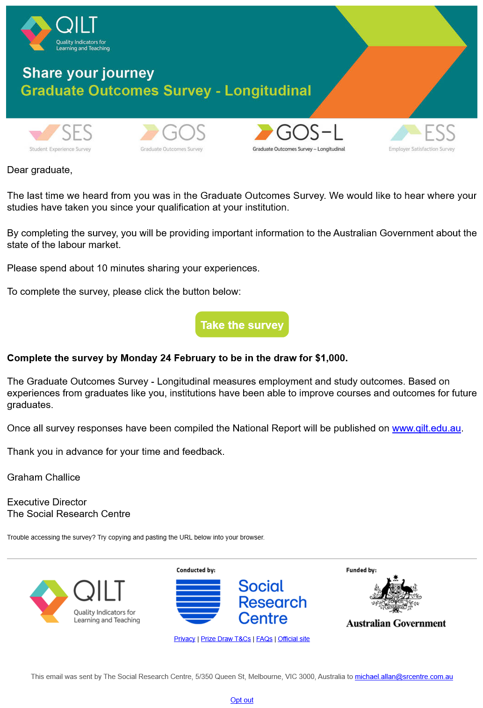
Example GOS-L survey invitation email – mobile
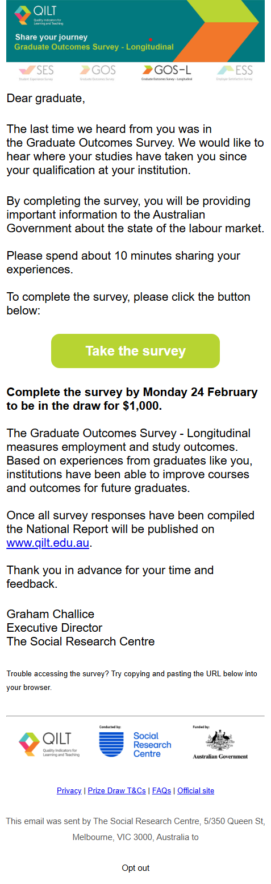

Example SMS content
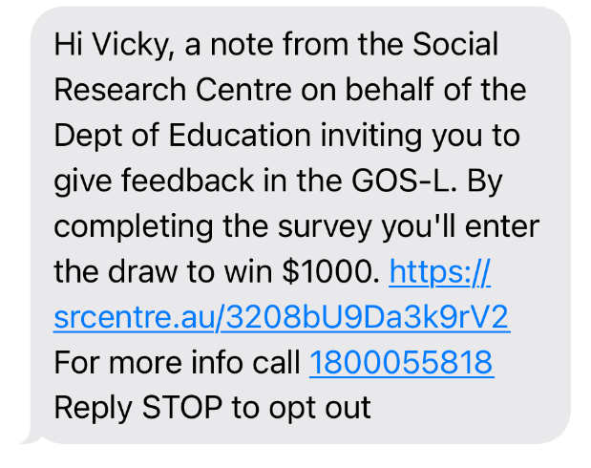
Example social media advertisement – Facebook news feed

Example landing page


Appendix 3: Core questionnaire
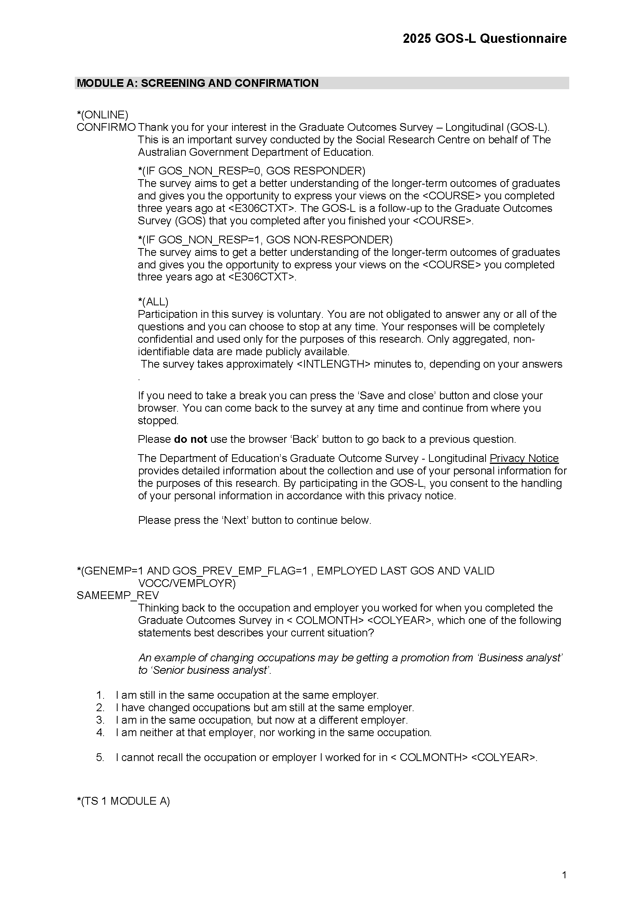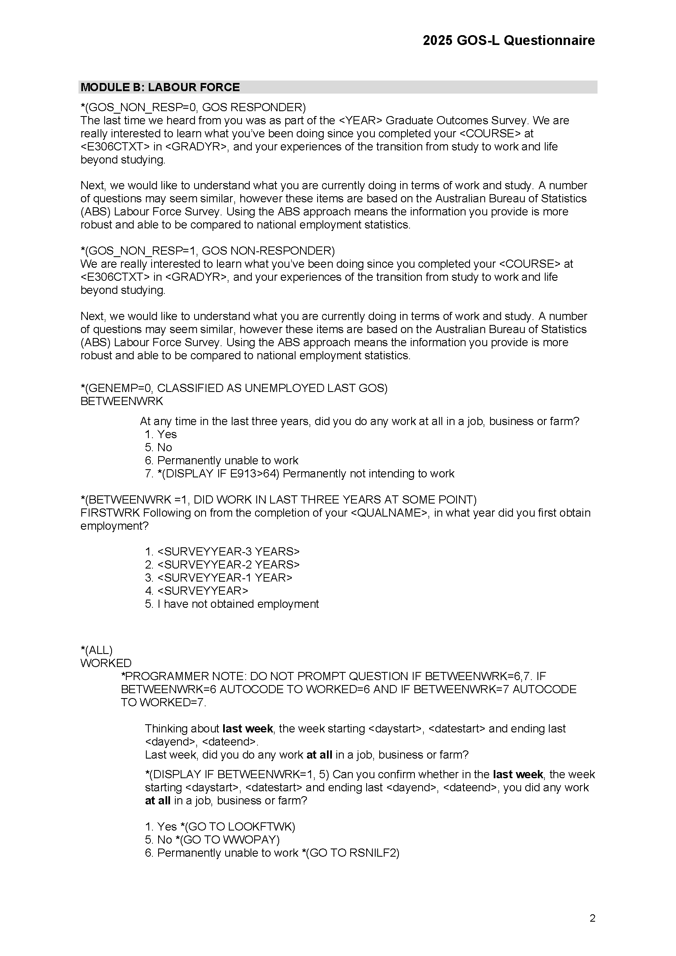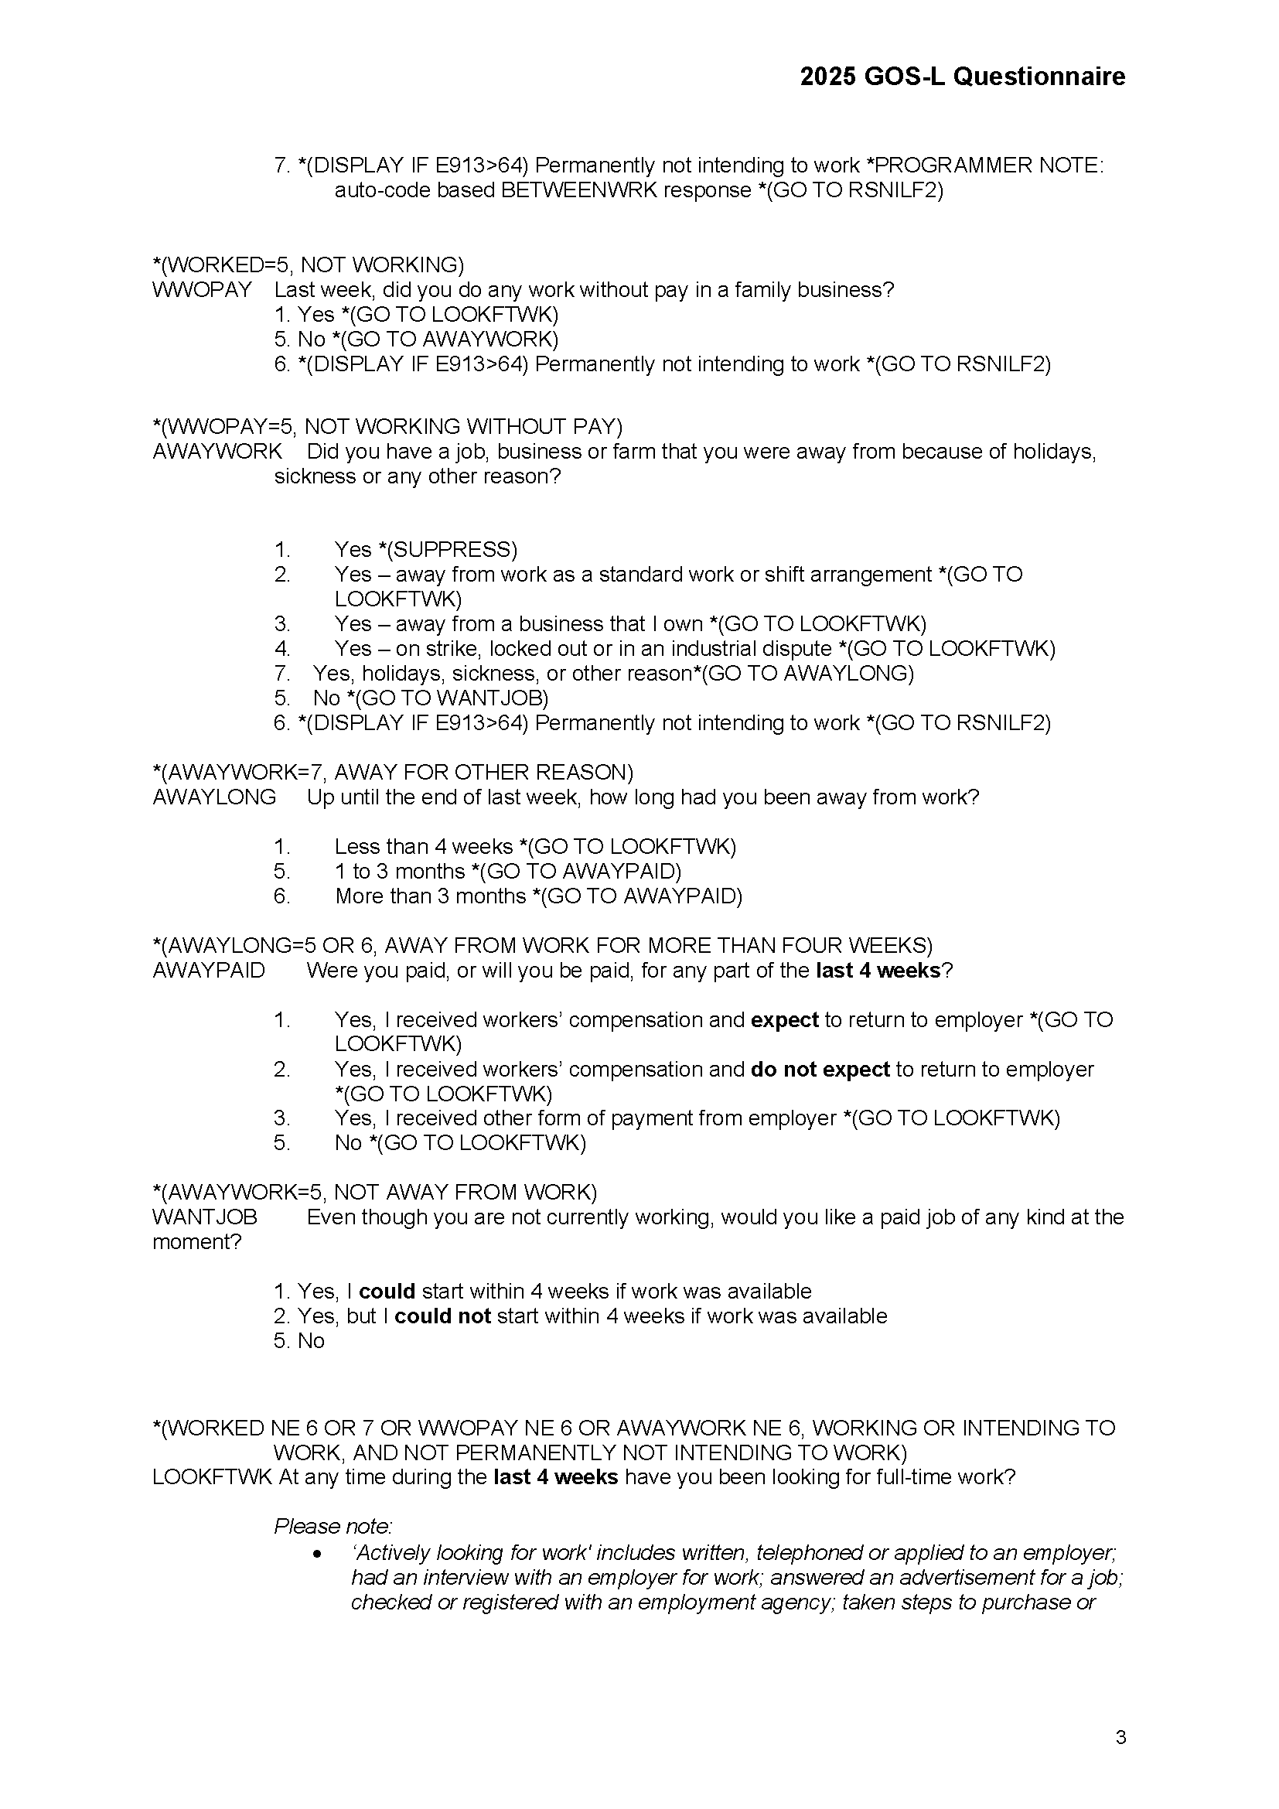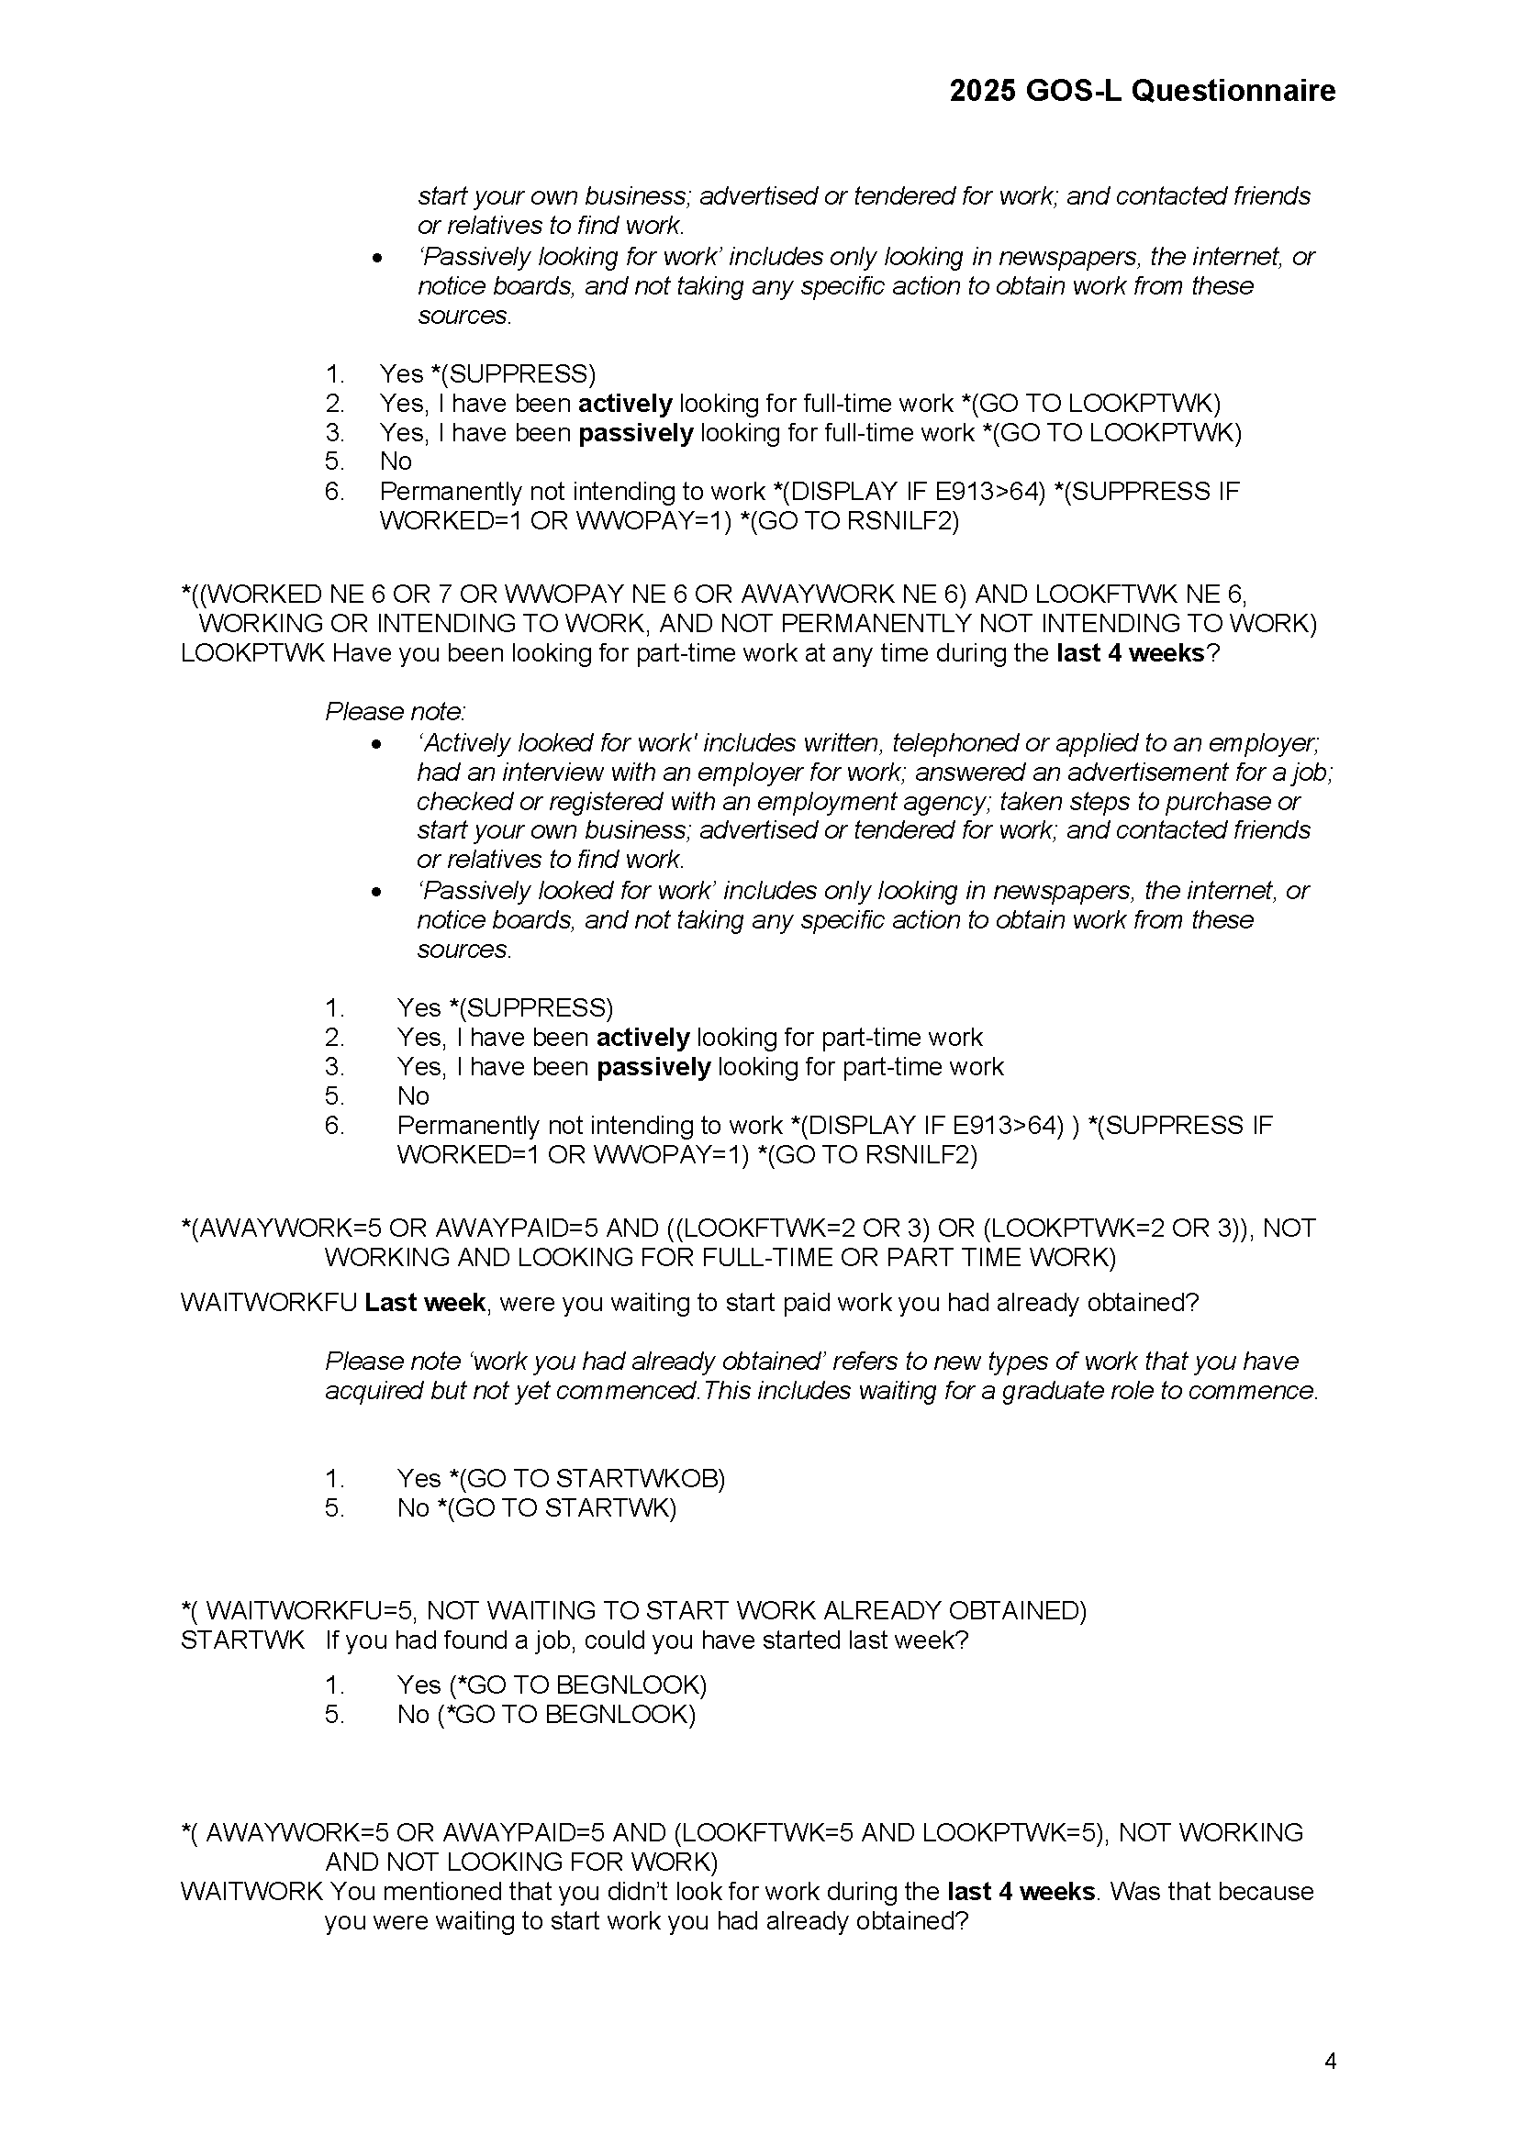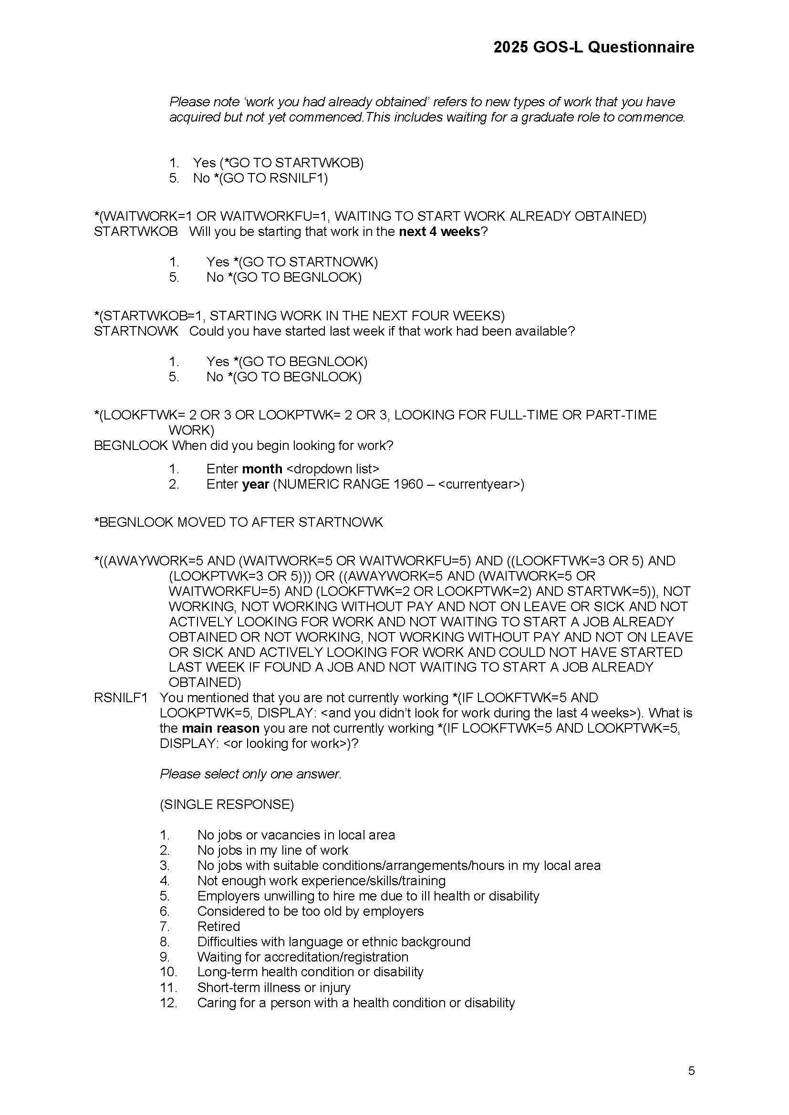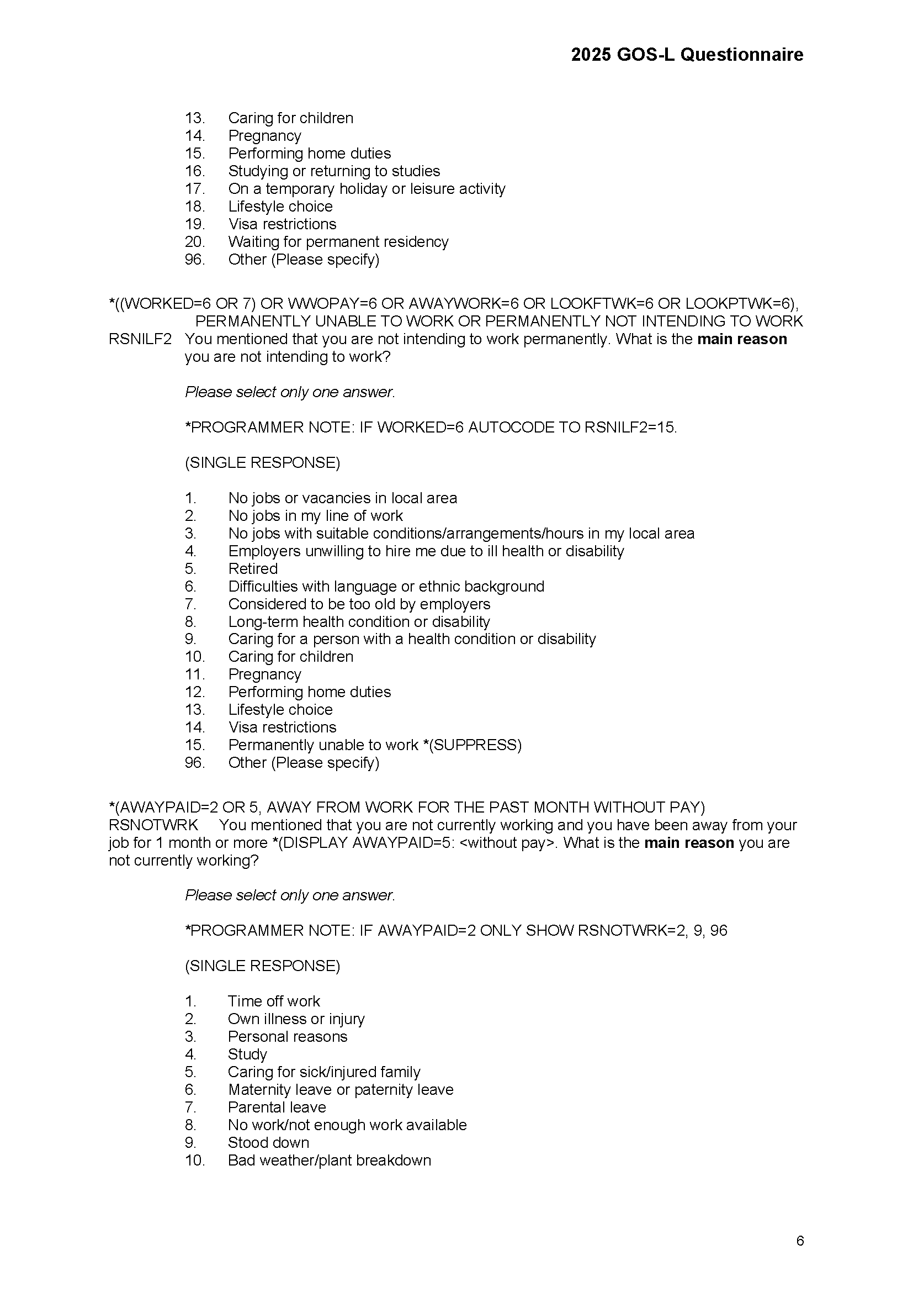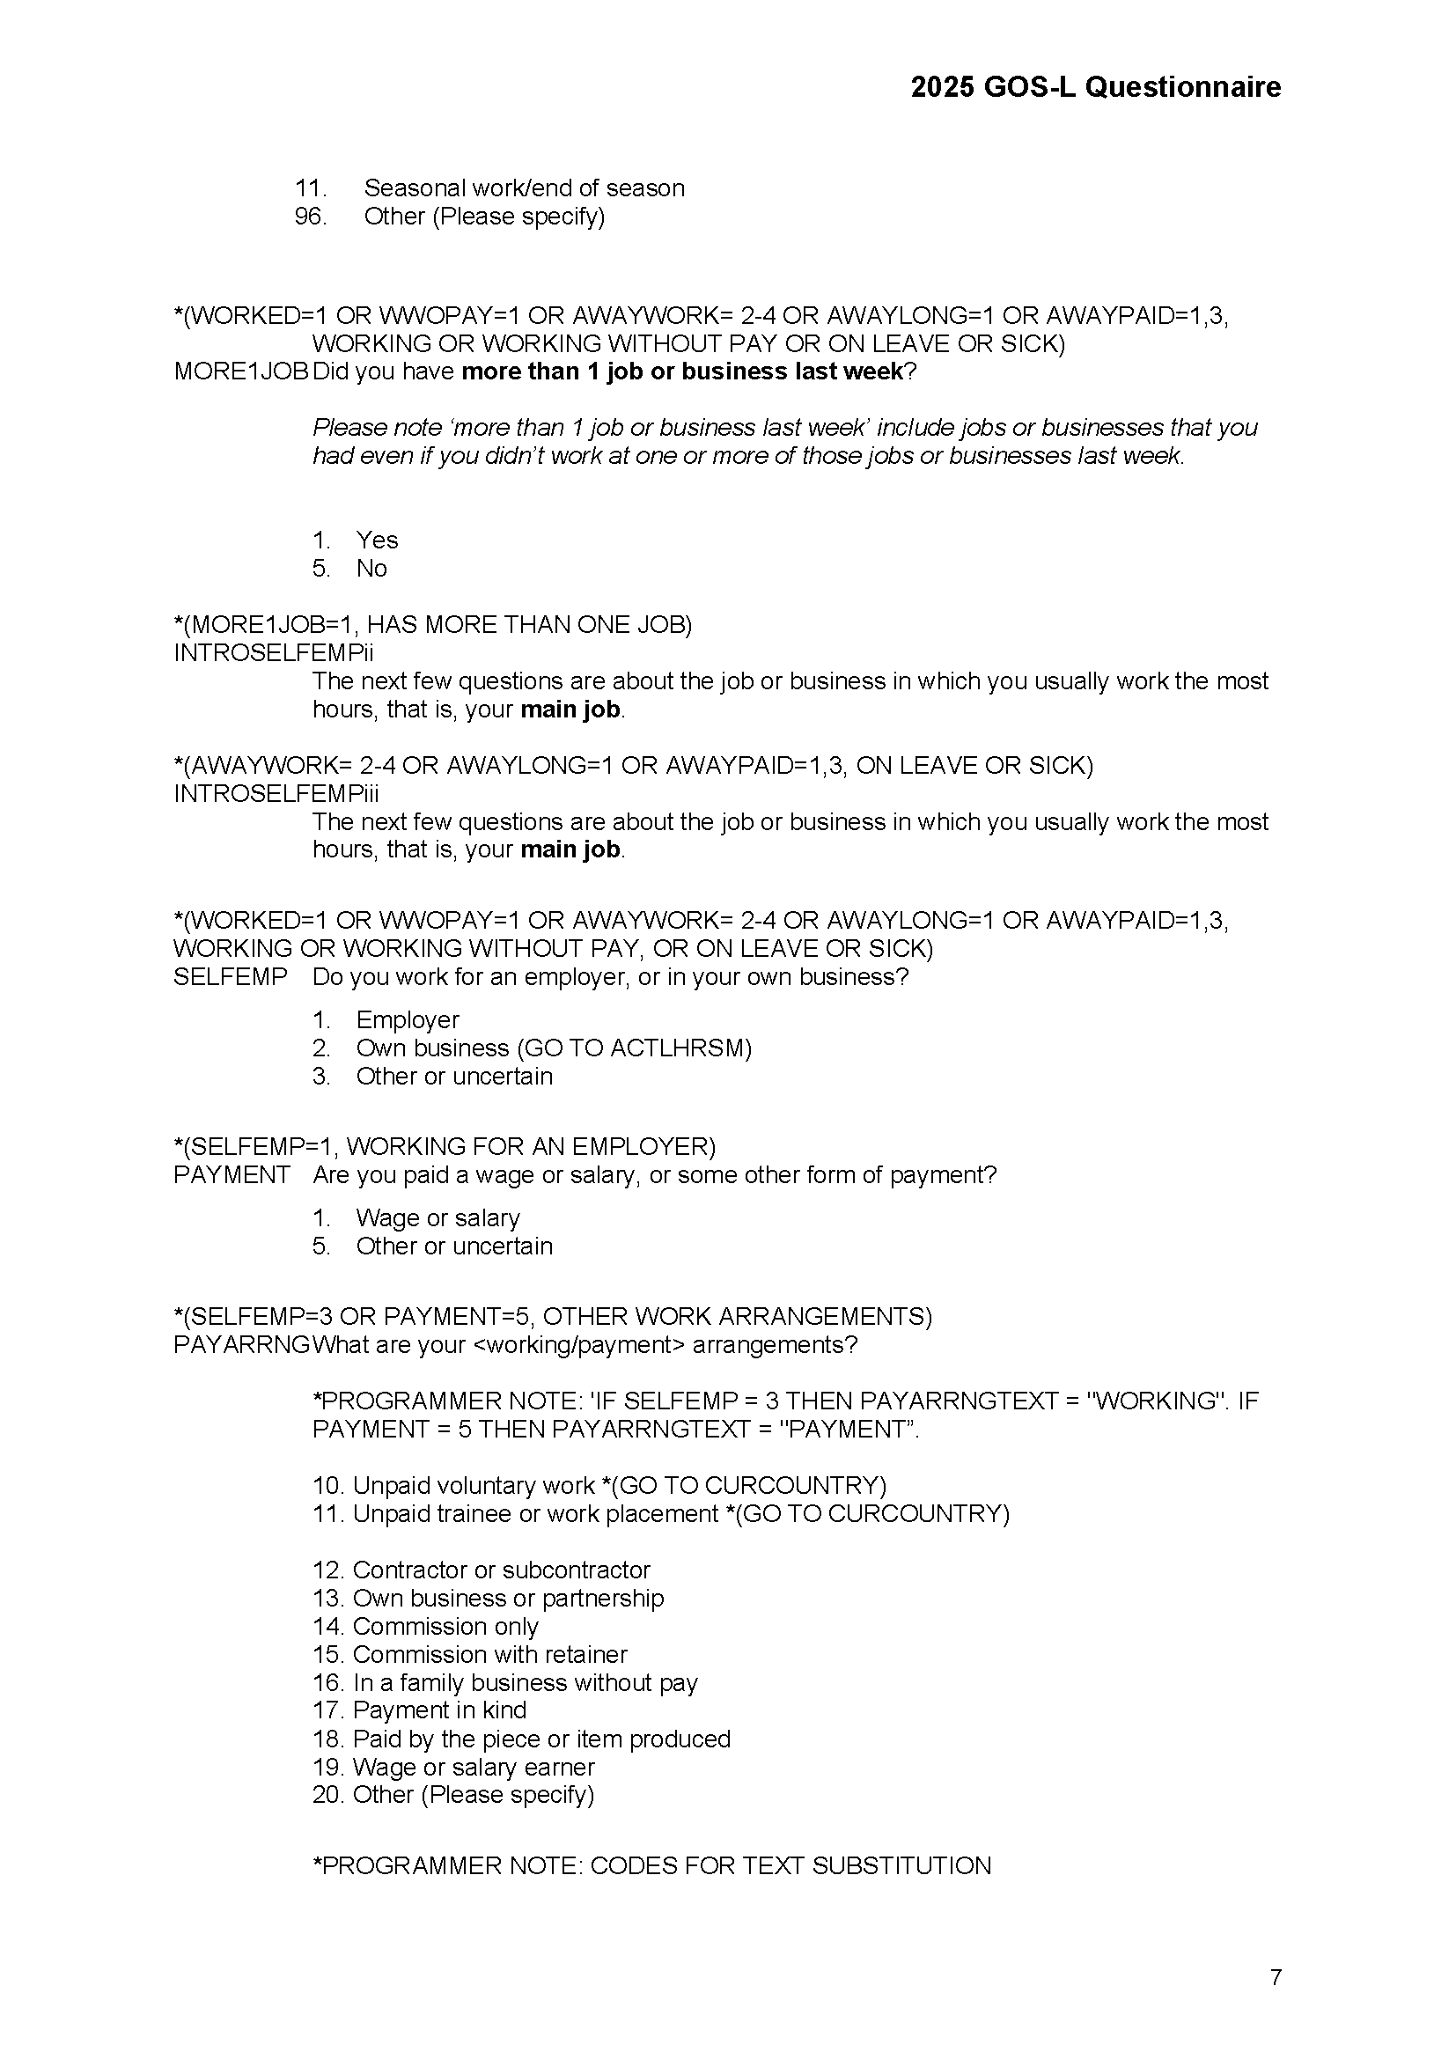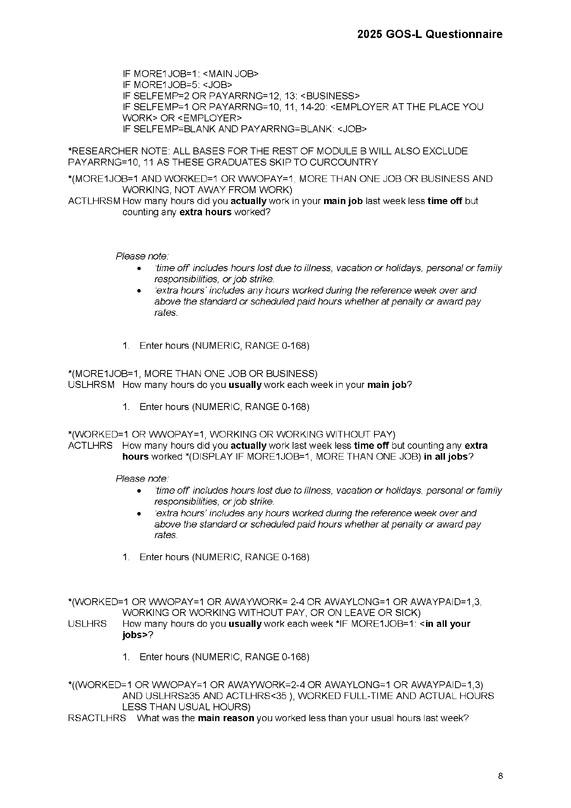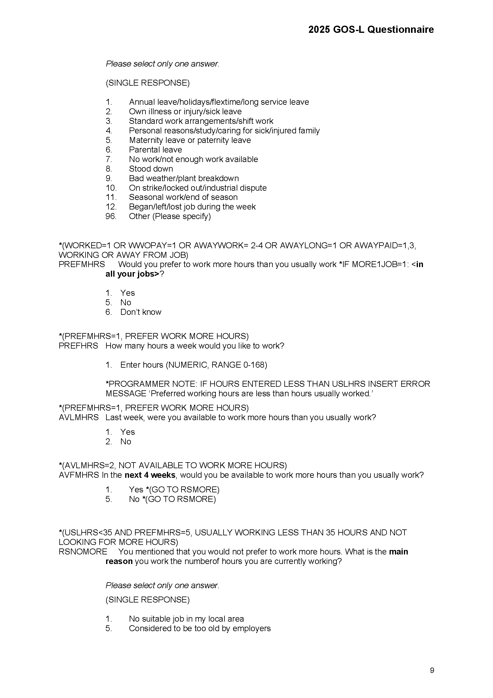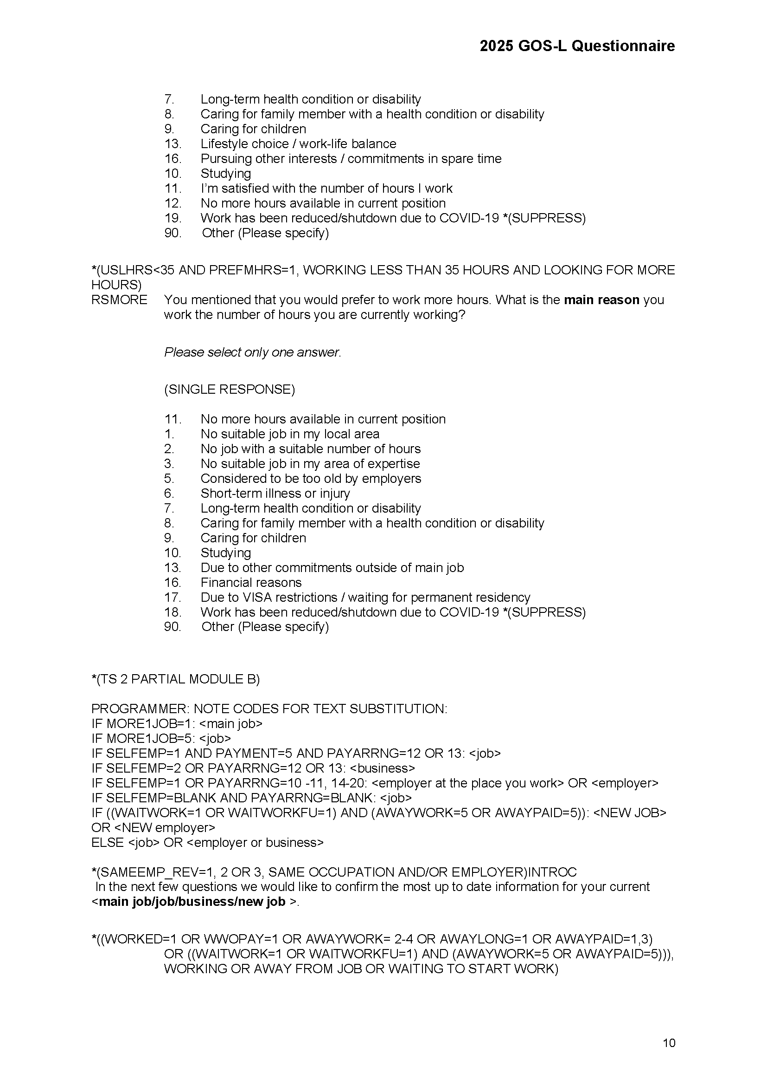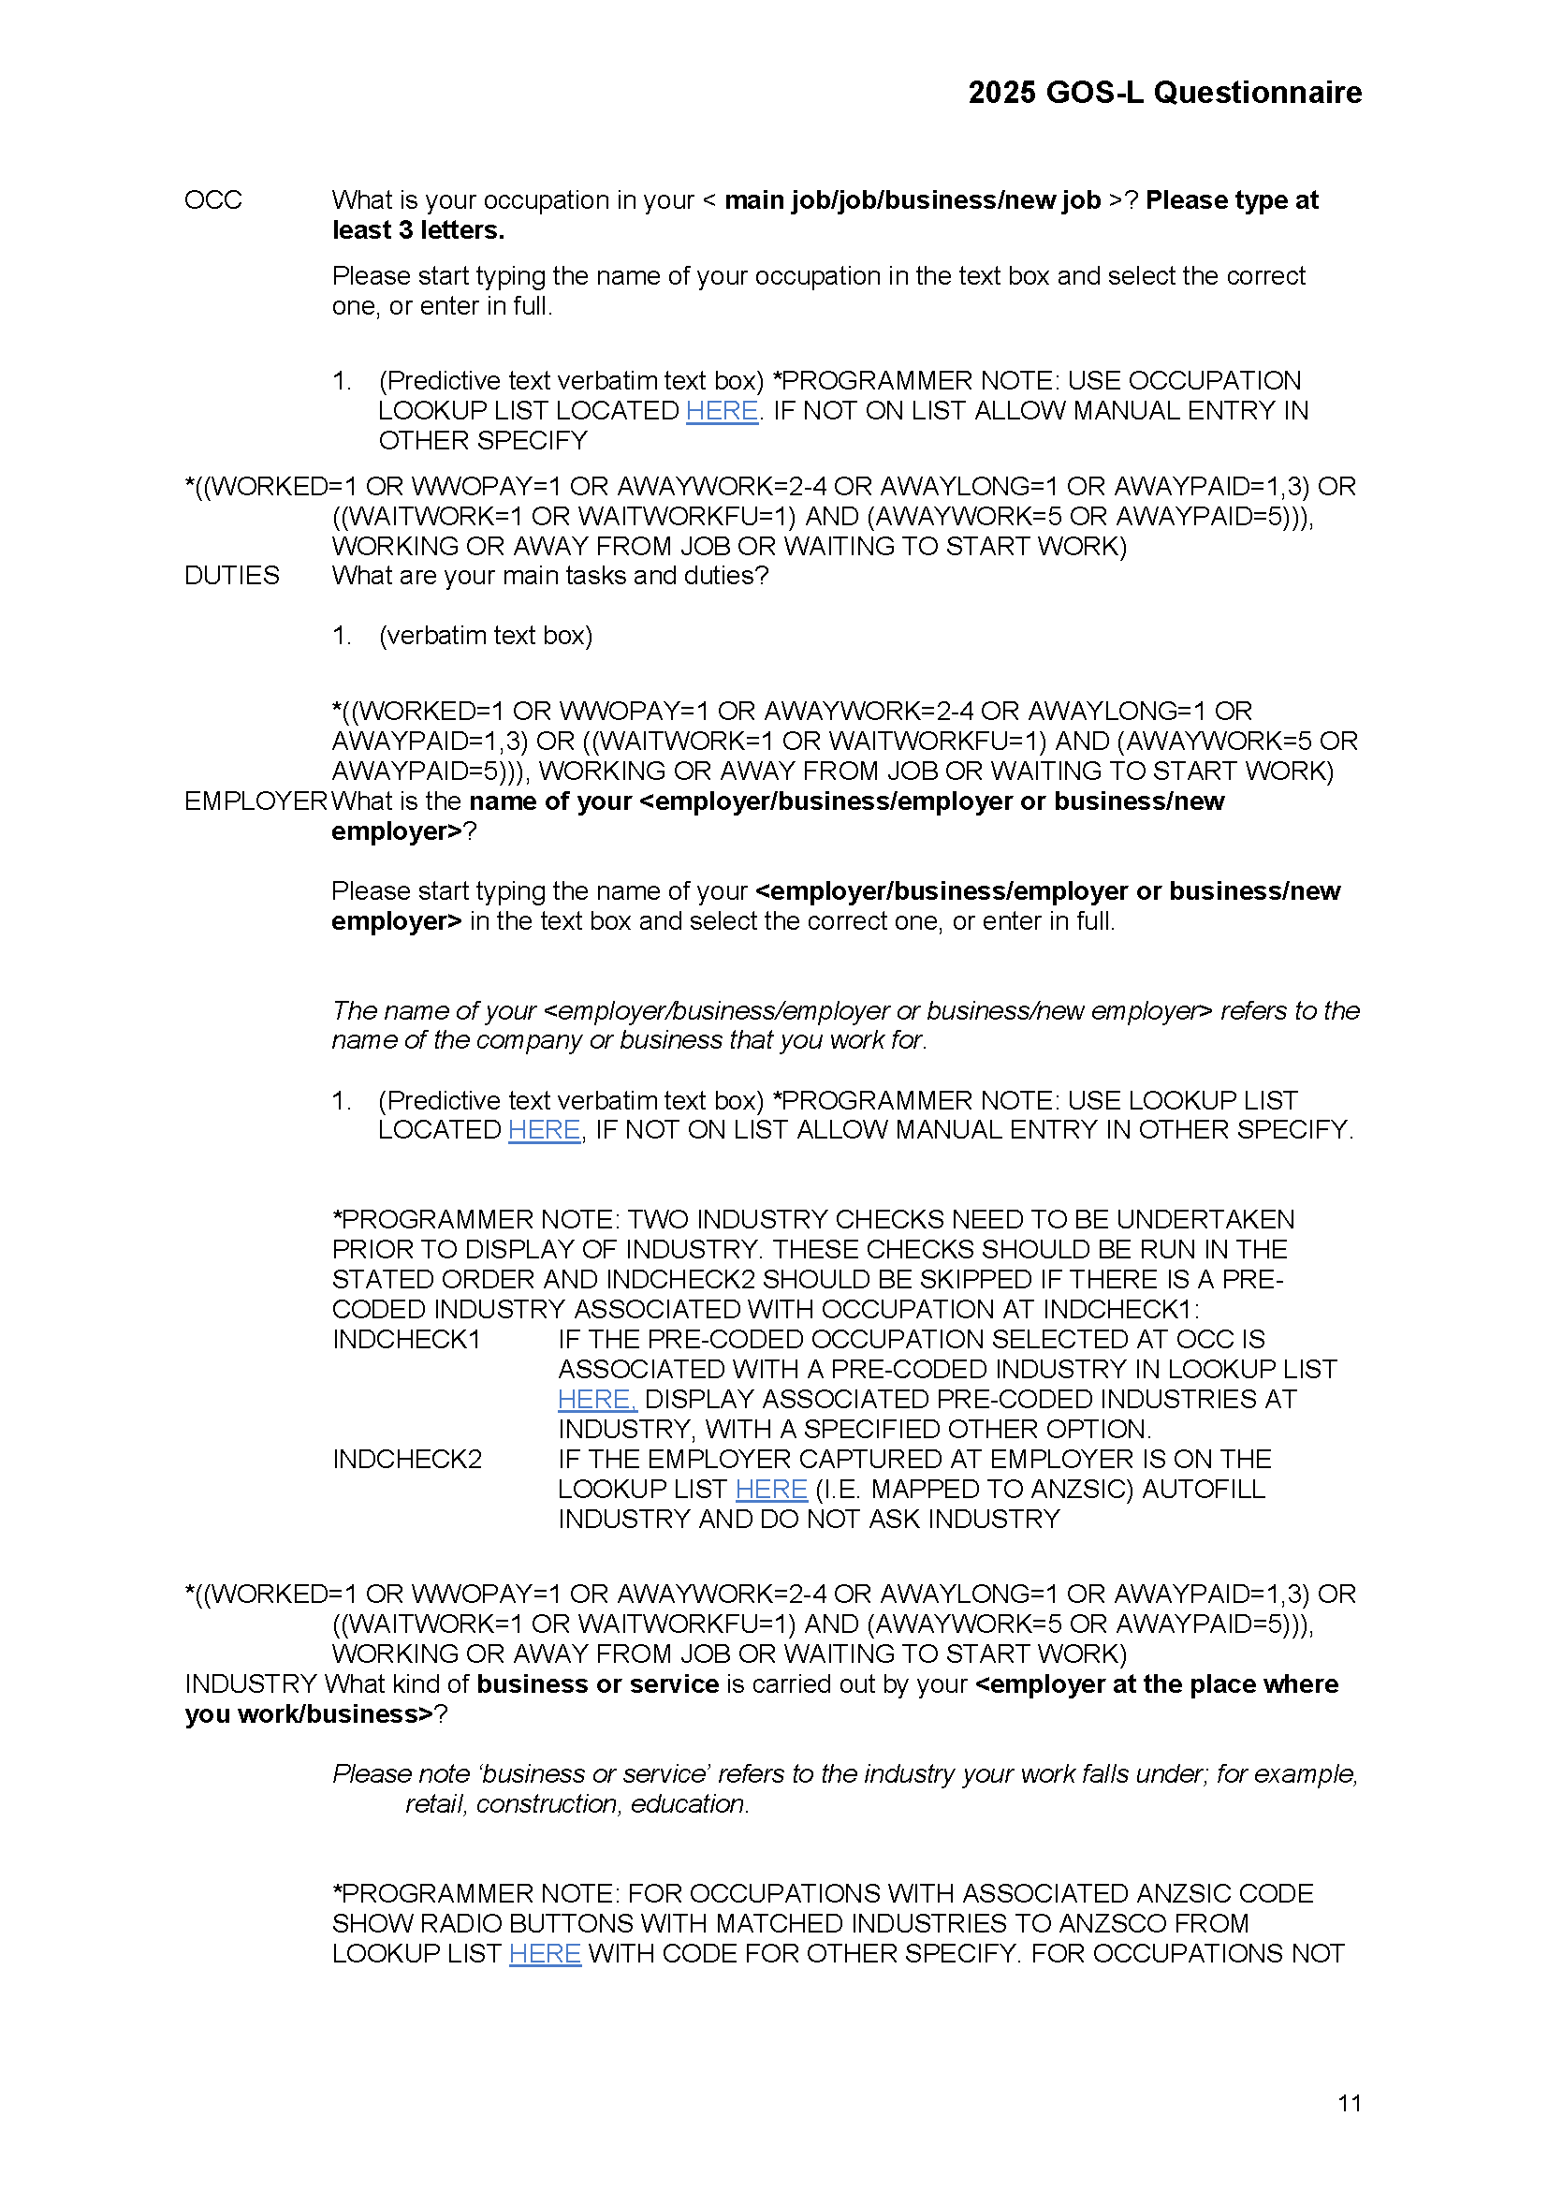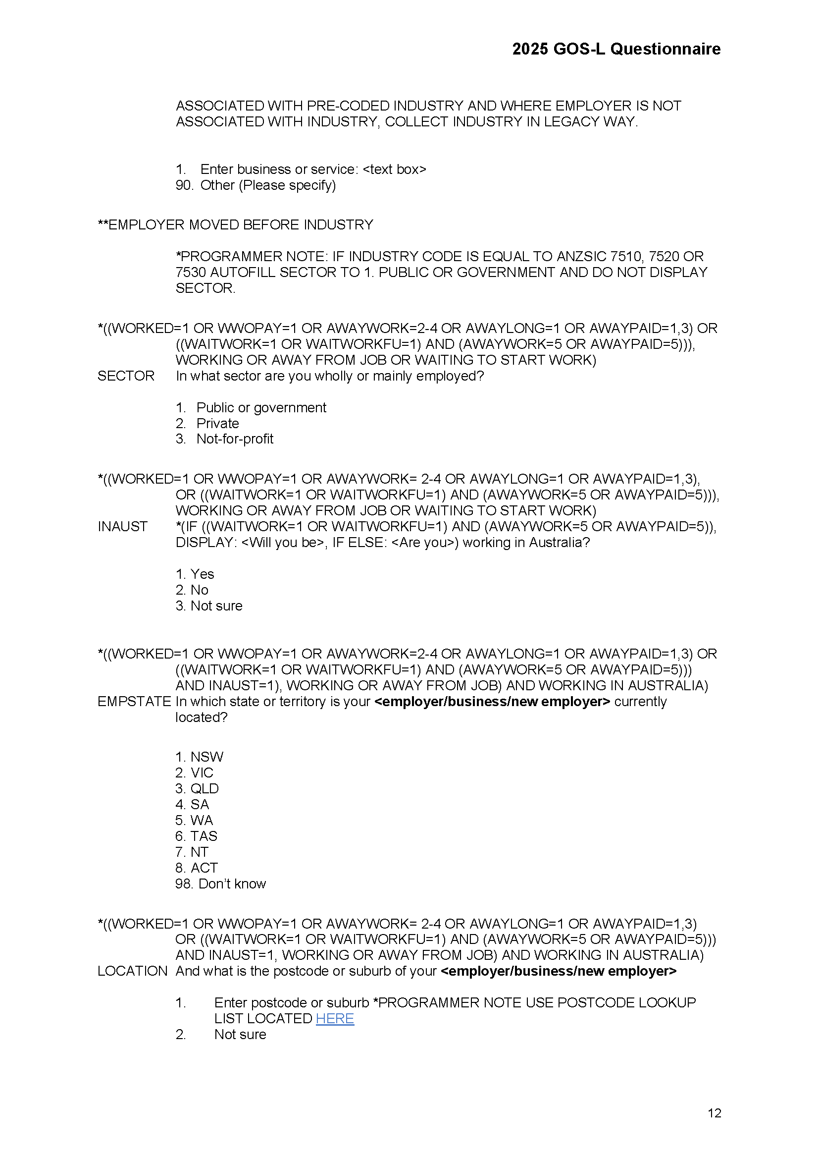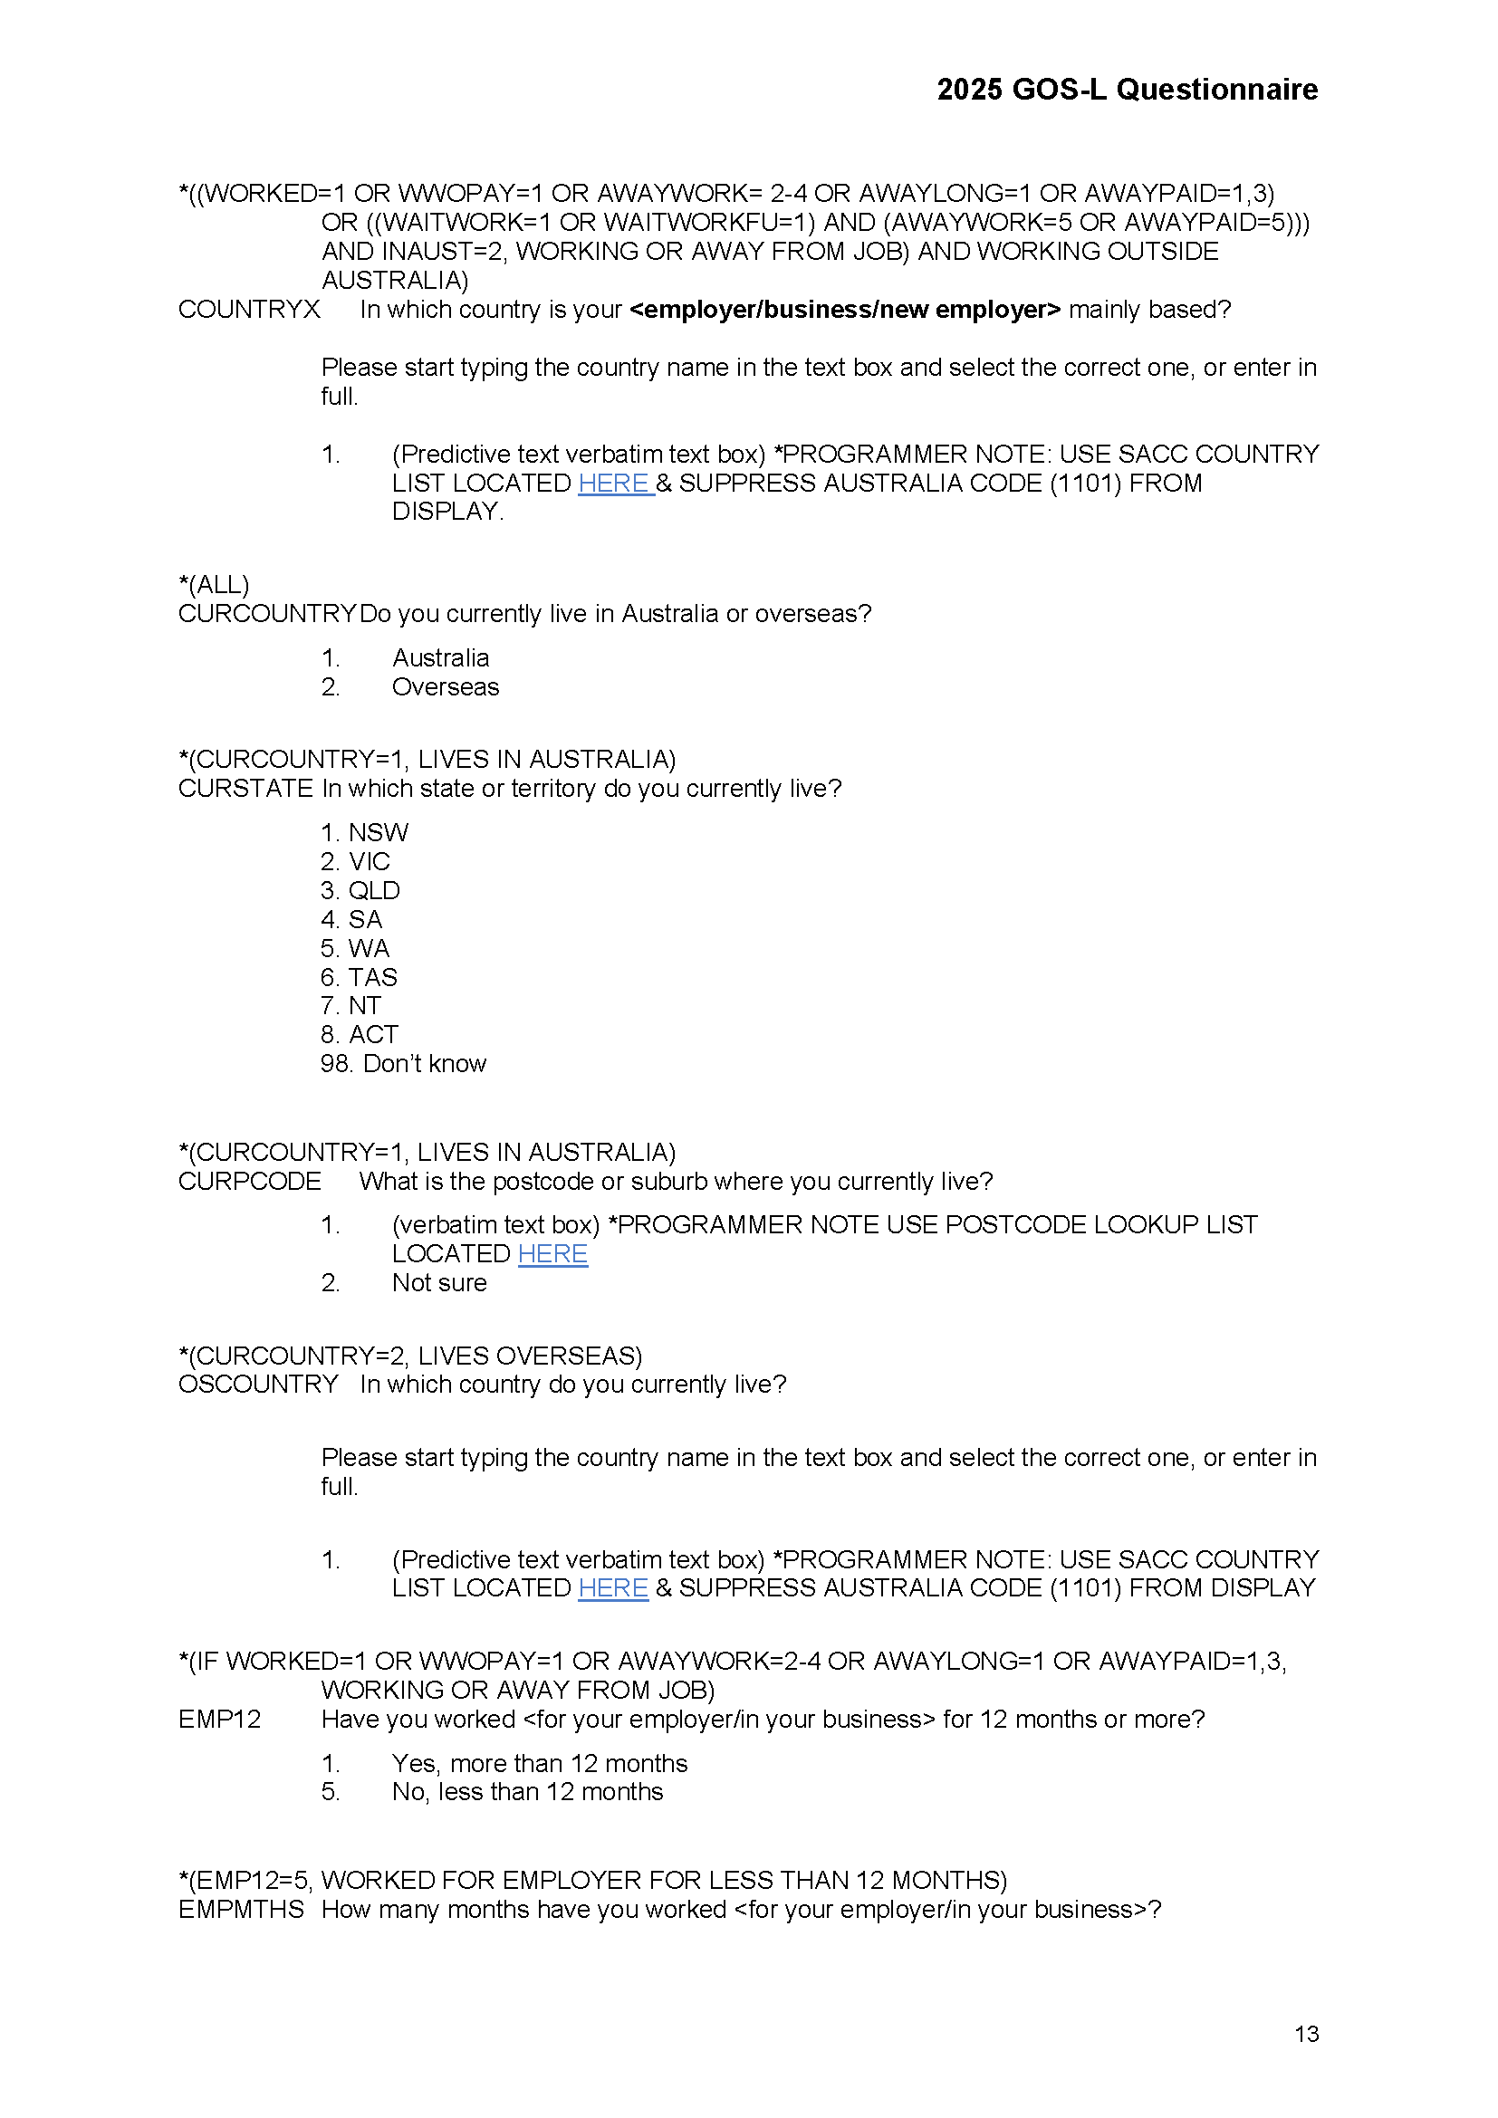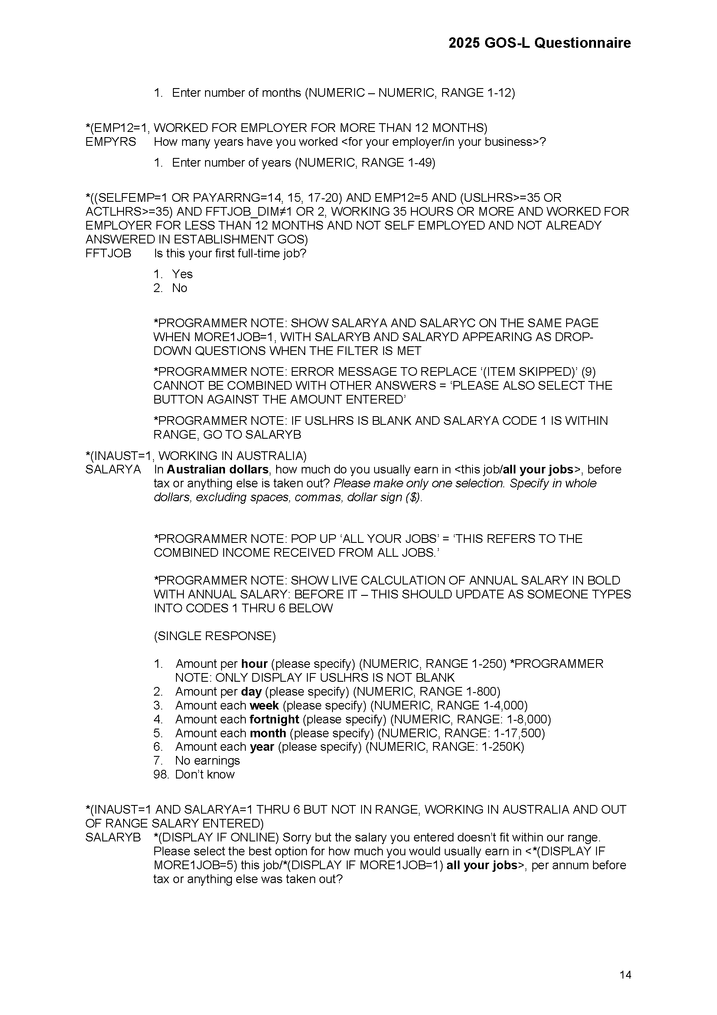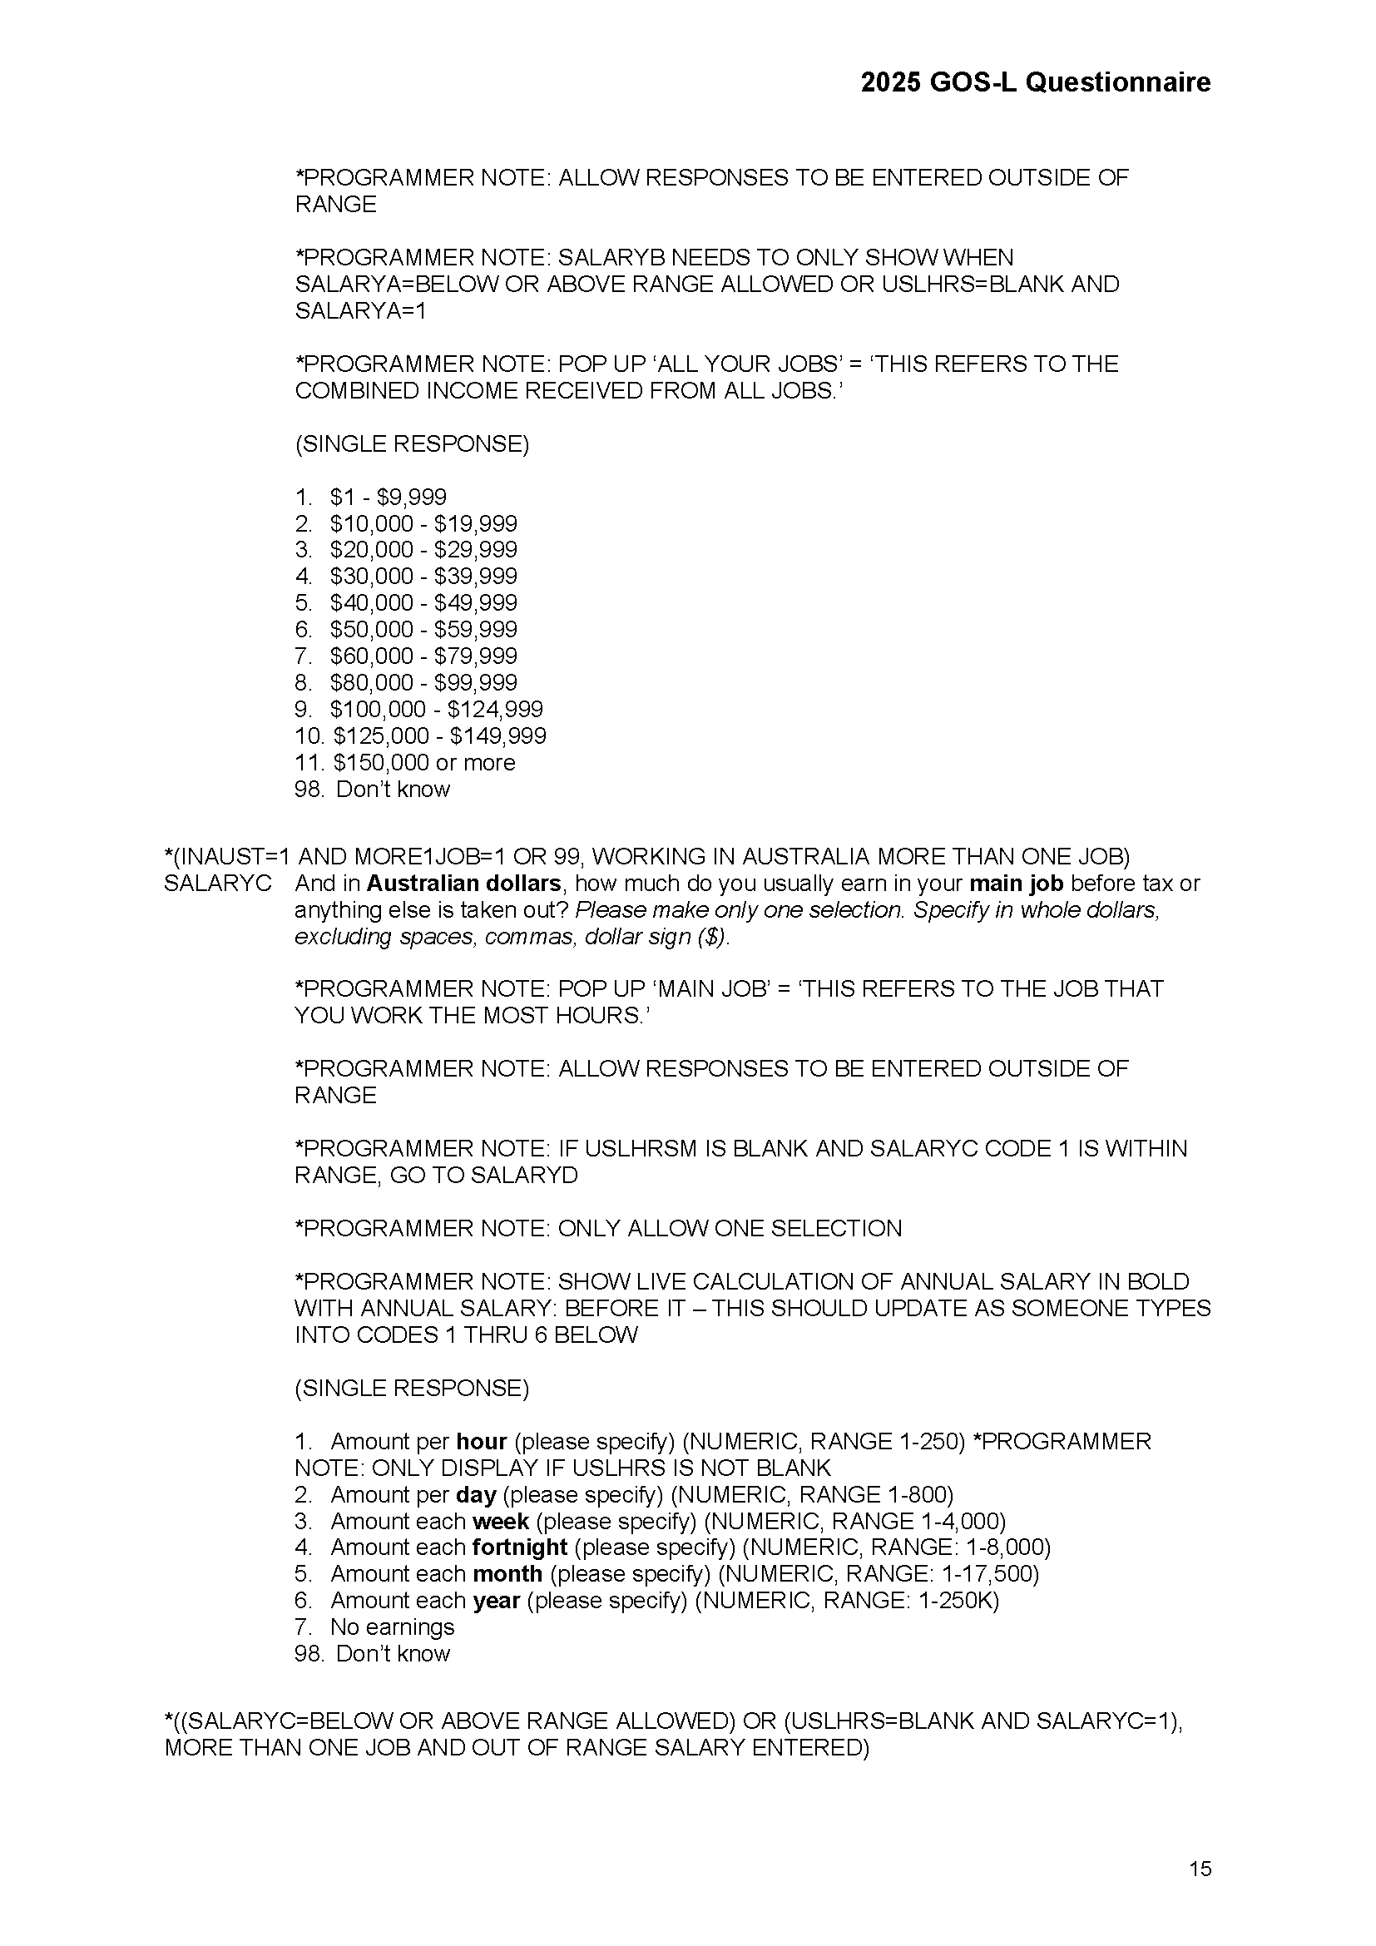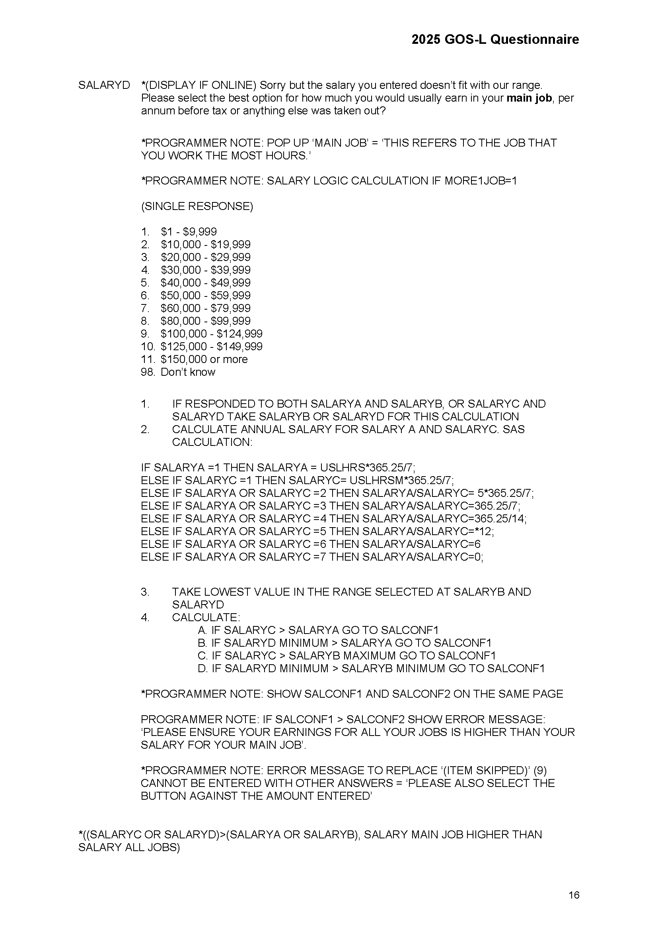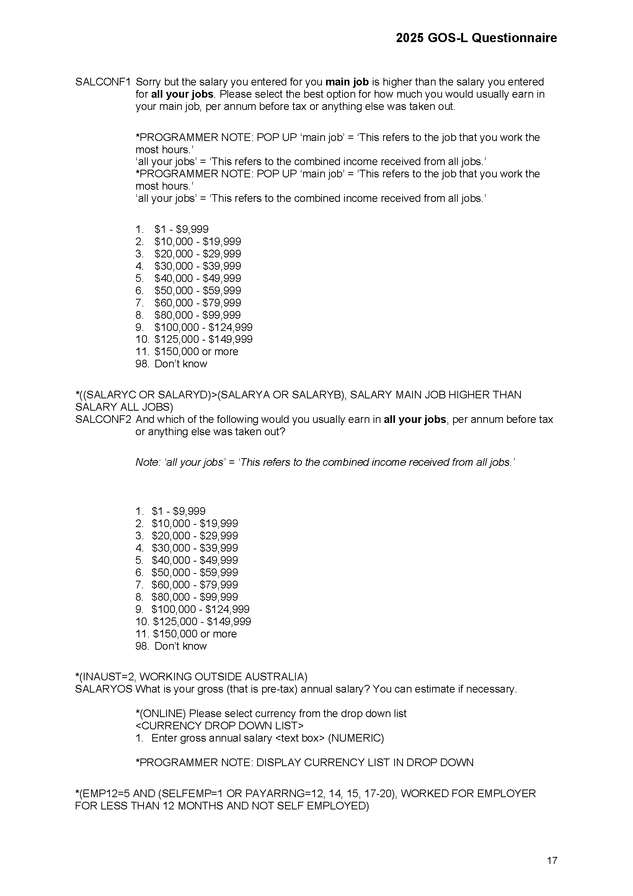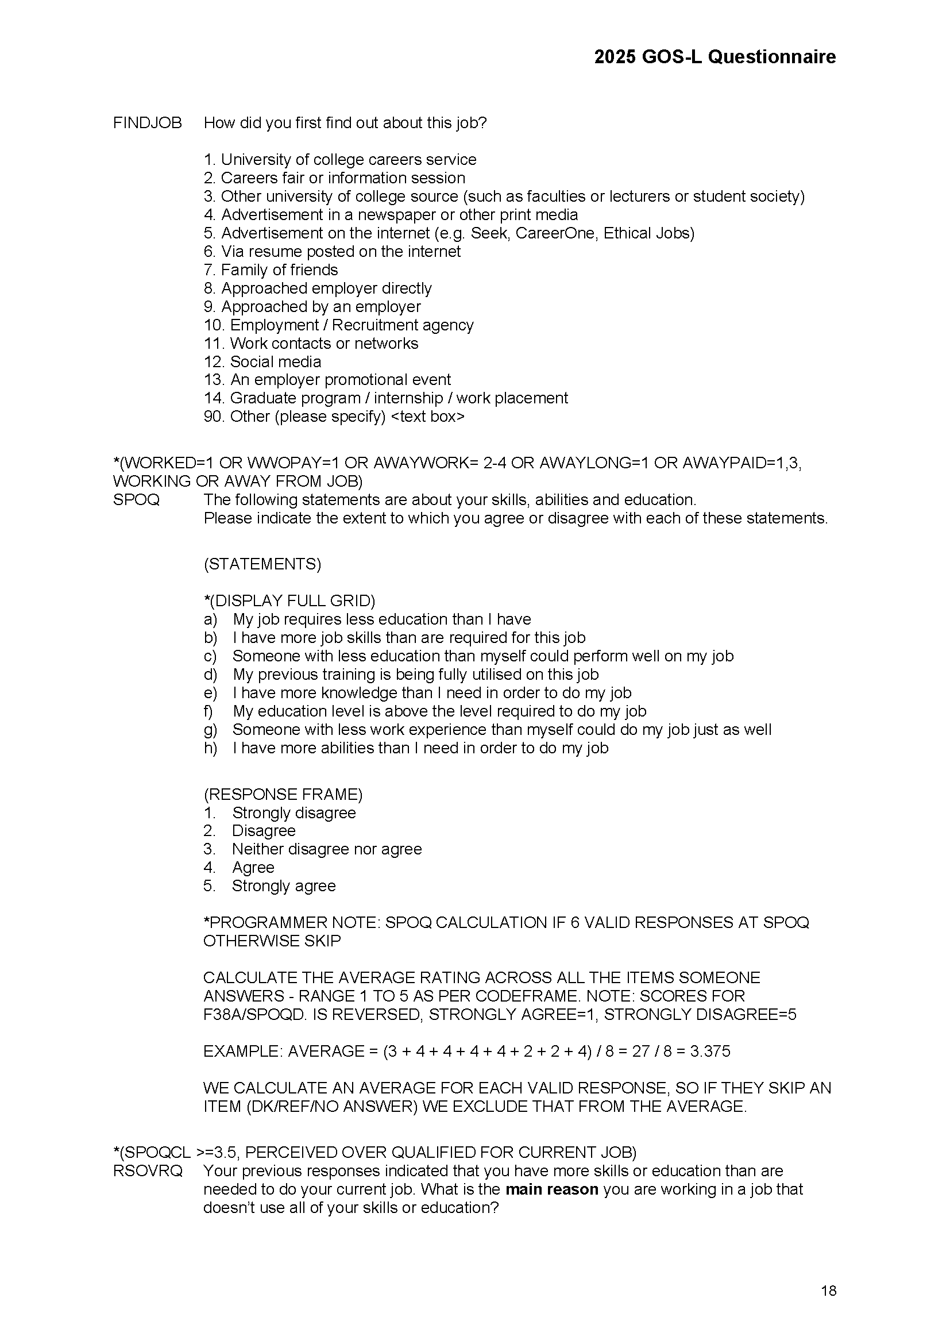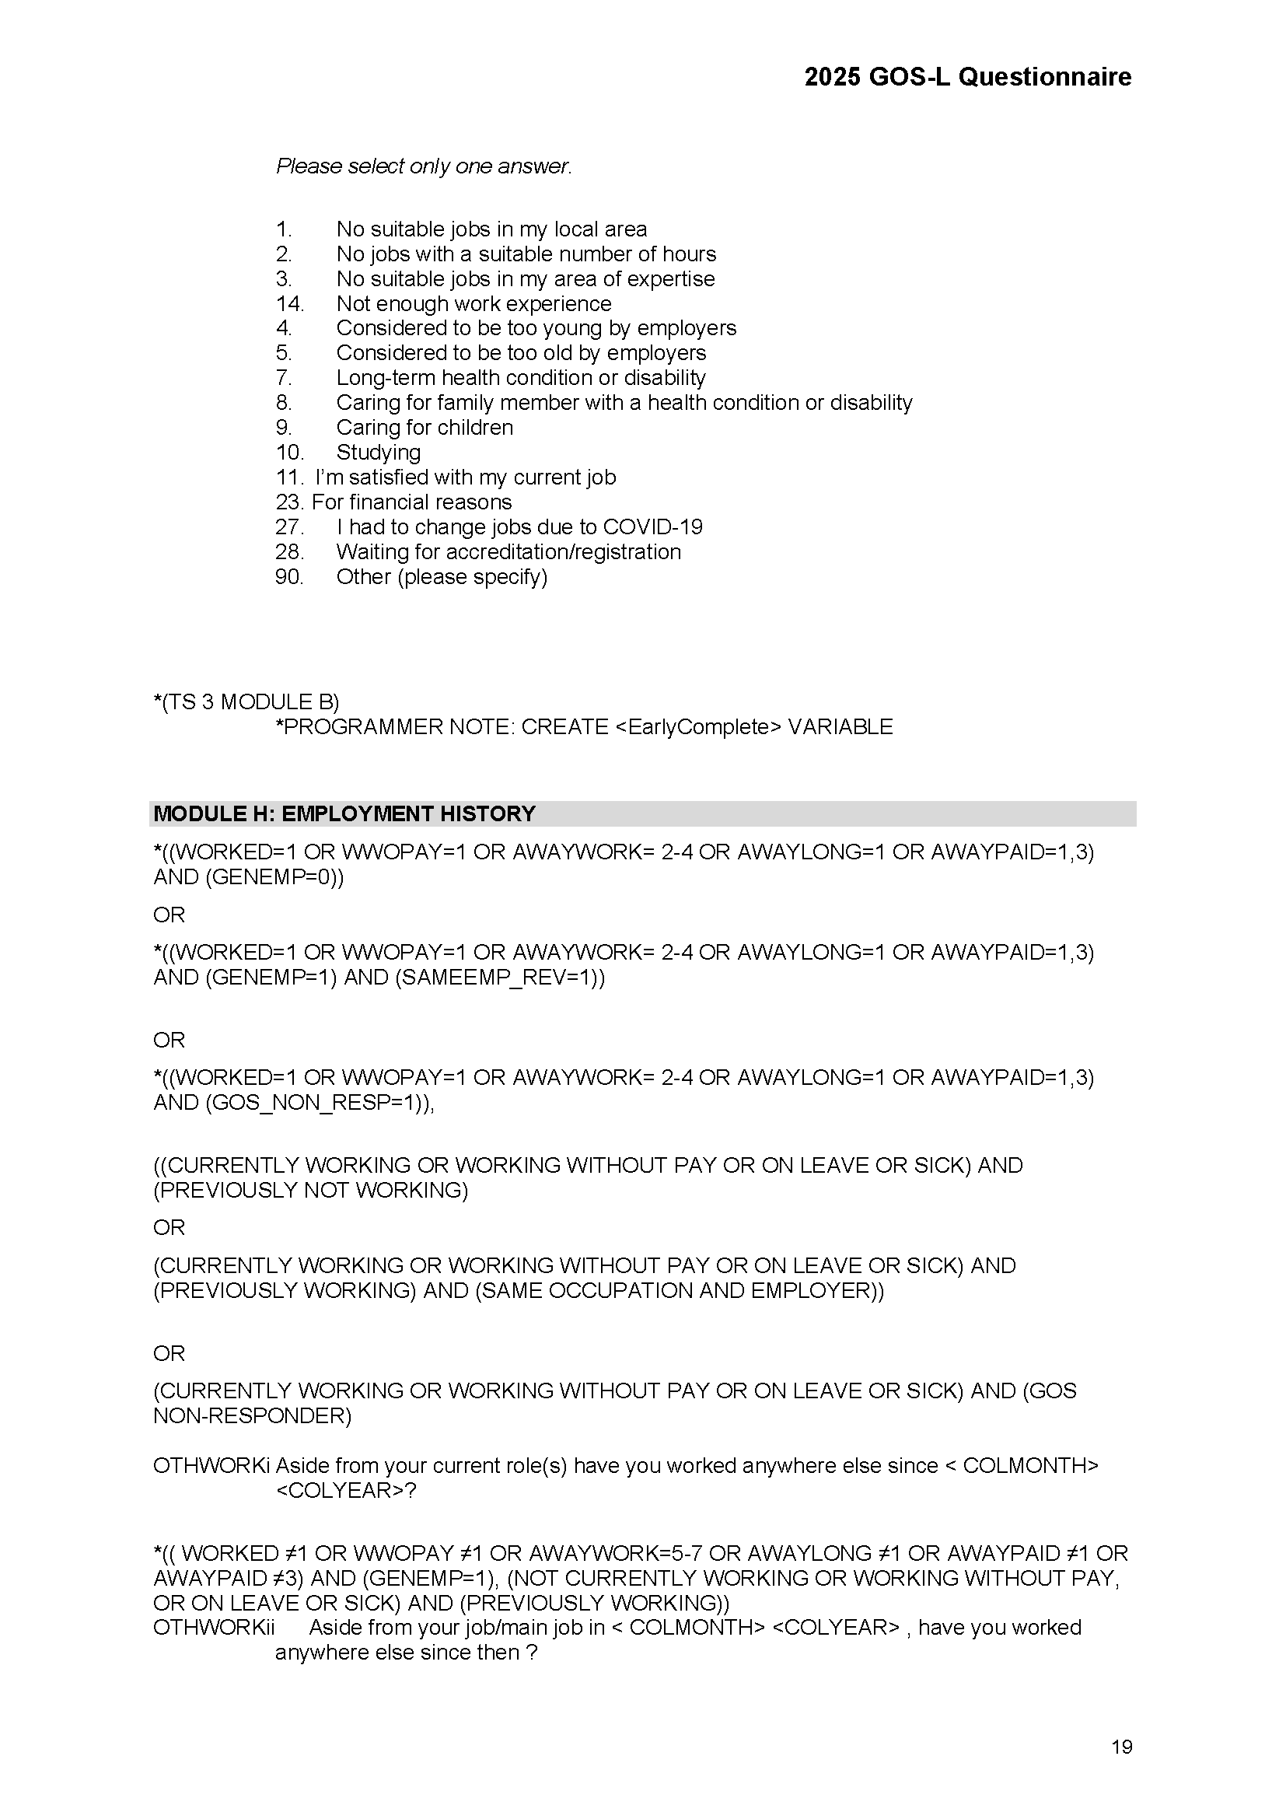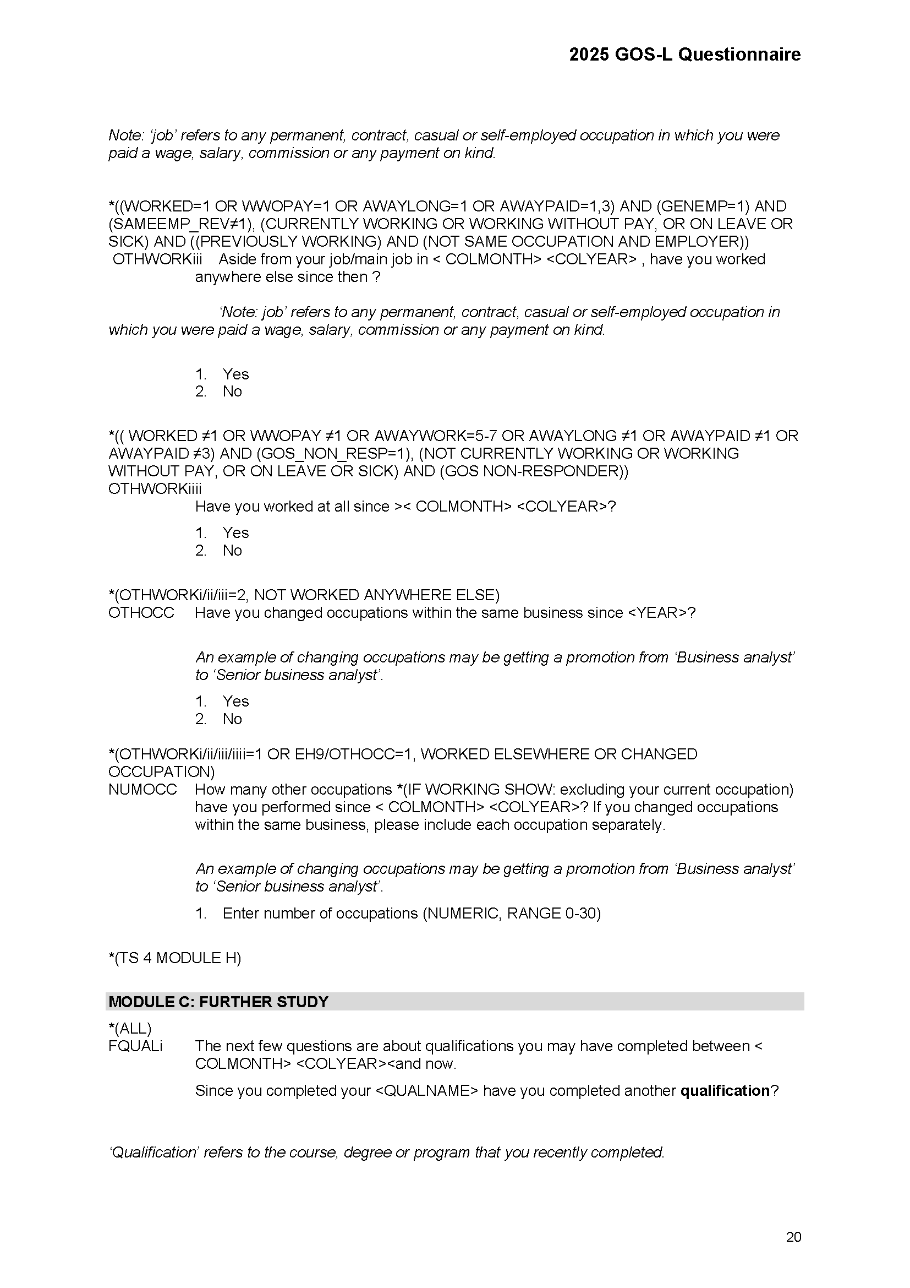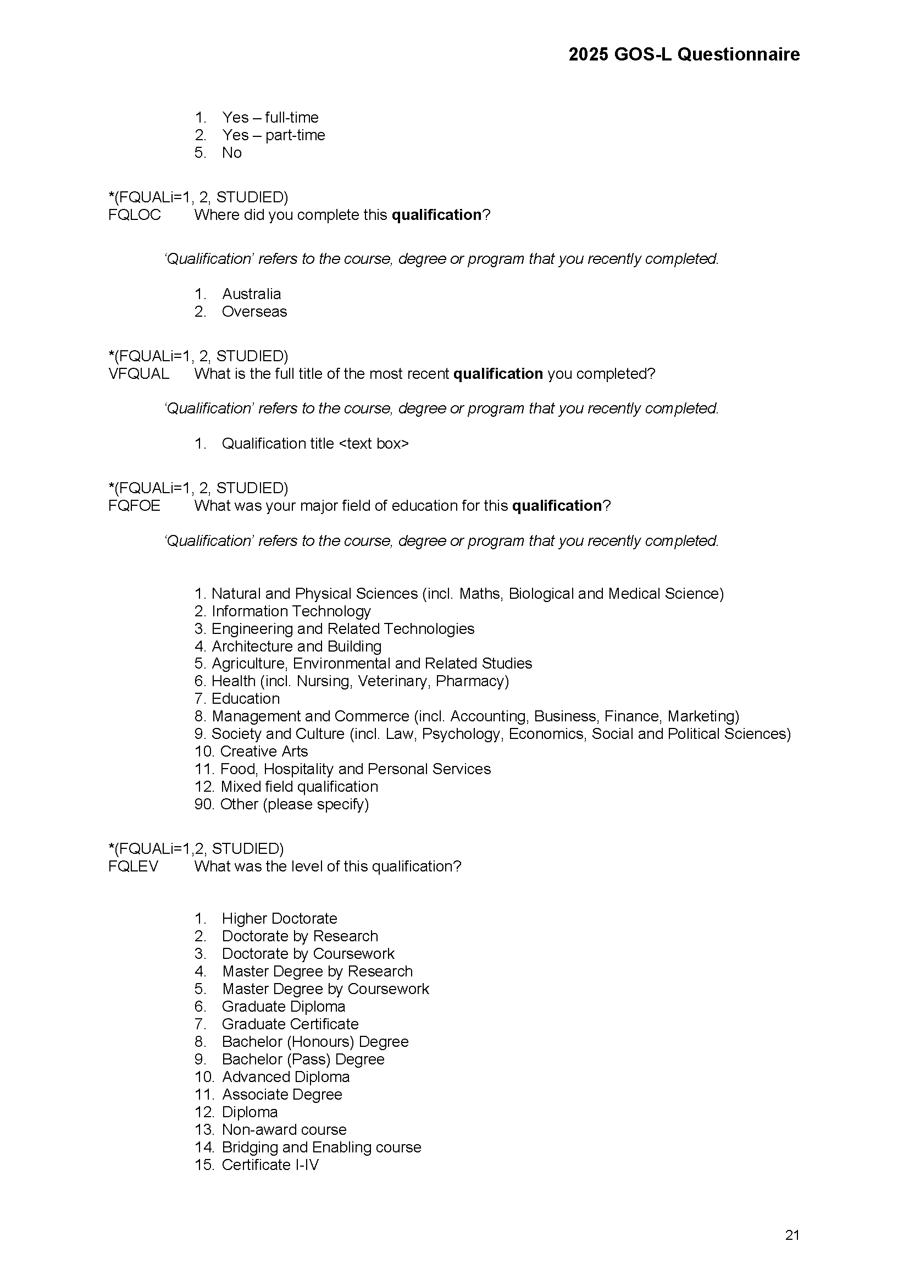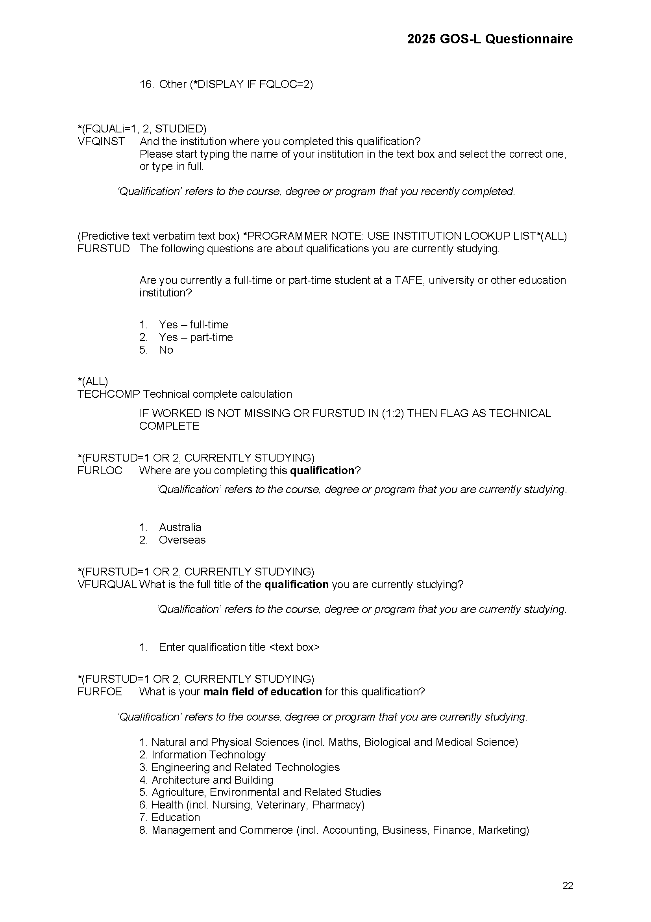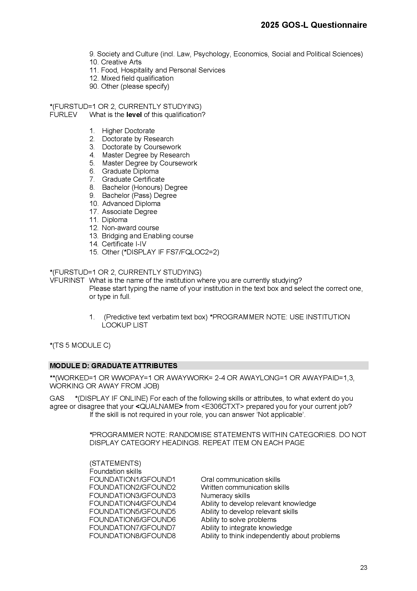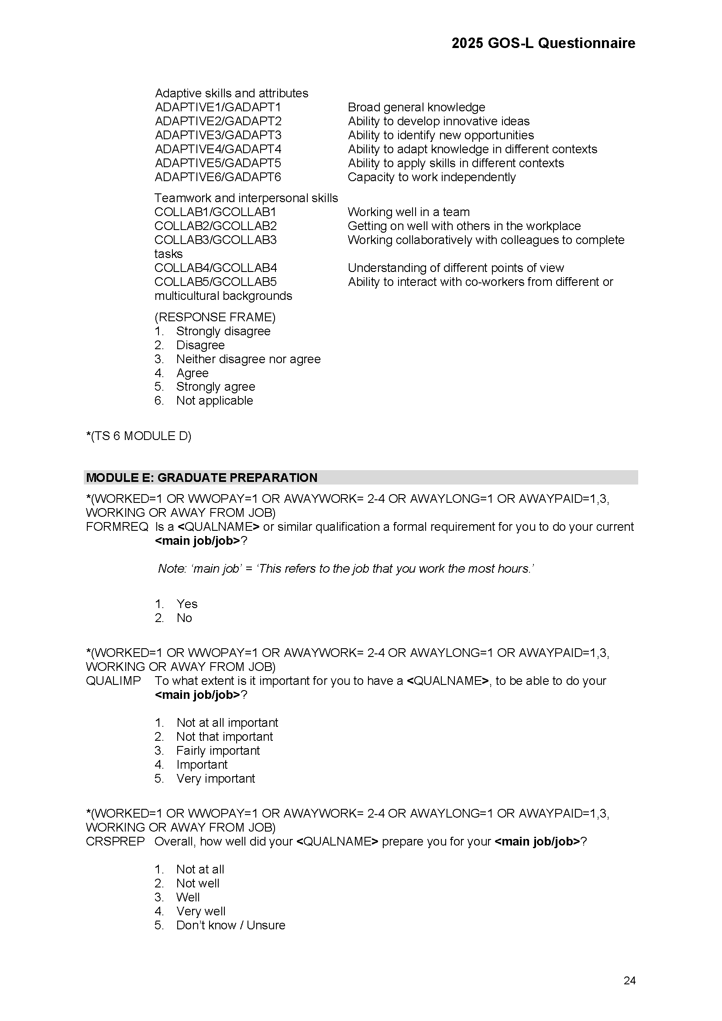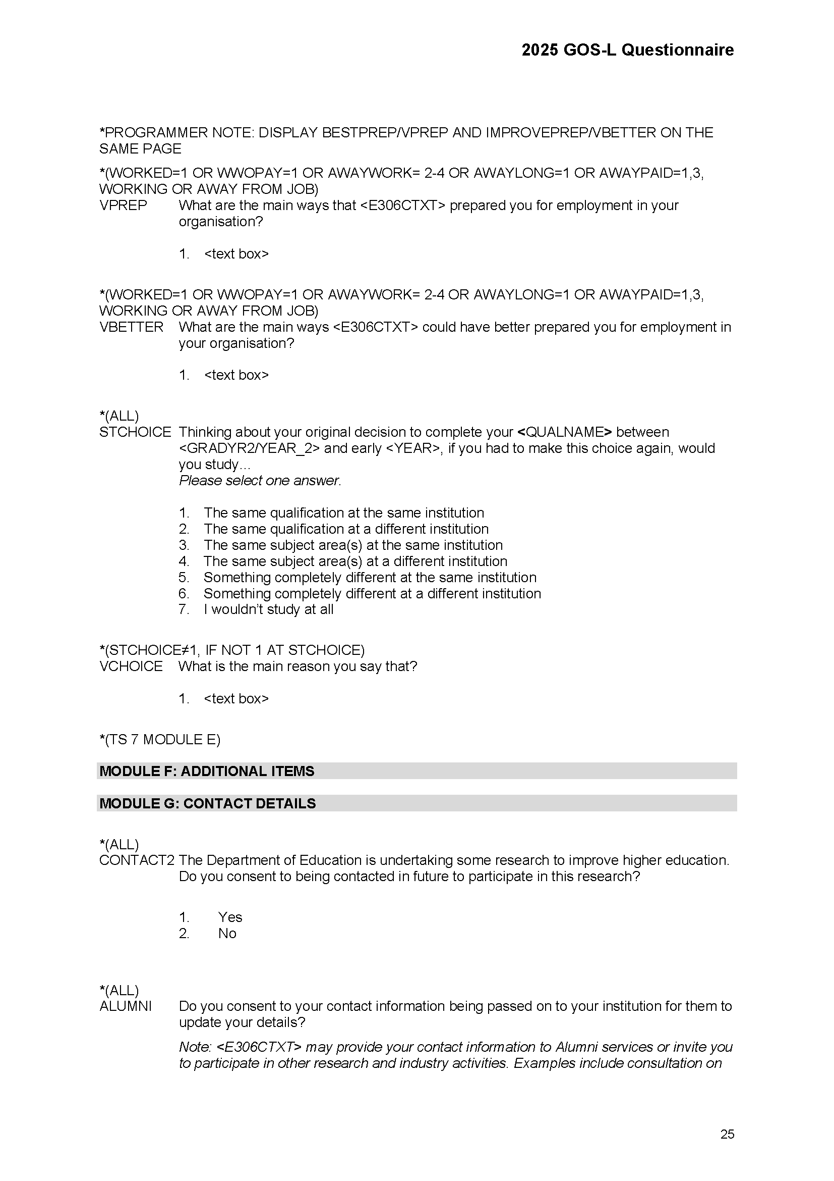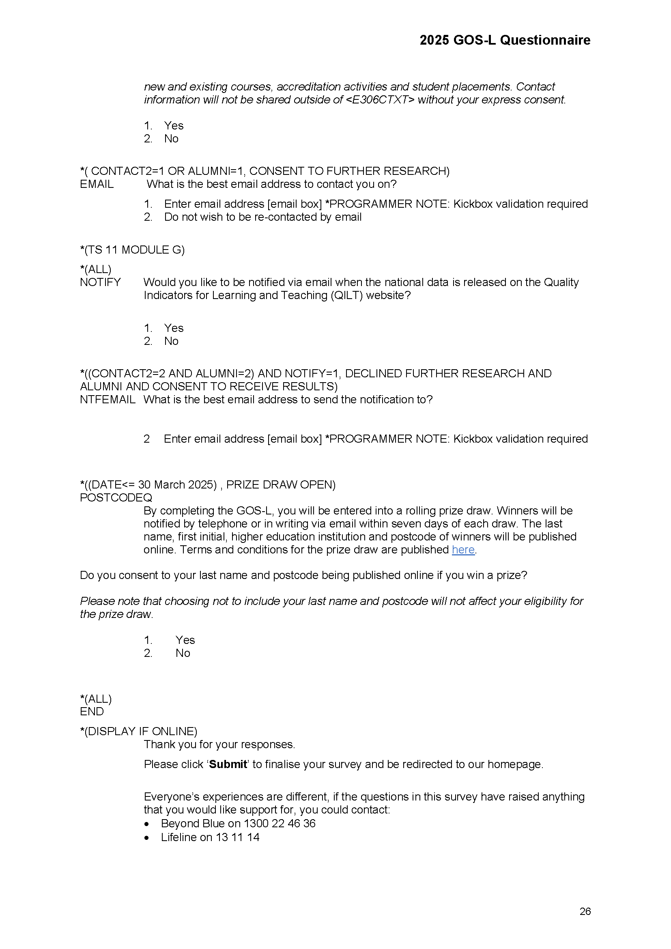

The Social Research Centre Pty Ltd
Level 5, 350 Queen Street, Melbourne Vic 3000
PO Box 13328, Law Courts Vic 8010
03 9236 8500 | info@srcentre.com.au
srcentre.com.au

The version of this publication is aimed to assist those with various
vision impairments; however, The Social Research Centre and its
employees do not guarantee that the publication meets all broad
accessibility standards and therefore disclaim all liability for any
inconvenience or other consequence that may arise from readers
relying on this publication. Please contact The Social Research
Centre if you require further assistance.

Note: Hyphens (-) represent no completed surveys for the collection year, <5 indicates a suppressed value (n < 5), and np indicates a value that is not published to prevent disclosure of a suppressed value
Note: Hyphens (-) represent no completed surveys for the collection year, <5 indicates a suppressed value (n < 5), and np indicates a value that is not published to prevent disclosure of a suppressed value

