 | 

2025 Graduate Outcomes Survey

Methodological Report – Accessible
June 2026



Acknowledgements
The Quality Indicators for Learning and Teaching (QILT) survey program, including the 2025 Graduate Outcomes Survey (GOS), is funded by the Australian Government Department of Education (the department).
The Department and the Social Research Centre acknowledge the Traditional Custodians of the lands and waters on which this research was conducted. We pay our respects to Elders, past, present and emerging.
The Social Research Centre would like to thank the higher education institutions that contributed to the GOS in 2025. Without the enthusiastic and committed assistance of the survey managers and institutional planners, the 2025 GOS would not have been such a success.
We are also very grateful to the graduates who took the time to provide valuable feedback about their employment and further study outcomes, and their experience with their completed course. Institutions use GOS data for continuous improvement including exploring ways to monitor and improve the short-term labour force outcomes of graduates.
For more information on the conduct and results of the 2025 GOS see the QILT website.
Report prepared for:
Australian Government Department of Education
50 Marcus Clarke St, Canberra ACT 2601

Report prepared by:
The QILT Team
The Social Research Centre
Level 5, 350 Queen Street
Melbourne, Victoria 3000
Telephone: (613) 9114 1003
qilt@srcentre.com.au
srcentre.com.au
Version: 1 ǀ June 2026

Contents
1. Introduction 1
1.1. About this report 1
1.2. Background 1
1.3. Objectives 1
1.4. Overview 2
1.5. Project milestones 3
2. Sample preparation 4
2.1. Target population 4
2.1.1 Additional populations 4
2.2. Institutional participation 4
2.3. Course majors 4
2.4. Sample frame 5
2.5. Sample preparation overview 5
2.5.1 Sample processing quality assurance 6
2.5.2 Exclusions 7
3. Survey design and procedures 8
3.1. Institutional engagement 8
3.2. Contact protocol 8
3.2.1 Email invitation and reminders 9
3.2.2 SMS reminders 15
3.2.3 Reminder calls 17
3.2.4 Fieldwork briefing 20
3.2.5 Quality control 20
3.2.6 Social media 21
3.3. Data collection 21
3.3.1 Online survey 21
3.3.2 Survey implementation 22
3.3.3 Quality assurance and applicable standards 22
3.3.4 Monitoring and progress reporting 22
3.3.5 Live online reporting module 22
3.4. Graduate support 23
3.5. Prize draw 23
4. Questionnaire 25
4.1. Development 25
4.2. Overview 25
4.3. Changes from 2024 25
4.3.1 Institution items 26
4.3.2 Stakeholder items 26
4.3.3 Retired items 27
5. Data preparation 28
5.1. Definition of the analytic unit 28
5.2. Data cleaning and preparation 28
5.3. Coding and processing of open text responses 28
5.4. Data deliverables 29
5.5. Weighting 29
6. Final dispositions and response rates 30
7. Response analysis 32
7.1. Response by time 32
7.2. Operational response 33
7.3. Data representativeness 34
7.3.1 Characteristics associated with propensity to respond 34
7.3.2 Characteristic differences between respondents and population 37
7.3.3 Adjusting for non-response 40
7.4. Sources of response 41
7.5. Sample retention for GOS-L 42
8. Considerations for future surveys 44
8.1. Review of marketing materials 44
8.2. Social media engagement 44
8.3. Response quality maximisation 44
Appendix 1 Participating institutions 45
Appendix 2 Contact protocol 49
Appendix 3 Core questionnaire 53
Appendix 4 Response rate by institution 81

List of tables
Table 1 Key project statistics 2
Table 2 Key project milestones 3
Table 3 Outcomes of contact list cleaning process 6
Table 4 Invitation and reminder schedule 8
Table 5 Email plan message intent 9
Table 6 Email send outcomes by round of activity – November 2024 13
Table 7 Email send outcomes by round of activity – February 2025 13
Table 8 Email send outcomes by round of activity – May 2025 13
Table 9 SMS based follow up activity outcomes 17
Table 10 In-field reminder call outcomes 19
Table 11 Post-field reminder call outcomes 20
Table 12 Graduate enquiries to the GOS helpdesk 23
Table 13 Prize pool and prize draw schedule 24
Table 14 GOS module themes 25
Table 15 Items coded and source for coding decisions 29
Table 16 Final survey outcomes 30
Table 17 2025 GOS technical and operational response rates by collection round 34
Table 18 2025 GOS population parameters by subgroup and response characteristics 35
Table 19 2025 GOS population parameters by study area and response characteristics 36
Table 20 Comparison between selected characteristics for respondents and population 37
Table 21 Average absolute bias (AAB) and maximum absolute bias (MAB) for selected characteristics sorted by descending AAB 40
Table 22 Comparison of weighted and unweighted indicators (graduate level) 41
Table 23 Sources of response 42
Table 24 Graduate responses to further contact for GOS-L 42

List of figures
Figure 1 Response rates by date – November 2024 32
Figure 2 Response rates by date – February 2025 33
Figure 3 Response rates by date – May 2025 33

Introduction

About this report
This Methodological Report describes the sample preparation, data collection and data preparation aspects of the 2025 Graduate Outcomes Survey (GOS, ‘the survey’), conducted on behalf of the Australian Government Department of Education (‘the department’) by the Social Research Centre.
This report is structured into the following sections:
- Section 1 provides background information and a general overview.
- Section 2 describes the target audience and sample design.
- Section 3 documents the survey design and procedures for conducting the study.
- Section 4 outlines the questionnaire development phase and provides an overview of changes from the previous iteration including institution specific items.
- Section 5 describes the data preparation procedures.
- Section 6 documents the final dispositions and response rates.
- Section 7 presents an analysis of response.
- Section 8 summarises key learnings and considerations for future iterations of the GOS.

Background
The GOS is a component of the Quality Indicators for Learning and Teaching (QILT) suite of surveys, commissioned by the department. From November 2015, the GOS replaced the Australian Graduate Survey (AGS) which was conducted between 2009 and 2014.
The key focus of the development of the GOS was to take existing concepts in the GDS and align them with contemporary good practice in the measurement and tracking of labour market participation. For a more detailed history of the GOS and its predecessor instruments, refer to the 2017 GOS Methodological Report.

Objectives
The broad aim of the GOS is to measure the short-term labour force outcomes achieved by graduates of Australian higher education institutions approximately four to six months post completion of their undergraduate or postgraduate award.
The development, collection and reporting of these measures provides reliable, valid and generalisable information on graduate outcomes to the Australian government and to higher education providers.
Specific research objectives of the GOS are to measure recent higher education graduates’:
- Employment and further study outcomes.
- Level of satisfaction with their higher education course.
The GOS survey instrument is also the mechanism for building the sample for another component of the QILT suite of surveys, the Employer Satisfaction Survey (ESS), through the collection of work supervisor contact details from employed GOS respondents. The ESS is a national survey that directly links the experiences of graduates to the views of their direct supervisors. Refer to the ESS Methodological Report series for more information about the ESS.

Overview
Graduates who completed a course from March 2024 through to February 2025 were invited to participate in the 2025 GOS. The 2025 GOS collection cycle was conducted over three distinct collection rounds (November 2024, February 2025, and May 2025).
Table 1 provides an overview of participation by collection round. A total of 136 institutions participated in the 2025 GOS. From a final in-scope sample of 332,988 graduates, a total of 129,220 surveys were completed (as defined in Section 5.1). This was made up of 118,609 graduates of 42 universities and 10,611 graduates of 94 non-university higher education institutions (NUHEIs).
Response rate varied across each collection round, with a marginally stronger response in the February and May rounds, relative to the November round. The final overall response rate for the 2025 GOS was 38.8 per cent, broadly consistent with recent years – 2024 GOS (38.5 per cent), 2023 GOS (38.7 per cent) and 2022 GOS (39.4 per cent). The final response rate for the 2025 GOS was higher for universities (38.8 per cent) compared to NUHEIs (38.6 per cent).
Table 1 Key project statistics
Collection round | Participating institutions  (n) | Total sample  (n) | Final in-scope graduates  (n) | Surveys completed (n) | Response rate  (%)
2024 November University | 42 | 100,497 | 91,648 | 30,534 | 33.3
2024 November NUHEI | 68 | 12,249 | 10,909 | 3,529 | 32.3
Total | 110 | 112,746 | 102,557 | 34,063 | 33.2
2025  February University | 35 | 26,426 | 24,356 | 9,719 | 39.9
2025  February NUHEI | 57 | 6,433 | 5,713 | 2,037 | 35.7
Total | 92 | 32,859 | 30,069 | 11,756 | 39.1
2025  May University | 42 | 208,477 | 189,492 | 78,356 | 41.4
2025  May  NUHEI | 83 | 11,877 | 10,870 | 5,045 | 46.4
Total | 125 | 220,354 | 200,362 | 83,401 | 41.6
2025 Total collection University | 42 | 335,400 | 305,496 | 118,609 | 38.8
2025 Total collection NUHEI | 94 | 30,559 | 27,492 | 10,611 | 38.6
Total | 136 | 365,959 | 332,988 | 129,220 | 38.8
Note: For QILT projects, ‘response rate’ is defined as surveys completed as a proportion of in-scope sample approached, where in-scope sample approached excludes unusable sample (e.g. no contact details), out-of-scope and opted-out. This definition of response rate differs from industry standards by excluding certain non-contact and refusal outcomes from the denominator for the response rate calculation. For details of industry standards, refer to the American Association for Public Opinion Research Standard Definitions Report (2023).

The survey was fielded online in English only. Invitations were sent by email, with reminders sent by email and SMS. Reminder calls were also deployed with selected non-responding graduates in-field.
Participating institutions could commission an additional round of targeted SMS reminders during the main online fieldwork period, and additional reminder calls after the conclusion of the main online fieldwork period. Surveys completed as a result of these reminder calls are included as completed surveys in this report.

Project milestones
Table 2 provides a summary of the key project milestones for each collection round in the 2025 GOS.
Table 2 Key project milestones
Milestone | Collection round 2024  November | Collection round 2025  February | Collection round 2025  May
Start-up  Sample preparation | 29-Aug-24 to  04-Oct-24 | 07-Nov-24 to  29-Nov-24 | 12-Feb-25 to  28-Mar-25
Start-up  Questionnaire development* | 19-Aug-24 to  13-Sep-24 | 28-Oct-24 to  22-Nov-24 | -
Fieldwork  Start main online fieldwork | 29-Oct-24 | 4-Feb-25 | 29-Apr-25
Fieldwork  In-field reminder calls | 07-Nov-24 to  28-Nov-24 | 13-Feb-25 to  06-Mar-25 | 08-May-25 to  29-May-25
Fieldwork  Main online fieldwork close** | 01-Dec-24 | 09-Mar-25 | 01-Jun-25
Fieldwork  Post-field reminder calls† | 02-Dec-24 | 10-Mar-25 | 02-Jun-25
Fieldwork  Fieldwork close† | 15-Dec-24 | 26-Mar-25 | 16-Jun-25
Data preparation  Draft data and documentation to the department | - | - | 18-Jul-25
Data preparation  Final data and documentation to the department | - | - | 01-Aug-25
Data preparation  Institutional Tableau report and data files delivered | - | - | 29-Aug-25
*May dates not shown as only minor changes were made to the questionnaire for this collection round.
**For institutions that did not opt for post-field reminder calls.
† For institutions that opted for post-field reminder calls.

Sample preparation

Target population
The in-scope population consisted of all graduates who completed the requirements of an undergraduate or postgraduate award at a participating Australian higher education institution between March 2024 and February 2025. This included domestic and international graduates living outside Australia who studied at an Australian campus.
Offshore graduates who studied at a campus outside Australia were excluded from the core survey.
All graduates meeting these criteria were selected for inclusion in the survey. In this way, the 2025 GOS was an attempted census of all in-scope higher education graduates, thereby ensuring as full coverage as possible.

Additional populations
Institutions could include out-of-scope graduates as additional populations in the GOS on a fee-for-service basis. The sample return process allowed institutions to provide additional populations in their returned sample files.
GOS additional populations can include groups such as offshore graduates who completed the requirements for an Australian award during the relevant GOS data collection reference period, or out of cycle graduates (graduates in-scope for a previous collection round but not approached).
Six institutions (three universities, three NUHEIs) opted to survey additional populations in the 2025 GOS. Additional populations are not included in the National Report and do not appear in results presented in this report.

Institutional participation
As with previous collection cycles, institutional participation in the 2025 GOS was optional.
A total of 161 institutions were invited to participate in the 2025 GOS, comprising of 42 universities and 119 NUHEIs. Of the institutions invited to participate, all universities participated, whilst 25 NUHEIs chose not to participate. The main reasons cited by NUHEIs for non-participation included not having any student completions in the reference period.
For a list of participating institutions and total sample size by collection round, refer to Appendix 1. Please note that the November and May collection rounds historically have higher levels of institutional participation as the in-scope reference period for graduates aligns with the more common course completion dates in the middle or end of the year.

Course majors
The default methodology for the GOS is to survey at the course/qualification level. However, institutions also have the option to survey their graduates at the majors level. Prior to providing the sample for the 2025 GOS, institutions were asked to confirm whether they wanted their graduates surveyed at the majors level. For consistency of data, institutions were required to take a uniform approach to surveying at the course level or majors level across the entire 2025 GOS collection cycle.
As majors data is not included in the TCSI system, the option of surveying using majors was only recommended for institutions with generic course offerings (i.e. Bachelor of Arts, Bachelor of Science, Doctor of Philosophy) that also had accurate administrative majors data available for populating the sample. Institutions that elected to survey using majors were asked to complete or update a concordance of majors to courses for their institution and provide data for each graduate’s major(s) in the returned sample files.
In the 2025 GOS, there were 11 institutions (all universities) that opted to survey using majors. All other institutions chose to survey their graduates at the course level.

Sample frame
The GOS used a centralised approach to sampling based on data extracted from the TCSI system to create sample files for individual institutions. This ensured the sampling methodology was robust, consistent and transparent across all institutions.
Institutions are able to submit course completion data to TCSI on a continuous basis. For the purpose of extracting the GOS sample, an agreed cut-off date for all completion data to be submitted to TCSI (approximately one week prior to the delivery of institution sample files in each collection round) was communicated to institutions.

Sample preparation overview
Detailed information regarding the GOS sampling process was available to institutions in the Collection and Sample Guide (refer to Section 3.1). The guide was provided to institutions prior to each GOS collection round and outlined the:
- The timeline for sample provision.
- Data elements required, including essential and optional fields.
- Processes for inclusion of additional populations and majors data.
- Data elements important for response maximisation.
- Steps for flagging in-scope graduates.
The department provided an extract of all TCSI submissions from institutions to the Social Research Centre. The Social Research Centre then reviewed this extract to identify records eligible to participate in the GOS. Sample counts by institution were checked against historical submissions to ensure all expected TCSI submissions were included in the extract. Following this, individual sample file templates were distributed to institutions for verification of the included graduate data and to append contact information.
Institutions could provide up to three email addresses and three phone numbers for each graduate. Institutions were expected to provide at least one email address for each graduate, preferably a personal email, with the inclusion of a secondary email address recommended. Provision of at least one phone number was taken as consent to include the graduate in reminder calls (see Section 3.2.3) and inclusion of a mobile phone number was considered as consent to include the graduate in SMS reminders (see Section 3.2.2).
Institutions were also asked to review the in-scope status of all sample records, with an option to flag graduates who should not be surveyed as out-of-scope.
Institutions that had missing course completion data in TCSI were offered a full population template to provide all or part of their sample. The full population template enabled institutions to submit TCSI-consistent data elements for survey execution and reporting.

Sample processing quality assurance
Upon receipt of an institution’s returned sample file, the Social Research Centre undertook a range of validation checks to ensure the quality of returned sample files.
Issues identified through the validation checks were communicated to institution contacts, with assistance provided to resolve issues, as necessary, so that all required checks were passed.
Sample preparation guidelines were reviewed ahead of each collection round to incorporate learnings related to sample file quality issues. The main quality issues observed were as follows:
- Information essential for survey operationalisation or analysis not being provided or not provided in the specified format.
- Insufficient, limited, or unclean contact information (i.e. phone number, email).
- Formatting issues such as altering of templates, use of special characters or duplication of unique records/identifiers.
- Incorrect course codes being provided or course codes not being up to date in the master course list.
- Inconsistent course information (i.e. courses with the same course code submitted with different field of education codes within a collection round or between collection rounds).
- Incorrect assignment of majors or missing majors data.
Table 3 summarises the outcomes from the contact list cleaning process on contact information for all in-scope sample records provided by participating institutions. Given that many graduates could be contacted via multiple email addresses or phone numbers, the number of emails or phone numbers do not match the total sample for the 2025 GOS. Since the extent of duplication is unknown before cleaning, all contacts are initially treated as unique, inflating the base. Cleaning removes duplicates, reducing the base and resulting in a lower proportion of valid records.
Table 3 Outcomes of contact list cleaning process
 | Email  Base before pre-field cleaning  (n) | Email  Base after pre-field cleaning  (n) | Email  % valid cleaned | Phone  Base before pre-field cleaning  (n) | Phone  Base after pre-field cleaning  (n) | Phone  % valid cleaned
Total | 676,622 | 652,008 | 96.4 | 451,860 | 387,989 | 85.9
University | 630,747 | 607,620 | 96.3 | 414,206 | 358,348 | 86.5
NUHEI | 45,875 | 44,388 | 96.8 | 37,654 | 29,641 | 78.7
Note: Before pre-field cleaning reflects the number of contact information for all in-scope graduates. After pre-field cleaning reflects the number of validated contact information after cleaning duplicate or invalid email addresses and phone numbers.

Exclusions
The following exclusion rules were applied for the 2025 GOS:
- Out-of-scope sample records based on the GraduateStatus variable (reasons include not being a graduate, graduate should not be contacted, graduate has been surveyed in a prior collection round or other reasons as determined by the institution).
- Sample records with course information insufficient for the administration of the GOS instrument.
- Duplicate sample records.
After application of the exclusion rules, 244,152 records were removed from the sample. This is slightly higher than the 2024 exclusions count (222,855). The TCSI extracts received by the Social Research Centre contained all sample records in the TCSI database for every collection round, thus duplicate records (239,805) were included in TCSI templates provided to institutions to provide transparency of the TCSI extract data. The increase in exclusions in 2025 is correlated to the increase in graduate population in the 2025 GOS as compared to 2024.

Survey design and procedures

Institutional engagement
The institutional engagement strategy for the 2025 GOS included:
- The timely provision of institutional planning resources, such as the QILT Key Dates Calendar and Collection and Sample Guide, accessible via the QILT provider portal.
- Confirmation of participation and nomination for ‘fee-for-service’ activities via the Participation and Additional Services Form (PASF).
- GOS specific content in the QILT webinar and newsletter series, encompassing analysis of prior year survey results, sample preparation, questionnaire changes, response maximisation, survey methodology and fieldwork progress.
- An update to the GOS Marketing Pack which included more diverse images and new taglines, along with new contemporary designs for each asset, featuring drawings and word arts. This pack also includes a Marketing Pack User Guide and an engagement activity plan.
- An ongoing dialogue with survey managers at participating institutions to discuss overall progress and work through response maximisation strategies, with a focus on assisting under-performing institutions.
Institutional engagement processes and the resources provided were reviewed at the conclusion of the collection year through the Respondent Engagement Survey (RES). Feedback was gathered on how the marketing materials were being used and how they could continue to evolve to best support institutions in their engagement efforts. Of those who responded to the RES and used the marketing materials, 96 per cent found them useful and aligned with their needs in administering the 2025 GOS. Valuable suggestions for further refinement were also offered, reflecting the diverse communication environments and preferences across institutions.

Contact protocol
The 2025 GOS employed an extensive protocol of contact attempts, including an email invitation and up to nine email reminders, up to three SMS reminders, and telephone reminder call activity. Additionally, institutions could commission an extra SMS and/or post-field reminder calls on a fee-for-service basis.
Each contact mode included provision to opt-out or unsubscribe from future contact, in alignment with obligations under the Australian Communications and Media Authority (ACMA) Spam Act. Graduates could also opt-out by contacting the GOS helpdesk.
Table 4 shows the date of contact activity. A copy of the GOS email and SMS invitation from the May collection round is provided in Appendix 2.
Table 4 Invitation and reminder schedule
Round of contact activity | Collection round 2024 November | Collection round 2025 February | Collection round  2025 May
Email invitation (launch period) | 29-Oct-24 to  31-Oct-24 | 04-Feb-25 to 06-Feb-25 | 29-Apr-25 to  1-May-25
Email reminder 1 | 02-Nov-24 | 08-Feb-25 | 03-May-25
Email reminder 2 | 04-Nov-24 | 10-Feb-25 | 05-May-25
Email reminder 3 and in-field reminder calls commenced | 07-Nov-24 | 13-Feb-25 | 08-May-25
SMS 1 | 11-Nov-24 | 17-Feb-25 | 12-May-25
Email reminder 4 | 11-Nov-24 | 17-Feb-25 | 12-May-25
Email reminder 5 | 13-Nov-24 | 19-Feb-25 | 14-May-25
Supplementary reminder | 16-Nov-24 | 26-Feb-25 | n/a
SMS 2 | 18-Nov-24 | 24-Feb-25 | 19-May-25
Email reminder 6 | 18-Nov-24 | 24-Feb-25 | 19-May-25
Email reminder 7 | 22-Nov-24 | 28-Feb-25 | 23-May-25
SMS 3 | 25-Nov-24 | 03-Mar-25 | 26-May-25
Email reminder 8 | 25-Nov-24 | 03-Mar-25 | 26-May-25
Email reminder 9 | 28-Nov-24 | 06-Mar-25 | 29-May-25
SMS fee-for-service | 28-Nov-24 | 06-Mar-25 | 29-May-25
Online fieldwork closes* | 01-Dec-24 | 09-Mar-25 | 01-Jun-25
Post-field reminder calls  commenced † | 02-Dec-24 | 10-Mar-25 | 02-Jun-25
Fieldwork closes† | 15-Dec-24 | 26-Mar-25 | 16-Jun-25
*For institutions that did not opt for post-field reminder calls.
† For institutions that opted for post-field reminder calls.
± A supplementary email was sent in the middle of main online fieldwork of the November and February collection round due to low response.
n/a indicates that this additional email was not required for the May 2025 collection round.

Email invitation and reminders
The message intent for the GOS emails is summarised in Table 5.
An example of the invitation email used in the 2025 GOS is provided in Appendix 2.
Table 5 Email plan message intent
Activity | Message intent
Invitation | Awareness raising and invitation
Reminder 1 | Your feedback is important and will contribute to the experience current and future students, acknowledge graduate may be busy, soft mention of first prize draw
Reminder 2 | Encourage early completion with prize incentive, and grateful if you could spare the time
Reminder 3 | Help government understand graduate employment and further study outcomes
Reminder 4 | Grateful if you could spare the time to give feedback to benefit future students, improve course experiences at institutions, soft mention of second prize draw
Reminder 5 | More feedback needed from graduates, important to give feedback even if not working
Supplementary email± | Your feedback is valued. Describe how completing the survey can make a difference
Reminder 6 | Empathetic tone, acknowledge frequency of contact, improve career resources at institution, attention drawn to unsubscribe option, mention of penultimate prize draw
Reminder 7 | Recognise uniqueness of graduate, acknowledge graduate may be busy, help improve outcomes for graduates and inform choices for future students
Reminder 8 | Mention of final prize draw, still need to hear from more graduates from your course, grateful if you could spare the time
Reminder 9 | Survey closing soon, important to give feedback
± A supplementary email was sent in the middle of main online fieldwork of the November and February collection round due to low response

Email inbox placement optimisation
Extensive pre-field testing was undertaken to maximise the proportion of emails placed in primary inboxes (such as the ‘primary’ tab in Gmail and ‘focused’ inbox in Outlook). In 2025, this process was refined further, with particular attention during the February and May rounds when higher rates of emails were filtered into non-primary folders. This year’s approach also emphasised consistency, reusing proven elements from past campaigns to support reliable inbox placement.
Adjustments to subject lines and content were made to prioritise primary inbox placement. Poor inbox placement is often linked to themes and words such as ‘win’ and ‘prize draw’, resulting in emails being directed to email spam folders (including ‘Promotions’). However, inbox placement can at times appear inconsistent, with no clear link to specific words or phrases, making it difficult to reliably predict which messages will be directed to the primary inbox. When analytics tools detected inbox placement issues, the wording was tweaked where necessary, to ensure placement to the primary inbox, without altering the overall theme of message where possible.
Despite the substantial advancements made in email inbox placement testing, consistency and reliability of bulk email placement remains an ongoing challenge for the GOS and the QILT suite of surveys more broadly.

Email inbox deliverability optimisation
Actions taken and products used to optimise email deliverability included:
- A dedicated Internet Protocol (IP) address range used only by the Social Research Centre for bulk email delivery. The reputation of this range was maintained year-round by keeping the IP addresses ‘warm’, which means preserving their good sender reputation through regular and consistent email activity rather than large spikes in volume. Using a dedicated range also eliminated risks associated with bulk mailing from a shared IP pool.
- During sample cleaning, email addresses were validated to reduce bounce rates, thereby minimising the degradation of IP reputation
- Ongoing maintenance of technical services and policies to meet sender best practice
- Optimisation of all images, hyperlinks and HTML code used in emails to meet deliverability best practices
- Pre-field testing of emails across a broad range of mail clients, devices, and providers to confirm and optimise compatibility, display and delivery
- In-field tracking of email deliverability using analytics tools.

Email subject line and messaging adjustments
Improving the placement of invitations / reminders to Gmail accounts was a particular focus, as Gmail accounts are held by more than one third of the sample. Due to an excess of invitations and reminders filtering into non-primary inboxes of Gmail accounts during testing, several messages were modified to maximise the proportion landing in primary inboxes. Key changes included adding explicit references to the Australian Government, piping in the recipient’s name (or “Graduate” if the first name is unavailable) for personalisation, and removing any mention of "winning" prizes to avoid potential spam filters. Additionally, reminders were clearly flagged using terms such as ‘REMINDER’, ‘IMPORTANT REMINDER’ or ‘FINAL REMINDER’ to capture attention.
The SRC attributes improved inbox placement to the use of neutral language and references to trusted entities (e.g. the Australian Government). While the exact filtering mechanisms used by email providers remain unclear, these adjustments are believed to have reduced the likelihood of emails being flagged as promotional. Optimisation efforts are ongoing.
Sentences from emails with stronger inbox placement performance were reused and incorporated into other messages. Common phrases included:
- ‘In the past, [institution name] have used Graduate Outcomes Survey results to improve services that prepare students for work and life after studying.’
- ‘Having your experiences can help improve outcomes for international graduates and inform the choices future students make on their higher education journey.’
- ‘It’s important for the Australian Government to hear the experiences of as many graduates as possible so that higher education can best reflect the needs of graduates.’

Email reminder experimentation
An email send-time experiment was conducted in the May 2025 collection round to explore whether the time of day an email is sent influences response rates. Specifically, the experiment tested whether sending both the invitation email and the Reminder 2 later in the day would improve engagement.
Half of the sample received these emails at 10:30am, while the other half received them at 2:00pm. Results showed no significant difference in response rates between the two groups. Based on these findings, no changes were made to the standard email send schedule.

International engagement strategy
The Social Research Centre is committed to an International Engagement Strategy with the goal of increasing international student and graduate response, thereby improving their representation in the QILT data.
The customised email plan was implemented in GOS to appeal to the ‘international graduate’ identity (Reminder 1, Reminder 4, Reminder 6, Reminder 7, Reminder 8). An example of the reminder email used in the May collection round for the international graduate cohort is provided in Appendix 2. Additionally, international graduates were prioritised for in-field reminder calls (refer to Section 3.2.3).

Email invitation and reminder performance
A breakdown of email send outcomes by round of activity is provided at Table 6, Table 7, and Table 8. ‘Clicked on link’ is the key indicator used to measure email performance. Note these tables indicate the number of unique email addresses that invitations were sent to. Given that many graduates could be contacted via multiple email addresses, the number sent for the invitation email does not match the total number of graduates approached for the 2025 GOS.
The invitation remained the most effective email in the schedule with the highest ‘clicked on link’ rates across the schedule – 8.0 per cent in November, 6.7 per cent in February and 7.8 per cent in May. As could be expected, ‘clicked on link’ rates generally trended down with each subsequent reminder. Exceptions to this usually coincided with email reminders timed to align with prize draw close dates (Reminder 4, Reminder 6 and Reminder 8).
The proportion of bounced emails (sent emails that return with a server response indicating non-delivery) across the 2025 GOS collection cycle was lowest in May. However, Reminders 5, 6 and 7 in the November round experienced unusually high soft bounce rates. This was due to a temporary inbox placement issue where emails to Hotmail domains were delivered to spam folders, contributing to higher bounce rates. Additional steps were taken ahead of the February and May rounds to improve inbox placement and mitigate this deliverability issue.
Opt-outs were less than one per cent at each email, suggesting the nature of the survey and the timing of sends were not a concern for graduates.
Table 6 Email send outcomes by round of activity – November 2024
Total | Invite | R1 | R2 | R3 | R4 | R5 | R6 | R7 | R8 | R9
Total sent (n) | 112,441 | 107,082 | 103,310 | 99,166 | 95,617 | 90,990 | 87,698 | 82,890 | 81,880 | 76,567
Clicked on link (%) | 8.0 | 6.5 | 4.8 | 4.8 | 6.7 | 3.4 | 5.0 | 2.1 | 2.2 | 2.1
Opt-out from link (%) | 0.5 | 0.4 | 0.7 | 0.7 | 0.7 | 0.6 | 0.8 | 0.4 | 0.3 | 0.3
Opened email (%) | 55.3 | 53.5 | 51.2 | 54.7 | 49.2 | 43.5 | 48.5 | 34.1 | 34.4 | 35.5
Unopened (%) | 35.3 | 35.7 | 42.9 | 39.5 | 42.9 | 40.9 | 30.1 | 46.9 | 58.7 | 59.4
Soft bounce (%) | 0.2 | 3.7 | 0.2 | 0.2 | 0.4 | 11.5 | 15.6 | 16.4 | 4.4 | 2.7
Hard bounce (%) | 0.8 | 0.2 | 0.1 | 0.1 | 0.1 | 0.1 | <0.1 | 0.1 | <0.1 | <0.1
Table 7 Email send outcomes by round of activity – February 2025
Total | Invite | R1 | R2 | R3 | R4 | R5 | R6 | R7 | R8 | R9
Total sent (n) | 32,609 | 31,152 | 30,010 | 28,999 | 27,989 | 25,908 | 24,945 | 23,105 | 22,565 | 21,344
Clicked on link (%) | 6.7 | 5.4 | 4.0 | 5.0 | 7.0 | 5.1 | 5.5 | 3.3 | 3.7 | 3.4
Opt-out from link (%) | 0.4 | 0.4 | 0.5 | 0.7 | 0.6 | 0.8 | 0.9 | 0.8 | 0.7 | 0.6
Opened email (%) | 53.4 | 55.6 | 52.3 | 66.0 | 65.7 | 64.7 | 66.0 | 63.9 | 64.4 | 53.0
Unopened (%) | 36.9 | 38.3 | 42.9 | 28.1 | 26.3 | 29.0 | 27.2 | 31.3 | 31.0 | 42.1
Soft bounce (%) | 2.5 | 0.2 | 0.3 | 0.2 | 0.4 | 0.4 | 0.3 | 0.5 | 0.2 | 0.8
Hard bounce (%) | 0.2 | <0.1 | <0.1 | <0.1 | <0.1 | <0.1 | 0.2 | 0.1 | 0.1 | <0.1
Table 8 Email send outcomes by round of activity – May 2025
Total | Invite | R1 | R2 | R3 | R4 | R5 | R6 | R7 | R8 | R9
Total sent (n) | 219,307 | 207,162 | 194,980 | 183,987 | 176,956 | 167,079 | 157,992 | 147,404 | 143,361 | 138,289
Clicked on link (%) | 7.8 | 9.4 | 6.3 | 4.1 | 4.7 | 4.8 | 4.6 | 3.0 | 3.0 | 2.8
Opt-out from link (%) | 0.5 | 0.6 | 0.8 | 0.9 | 0.9 | 0.8 | 1.0 | 0.9 | 0.7 | 0.6
Opened email (%) | 63.2 | 61.4 | 60.4 | 60.7 | 59.7 | 57.2 | 57.5 | 57.7 | 57.5 | 56.9
Unopened (%) | 28.0 | 28.4 | 32.2 | 34.1 | 34.4 | 36.8 | 36.5 | 37.9 | 38.4 | 39.4
Soft bounce (%) | 0.2 | 0.2 | 0.2 | 0.2 | 0.3 | 0.3 | 0.4 | 0.4 | 0.4 | 0.3
Hard bounce (%) | 0.3 | 0.1 | <0.1 | <0.1 | <0.1 | <0.1 | <0.1 | <0.1 | <0.1 | <0.1

SMS reminders
SMS reminders were used during fieldwork to compliment the email contact strategy and provide an alternative contact channel as insurance against email deliverability issues. Up to three SMS reminders were sent during fieldwork as part of the standard QILT contact protocol. An example of the first SMS used in the May collection round is provided in Appendix 2.
To reinforce the legitimacy of the SMS and email contact, each SMS was paired with an email reminder, sent on the same day as the email reminder, with the SMS content referencing the email as appropriate and timed to align with prize draw close dates (Reminder 4, Reminder 6 and Reminder 8).
An SMS reminder was sent to all in-scope sample members with a valid Australian mobile number who had yet to complete the survey. Those who had already completed the survey, unsubscribed from email activity, refused participation during in-field reminder calls or opted out via a prior SMS were excluded from the SMS sends.
Institutions could also opt-in for an additional fee-for-service SMS (refer to Additional SMS below).

Additional SMS
Institutions were also able to nominate for participation in an additional SMS (‘F4S SMS’, or fee-for-service SMS) on a fee-for-service basis. The additional SMS was sent with Reminder 9 and featured an abbreviated version of the institution’s name. Institutions could choose to send the message to either all, or a subset, of in-scope graduates with a mobile number during each collection round.
In total, 21 institutions across the 2025 GOS collection cycle opted to send an additional SMS.

SMS reminder performance
Table 9 summarises the number of SMS sent and the outcomes.
The rate of survey completions directly attributable to SMS1 and SMS3 was over one per cent across the three collection rounds while SMS 2 completion rates were lower in November but exceeded one percent in February and May.
The additional SMS (featuring the abbreviated institution name) sent in all three collection rounds achieved completion rates that were generally comparable to SMS 1, SMS2 and SMS3. The higher November completion rate (8.1 per cent) reflects an extended SMS protocol, where SMS4 was sent to selected non-responders from low-performing cohorts and is therefore not directly comparable to the additional SMS used in later rounds. As the additional SMS and SMS4 used the same survey link, the completion rate for the fee-for-service SMS appears to be inflated.
These results illustrate the relative importance of sample members receiving SMS reminders, including the additional SMS, in comparison to email and provide justification for implementing the high performing strategy used in the additional SMS as a standard part of the contact protocol (refer to SMS reminder experimentation).

SMS reminder experimentation
In 2025, further experiments were conducted on SMS, building on the findings from prior SMS experiments in 2024. While previous experimentation showed that prize draw-themed messaging consistently outperformed institution-themed SMS, the experiment conducted on SMS1 in the November round explored whether combining both elements, mention of the prize draw and the abbreviated institution name, would yield stronger engagement than the standard prize draw message alone.
This new version was trialled against the standard prize draw message, with results indicating that the combined message performed better in driving response. Following this outcome, the updated messaging was adopted as the new standard for SMS1 and implemented for both the February and May rounds.

Table 9 SMS based follow up activity outcomes
Contact activity | Collection round  2024 November (n) | Collection round  2024 November (%) | Collection round  2025 February  (n) | Collection round  2025 February  (%) | Collection round  2025 May  (n) | Collection round  2025 May  (%)
SMS1  Sent | 80,866 | 100.0 | 23,555 | 100.0 | 151,796 | 100.0
Opened | 71,315 | 88.2 | 12,634 | 53.6 | 86,757 | 57.2
Unopened | 8,436 | 10.4 | 10,598 | 45.0 | 62,563 | 41.2
Unsubscribed | 1,115 | 1.4 | 323 | 1.4 | 2,476 | 1.6
Completed via SMS link* | 1,129 | 1.4 | 602 | 2.6 | 2,192 | 1.4
SMS2  Sent | 63,595 | 100.0 | 17,071 | 100.0 | 120,744 | 100.0
Opened | 60,271 | 94.8 | 11,212 | 65.7 | 75,909 | 61.3
Unopened | 1,909 | 3.0 | 5,495 | 32.2 | 42,465 | 36.7
Unsubscribed | 1,415 | 2.2 | 364 | 2.1 | 2,370 | 1.9
Completed via SMS link* | 160 | 0.3 | 262 | 1.5 | 1,964 | 1.6
SMS3  Sent | 56,565 | 100.0 | 14,625 | 100.0 | 108,112 | 100.0
Opened | 53,891 | 95.3 | 10,273 | 70.2 | 65,878 | 60.9
Unopened | 1,499 | 2.7 | 4,067 | 27.8 | 40,246 | 37.2
Unsubscribed | 1,175 | 2.1 | 285 | 1.9 | 1,988 | 1.8
Completed via SMS link* | 783 | 1.4 | 203 | 1.4 | 1,611 | 1.5
F4S SMS  Sent | 6,189 | 100.0 | 5,617 | 100.0 | 29,033 | 100.0
Opened | 5,712 | 92.3 | 3,594 | 64.0 | 16,744 | 57.7
Unopened | 382 | 6.2 | 1,926 | 34.3 | 11,775 | 40.6
Unsubscribed | 95 | 1.5 | 97 | 1.7 | 514 | 1.8
Completed via SMS link* | 504 | 8.1† | 72 | 1.3 | 331 | 1.1
*Graduate completed survey directly via the SMS link. Due to the large scope of SMS activity, completions that could be indirectly associated with SMS (i.e. SMS prompted graduate to complete via email link) are not shown and would instead be attributed to other sources of response (refer to Section 7.3).
†Due to a low response rate in the November collection, the SMS protocol was extended (SMS4) for selected non-responders from underperforming study levels, alongside the F4S SMS. As a result, the response rate from the F4S SMS link appears higher than it would have otherwise been.

Reminder calls
Reminder calls were undertaken in-field and post-field as part of a ‘push to web’ response maximisation strategy during each collection round, designed to encourage online completion.
In the 2025 GOS in-field reminders were used primarily to improve the representation of international graduates (refer to Section 7.2). Post-field telephone activity was a fee-for-service option to enable institutions to boost response rates.

In-field reminder calls
The purpose of in-field reminder call activity was to confirm or update the best contact email address for graduates and ask graduates to complete the survey online. A survey invitation was automatically emailed shortly after the reminder call. Up to two call attempts were made on different days and at different times, and a voicemail left where possible.
In-field reminders were conducted between the second and final weeks of the main fieldwork period of each collection round. To be selected for an in-field telephone reminder call, a graduate had to meet the following criteria:
- Have a valid phone number available in the sample.
- Have not opted-out, screened-out or completed the online survey.
In support of the International Engagement Strategy, in-field reminder call activity for the 2025 GOS prioritised international graduates as determined by citizenship indicator.
Table 10 provides a summary of in-field reminder call outcomes by citizenship indicator. In-field reminder calls were made to 27.7 per cent of the in-scope sample approached for the 2025 GOS.
Approximately one-seventh of the sample initiated agreed to complete online by confirming or updating their best contact email address (14.9 per cent). In total, a completed survey could be directly attributed to the in-field reminder call for 3.3 per cent of graduates called. For example, after speaking with a call centre operator or listening to a voicemail left during an in-field reminder call, a graduate contacted via reminder calls may have been prompted to complete the GOS via a link included in the email invitation or an SMS reminder.
Marginally better outcomes were reported for domestic graduates (18.6 per cent agreed to complete online) than international graduates (13.3 per cent). International graduates were prioritised for in-field reminder calls; however, their outcomes were lower in 2025 due to a higher proportion of unusable sample and unsuccessful contact attempts.
Table 10 In-field reminder call outcomes
 | Domestic  (n) | Domestic  (%) | International (n) | International (%) | Total  (n) | Total (%)
Total sample initiated | 28,034 | 100.0 | 64,060 | 100.0 | 92,094 | 100.0
Unusable sample | 455 | 1.6 | 4,860 | 7.6 | 5,315 | 5.8
No contact | 21,565 | 76.9 | 49,420 | 77.1 | 70,985 | 77.1
Total contacts | 6,014 | 21.5 | 9,780 | 15.3 | 15,794 | 17.1
Collected graduate’s email | 5,202 | 18.6 | 8,551 | 13.3 | 13,753 | 14.9
Other contact type | 812 | 2.9 | 1,229 | 1.9 | 2,041 | 2.2
Completed directly* | 1,068 | 3.8 | 1,981 | 3.1 | 3,049 | 3.3
Completed indirectly† | 4,425 | 15.8 | 11,355 | 17.7 | 15,780 | 17.1
* Graduate completed the survey directly via the in-field reminder email.
†Graduate completed the survey by any means other than the in-field reminder email after being contacted or left a voicemail from in-field reminder calls (excludes non-contact outcomes such as no answer, disconnected phone number).
Note: Unusable sample includes wrong numbers, disconnected numbers, not a residential number, fax lines, incoming call restrictions and respondent unreliable

Post-field reminder calls
Post-field reminder calls were a fee-for-service option to enable institutions to boost response rates for reporting purposes and their own internal analysis.
The number of institutions opting for post-field reminder calls at the November, February and May collection rounds was six, four and seven respectively.
Post-field reminder calls were conducted following the close of the main online fieldwork, with the online survey remaining open for approximately a two-week period (refer to Table 2) to allow for graduates of participating institutions to respond following telephone contact. Online survey completions resulting from post-field reminder calls were included in national reporting.
To qualify for a post-field reminder call, a graduate was required to meet the following criteria:
- Have a valid phone number available in the sample.
- Have not opted-out, screened-out or completed the online survey.
- Not have a ‘contact’ outcome from in-field reminder calls.
- Meet any custom criteria chosen by the institution (e.g. the institution may only want to boost response in certain study areas).
The purpose of post-field reminder call activity was to confirm or update the best contact email address for graduates and ask graduates to complete the survey online.
Table 11 provides a summary of post-field reminder call outcomes. Post-field reminder calls were made to 8.3 per cent of the in-scope sample approached for the 2025 GOS.
Email addresses were confirmed or updated for around a third of all graduates called (27.6 per cent).
Contact rates were generally higher for post-field reminder calls than in-field reminder calls. This could be due to factors such as differing demographics (the focus of in-field reminder call activity was international graduates).
A completed survey could be directly attributed to the post-field reminder call for 4.3 per cent of the sample called. As for in-field reminder calls, there are survey completions that may be indirectly attributed to post-field reminder calls (a further 6.6 per cent of graduates called). The lower rate of indirect completion, compared to in-field reminder calls, could be due to no other engagement activity being undertaken during the post-field period.
Table 11 Post-field reminder call outcomes
 | Citizenship indicator Domestic (n) | Citizenship indicator Domestic (%) | Citizenship indicator International (n) | Citizenship indicator International (%) | Total  (n) | Total (%)
Total sample initiated | 19,360 | 100.0 | 8,430 | 100.0 | 27,790 | 100.0
Unusable sample | 313 | 1.6 | 200 | 2.4 | 513 | 1.8
No contact | 12,935 | 66.8 | 6,090 | 72.2 | 19,025 | 68.5
Total contacts | 6,112 | 31.6 | 2,140 | 25.4 | 8,252 | 29.7
Collected graduate’s email | 5,723 | 29.6 | 1,955 | 23.2 | 7,678 | 27.6
Other contact type | 389 | 2.0 | 185 | 2.2 | 574 | 2.1
Completed directly* | 883 | 4.6 | 317 | 3.8 | 1,200 | 4.3
Completed indirectly† | 1,298 | 6.7 | 532 | 6.3 | 1,830 | 6.6
* Graduate completed the survey directly via the post-field reminder email.
† Given that standard response maximisation initiatives cease at the end of the main online fieldwork period, ‘Completed indirectly for post-field reminder calls is defined as: graduate completed the survey by means other than the post-field reminder email after being called from post-field reminder calls (excludes calls to disconnected phone numbers).
Note: Unusable sample includes wrong numbers, disconnected numbers, not a residential number, fax lines, incoming call restrictions and respondent unreliable.

Fieldwork briefing
Call centre operators selected to work on the 2025 GOS in-field and post-field reminder calls attended a briefing session delivered by the QILT team at the Social Research Centre. Briefings were conducted prior to the commencement of in-field and post-field activities in each collection round. The briefings covered an overview of the GOS and QILT, privacy and confidentiality policy, reminder call procedures, and fieldwork timelines.
Each briefing session was followed by a run through of the reminder call script and a training module delivered by the operations team. The training module focused on building skills for respondent liaison and respondent engagement. It made use of interactive learning, utilising call recordings and role-play exercises to tailor response maximisation skills to the GOS.

Quality control
The in-field quality monitoring techniques applied to the reminder call components of the GOS included:
- Listening-in validations conducted in accordance with existing ISO 20252 procedures.
- Field team de-briefing after the first shift, and thereafter, whenever there was important information to impart to the field team in relation to engagement techniques, data quality, consistency of administration, or project performance.
- Maintenance of a ‘field team handout’ document detailing project performance metrics, graduate liaison techniques and data quality requirements.
- Monitoring (listening in) by the call centre and supervisory staff.
- Maintenance of a Wiki with answers to common graduate queries.

Social media
Due to relatively low social media engagement in recent collections, a limited social media campaign was conducted in 2025 to support the GOS response maximisation strategy. This involved organic (i.e. unpaid) ads that were shared across Facebook and Instagram from the QILT social media accounts to build a general level of social media presence.
Organic ad content was tailored with calls to action appropriate for each fieldwork milestone (e.g. referencing a ‘chance to win’ during the prize draw period) and built upon message intent themes from the email reminder plan. Social media post design aligned with themes from the marketing pack refresh and used custom graphic-style illustrations. An example of a social media ad is provided in Appendix 2.

Data collection

Online survey
The online survey could be accessed by clicking on the link in the email invitation or reminders, via the GOS landing page on the QILT website, by clicking the link in the SMS, or a redirect from the social media posts. Clicking from the email invitation, email reminder or SMS would go directly to the beginning of the graduate’s survey.
Graduates accessing the survey via the QILT website or social media redirect are directed to an authentication process on the GOS landing page, where they could log into a generic link to allow entry into the survey by validating themselves against the sample information as a legitimate sample member. A unique survey link is then sent to the graduates' choice of email or SMS based on available sample contact information. An example of the landing page used for the authentication process is provided in Appendix 2.
Alternatively, in-scope graduates without the required authentication information could access the survey by contacting the GOS helpdesk.
Online survey presentation was informed by the Australian Government accessibility guidelines, ensuring easy access for graduates to complete the survey. Standard online survey features included:
- Consistent presentation and placement of “Next” and “Previous” buttons.
- Input controls and internal logic/validation checks.
- Tailored error messages as appropriate.
- Splitting long statement batteries over multiple screens to reduce the number of items that require vertical scrolling.
- Sizing the panels for free text responses commensurate with the level of detail required in the response.
- Automatically ‘saving’ with progression to the next screen.
- The capacity to save and return to finish off at another time, resuming at the last question viewed.
The survey look and feel was customised to be consistent with QILT branding guidelines, including the use of the GOS logo and colour scheme. This ensured consistency with the look of the email invitation and reminders, advertisements placed on social media and the QILT website.

Survey implementation
Standard operational checks of the online survey were conducted pre-field to ensure implementation aligned with the intended questionnaire design. In addition to these standard checks, institutions with additional items (refer to Section 4.3.1) were sent test links to facilitate testing and sign off on their items prior to field launch.
The survey launch was staggered over three days per collection round: 15 per cent of the sample received email invitations on the first day, 25 per cent on the second day, and the remaining 60 per cent on the third. This staggered schedule aimed to quickly identify and address any issues with email deliverability, inbox placement or incorrect domains.
Data checks conducted after the first day confirmed correct survey sequencing, with no issues detected during the staggered launch for each collection round. Additional post-launch checks also further ensured the integrity of the data.

Quality assurance and applicable standards
As part of ongoing improvements to survey transparency and data governance, a new privacy notice was implemented at the beginning of the GOS. This update introduced a revised online survey introduction that informs respondents about the privacy policy and explains how their personal information is used by the department for the purposes of the GOS.
All aspects of the GOS were undertaken in accordance with the Privacy (Market and Social Research) Code 2021, the Research Society’s Code of Professional Behaviour, and ISO 20252 standards.
All senior QILT staff are full members of the Research Society or maintain professional membership relevant to their role, and the Social Research Centre is also a member of the Australian Data and Insights Association (ADIA).
All sensitive or personally identifiable information such as sample and data were transferred using the QILT Secure File Exchange (SFX).

Monitoring and progress reporting
Weekly fieldwork update emails were sent to institutions detailing the response rate that had been achieved and how the individual institution compared to the overall response rate, their cohort (university or NUHEI) average, and the previous year’s results.
The department was provided with weekly updates covering survey launch, in-field milestones and the overall response rate.

Live online reporting module
In addition to weekly updates, the department had access to a live, online reporting module which provided an overview of response rates by institution and a national average for universities and NUHEIs. Results were provided in real time and included a summary of sample outcomes (e.g. completes, out-of-scopes and opt-outs) and response by institution.
Institutions were also able to monitor their progress through a subset of the same online reporting module. Each institution was provided with their own login which allowed them to track their sample outcomes and response rates, split by a selection of key graduate demographic variables.
Summary tables could be downloaded in csv format by the department and institutions. Institutions also had the option of downloading sample outcomes at the unit record level. The reporting module enabled institutions to monitor response, identify underperforming demographic groups and target engagement activity based on live sample outcomes.

Graduate support
The Social Research Centre maintained a GOS helpdesk to provide assistance to graduates during fieldwork across the GOS collection year. The helpdesk featured an 1800 number and a tailored inbox. Team members responded to queries within one business day. The 1800 number was also available to offshore graduates (with an international dialling code). The helpdesk was staffed seven days a week during call centre operational hours. All calls outside these hours were routed to a voicemail service. Additionally, a general inbox was also maintained year-round, managed by the QILT team and staffed during business hours.
The GOS helpdesk team was briefed on the GOS background, procedures and questionnaire, enabling them to answer a wide range of queries. All opt-outs and out-of-scope outcomes identified via the helpdesk were removed from the in-scope sample to cease further contact with these graduates.
A summary of graduate enquires to the GOS helpdesk is provided at Table 12. Survey queries remained the most common reason for contacting the helpdesk, accounting for one third of total enquiries. The relatively low volume of helpdesk traffic, relative to the population approached, indicates that the current survey communications, including links to supporting information in the engagement emails (privacy policy, online FAQ, etc) are clear and have pre-emptively addressed many graduate concerns.
Additionally, the 2025 GOS survey introduction was updated to include a summary and link to the Department of Education’s privacy notice which may have served to address sample member concerns at the outset.
Table 12 Graduate enquiries to the GOS helpdesk
Type of enquiry | 1800 number (n) | 1800 number (%) | GOS inbox  (n) | GOS inbox  (%) | Total  (n) | Total  (%)
Total | 492 | 100.0 | 543 | 100.0 | 1,035 | 100.0
Survey query | 165 | 34.0 | 127 | 23.0 | 292 | 28.0
Opt-out | 85 | 17.0 | 132 | 24.0 | 217 | 21.0
General query | 68 | 14.0 | 143 | 26.0 | 211 | 20.0
Supervisor contact details query | 42 | 9.0 | 104 | 19.0 | 146 | 14.0
Request for follow up | 90 | 18.0 | 0 | 0.0 | 90 | 9.0
Deletion or removal request | 25 | 5.0 | 6 | 1.0 | 31 | 3.0
Out-of-scope | 9 | 2.0 | 15 | 3.0 | 24 | 2.0
Change of contact details | 7 | 1.0 | 14 | 3.0 | 21 | 2.0
Other query | <5 | 0.0 | <5 | 0.0 | <5 | 0.0

Prize draw
All respondents were entered into a rolling prize draw that ran over four weeks for each round of data collection (refer to Table 13). The rolling prize draw was designed to encourage early survey completion by offering more chances to win, the earlier the survey was completed (e.g. if the survey was completed by the end of the first week, the respondent would be entered into all four prize draws). The terms and conditions of the prize draw were available on the Social Research Centre website and were provided in all email communications sent to graduates.
In compliance with State and Territory gaming and lottery legislation, prize draw winners were notified in writing or by phone (if necessary) and published on the QILT Facebook and Instagram pages. Winners were published on the same day as the prize draw was conducted. All prizes were awarded as a prepaid e-gift card.
The total prize pool for the 2025 GOS was divided into national and state-based prize pools, with an equitable split based on institutional representation in the sample. The total prize pool was valued at $27,000 in the November collection round, $6,000 in February, and $37,000 in May.
Each prize draw consisted of the following prepaid e-gift card incentives:
- First prize received a $1,000 gift card.
- Second prize received a $500 gift card.
- Third prize received a $250 gift card.
Table 13 shows a breakdown of the value of each prize draw and the prize draw schedule.
Table 13 Prize pool and prize draw schedule
Prize draw activity | Collection round 2024 November | Collection round 2025  February | Collection round 2025  May
Prize pool
Total prize pool | $27,000 | $6,000 | $37,500
Total $1,000 prize pool | $12,000 | $4,000 | $12,000
Total $500 prize pool | $10,000 | - | $10,000
Total $250 prize pool | $5,000 | $2,000 | $15,000
Prize draw schedule
Prize draw period opens/Fieldwork starts | 29-Oct-24 | 4-Feb-25 | 29-Apr-25
Prize draw 1 close | 4-Nov-24 | 10-Feb-25 | 5-May-25
Prize draw conducted | 6-Nov-24 | 12-Feb-25 | 7-May-25
Prize draw 2 close | 11-Nov-24 | 17-Feb-25 | 12-May-25
Prize draw conducted | 13-Nov-24 | 19-Feb-25 | 14-May-25
Prize draw 3 close | 18-Nov-24 | 24-Feb-25 | 19-May-25
Prize draw conducted | 20-Nov-24 | 26-Feb-25 | 21-May-25
Prize draw 4 close | 25-Nov-24 | 3-Mar-25 | 26-May-25
Prize draw conducted | 27-Nov-24 | 5-Mar-25 | 28-May-25
Main online fieldwork close | 1-Dec-24 | 9-Mar-25 | 1-Jun-25

Questionnaire

Development
The 2025 GOS questionnaire was based on that used in 2024, with standard operational updates made to align the questionnaire with current reference periods. There were also changes made to the core instrument in consultation with the department, which are detailed in Section 4.3 below.
Institutions were able to add, modify or remove their additional items for each collection round. Institutions were also given the option of including stakeholder items (refer to Section 4.3.2) or retired items (refer to Section 4.3.3) for the full collection year.

Overview
Table 14 outlines the thematic areas of the eight main modules in the questionnaire.
The design of the GOS instrument was modular, with items essential to analysis (Labour force, Further study) positioned early in the questionnaire and other core item modules positioned before additional items (Module F). Items related to future contact details and further research were presented in the final two modules.
A copy of the generic survey instrument (excluding any additional items) is included at Appendix 3.
The ESS Methodological Report provides a full description of the ESS bridging (Module X).
Table 14 GOS module themes
Module | Themes
Module A | Introduction, screening and confirmation
Module B | Labour force
Module C | Further study
Module D | Graduate Attributes – Overall satisfaction/PREQ
Module E | Graduate preparation
Module F | Additional items (including stakeholder items and retired items)
Module G | Contact details
Module X | ESS bridging

Changes from 2024
As part of ongoing efforts to enhance survey transparency and data governance, a new privacy notice was implemented at the February collection round of the 2025 GOS. This update included a revised online survey introduction informing respondents about the privacy policy and how their personal information is used by the department for the purposes of the GOS.
The 2025 GOS questionnaire incorporated the new Labour Force Module. These key changes to the core questionnaire for 2025 included:
- Addition of 11 new questions, removal of one question, and modifications to five existing questions. These changes align with Australian Bureau of Statistics (ABS) Labour Force Survey definitions to better measure employment, unemployment, underemployment, labour force participation barriers, and graduates’ attachment to the labour market. While affecting only a small subset of graduates, these adjustments ensure an alignment to the definitions and concepts used by ABS standards.
  - Modifications to the existing item AWAYWORK and the addition of AWAYLONG and AWAYPAID to align the GOS employment definition with the ABS Labour Force Survey.
  - Changes to LOOKFTWK and LOOKPTWK, along with new items WAITWORKFU, STARTWKOB, and STARTNOWK, to allow for alignment with the GOS unemployment definition in the ABS Labour Force Survey.
  - New item RSACTLHRS to identify reasons graduates are working less than usual hours.
  - New item AVFMHRS to understand graduate’s future availability to work more hours.
  - New items RSNILF1 and RSNILF2 to better understand why graduates are not participating in the labour force.
  - New item WANTJOB to identify graduates with a marginal attachment to the labour force despite not participating.
  - References to the COVID-19 pandemic have been removed as they are no longer relevant, which includes removal of existing item STARTWKFU.
Updates were applied to the base filters for relevant core and additional items, with some filters revised to incorporate newly added questions from the Labour Force Module. This ensures that these changes do not affect the intended target audience for these items.
In addition, the consent question for the prize draw was revised to align with the South Australian Government’s lottery licensing requirements, which newly include the addition of full last name, as well as first name initials and postcode to be published with the winner announcement.

Institution items
A total of 17 institutions (15 universities and 2 NUHEIs) included institution specific items in the 2025 GOS. Institution specific items can be the same or a variation on questions included in prior collection rounds of the GOS, or new questions entirely.
Content covered by institution specific items included questions relating to the net promoter score, work preparedness, further study plans, graduate job search and employability, professional development and other co-curricular activities.
Currently, institution specific items do not fall under any data sharing arrangements and are therefore only included in the respective institution’s data files.

Stakeholder items
Stakeholders including the Australian Association of Graduate Employers (AAGE) and Work-Integrated Learning Australia (WIL Australia) included items in the 2025 GOS. Content covered by the stakeholder items included employment pathways and work integrated learning.
Institutions were invited to participate in these items, where applicable, by each of the relevant stakeholders.

Retired items
When confirming participation in a collection round of the 2025 GOS, institutions were also able to nominate participation in the CEQ and/or GAS on a fee-for-service basis.
In total, 46 institutions (21 universities, 25 NUHEIs) opted to include the CEQ, and 40 institutions (22 universities and 18 NUHEIs) opted to include the GAS.

Data preparation

Definition of the analytic unit
The analytic unit for the GOS is the graduate. The data file contained one record for each respondent to the survey.
In the 2025 GOS data set, a record was considered a ‘technical’ complete if the graduate had:
- provided a response as to whether they had worked in the last week, or
- responded that they were in further study, and
- did not disqualify themselves at the start of the survey (e.g. did not study the named course at the named institution).
A record was considered as an ‘operational’ complete if the graduate had completed up to and including the final survey question.

Data cleaning and preparation
Data preparation occurred on the raw data file exported from the data collection platform with derivations, re-coding and cleaning routines applied, including:
- Derivation of labour force status, salary and other reporting outcome variables based on the ABS standards (derivations are documented in the 2025 GOS Data Dictionary, made available to institutions on the QILT provider portal).
- Re-coding value labels where required.
- Re-coding of ‘no answer’ to the missing values conventions.
- Cleaning of employer name.
- Coding of occupation, industry, and further study field of education.

Coding and processing of open text responses
Spell checking and light cleaning of free text responses were applied, seeking to remove identifiers and expletives.
Table 15 summarises the items where industry standard frames were applied for the coding of free text responses. For items with free text responses not associated with an industry standard frame, code frames and back-coding rules were developed in conjunction with, and approved by, the department, and were largely unchanged from previous iterations of the GOS.

Table 15 Items coded and source for coding decisions
Item coded | Code frame source
Course A Major(s) field of education,  Course B Major(s) field of education | Field of education was coded using the Australian Standard Classification of Education (ASCED, 2001, ABS catalogue number 1272.0) at the six-digit level.
Occupation | Occupation was coded using the Occupation Standard Classification for Australia (OSCA, 2024, Version 1.0)
Industry | Industry was coded using the Australia and New Zealand Standard Classification of Occupations (ANZSIC, 2006 Revision 2.0, ABS catalogue number 1292.0)
Country employer/business is based | For graduates working overseas, country of employment was coded using the Standard Australian Classification of Countries (SACC, 2016, Second edition, ABS catalogue number 1269.0).
Further study field of education | Field of education was coded using the Australian Standard Classification of Education (ASCED, 2001, ABS catalogue number 1272.0) at the single digit level.
Overseas country location | For graduates living overseas, country of residence was coded using the Standard Australian Classification of Countries (SACC, 2016, Second edition, ABS catalogue number 1269.0).

Data deliverables
The Social Research Centre provided the department and institutions the following data deliverables at the completion of the 2025 GOS collection cycle:
- Department national data file and national final population file in csv, spss and sas format.
- Institution data files in csv and SPSS format as a standard, and in SAS format for institutions specifically requesting this format.
- Final population files provided to institutions upon request.
- Data dictionary and data map.
- Fieldwork and data package summary in MS Word format.
- Files in Tableau packaged workbook format at the institution, Universities Australia and Independent Higher Education Australia level.
- Files of responses to open-ended questions in MS Excel at institution level.
- ComparED Website Tables, National Report Tables, International Report Tables.

Weighting
As was the case for previous surveys in the series, no weights were applied to the GOS data.

Final dispositions and response rates
Table 16 shows the final survey outcomes at an overall level and for each collection round of the 2025 GOS collection cycle.
For the QILT suite of surveys, ‘response rate’ is defined as completed surveys (as described as ‘technical completes’, refer to Section 5.1) as a proportion of final sample, where final sample is the total sample excluding unusable sample (e.g. no contact details), out-of-scope and opted-out. This definition of response rate differs from industry standards by excluding certain non-contact and refusal outcomes from the denominator for the response rate calculation. For details of industry standards, refer to the American Association for Public Opinion Research Standard Definitions Report (2023).
The final response rate for the 2025 GOS collection cycle was 38.8 per cent, which was comparable to the final response rate achieved in 2024 (38.5 per cent). The response rate performance for sample sourced from universities (38.8 per cent) was stronger than sample sourced from NUHEIs (38.6 per cent) in 2025.
When reviewing response rate by course type, postgraduate research had the highest response rate (62.5 per cent), followed by postgraduate coursework (37.5 per cent) and undergraduate (38.6 per cent). Consistent with previous surveys in the series, the May collection round saw the highest overall response rate (41.6 per cent), followed by February (39.1 per cent) and November (33.2 per cent).
The opt-out rate in 2025 was 8.5 per cent, relatively comparable to the 2024 rate of 8.1 per cent. Final response rates by institution for each collection round are provided at Appendix 4.
Table 16 Final survey outcomes
Institution | Sample approached  (n) | Unusable sample (n) | Out-of-scope (n) | Opted out  (n) | In-scope sample approached  (n) | Surveys completed  (n) | Response rate (%)
2025 GOS overall  Total | 365,959 | 1,191 | 759 | 31,021 | 332,988 | 129,220 | 38.8
2025 GOS overall Universities | 335,400 | 1,124 | 661 | 28,119 | 305,496 | 118,609 | 38.8
2025 GOS overall  NUHEIs | 30,559 | 67 | 98 | 2,902 | 27,492 | 10,611 | 38.6
Course type  Undergraduate | 191,623 | 693 | 571 | 17,951 | 172,408 | 66,562 | 38.6
Course type  Postgraduate | 174,336 | 498 | 188 | 13,070 | 160,580 | 62,658 | 39.0
Course type  Postgraduate coursework | 164,169 | 414 | 176 | 12,625 | 150,954 | 56,637 | 37.5
Course type  Postgraduate research | 10,167 | 84 | 12 | 445 | 9,626 | 6,021 | 62.5
2024 November Total | 112,746 | 305 | 193 | 9,691 | 102,557 | 34,063 | 33.2
2024 November Universities | 100,497 | 277 | 135 | 8,437 | 91,648 | 30,534 | 33.3
2024 November  NUHEIs | 12,249 | 28 | 58 | 1,254 | 10,909 | 3,529 | 32.3
Course type  Undergraduate | 51,007 | 148 | 88 | 4,850 | 45,921 | 14,315 | 31.2
Course type  Postgraduate | 61,739 | 157 | 105 | 4,841 | 56,636 | 19,748 | 34.9
Course type  Postgraduate coursework | 57,397 | 131 | 99 | 4,645 | 52,522 | 17,328 | 33.0
Course type  Postgraduate research | 4,342 | 26 | 6 | 196 | 4,114 | 2,420 | 58.8
2025 February Total | 32,859 | 258 | 42 | 2,490 | 30,069 | 11,756 | 39.1
2025 February  Universities | 26,426 | 245 | 24 | 1,801 | 24,356 | 9,719 | 39.9
2025 February  NUHEIs | 6,433 | 13 | 18 | 689 | 5,713 | 2,037 | 35.7
Course type  Undergraduate | 11,104 | 136 | 11 | 842 | 10,115 | 3,937 | 38.9
Course type  Postgraduate | 21,755 | 122 | 31 | 1,648 | 19,954 | 7,819 | 39.2
Course type  Postgraduate  coursework | 19,626 | 90 | 28 | 1,560 | 17,948 | 6,525 | 36.4
Course type  Postgraduate research | 2,129 | 32 | 3 | 88 | 2,006 | 1,294 | 64.5
2025 May Total | 220,354 | 628 | 524 | 18,840 | 200,362 | 83,401 | 41.6
2025 May  Universities | 208,477 | 602 | 502 | 17,881 | 189,492 | 78,356 | 41.4
2025 May  NUHEIs | 11,877 | 26 | 22 | 959 | 10,870 | 5,045 | 46.4
Course type  Undergraduate | 129,512 | 409 | 472 | 12,259 | 116,372 | 48,310 | 41.5
Course type  Postgraduate | 90,842 | 219 | 52 | 6,581 | 83,990 | 35,091 | 41.8
Course type  Postgraduate coursework | 87,146 | 193 | 49 | 6,420 | 80,484 | 32,784 | 40.7
Course type  Postgraduate research | 3,696 | 26 | 3 | 161 | 3506 | 2,307 | 65.8

Response analysis

Response by time
Figure 1, Figure 2 and Figure 3 illustrate the daily and cumulative response rates (refer to Section 6.1 for a definition) and operational response rates for the main online field period of the November, February and May collection rounds respectively. Operational response rate is calculated as ‘A completed survey in which all survey items have been responded to, as a proportion of in-scope sample approached’. Key email and SMS engagement activities are overlayed (refer to Section 3.2 for a full schedule by round).
The pattern of response across all reminder activity was broadly similar. The most effective contact strategy across all collection rounds occurred when two forms of communication (i.e. an email and SMS) were sent on the same day, as evidenced by the relative performance of e.g. R2/SMS1 in the February and May rounds.
The strong daily response reminders timed with prize draws (Reminders 4, 6 and 8) is visible in all rounds, though diminished by Reminder 8. Response was front loaded, with at least half of the final response for each round achieved by day 14 in field.
Figure 1 Response rates by date – November 2024
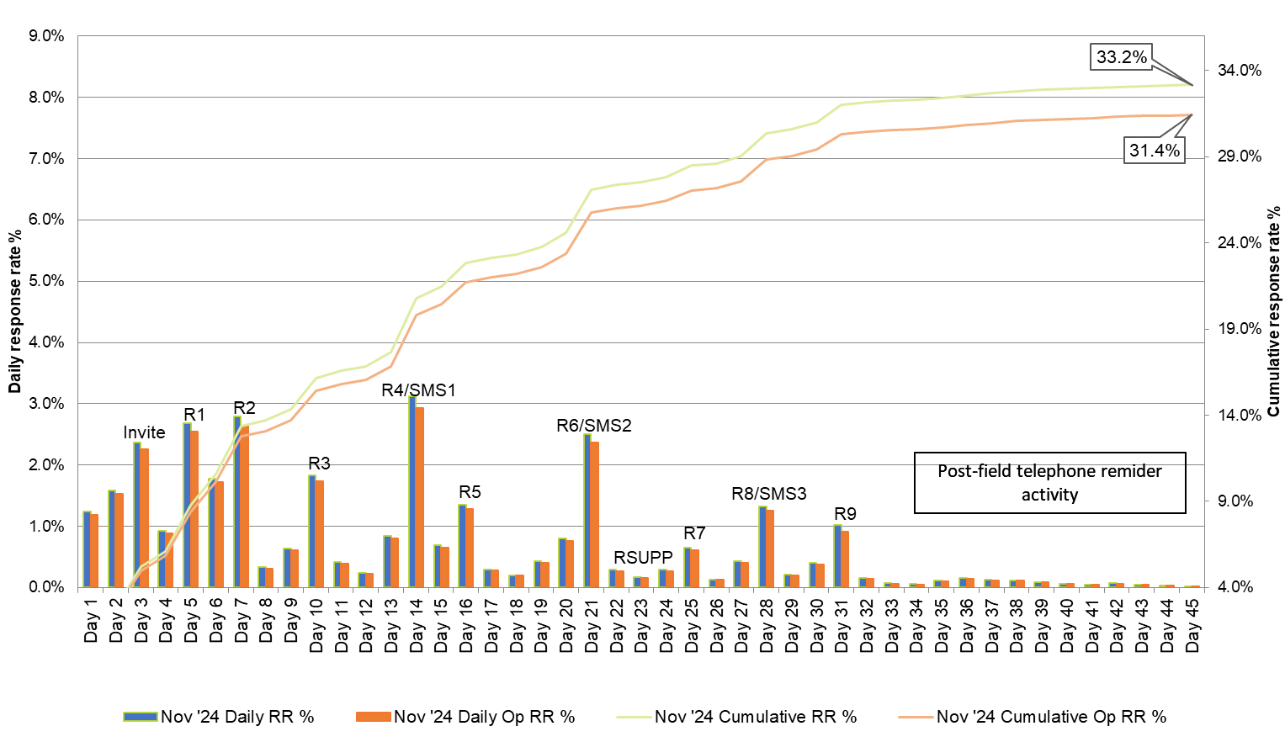

Figure 2 Response rates by date – February 2025
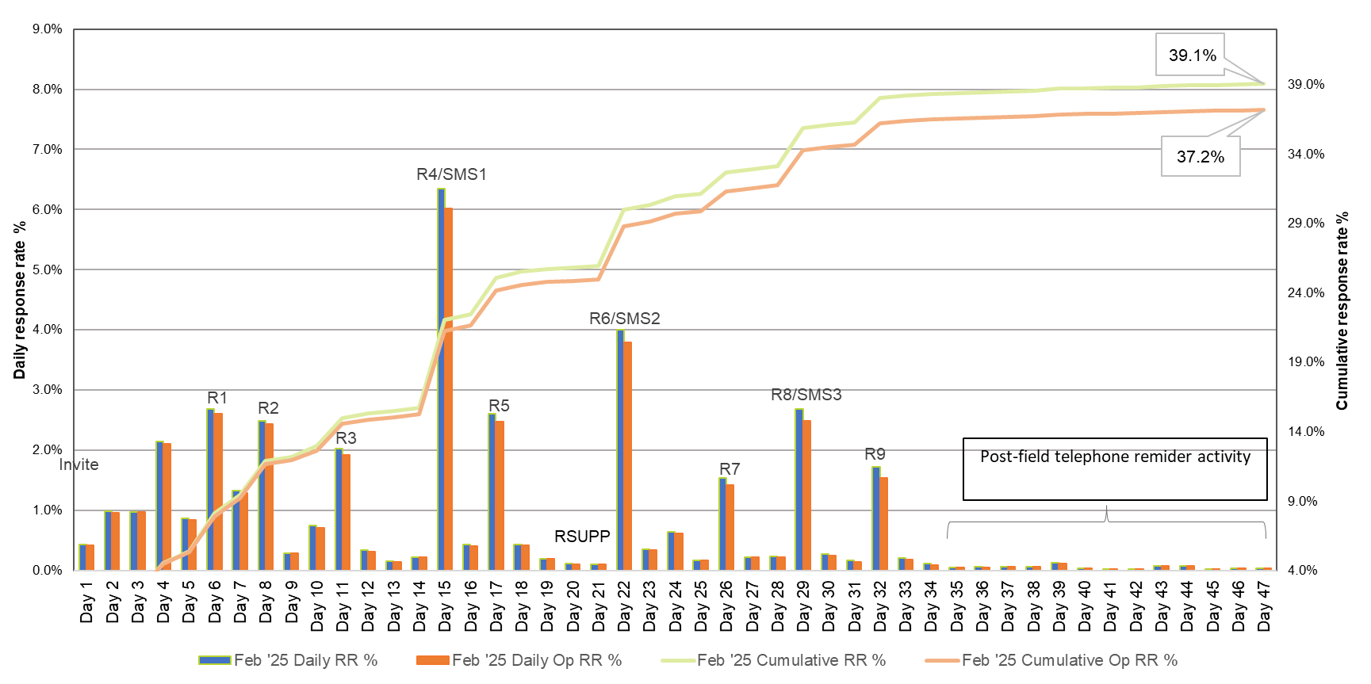
RSUPP in Figure 1 and Figure 2 refer to supplementary email reminder sent in the middle of fieldwork to boost response.
Figure 3 Response rates by date – May 2025
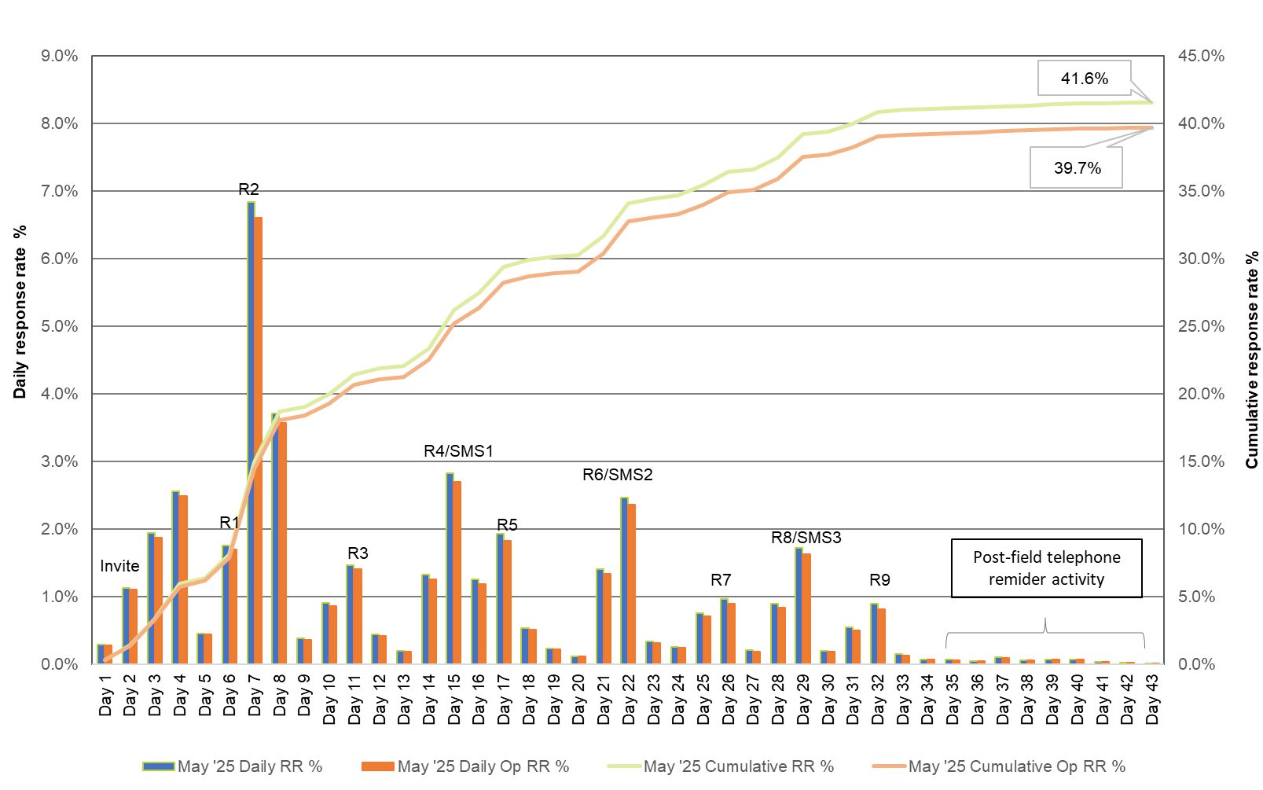

Operational response
It was observed that the gap between operational and technical response rates has been widening over recent years (see Section 5.1). While technical response rates have remained relatively strong, operational completion rates have not followed the same trend, as shown in Table 17.

Table 17 2025 GOS technical and operational response rates by collection round
Collection round | Technical  response rate  (%) | Operational response rate  (%) | Difference  (%)
2025 November | 33.2 | 37.1 | 36.6
2025 February | 24.4 | 28.7 | 27.5
2025 May | 39.1 | 38.6 | 39.5
2024 November | 29.8 | 29.7 | 31.8
2024 February | 41.6 | 38.7 | 39.9
2024 May | 31.5 | 30.8 | 32.4
2023 November | 33.2 | 37.1 | 36.6
2023 February | 24.4 | 28.7 | 27.5
2023 May | 39.1 | 38.6 | 39.5
This widening gap suggests that more respondents are starting the survey but not completing it in full. Survey breakoff analysis showed that graduates are most likely to drop off at Module B, particularly at questions that require recall of specific information (e.g. exact income figures or detailed descriptions of duties in the graduate’s main job).
Operational completion is important because it ensures respondents complete the entire survey, providing a full set of data for analysis. It also limits the responses to end-of-survey questions such as the ESS bridge which collects employer details for the Employer Satisfaction Survey (ESS), and the future contact questions for the GOS-L (Graduate Outcomes Survey – Longitudinal), thereby affecting the sample available for subsequent QILT surveys. Partial completions limit the ability to analyse certain measures, which reduces the completeness and comparability of the dataset. To address this, refinements should be prioritised for Module B to reduce respondent burden, improve clarity, and support higher operational completion rates (see Section 8).

Data representativeness
This section aims to investigate the extent to which those who responded to the 2025 GOS were representative of the in-scope population and assesses the impact of non-response bias. Non-response bias occurs when the responding population is systematically different from the non-responding population, leading to results that do not accurately reflect the overall population. The following assessment is approached from several perspectives, by:
- identifying administrative characteristics of graduates that are most different between respondents and non-respondents and that are most strongly associated with the propensity to respond to the survey
- determining if adjusting for non-response changes the key GOS indicators.

Characteristics associated with propensity to respond
Response propensity is calculated by predicting survey completion conditional upon the characteristics available for both respondents and non-respondents. Assessment for potential non-response bias is to compare the profile of respondents with that of non-respondents and identify any characteristics in which respondents differ markedly from the population. The respondent characteristics are presented alongside population parameters in Table 18.
Groups with a higher propensity to respond in the 2025 GOS (i.e. groups where the proportion of respondents exceeds the proportion in the in-scope population) were postgraduate research graduates, females, external (including distance education) graduates, those attending part-time, those who mainly speak English at home, domestic residents, graduates who were classified as first in family, and those from low socio-economic areas.
Males were among the groups with a lower propensity to respond in the 2025 GOS – by 3.0 percentage points in comparison to females, though this was similar to prior years of the GOS.
International graduates and those who spoke a language other than English at home also had a lower propensity to respond, with differences to their comparison group of 4.6 and 3.5 percentage points respectively.
Table 18 2025 GOS population parameters by subgroup and response characteristics
Characteristic | In-scope population (n) | In-scope  population (%) | Respondents  (n) | Respondents  (%)
Base | 332,988 | 100.00 | 129,220 | 100.00
Study level  Undergraduate | 172,408 | 51.8 | 66,562 | 51.5
Study level  Postgraduate coursework | 150,954 | 45.3 | 56,637 | 43.8
Study level  Postgraduate research | 9,626 | 2.9 | 6,021 | 4.7
Gender  Male | 133,670 | 40.2 | 47,942 | 37.2
Gender  Female | 198,445 | 59.8 | 80,811 | 62.8
Combined course of study indicator  Combined/double degree | 17,172 | 5.2 | 6,893 | 5.3
Combined course of study indicator  Single degree | 315,816 | 94.8 | 122,327 | 94.7
First Nations  First Nations | 3,769 | 1.1 | 1,674 | 1.3
First Nations  Non-Indigenous | 211,857 | 63.6 | 88,010 | 68.1
Mode of attendance*  Internal/multi-mode | 256,,415 | 79.2 | 96,307 | 76.5
Mode of attendance*  External study mode | 67,485 | 20.8 | 29,504 | 23.5
Type of attendance  Full-time | 242,446 | 74.2 | 90,954 | 71.7
Type of attendance  Part-time | 84,430 | 25.8 | 35,974 | 28.3
Home language****  English | 257,213 | 77.2 | 104,253 | 80.7
Home language****  Other | 75,775 | 22.8 | 24,967 | 19.3
Citizenship status  Domestic | 215,626 | 64.8 | 89,684 | 69.4
Citizenship status  International | 117,362 | 35.2 | 39,536 | 30.6
Disability‡  Disability | 24,646 | 7.4 | 11,515 | 8.9
Disability‡  No disability | 308,342 | 92.6 | 117,705 | 91.1
First in family status**  First in family | 86,825 | 39.0 | 35,205 | 40.4
First in family status**  Not first in family | 135,925 | 61.0 | 51,981 | 59.6
Socio-economic status***  High | 65,609 | 35.4 | 26,453 | 34.2
Socio-economic status***  Medium | 92,661 | 50.0 | 38,809 | 50.2
Socio-economic status***  Low | 27,036 | 14.6 | 12,043 | 15.6
Location*** †  Metropolitan | 149,781 | 45.0 | 60,827 | 47.1
Location*** †  Regional/remote | 35,314 | 10.6 | 16,382 | 12.7
Note: Components may not sum to base number, as records with unknown characteristics are not included in the sub-categories.
* Internal mode of attendance is where (i) the study is undertaken through attendance at the higher education provider on a regular basis, or (ii) for higher degree unit enrolments, where regular attendance is not required but the student attends the higher education provider on an agreed schedule for the purposes of supervision and/or instruction. External mode of attendance is where lesson materials, assignments, etc. are delivered to the student, and any associated attendance at the institution is of an incidental, irregular, special or voluntary nature. Mixed mode of attendance is where study is undertaken partially on an internal mode of attendance and partially on an external mode of attendance.
** First in family refers to the graduate attaining a bachelor degree level qualification when their parent(s) or guardian(s) have not. Based on the highest level of educational attainment of a student’s parent(s) or guardian(s) as identified by the student. This information is reported by institutions through the Tertiary Collection of Student Information (TCSI) system.
*** Socio-economic status (SES) and location measures are area-based, associated with students’ first permanent home address submitted when they commenced with their provider, as collected through the TCSI system. The SES is based on the ABS SEIFA Index of Education and Occupation.
**** Home language other than English refers to graduates who arrived in Australia less than 10 years prior to the year in which the data was collected, and comes from a home where a language other than English is spoken. This information is reported by institutions through the TCSI system.
‡ Disability information is reported by institutions through the Tertiary Collection of Student Information (TCSI) system, reflecting a disability, impairment or long-term condition which may affect a graduate’s studies.
† Location measures are calculated according to the proportion of metro and regional/remote categories.

In terms of study area, the achieved respondent profile closely matched the population in 2025 (Table 19). Graduates with a higher propensity to respond were from the study areas of Science and mathematics, and Humanities, culture and social sciences. Graduates from Business and management continued to show the lowest propensity to respond, followed by Law and paralegal studies.
Table 19 2025 GOS population parameters by study area and response characteristics
Study area | In-scope population (n) | In-scope  population (%) | Respondents  (n) | Respondents  (%)
Agriculture and environmental studies | 4,239 | 1.3 | 2,133 | 1.7
Architecture and built environment | 8,312 | 2.5 | 2,951 | 2.3
Business and management | 72,613 | 21.8 | 22,931 | 17.7
Communications | 8,135 | 2.4 | 2,820 | 2.2
Computing and information systems | 27,065 | 8.1 | 10,332 | 8.0
Creative arts | 9,791 | 2.9 | 3,866 | 3.0
Dentistry | 1,064 | 0.3 | 386 | 0.3
Engineering | 18,851 | 5.7 | 7,647 | 5.9
Health services and support | 21,710 | 6.5 | 9,425 | 7.3
Humanities, culture and social sciences | 21,878 | 6.6 | 9,968 | 7.7
Law and paralegal studies | 16,456 | 4.9 | 5,653 | 4.4
Medicine | 5,792 | 1.7 | 2,009 | 1.6
Nursing | 28,562 | 8.6 | 11,734 | 9.1
Pharmacy | 2,069 | 0.6 | 807 | 0.6
Psychology | 13,480 | 4.0 | 6,030 | 4.7
Rehabilitation | 4,452 | 1.3 | 1,523 | 1.2
Science and mathematics | 25,732 | 7.7 | 11,536 | 8.9
Social work | 9,237 | 2.8 | 4,317 | 3.3
Teacher education | 31,855 | 9.6 | 12,466 | 9.6
Tourism, hospitality, personal services, sport and recreation | 672 | 0.2 | 223 | 0.2
Veterinary science | 1,023 | 0.3 | 463 | 0.4
Total | 332,988 | 100.0 | 129,220 | 100.0

Characteristic differences between respondents and population
To quantify how each of these characteristics differ between respondents and population, Table 20 presents the difference in proportions between respondents and population in percentage points. Differences across sub-groups can vary, with some characteristics matching the population more closely than others. A negative difference means the sub-group was under-represented among respondents compared to population, whereas a positive difference means the sub-group was over-represented. Where the respondents perfectly mirror the population, all the differences would be zero.
Table 20 Comparison between selected characteristics for respondents and population
Characteristic | Population  (%) | Respondents  (%) | Difference  (%)
Study level  Undergraduate | 51.8 | 51.5 | -0.3
Study level  Postgraduate coursework | 45.3 | 43.8 | -1.4
Study level  Postgraduate research | 2.9 | 4.7 | 1.8
Age  15-19 years | 1.5 | 1.5 | 0.0
Age  20-24 years | 46.6 | 40.0 | -6.6
Age  25-29 years | 23.5 | 20.8 | -2.6
Age  30-34 years | 10.3 | 12.3 | 1.9
Age  35-39 years | 6.7 | 8.5 | 1.8
Age  40-44 years | 4.6 | 6.3 | 1.7
Age  45-49 years | 2.9 | 4.3 | 1.3
Age  50-54 years | 2.0 | 3.0 | 1.1
Age  55+ years | 1.8 | 3.3 | 1.4
Gender  Female | 59.6 | 62.5 | 2.9
Gender  Male | 40.1 | 37.1 | -3.0
Gender  Indeterminate/Intersex/Unspecified | 0.3 | 0.4 | 0.1
First Nations  Non-indigenous | 98.9 | 98.7 | -0.2
First Nations  First Nations | 1.1 | 1.3 | 0.2
Mode of attendance  Internal study mode | 51.9 | 49.4 | -2.5
Mode of attendance  External study mode | 20.2 | 22.7 | 2.5
Mode of attendance  Multi-modal study mode | 25.1 | 25.2 | 0.0
Mode of attendance  Other | 2.8 | 2.8 | -0.1
Type of attendance  Full-time | 72.8 | 70.4 | -2.4
Type of attendance  Part-time | 25.4 | 27.8 | 2.5
Type of attendance  No information | 1.8 | 1.8 | -0.1
Disability  No disability | 92.6 | 91.1 | -1.5
Disability  Disability | 7.4 | 8.9 | 1.5
Home language  English | 77.3 | 80.7 | 3.4
Home language  Other | 22.7 | 19.3 | -3.4
Citizenship status  Domestic | 64.9 | 69.4 | 4.5
Citizenship status  International | 35.1 | 30.6 | -4.5
Source country  Australia | 64.9 | 69.4 | 4.5
Source country  China (excludes SARs and Taiwan) | 13.5 | 6.9 | -6.6
Source country  India | 5.3 | 5.5 | 0.2
Source country  Nepal | 2.6 | 3.0 | 0.4
Source country  Vietnam | 1.4 | 1.3 | -0.1
Source country  Sri Lanka | 0.9 | 1.1 | 0.1
Source country  Bhutan | 0.7 | 1.2 | 0.4
Source country  Pakistan | 0.6 | 0.6 | 0.0
Source country  Indonesia | 1.0 | 1.0 | 0.0
Source country  Bangladesh | 0.5 | 0.6 | 0.1
Source country  Hong Kong (SAR of China) | 0.9 | 0.9 | 0.1
Source country  Other or unknown | 7.6 | 8.6 | 1.0
Country of birth  Australia | 47.6 | 50.3 | 2.8
Country of birth  Other English-speaking | 5.0 | 5.7 | 0.7
Country of birth  Non-English-speaking | 46.9 | 43.3 | -3.5
Country of birth  Unable to establish | 0.6 | 0.7 | 0.1
Study area  Agriculture and environmental studies | 1.3 | 1.7 | 0.4
Study area  Architecture and built environment | 2.5 | 2.3 | -0.2
Study area  Business and management | 21.8 | 17.7 | -4.0
Study area  Communications | 2.4 | 2.2 | -0.3
Study area  Computing and information systems | 8.1 | 8.0 | -0.1
Study area  Creative arts | 2.9 | 3.0 | 0.0
Study area  Dentistry | 0.3 | 0.3 | 0.0
Study area  Engineering | 5.7 | 5.9 | 0.3
Study area  Health services and support | 6.5 | 7.3 | 0.8
Study area  Humanities, culture and social sciences | 6.6 | 7.7 | 1.1
Study area  Law and paralegal studies | 4.9 | 4.4 | -0.6
Study area  Medicine | 1.7 | 1.6 | -0.2
Study area  Nursing | 8.6 | 9.1 | 0.5
Study area  Pharmacy | 0.6 | 0.6 | 0.0
Study area  Psychology | 4.0 | 4.7 | 0.6
Study area  Rehabilitation | 1.3 | 1.2 | -0.2
Study area  Science and mathematics | 7.7 | 8.9 | 1.2
Study area  Social work | 2.8 | 3.3 | 0.6
Study area  Teacher education | 9.6 | 9.6 | 0.1
Study area  Tourism, hospitality, personal services, sport and recreation | 0.2 | 0.2 | 0.0
Study area  Veterinary science | 0.3 | 0.4 | 0.0
Institution size  1-2,500 records | 9.0 | 9.6 | 0.6
Institution size  2,501-5,500 records | 13.6 | 15.6 | 2.0
Institution size  5,501-7,500 records | 26.3 | 26.4 | 0.1
Institution size  7,501-10,500 records | 16.7 | 17.8 | 1.1
Institution size  10,501+ records | 34.3 | 30.6 | -3.7
Institution type  Group of 8 | 33.0 | 28.9 | -4.0
Institution type  NUHEI | 58.8 | 62.9 | 4.0
Institution type  Other university | 8.2 | 8.2 | 0.0

Table 21 summarises the discrepancy for selected characteristics, the average and maximum absolute difference in percent between respondents and population. The characteristics with the highest average absolute bias being citizenship status at 4.5 percentage points, and the highest maximum bias being age and source country at 6.6 percentage points respectively.
Table 21 Average absolute bias (AAB) and maximum absolute bias (MAB) for selected characteristics sorted by descending AAB
Characteristic | Average absolute bias (pp) | Maximum absolute bias (pp)
Citizenship status | 4.5 | 4.5
Home language | 3.4 | 3.4
Institution type | 2.7 | 4.0
Gender | 2.0 | 3.0
Age | 1.9 | 6.6
Country of birth | 1.8 | 3.5
Type of attendance | 1.6 | 2.5
Disability | 1.5 | 1.5
Institution size | 1.5 | 3.7
Mode of attendance | 1.3 | 2.5
Study level | 1.2 | 1.8
Source country | 1.1 | 6.6
Study area | 0.5 | 4.0
First Nations | 0.2 | 0.2

Adjusting for non-response
Although the composition of respondents versus population revealed relatively small imbalances in representation, it is useful to assess whether adjusting for non-response would change the key GOS indicators in any meaningful way. A common technique to adjust for differences between survey respondents and the population of interest is the calculation of ‘weights’. These are values derived for respondents to denote how much each should ‘count’ towards survey results.
Persons that are under-represented among respondents (for example, males) are assigned a higher weight so that their contribution to the survey results correctly reflects their representation in the population. In a similar way, persons that are over-represented among respondents (for example, females) receive a lower weight. Scientifically balancing the extent to which respondents contribute to survey results, some more and some less, ensures that the results of the survey represent the student population as closely as possible. This is a very common approach to deriving estimates from a subset of the population and is used the world over by official statistics agencies such as the ABS.
On the basis of the characteristics that were most different between respondents and the population, a weight was calculated for each responding student to account for imbalances. Along with the top four characteristics with the largest average absolute bias between respondents and population, highest education provider was also included in weighting, to ensure that weights add to provider size, leading to the following selection of weighting characteristics: gender, home language, citizenship status, and institution type.
Table 22 compares overall results for the key GOS indicators, using both simple counting of respondents along with summing of their weights. Note that figures presented in this table may not match those reported elsewhere, as they are intended to illustrate the effect of weighting on the full responding dataset. Also included is the percentage point difference between the two methods, where a negative difference shows that the adjusted (weighted) calculation yielded a higher value for the indicator than the unadjusted calculation, and a positive value shows that the unadjusted calculation yielded a higher value than the adjusted calculation. An asterisk is used to note rows where the difference is considered statistically significantly different from zero.
Although the majority of the differences are considered statistically significant, the magnitude of differences are all less than 1.6 percentage points, which is only a small difference to the key indicators. Thus, although there are minor discrepancies in characteristics between respondents and population, the non-response bias does not highly misrepresent results for the population of interest.
Table 22 Comparison of weighted and unweighted indicators (graduate level)
Key indicator | Counting graduates (%) | Summing weights (%) | Difference (%)
Scale of Perceived Over-qualification (SPOQ) indicator – positive response Overall | 38.2 | 38.1 | 0.2*
Scale of Perceived Over-qualification (SPOQ) indicator – positive response Undergraduate | 40.6 | 40.7 | -0.2*
Scale of Perceived Over-qualification (SPOQ) indicator – positive response Postgraduate coursework | 36.6 | 36.7 | 0
Scale of Perceived Over-qualification (SPOQ) indicator – positive response Postgraduate research | 28.2 | 27.6 | 0.6*
General employment indicator – positive response  Overall | 73.3 | 72.4 | 1.1*
General employment indicator – positive response  Undergraduate | 71.7 | 70.8 | 1.6*
General employment indicator – positive response  Postgraduate coursework | 74.4 | 73.4 | 1*
General employment indicator – positive response  Postgraduate research | 80.0 | 79.7 | 0.3*
Part-time employment indicator – positive response  Overall | 25.8 | 25.1 | 0.6*
Part-time employment indicator – positive response  Undergraduate | 29.3 | 28.9 | 0
Part-time employment indicator – positive response  Postgraduate coursework | 22.3 | 21.6 | 0.7*
Part-time employment indicator – positive response  Postgraduate research | 18.5 | 18.2 | 0.3*
Full-time employment indicator – positive response  Overall | 47.5 | 47.2 | 0.5*
Full-time employment indicator – positive response  Undergraduate | 42.4 | 41.8 | 1.6*
Full-time employment indicator – positive response  Postgraduate coursework | 52.1 | 51.8 | 0.3*
Full-time employment indicator – positive response  Postgraduate research | 61.4 | 61.5 | -0.1

Sources of response
Table 23 summaries the breakdown of online survey completion methods and includes sources of response by gender, age, and citizenship due to the variation in method of accessing the survey within these groups. As only minimal differences were observed when reviewing source of response by institution type or course level, these groups are not displayed.
Survey completion via the direct link in email communications was most popular for all sub-groups. Completing via the direct link in SMS was the next most popular method of response amongst most sub-groups. Completion via SMS was marginally more likely among undergraduates, external and domestic graduates.
In-field reminder calls were targeted at international graduates in the 2025 GOS in continued support of the International Engagement Strategy, which accounts for the high proportion of international graduates responding via this contact method. The authentication source of response, which represents graduates who accessed the survey via the QILT website, accounted for around one per cent of total response.
Table 23 Sources of response
 | Total  (%) | Study level Undergraduate  (%) | Study level Postgraduate  (%) | Mode of attendance Internal  /multi-mode  (%) | Mode of attendance External  (%) | Citizenship indicator Domestic  (%) | Citizenship indicator International  (%)
Final response rate | 38.8 | 38.6 | 39.0 | 37.6 | 43.7 | 41.6 | 33.7
Authentication | 1.1 | 1.2 | 1.0 | 0.3 | 0.4 | 1.2 | 1.0
Type in | <0.1 | <0.1 | <0.1 | 1.0 | 0.2 | <0.1 | <0.1
Survey link (email) | 88.0 | 87.5 | 88.5 | 87.7 | 88.8 | 88.2 | 87.5
Survey link (SMS) | 6.9 | 7.4 | 6.3 | 6.6 | 7.7 | 7.7 | 5.1
In-field reminder calls | 2.4 | 2.3 | 2.5 | 2.3 | 3.0 | 1.2 | 5.0
Post-field reminder calls | 0.9 | 0.9 | 0.9 | 0.9 | 0.9 | 1.0 | 0.8
SMS fee-for-service | 0.7 | 0.6 | 0.8 | 0.7 | 0.7 | 0.7 | 0.6
It should be noted that only completed surveys directly attributable to the in-field reminder calls, post-field reminder calls and SMS are recorded as such in Table 17. It is possible that, for example, reminder call activity may prompt a graduate to click on the direct survey link in an email they had previously received. In this context, the analysis presented should only be considered indicative. It should also be noted that the opportunity to complete via each method was not necessarily equal between sub-groups.

Sample retention for GOS-L
Graduates were generally open to being contacted for future research across all 2025 GOS collection rounds, which is the point at which the sample is built for the Graduate Outcomes Survey – Longitudinal (GOS-L).
As shown in Table 19, a total of 71,867 graduates, or more than half (54.4 per cent) of all GOS completes, agreed to be contacted for future research purposes. This level of agreement improved in 2025 compared to 2024 (53.1 per cent). Improved understanding of factors correlated with consent to recontact should remain an area of interest to achieve further growth of the GOS-L sample base.
Table 24 Graduate responses to further contact for GOS-L
Sample retention phase | Collection round  2024 November (n) | Collection round  2024 November (%) | Collection round  2025 February | Collection round  2025 February | Collection round  2025 May (n) | Collection round  2025 May (%) | Collection round  Total (n) | Collection round  Total (%)
Consent to contact at GOS-L  Yes | 18,938 | 54.2 | 6,934 | 55.8 | 45,995 | 54.3 | 71,867 | 54.4
Consent to contact at GOS-L  No | 6,635 | 19.0 | 2,480 | 20.0 | 18,165 | 21.4 | 27,280 | 20.6
Consent to contact at GOS-L  Missing | 9,395 | 26.9 | 3,009 | 24.2 | 20,571 | 24.3 | 32,975 | 25.0
Consent to contact at GOS-L  Total | 34,968 | 100.0 | 12,423 | 100.0 | 84,731 | 100.0 | 132,122 | 100.0
Details provided for GOS-L sample  Email address provided | 18,861 | 87.2 | 6,806 | 86.4 | 45,087 | 85.6 | 70,754 | 86.1
Details provided for GOS-L sample  Do not wish to be re- contacted by email | 2,277 | 10.5 | 883 | 11.2 | 6,348 | 12.1 | 9,508 | 11.6
Details provided for GOS-L sample Missing | 495 | 2.3 | 185 | 2.3 | 1,240 | 2.4 | 1,920 | 2.3
Total | 21,633 | 100.0 | 7,874 | 100.0 | 52,675 | 100.0 | 82,182 | 100.0
Note: The responses shown here are raw and derived before data processing in accordance with the definition of the analytic unit is undertaken (refer to Section 5.1), as such total completes will not align to figures presented earlier in the report.

One in four graduates (25.0 per cent) did not provide a response to the ‘consent to future contact’ question, by either choosing not to provide a response or stopping the survey before seeing the ‘consent to future contact’ question.
Refer to the GOS-L Methodological Report series for more information about panel maintenance activity, whereby contact is made with sample members between surveys to maintain an ongoing relationship and build engagement in the lead up to the GOS-L.

Considerations for future surveys
The following recommendations outline specific opportunities to strengthen the survey’s outcomes while maintaining the established foundation.

Review of marketing materials
As outlined in Section 3.1, the 2025 GOS introduced an updated Marketing Pack with contemporary designs for institutions to promote the survey. Following this refresh, a workshop was held with institutions to gather feedback and identify opportunities for further enhancement. Some of these suggestions were implemented in the 2025 SES, with additional refinements planned for the 2026 GOS based on ongoing feedback.
While most institutions expressed satisfaction with the materials, future updates will focus on streamlining content and addressing specific institutional needs. Ongoing dialogue with institutions will ensure the marketing materials continue to be refined and aligned with sector requirements, remaining a valuable tool for graduate (and student) engagement.

Social media engagement
In recent years, social media posts have incorporated direct links to the survey authentication process, successfully increasing graduate authentication and survey participation. The 2025 Marketing Pack refresh included updated social media tiles designed to enhance visual appeal and support these engagement efforts.
To further strengthen brand recognition and awareness, it can be beneficial to explore additional social media platforms and increase posting frequency. Given the younger graduate cohort, Instagram is likely to remain a key platform, alongside potential new channels that align with their social media habits.
Continuing to optimise social media requires a clear understanding of target audiences and their behaviour on different platforms. Leveraging this insight can enable more tailored, engaging content and more effective use of both paid and organic campaigns. Some initial ideas include making greater use of Stories features and short-form videos like Instagram Reels. Future efforts can focus on integrating social media as a stronger call to action, maximising reach, and improving overall engagement.

Response maximisation strategy
As outlined in Section 7.2, the gap between operational and technical response rates has been widening in recent years. While the technical response rate has steadily improved, operational completion rates have not followed the same trend.
To reduce dropout rates and improve operational completion, tailored follow-up strategies for partial completers can be explored, such as customised reminder emails that acknowledge progress and encourage survey resumption. Additional channels, including SMS reminders for technical completers, can also be considered following a cost–benefit assessment.
Addressing known dropout points will be critical, particularly within Module B, where questions requiring detailed recall, such as exact income figures or specific job duties, have higher breakoff rates. Refinements may include simplifying question wording, improving overall flow and offering the option to skip certain questions rather than dropping out, to reduce respondent burden. These targeted changes can help improve operational completion rates while maintaining the quality of the data.

Appendix 1 Participating institutions
Universities provider  code | Institution name | Total Sample (n) Nov ‘24 | Total Sample (n) Feb ‘25 | Total Sample (n) May ‘26 | Total Sample (n) Total
1019 | James Cook University | 694 | 482 | 2,096 | 3,272
1034 | Murdoch University | 858 | 475 | 2,711 | 4,044
1055 | The University of Western Australia | 2,160 | 261 | 4,409 | 6,830
1058 | University of Wollongong | 1,616 | - | 4,664 | 6,280
2154 | Federation University Australia | 813 | 145 | 1,925 | 2,883
2177 | Swinburne University of Technology | 3,317 | - | 5,062 | 8,379
2200 | Central Queensland University | 1,647 | 147 | 2,634 | 4,428
2201 | University of Southern Queensland | 2,048 | - | 2,839 | 4,887
2235 | Edith Cowan University | 2,377 | 658 | 4,055 | 7,090
2236 | Curtin University | 3,002 | - | 6,327 | 9,329
2241 | University of Canberra | 1,352 | - | 2,817 | 4,169
2252 | Avondale University | 13 | 10 | 213 | 236
3001 | Charles Darwin University | 1,031 | 245 | 1,580 | 2,856
3003 | Bond University | 457 | 345 | 635 | 1,437
3004 | Western Sydney University | 3,033 | 665 | 5,640 | 9,338
3005 | Charles Sturt University | 1,839 | 311 | 3,777 | 5,927
3006 | Australian Catholic University | 1,273 | 242 | 5,515 | 7,030
3007 | Victoria University | 3,000 | 1,567 | 4,275 | 8,842
3010 | The University of Adelaide | 2,063 | 544 | 4,772 | 7,379
3013 | University of New South Wales | 4,552 | 5,949 | 9,585 | 20,086
3014 | University of Newcastle | 1,377 | 672 | 4,817 | 6,866
3016 | University of Technology Sydney | 2,978 | 907 | 7,720 | 11,605
3019 | The University of Queensland | 5,214 | 172 | 9,076 | 14,462
3020 | La Trobe University | 2,014 | 477 | 5,770 | 8,261
3025 | Macquarie University | 3,265 | 414 | 5,980 | 9,659
3027 | The University of South Australia | 2,005 | - | 5,318 | 7,323
3029 | Flinders University | 1,377 | 326 | 4,082 | 5,785
3030 | Deakin University | 3,633 | 136 | 9,094 | 12,863
3032 | Griffith University | 2,974 | - | 6,853 | 9,827
3033 | The Australian National University | 2,975 | 274 | 3,825 | 7,074
3034 | RMIT University | 4,109 | 944 | 8,519 | 13,572
3035 | Monash University | 6,350 | 1,234 | 13,060 | 20,644
3036 | The University of Melbourne | 7,079 | 1,502 | 13,887 | 22,468
3038 | Southern Cross University | 1,037 | 1,264 | 1,976 | 4,277
3039 | University of New England | 1,138 | 1,447 | 709 | 3,294
3040 | The University of Sydney | 6,636 | 1,135 | 13,199 | 20,970
3042 | Queensland University of Technology | 3,538 | 627 | 7,351 | 11,516
3043 | University of the Sunshine Coast | 835 | 636 | 1,909 | 3,380
3044 | The University of Notre Dame Australia | 602 | 199 | 871 | 1,672
3045 | University of Tasmania | 2,376 | 367 | 6,598 | 9,341
4331 | University of Divinity | 80 | 57 | 267 | 404
4449 | Torrens University | 1,760 | 1,590 | 2,065 | 5,415
All participating universities |  | 100,497 | 26,426 | 208,477 | 335,400

Non-university higher education institutions provider  code | Institution name | Total Sample (n) Nov ‘24 | Total Sample (n) Feb ‘25 | Total Sample (n) May ‘26 | Total Sample (n) Total
2170 | Marcus Oldham College | - | - | 94 | 94
4332 | Sydney College of Divinity | 392 | - | - | 555
4333 | Christian Heritage College | 2 | - | - | 159
4334 | Tabor College of Higher Education | 26 | 35 | 91 | 152
4335 | Australian College of Theology* | 51 | 237 | 317 | 605
4336 | ACAP University College | 786 | 533 | 32 | 1,351
4337 | Eastern College Australia | - | - | 18 | 18
4338 | Moore Theological College | 10 | - | 114 | 124
4339 | Holmes Institute | 890 | - | 703 | 1,593
4343 | The Australian Institute of Music | 42 | 59 | 100 | 201
4346 | Excelsia University College | 258 | 21 | 454 | 733
4347 | Australian College of Christian Studies | - | - | 2 | 2
4352 | The Australian College of Physical Education | 35 | - | 93 | 128
4359 | The College of Law Limited | 1,717 | 1,623 | 843 | 4,183
4360 | Perth Bible College | <5 | 2 | <5 | 15
4361 | Endeavour College of Natural Health | - | - | 631 | 631
4362 | ICHM | 7 | <5 | 28 | 72
4363 | Melbourne Polytechnic | 56 | 1 | 116 | 173
4366 | Box Hill Institute | 9 | 0 | 62 | 71
4367 | Melbourne Institute of Technology | 275 | - | 401 | 676
4368 | Campion College Australia | - | - | 65 | 65
4371 | SAE University College | 306 | 293 | 25 | 624
4377 | UOW College | 39 | - | - | 39
4381 | International College of Management, Sydney | 162 | 224 | 232 | 618
4382 | The Australian Guild of Music Education | 1 | 1 | 2 | 4
4383 | Holmesglen Institute | 74 | <5 | 120 | 197
4384 | Kaplan Business School | 1,150 | 428 | 1,018 | 2,596
4386 | The Institute of Creative Arts and Technology | 26 | 27 | 56 | 109
4388 | Australian Academy of Music and Performing Arts | 23 | - | 29 | 52
4392 | Gestalt Therapy Brisbane | - | - | 55 | 55
4393 | The MIECAT Institute | 54 | <5 | - | 55
4394 | William Angliss Institute | 34 | - | 46 | 80
4395 | Adelaide Central School of Art | - | - | 35 | 35
4396 | LCI Melbourne | 9 | - | 22 | 43
4401 | Whitehouse Institute of Design, Australia | - | - | 139 | 139
4402 | Leo Cussen Centre for Law | 284 | 254 | 265 | 803
4405 | Australian Institute of Professional Counsellors | - | 58 | - | 132
4407 | Alphacrucis University College | 298 | - | 162 | 460
4411 | Acknowledge Education | 165 | 75 | 444 | 684
4412 | Morling College | - | - | 17 | 17
4419 | National Art School | - | - | 121 | 121
4424 | Kaplan Professional | 525 | 189 | 431 | 1,145
4425 | Australian Institute of Business Pty Ltd | 435 | 269 | 175 | 879
4428 | Nan Tien Institute | 13 | 6 | 6 | 25
4434 | Wentworth Institute of Higher Education | 71 | 2 | <5 | 186
4435 | Australian Institute of Higher Education | - | - | - | 137
4450 | TAFE Queensland | 35 | - | - | 78
4451 | King's Own Institute | 743 | - | 494 | 1,572
4453 | Australasian College of Health and Wellness | 124 | - | 99 | 268
4455 | SP Jain School of Management | 173 | 0 | - | 173
4456 | Asia Pacific International College | 94 | 115 | 178 | 387
4458 | Australian Institute of Management Education & Training | 254 | - | - | 518
4463 | Institute of Health & Management | 76 | 35 | 88 | 199
4464 | Australian College of Nursing | 385 | 35 | 330 | 750
4465 | Sheridan College Inc. | 5 | 0 | 13 | 18
4466 | The Institute of Internal Auditors - Australia | 0 | 5 | 18 | 23
4467 | Polytechnic Institute Australia Pty Ltd | 190 | - | 133 | 509
4469 | Engineering Institute of Technology | 15 | - | 45 | 65
6014 | Governance Institute of Australia | 51 | 0 | 69 | 120
6016 | Institute of Chartered Accountants in Australia | 752 | 691 | - | 1,443
6022 | Academies Australasia Polytechnic Pty Limited | 35 | - | 3 | 76
6042 | Ozford Institute of Higher Education | 1 | - | 20 | 21
6043 | The Cairnmillar Institute | 40 | 7 | - | 234
6045 | ISN Psychology | 41 | - | <5 | 184
6046 | National Institute of Organisation Dynamics Aust | 0 | 0 | 8 | 8
6047 | Higher Education Leadership Institute | 3 | - | - | 9
6048 | Southern Cross Education Institute (Higher Education) | 154 | - | 261 | 496
6049 | The Institute of International Studies (TIIS) | - | - | <5 | <5
6052 | Leaders Institute | 7 | 0 | - | 7
6053 | Australian Chiropractic College Limited | 0 | - | - | 25
6055 | Adelaide Institute of Higher Education | <5 | <5 | <5 | 31
6057 | Universal Higher Education | 0 | 0 | 6 | 6
6060 | Edvantage Institute Australia Pty Ltd | 0 | 7 | 2 | 9
6061 | Sydney Institute of Higher Education | 0 | 14 | - | 14
6063 | Australia Advance Education Group Pty Ltd | - | - | - | 101
6064 | ECA College of Health Sciences | 0 | 42 | 53 | 95
6065 | The Metavision Institute | - | - | <5 | <5
6068 | HEPCo Pty Ltd | 6 | 0 | 34 | 40
7001 | Collarts (Australian College of the Arts) | 21 | - | 244 | 280
7014 | Jazz Music Institute | 0 | 0 | <5 | 12
7025 | CIC Higher Education | 42 | - | - | 93
7035 | Photography Studies College (Melbourne) | 0 | - | 101 | 101
7073 | Chisholm Institute | 34 | - | 52 | 90
7075 | TAFE NSW | 169 | <5 | 237 | 406
7124 | Academy of Information Technology | - | 73 | 69 | 281
7197 | Ikon Institute of Australia | <5 | 0 | 45 | 45
7221 | VIT (Victorian Institute of Technology) | - | - | 485 | 659
7262 | Equals International | - | - | 6 | 12
7334 | Performing Arts Education | - | - | 9 | 14
7338 | TAFE South Australia | - | - | 17 | 65
7454 | Stanley College | - | - | - | 12
7660 | Health Education & Training Institute | - | - | 21 | 39
7749 | Crown Institute of Higher Education Pty Ltd | - | - | 95 | 95
8119 | Lyons College | - | - | 5 | 5
All participating NUHEIs |  | 12,249 | 6,433 | 11,877 | 30,559

Appendix 2 Contact protocol
Example GOS survey invitation email (default) – desktop
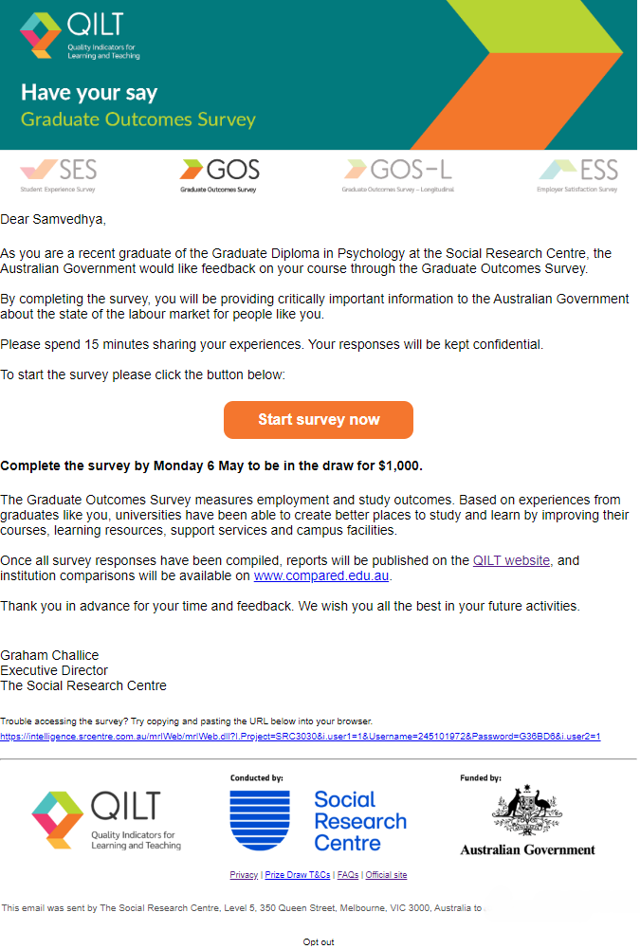

Example GOS survey invitation email (international) – desktop
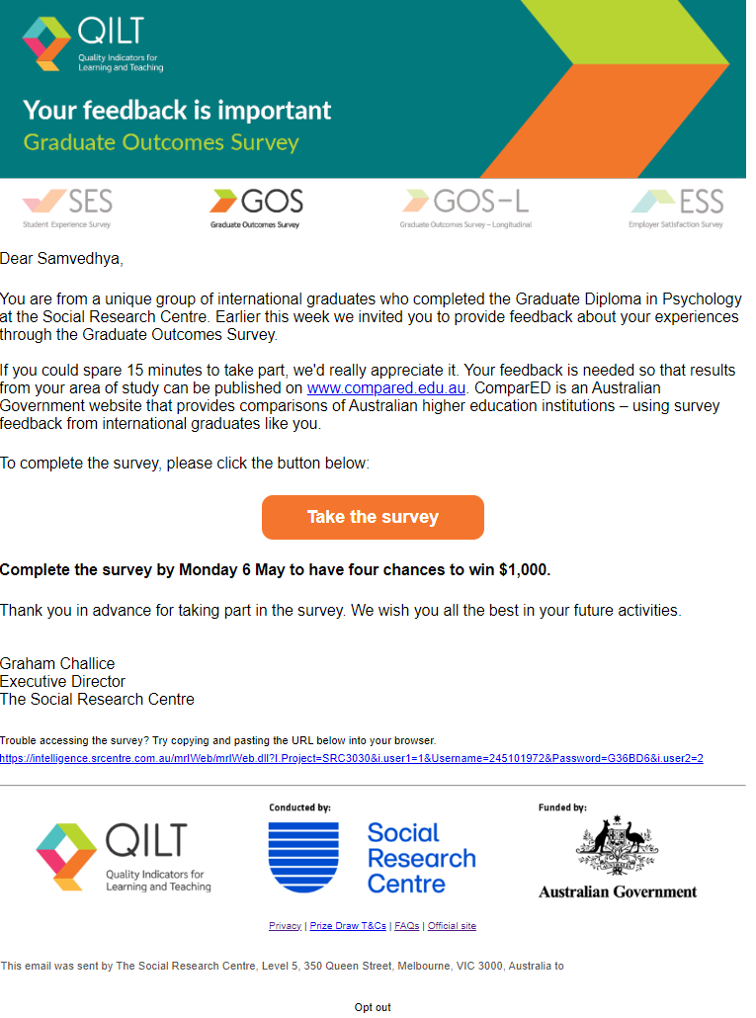

Example GOS survey invitation email – mobile
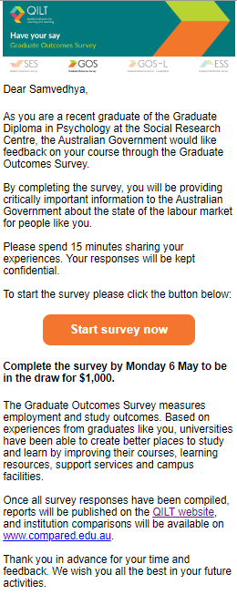

Example SMS content
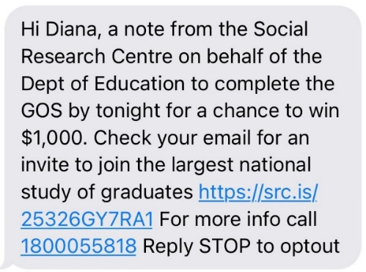

Example social media advertisement – Facebook news feed


Example landing page with authentication


Appendix 3 Core questionnaire
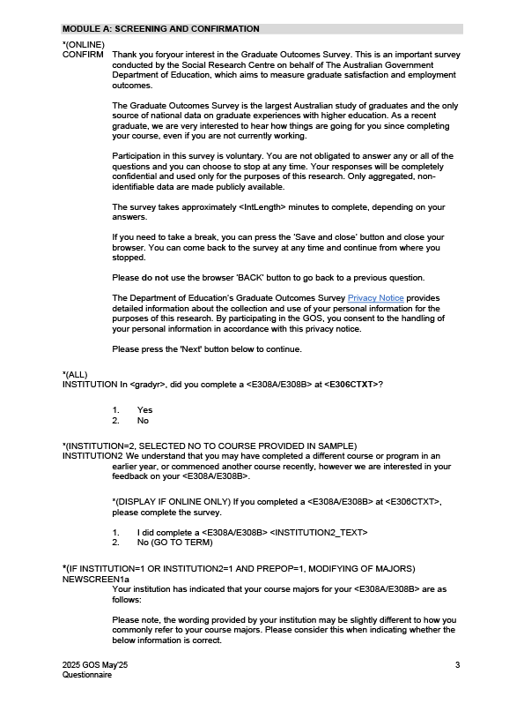
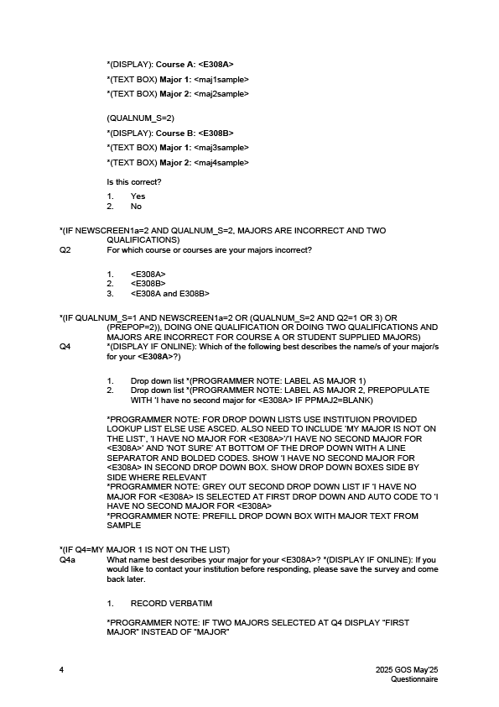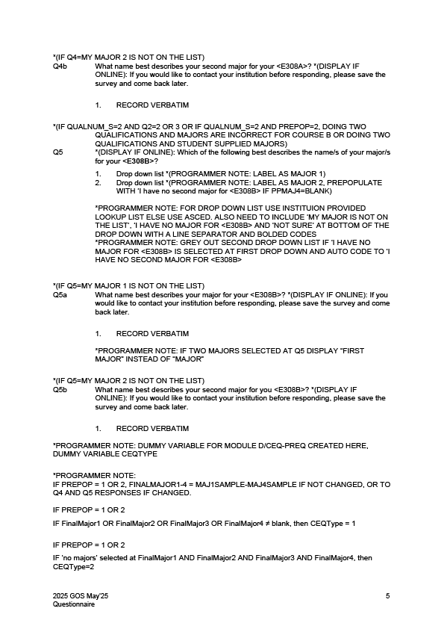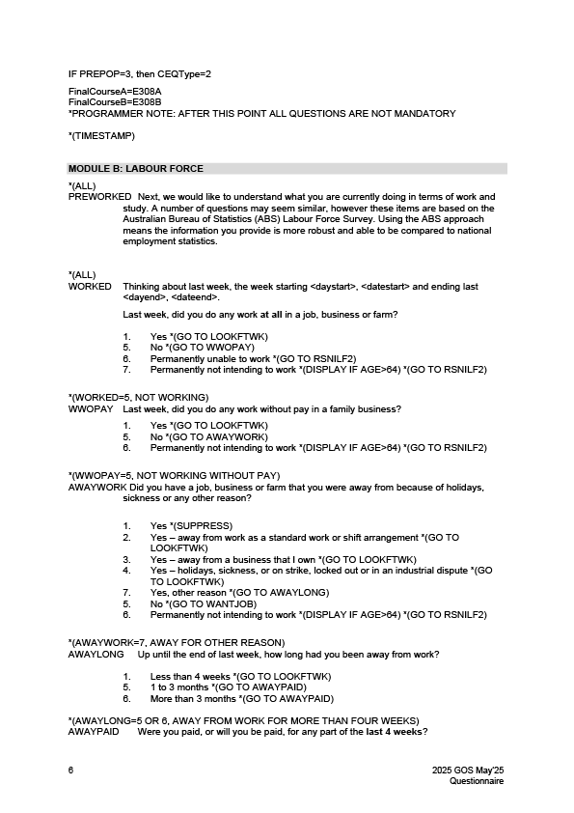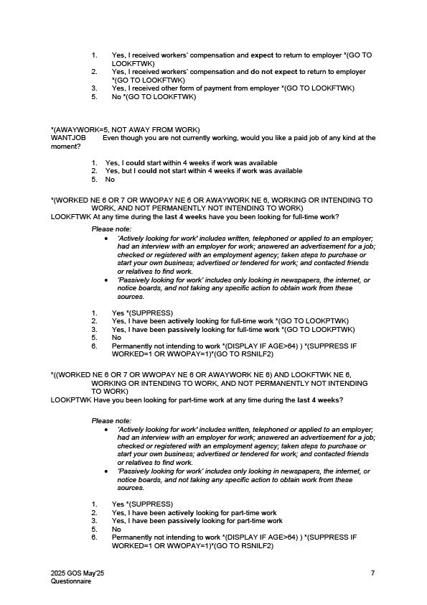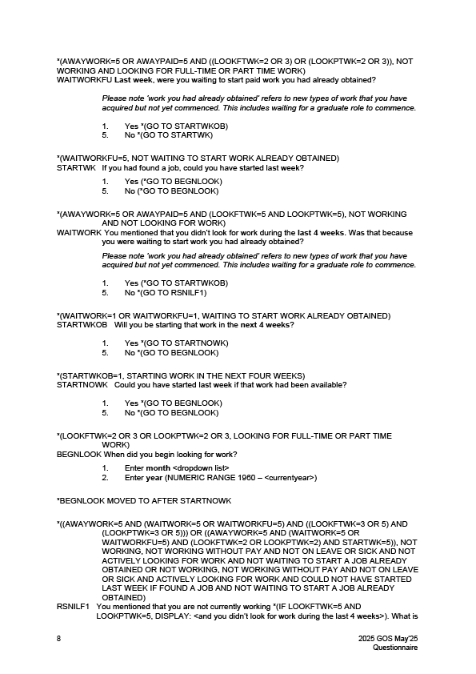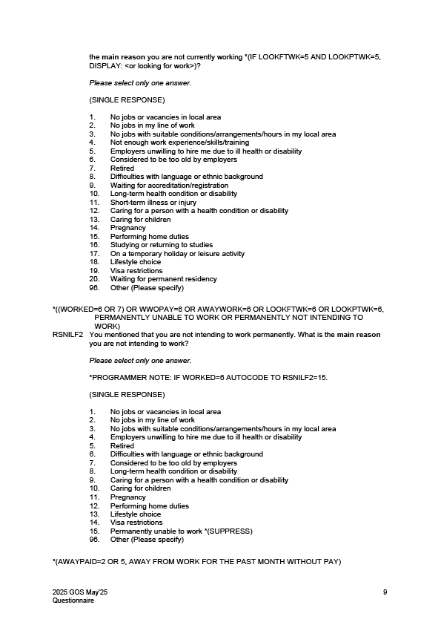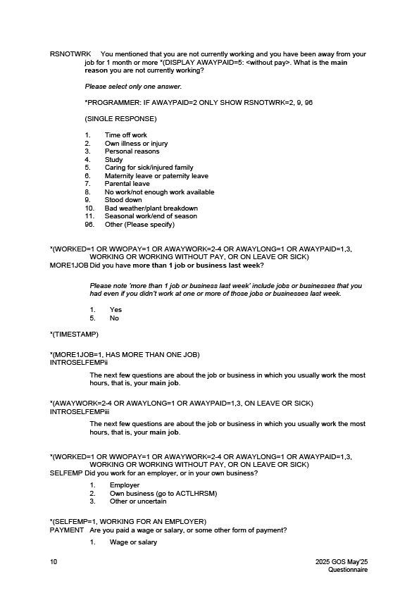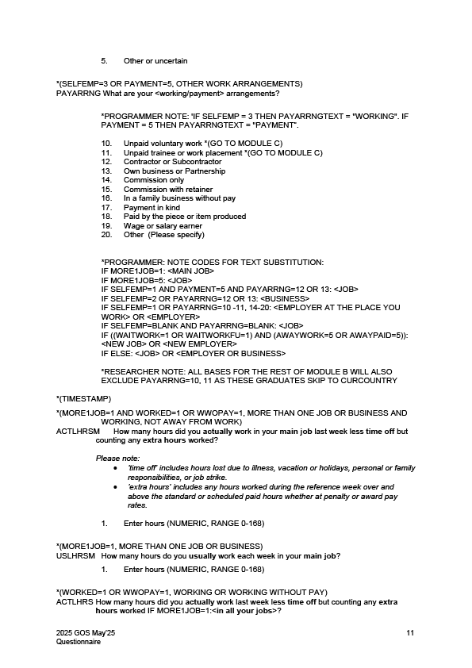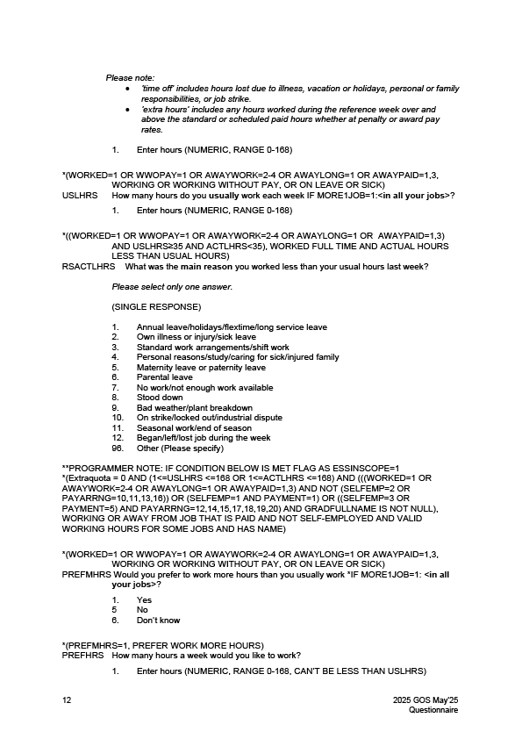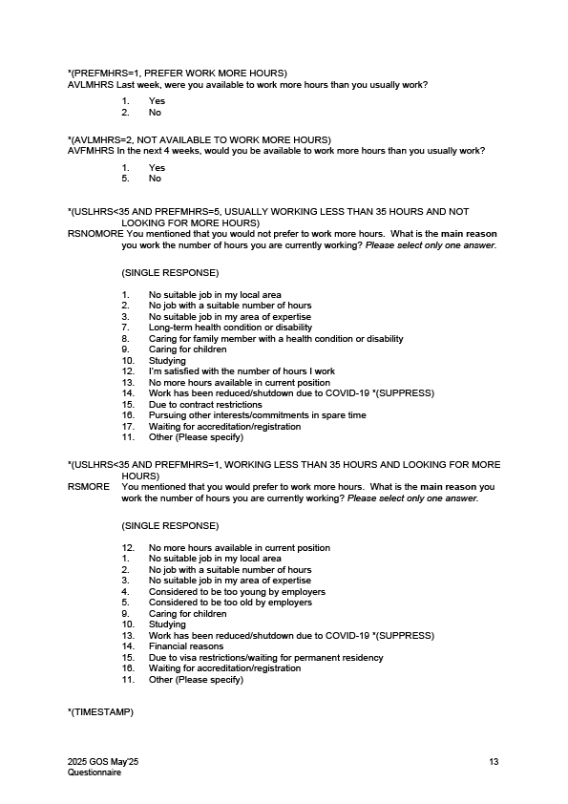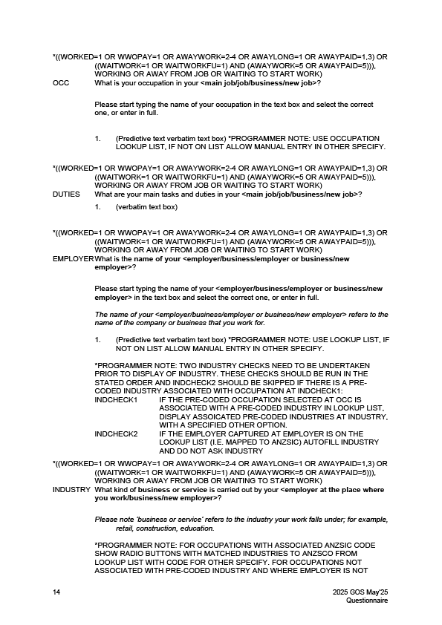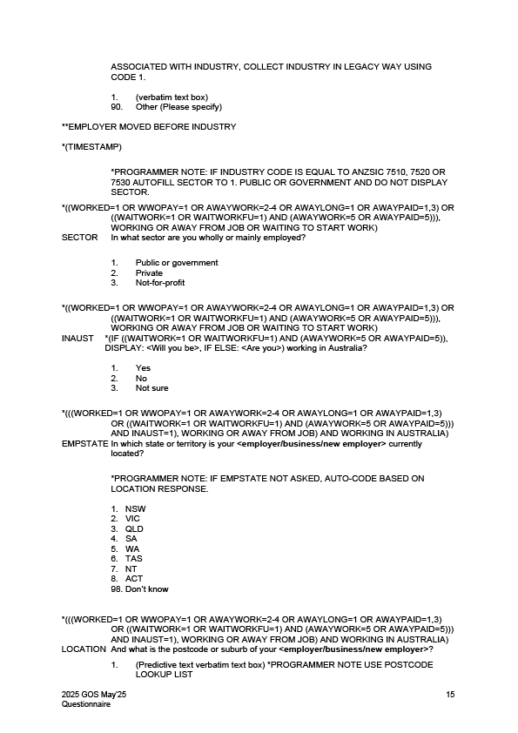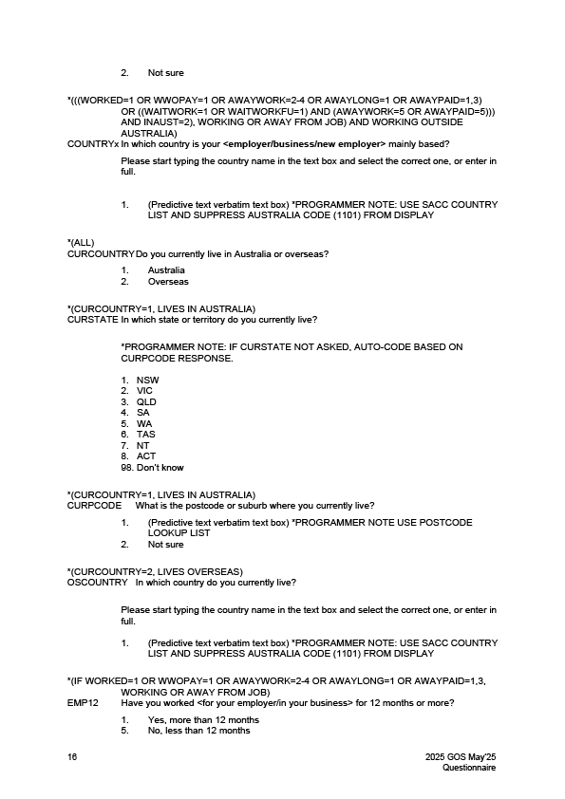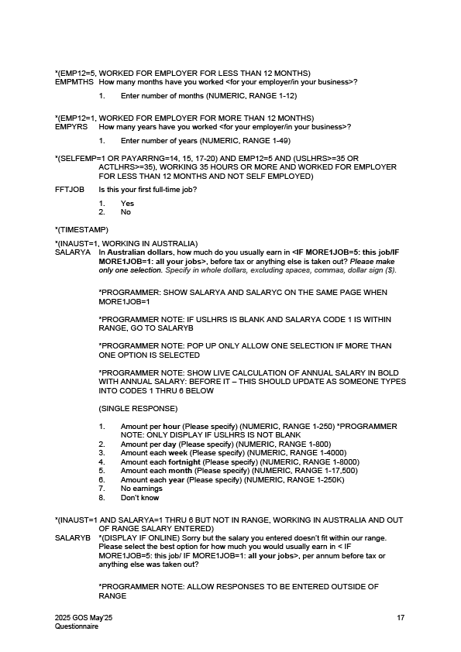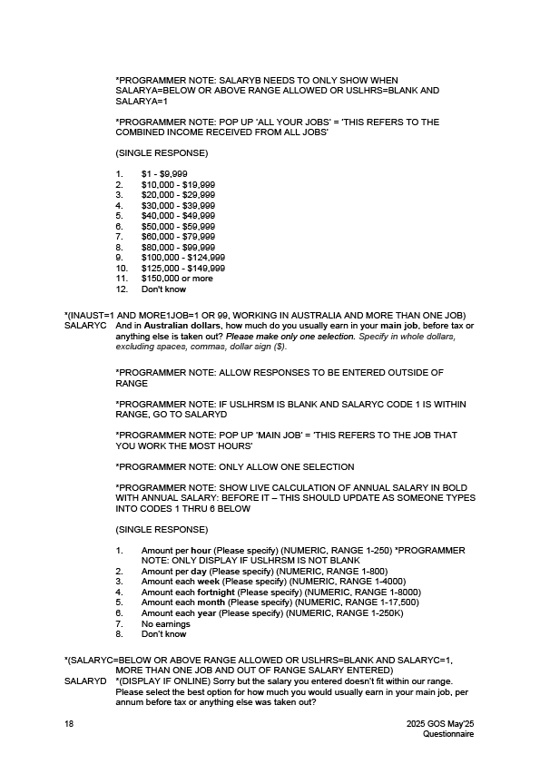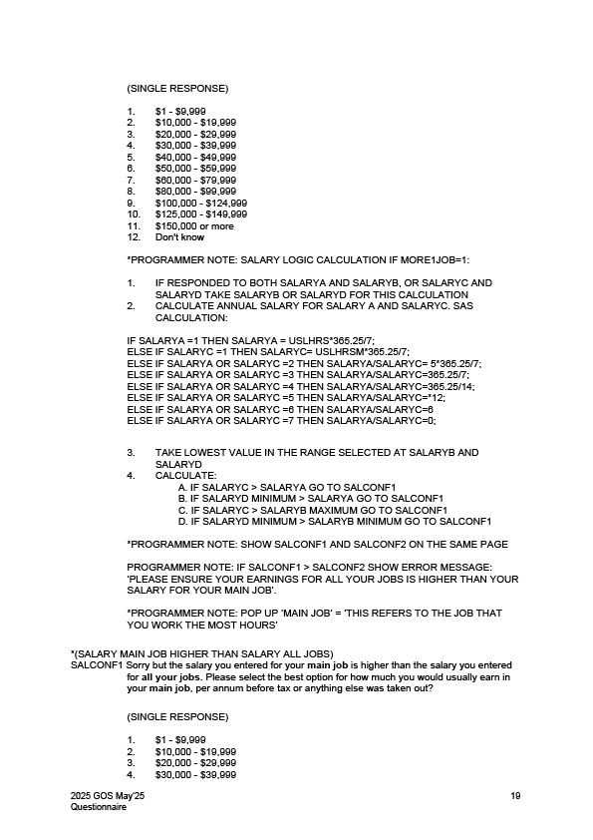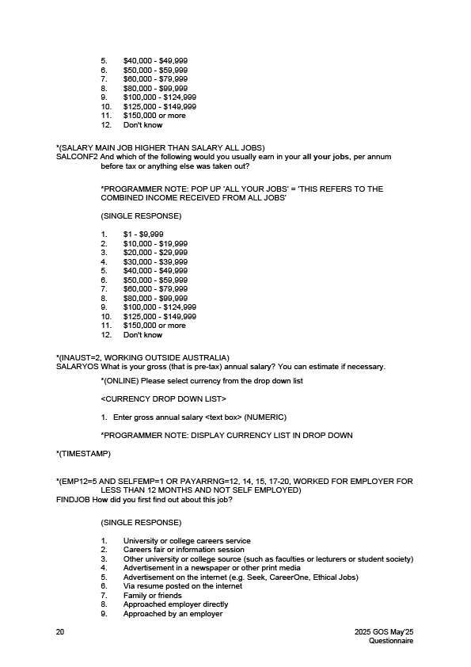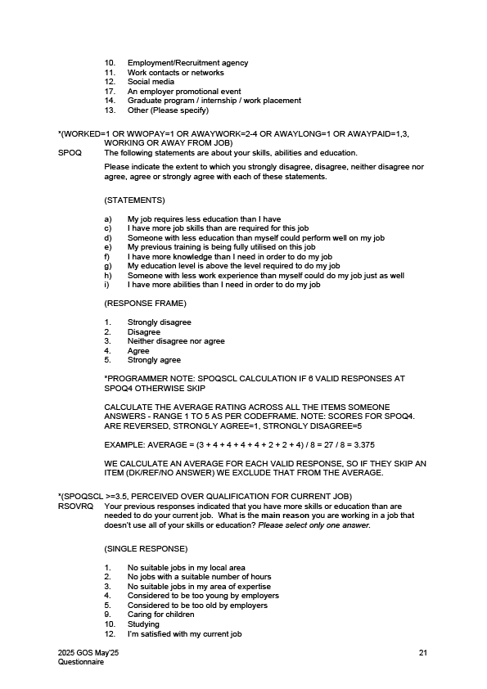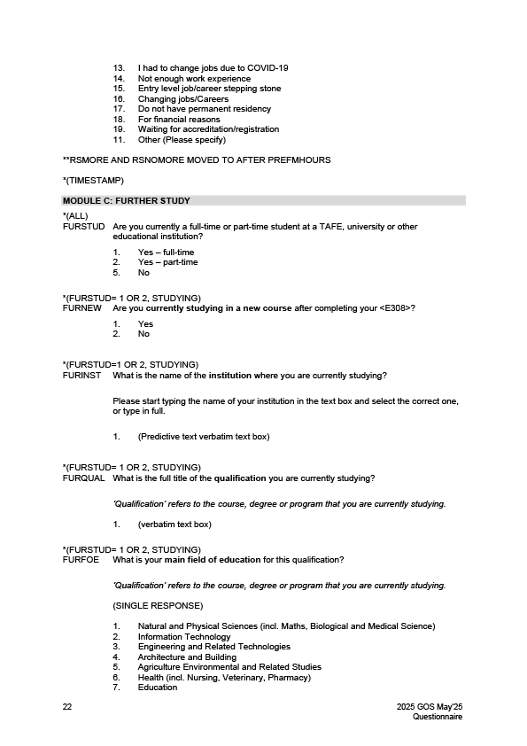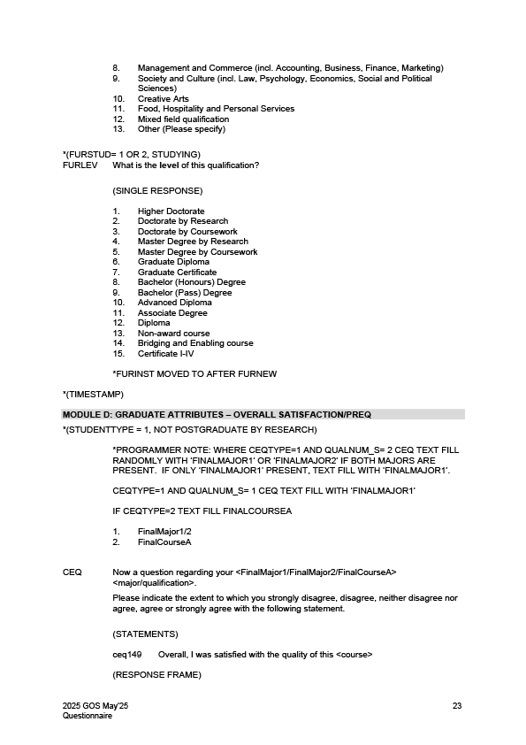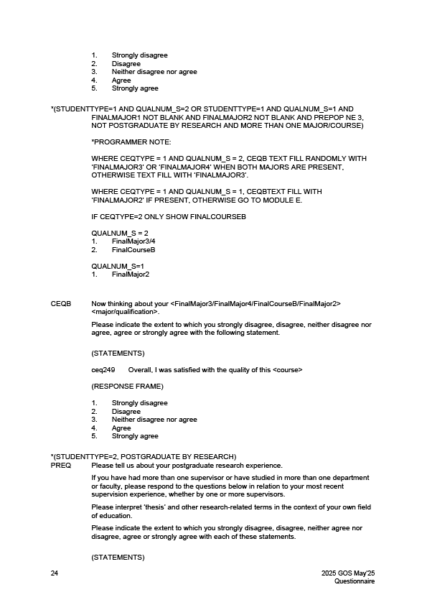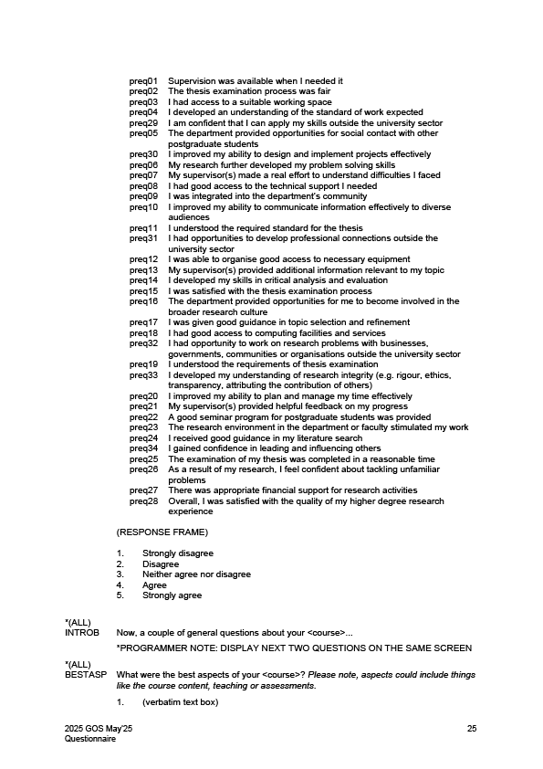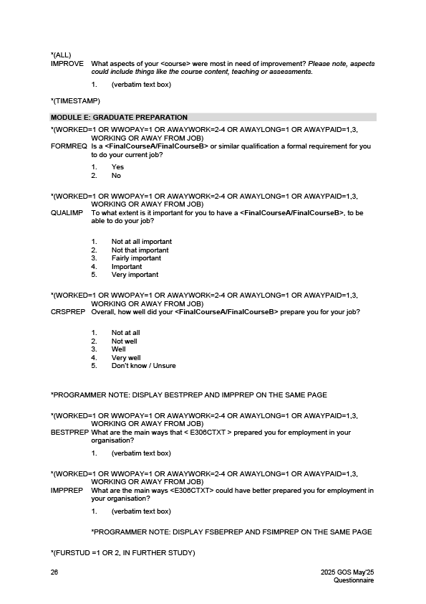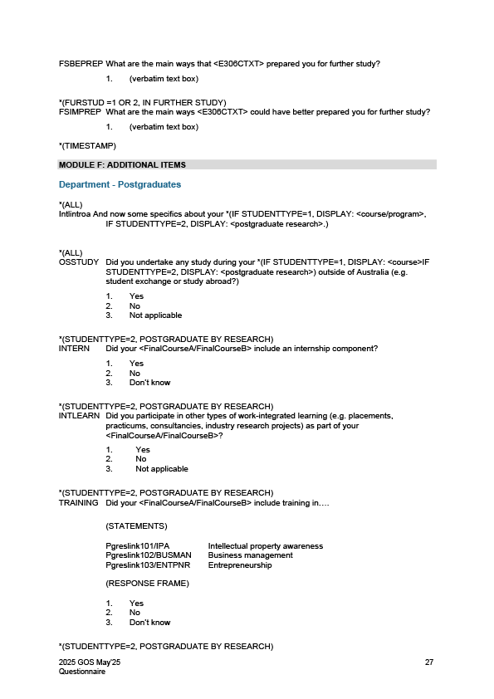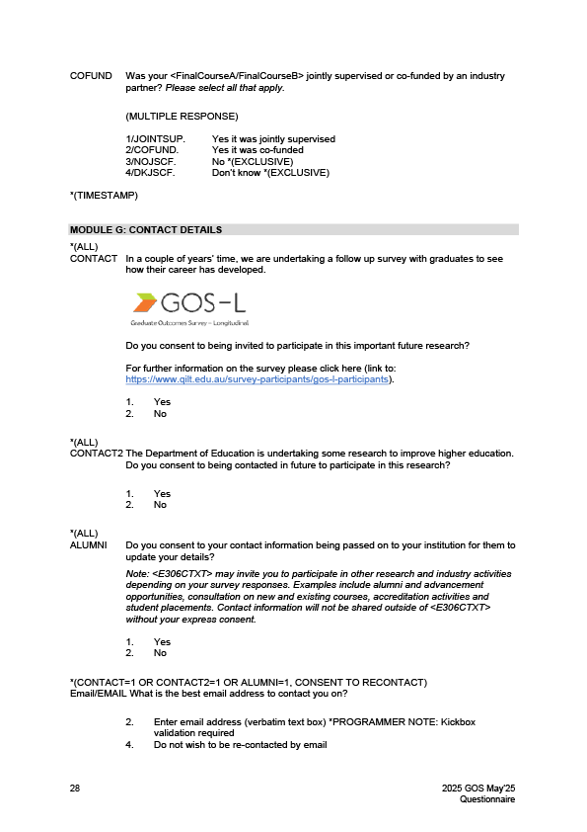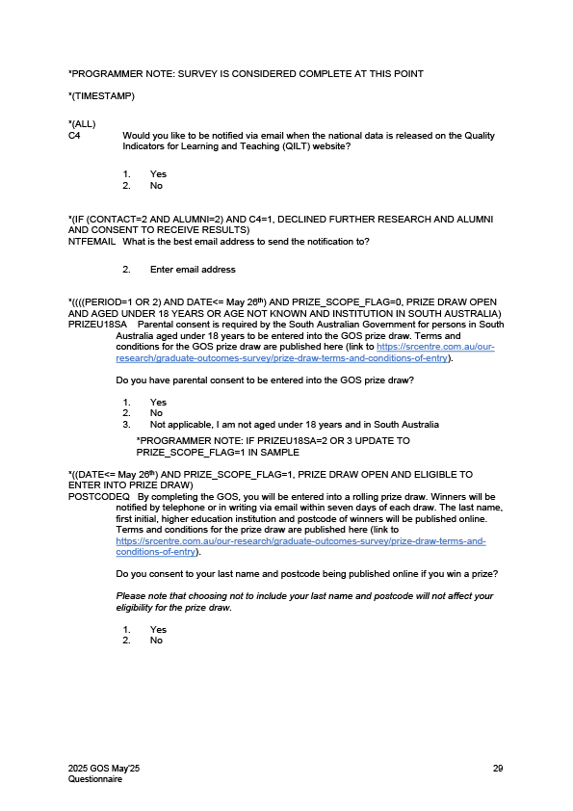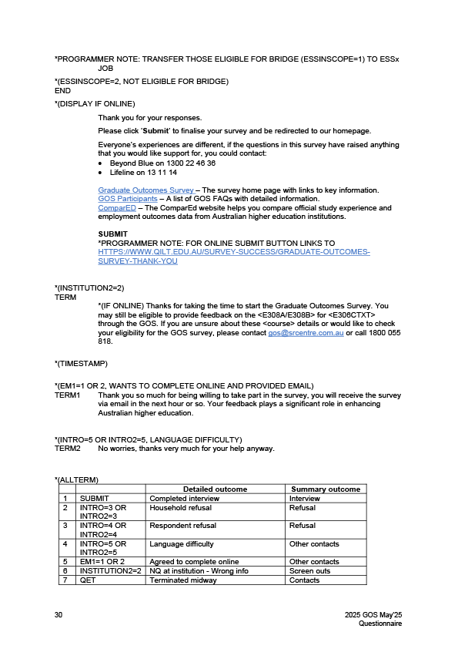

Appendix 4 Response rate by institution
The tables below show the final response rate by institution for each period of the 2025 GOS collection cycle. There was a minor variation in response rate by provider type, with an overall response rate of 38.9 per cent for universities and 38.3 per cent for NUHEIs.
At an individual institution level within provider type, the total collection response rate ranged from 59.9 per cent to 25.4 per cent for universities, and 87.5 per cent to 16.7 per cent for NUHEIs.
2025 GOS university response rates (%)
 | 2024  November | 2025  February | 2025  May | 2025  Total collection
Australian Catholic University | 38.0 | 37.4 | 36.3 | 36.6
Avondale University | 69.2 | 55.6 | 51.0 | 52.3
Bond University | 34.6 | 36.3 | 35.8 | 35.5
Central Queensland University | 38.7 | 50.4 | 49.3 | 45.4
Charles Darwin University | 42.9 | 53.6 | 56.6 | 51.4
Charles Sturt University | 33.7 | 32.7 | 49.5 | 43.8
Curtin University | 28.0 |  | 37.7 | 34.6
Deakin University | 35.7 | 58.3 | 44.2 | 42.0
Edith Cowan University | 37.7 | 44.5 | 46.3 | 43.2
Federation University Australia | 32.0 | 41.6 | 43.4 | 40.1
Flinders University | 46.1 | 53.6 | 45.9 | 46.4
Griffith University | 34.5 |  | 42.5 | 40.1
James Cook University | 46.0 | 50.1 | 48.8 | 48.4
La Trobe University | 33.2 | 45.4 | 39.5 | 38.3
Macquarie University | 33.1 | 43.0 | 40.5 | 38.1
Monash University | 30.6 | 45.1 | 38.6 | 36.5
Murdoch University | 36.4 | 52.0 | 50.5 | 47.7
Queensland University of Technology | 43.4 | 54.0 | 50.0 | 48.2
RMIT University | 36.6 | 43.1 | 42.8 | 40.9
Southern Cross University | 33.6 | 43.7 | 43.1 | 41.0
Swinburne University of Technology | 34.8 |  | 43.8 | 40.1
The Australian National University | 30.8 | 46.1 | 43.9 | 38.4
The University of Adelaide | 40.9 | 50.4 | 48.0 | 46.2
The University of Melbourne | 38.4 | 42.3 | 39.7 | 39.5
The University of Notre Dame Australia | 35.6 | 32.5 | 20.2 | 26.9
The University of Queensland | 26.9 | 57.0 | 40.3 | 35.6
The University of South Australia | 36.5 |  | 44.0 | 42.0
The University of Sydney | 20.4 | 27.5 | 30.7 | 27.3
The University of Western Australia | 25.8 | 42.4 | 38.3 | 34.4
Torrens University | 40.5 | 50.6 | 53.6 | 48.5
University of Canberra | 36.8 |  | 45.6 | 42.7
University of Divinity | 49.3 | 69.2 | 60.9 | 59.9
University of New England | 49.0 | 57.9 | 62.7 | 56.0
University of New South Wales | 24.2 | 21.6 | 28.3 | 25.4
University of Newcastle | 31.6 | 37.8 | 36.0 | 35.3
University of Southern Queensland | 33.3 |  | 53.1 | 44.9
University of Tasmania | 43.2 | 53.7 | 50.1 | 48.5
University of Technology Sydney | 29.3 | 45.7 | 39.9 | 37.6
University of the Sunshine Coast | 33.8 |  | 39.1 | 37.7
University of Wollongong | 40.8 | 43.9 | 46.6 | 44.7
Victoria University | 30.9 | 43.3 | 37.9 | 36.5
Western Sydney University | 26.3 | 35.1 | 40.1 | 35.3
All Universities | 33.3 | 39.9 | 41.4 | 38.8
Note: A blank cell indicates institution did not participate in that collection period and n/a indicates a suppressed value (n<25).

2025 GOS NUHEI response rates (%)
 | 2024  November | 2025  February | 2025  May | 2025  Total collection
ACAP University College Pty Ltd. | 44.2 | 45.6 | 53.3 | 45.0
Academies Australasia Polytechnic Pty Limited | 28.1 | 40.0 | n/a | 34.3
Academy of Interactive Technology | 30.6 | 28.4 | 55.7 | 36.1
Acknowledge Education | 24.5 | 40.0 | 48.0 | 41.5
Adelaide Central School of Art |  |  | 87.5 | 87.5
Adelaide Institute of Higher Education | n/a | 63.2 |  | 43.3
Alphacrucis University College | 38.6 |  | 49.0 | 42.4
Asia Pacific International College | 32.6 | 35.5 | 44.6 | 38.9
Australasian College of Health and Wellness | 25.0 | 39.5 | 29.1 | 28.9
Australia Advance Education Group Pty Ltd | 21.6 | 41.7 |  | 34.0
Australian Academy of Music and Performing Arts | 28.6 |  | 51.9 | 41.7
Australian Chiropractic College Limited |  |  | 43.5 | 43.5
Australian College of Christian Studies |  |  | n/a | n/a
Australian College of Nursing | 43.0 | 53.1 | 41.8 | 42.9
Australian College of Theology Limited | 31.9 | 51.2 | 58.5 | 53.4
Australian Institute of Business Pty Ltd | 34.4 | 44.9 | 50.3 | 40.8
Australian Institute of Higher Education | 23.3 | 54.2 |  | 29.1
Australian Institute of Management Education & Training | 36.7 | 38.6 | 51.0 | 41.6
Australian Institute of Professional Counsellors | 38.6 | 47.2 | 52.2 | 45.0
Box Hill Institute | 75.0 |  | 52.5 | 55.2
CIC Higher Education | 40.0 | n/a | 31.1 | 34.5
Campion College Australia |  |  | 30.5 | 30.5
Chartered Accountants Australia and New Zealand | 20.4 | 15.9 |  | 18.3
Chisholm Institute | 36.7 | n/a | 59.2 | 49.4
Christian Heritage College | n/a | n/a | 45.5 | 45.9
Collarts (Australian College of the Arts) | n/a | 42.9 | 49.5 | 47.1
Crown Institute of Higher Education Pty Ltd |  |  | 51.7 | 51.7
ECA Higher Education Institute Pty Ltd |  | 70.0 | 67.3 | 68.5
Eastern College Australia |  |  | 46.7 | 46.7
Edvantage Institute Australia Pty Ltd |  | n/a | n/a | n/a
Endeavour College of Natural Health |  |  | 35.2 | 35.2
Engineering Institute of Technology | n/a | n/a | 54.5 | 46.0
Equals International | n/a |  | n/a | 50.0
Excelsia College | 24.0 | 26.3 | 46.5 | 38.2
Gestalt Therapy Brisbane |  |  | 51.1 | 51.1
Governance Institute of Australia | 23.8 |  | 46.8 | 37.5
HEPCO The Tax Institute Higher Education | n/a |  | 60.6 | 59.0
Health Education & Training Institute | n/a | 50.0 | 47.6 | 47.4
Higher Education Leadership Institute | n/a | n/a | n/a | n/a
Holmes Institute | 38.2 |  | 45.6 | 41.4
Holmesglen Institute | 25.4 | n/a | 44.6 | 37.4
ICHM | n/a | 34.3 | 55.6 | 43.5
ISN Psychology | 32.5 | n/a | 42.7 | 38.9
Ikon Institute of Australia |  |  | 47.4 | 47.4
Institute of Health & Management | 66.2 | 69.7 | 75.0 | 70.6
International College of Management, Sydney | 25.5 | 34.0 | 41.1 | 34.5
Jazz Music Institute |  |  | 45.5 | 45.5
Kaplan Business School | 35.8 | 37.5 | 51.9 | 42.4
Kaplan Professional | 31.4 | 29.1 | 30.6 | 30.7
King's Own Institute | 38.9 | 56.0 | 65.9 | 51.1
LCI Melbourne | 87.5 | 58.3 | 55.0 | 62.5
Leaders Institute | n/a |  |  | n/a
Leo Cussen Centre for Law | 27.9 | 31.3 | 40.4 | 33.2
Lyons College |  |  | n/a | n/a
Marcus Oldham College |  |  | 59.8 | 59.8
Melbourne Institute of Technology | 28.9 |  | 35.2 | 32.6
Melbourne Polytechnic | 37.7 |  | 49.5 | 45.6
Moore Theological College | 55.6 |  | 56.3 | 56.3
Morling College |  |  | 43.8 | 43.8
Nan Tien Institute | n/a | n/a | n/a | 45.0
National Art School |  |  | 45.9 | 45.9
National Institute of Organisation Dynamics Aust |  |  | 75.0 | 75.0
Ozford Institute of Higher Education |  |  | 42.1 | 42.1
Performing Arts Education |  | n/a | n/a | 46.2
Perth Bible College | n/a | n/a | n/a | 69.2
Photography Studies College (Melbourne) |  |  | 47.7 | 47.7
Polytechnic Institute Australia Pty Ltd | 29.1 | 33.1 | 43.1 | 34.4
SAE Institute Pty Limited | 32.4 | 46.1 | 33.3 | 39.2
SP Jain School of Management | 34.2 |  |  | 34.2
Sheridan Institute of Higher Education | 100.0 |  | 83.3 | 88.2
Southern Cross Education Institute (Higher Education) | 16.1 | 52.1 | 40.7 | 34.9
Stanley College |  | n/a |  | n/a
Sydney College of Divinity | 26.7 | n/a | 40.2 | 30.8
Sydney Institute of Higher Education |  | 71.4 |  | 71.4
TAFE NSW | 44.6 |  | 46.4 | 45.6
TAFE Queensland | 31.3 |  | 63.9 | 48.5
TAFE South Australia | 27.9 | n/a | 64.7 | 37.7
Tabor College of Higher Education | 38.1 | 60.6 | 64.8 | 59.9
The Australian College of Physical Education | 21.9 |  | 31.4 | 28.8
The Australian Guild of Music Education | n/a | n/a | n/a | n/a
The Australian Institute of Music | 39.0 | 35.8 | 55.9 | 46.5
The Cairnmillar Institute | 58.3 | n/a | 45.9 | 46.9
The College of Law Limited | 20.9 | 25.1 | 28.6 | 24.2
The Institute of Creative Arts and Technology | 36.4 | 48.0 | 28.9 | 35.9
The Institute of Internal Auditors - Australia |  | n/a | 94.4 | 82.6
The Institute of International Studies (TIIS) |  | 70.6 |  | 70.6
The MIECAT Institute | 55.1 | n/a |  | 56.0
The Metavision Institute |  |  | 45.5 | 45.5
UOW College | 16.7 |  |  | 16.7
Universal Higher Education |  |  | 100.0 | 100.0
VIT (Victorian Institute of Technology) | 47.1 | 50.0 | 60.4 | 56.9
Wentworth Institute of Higher Education | 26.2 | n/a | 43.3 | 36.3
Whitehouse Institute of Design, Australia |  |  | 46.1 | 46.1
William Angliss Institute | 16.7 |  | 41.7 | 30.3
All NUHEIs | 32.3 | 35.7 | 46.4 | 38.6
Note: A blank cell indicates institution did not participate in that collection period and n/a indicates a suppressed value (n<25)


Level 5, 350 Queen Street
Melbourne VIC 3000
PO Box 13328
Law Courts VIC 8010
Phone (61 3) 9114 1003
qilt@srcentre.com.au
www.qilt.com.au
The version of this publication is aimed to assist those with various
vision impairments; however, The Social Research Centre and its
employees do not guarantee that the publication meets all broad
accessibility standards and therefore disclaim all liability for any
inconvenience or other consequence that may arise from readers
relying on this publication. Please contact The Social Research
Centre if you require further assistance.

Of the NUHEIs that agreed to participate in the 2025 GOS, 17 were non-Higher Education Support Act (HESA) institutions. In 2021, department funding of QILT participation was extended to HESA institutions for the first time and non-HESA institutions continued to be able to participate free of charge, beginning from the 2022 GOS collection cycle.
The TCSI system replaced the Higher Education Information Management System (HEIMS) as the authoritative source of information regarding higher education in Australia in mid-2021.
A soft bounce occurs when an email could not be delivered because of a temporary issue, such as the recipient’s mailbox being full or inactive.
A hard bounce occurs when an email could not be delivered for permanent reasons, for example when the recipient’s email address does not exist or the recipient’s email server has blocked delivery.
The percentage is calculated by dividing the total sample initiated for dialing (92,094) by the final in-scope sample (332,988).
The percentage is calculated by dividing the total sample initiated for dialing (27,790) by the total sample (332,988).
Work-Integrated Learning Australia (WIL Australia) was rebranded from Australian Collaborative Education Network (ACEN) in 2025. Data for the 2025 GOS was collected when WIL Australia was ACEN.
National in-scope population approached.
Note: Hyphens (-) represent no completed surveys for that collection round, <5 indicates a suppressed value (n < 5), and np indicates a value that is not published to prevent disclosure of a suppressed value
Note: Hyphens (-) represent no completed surveys for that collection round, <5 indicates a suppressed value (n < 5), and np indicates a value that is not published to prevent disclosure of a suppressed value
Note: Hyphens (-) represent no completed surveys for that collection round, <5 indicates a suppressed value (n < 5), and np indicates a value that is not published to prevent disclosure of a suppressed value
Note: Hyphens (-) represent no completed surveys for that collection round, <5 indicates a suppressed value (n < 5), and np indicates a value that is not published to prevent disclosure of a suppressed value
Note: Hyphens (-) represent no completed surveys for that collection round, <5 indicates a suppressed value (n < 5), and np indicates a value that is not published to prevent disclosure of a suppressed value * The Australian University of Theology was awarded university status in December 2024. Prior to this, the institution was known as the Australian College of Theology and was classified as a non-university higher education institution (NUHEI). Data for the 2025 GOS was collected when the institution was a NUHEI.
Note: Hyphens (-) represent no completed surveys for that collection round, <5 indicates a suppressed value (n < 5), and np indicates a value that is not published to prevent disclosure of a suppressed value * The Australian University of Theology was awarded university status in December 2024. Prior to this, the institution was known as the Australian College of Theology and was classified as a non-university higher education institution (NUHEI). Data for the 2025 GOS was collected when the institution was a NUHEI.
Note: Hyphens (-) represent no completed surveys for that collection round, <5 indicates a suppressed value (n < 5), and np indicates a value that is not published to prevent disclosure of a suppressed value * The Australian University of Theology was awarded university status in December 2024. Prior to this, the institution was known as the Australian College of Theology and was classified as a non-university higher education institution (NUHEI). Data for the 2025 GOS was collected when the institution was a NUHEI.
Note: Hyphens (-) represent no completed surveys for that collection round, <5 indicates a suppressed value (n < 5), and np indicates a value that is not published to prevent disclosure of a suppressed value * The Australian University of Theology was awarded university status in December 2024. Prior to this, the institution was known as the Australian College of Theology and was classified as a non-university higher education institution (NUHEI). Data for the 2025 GOS was collected when the institution was a NUHEI.

